Credit Risk & Loan Default Analytics
Project Report

1. Introduction
This report documents the Credit Risk & Loan Default Analytics project. The workflow moves from raw loan data understanding and cleaning through exploratory analysis, SQL analysis, feature preparation, model evaluation, reusable risk prediction, and a Streamlit dashboard.

2. Problem Statement
Loan default risk is influenced by borrower characteristics, credit history, employment information, and loan terms. The project organizes these variables into a reproducible analytical workflow and provides a model-backed interface for examining default patterns and assessing individual borrower risk.

3. Objectives
- Understand the dataset structure and quality.
- Explore default patterns across borrower and loan characteristics.
- Prepare features for machine-learning models.
- Compare classification models using evaluation metrics.
- Save the selected preprocessing and model pipeline for reuse.
- Provide an interactive dashboard for risk analysis and borrower prediction.

4. Dataset and Source
The project uses the Loan Default dataset from Kaggle:
https://www.kaggle.com/datasets/nikhil1e9/loan-default
The cleaned project dataset contains 255,347 rows and 18 columns. Default is the target variable and LoanID is excluded from model features.

5. Technologies Used
- Python, pandas, NumPy
- scikit-learn
- Matplotlib and Seaborn
- Plotly and Streamlit
- SQLite
- Jupyter notebooks

6. Data Understanding
The data-understanding notebook inspected shape, columns, data types, descriptive statistics, uniqueness, missing values, duplicates, and target distribution.
Measure | Value
Rows | 255,347
Columns | 18
Non-default loans | 225,694
Default loans | 29,653
Overall default rate | 11.6128%

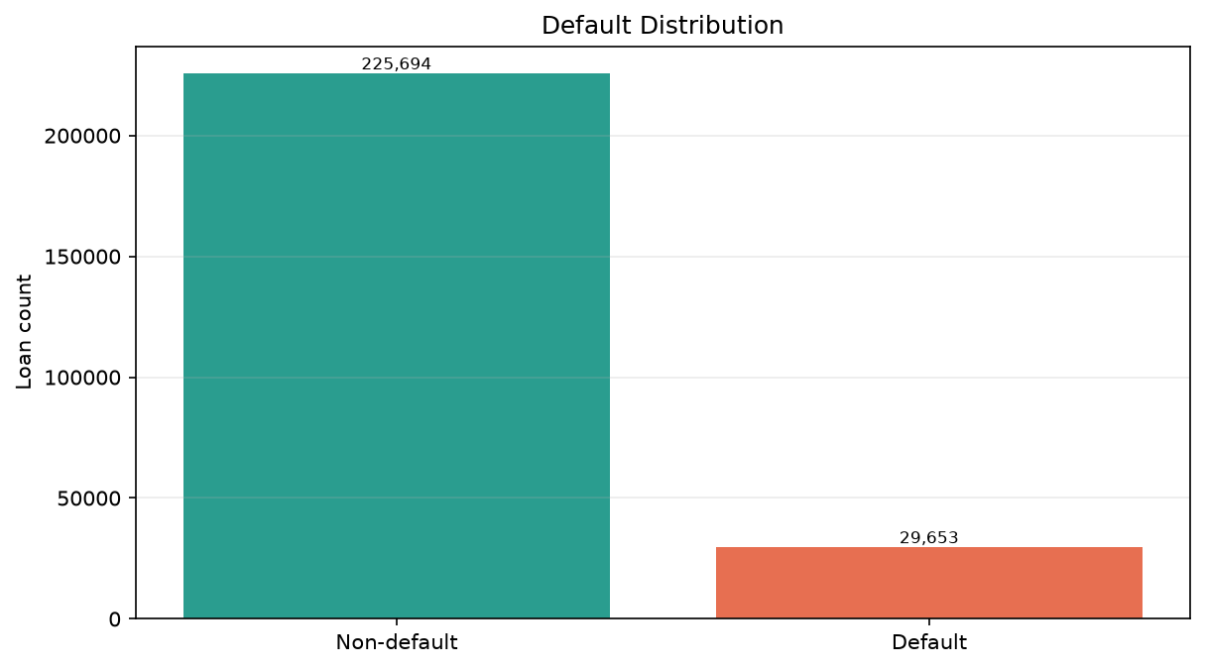
Figure 1. Default distribution calculated from the cleaned project dataset.

7. Data Cleaning
The cleaning notebook validated missing values, duplicate rows, numeric ranges, and allowed categorical values before saving outputs/cleaned_loan_default.csv.
- Missing values: 0 across all 18 columns.
- Duplicate rows: 0.
- Numeric range validation: 0 invalid values for the checked fields.
- Categorical validation: no invalid values in the checked category columns.
- The cleaned output retains 255,347 rows and 18 columns.

8. EDA with Important Charts and Results
The overall default rate is 11.6128%. The EDA notebook and dashboard examine default rates by credit score group, income group, employment type, and loan purpose.
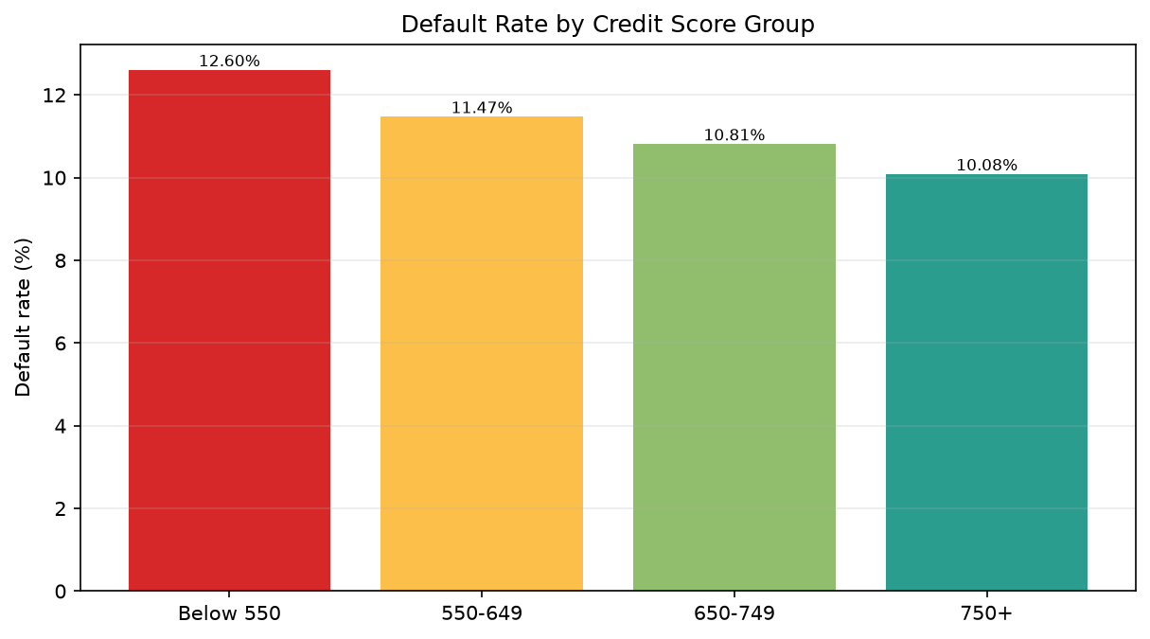
Figure 2. Default rate by credit score group.
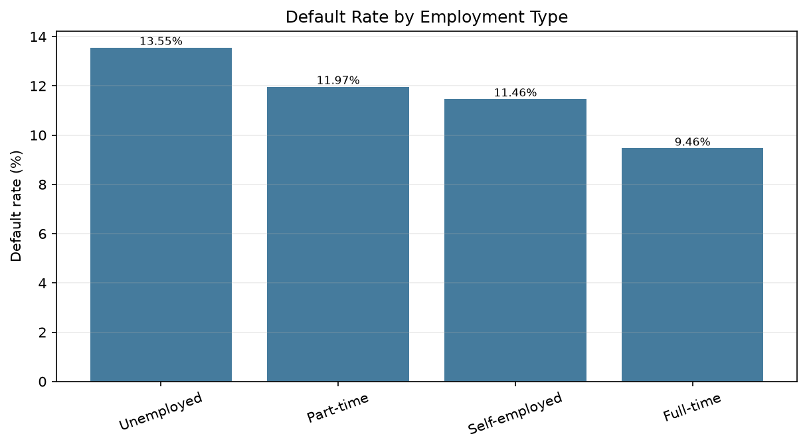
Figure 3. Default rate by employment type.
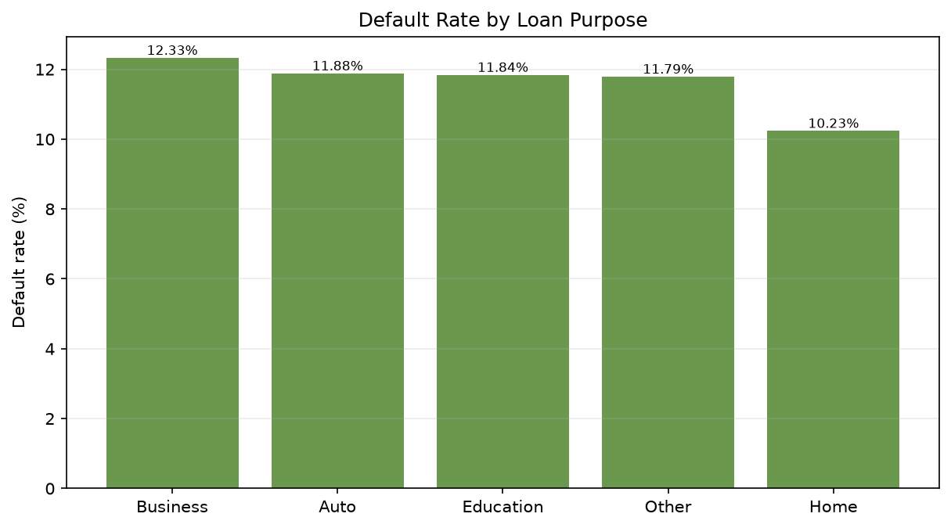
Figure 4. Default rate by loan purpose.

9. SQL Analysis
The SQL notebook loads the cleaned CSV into an in-memory SQLite table named loan_data and queries totals, defaults, average income, average loan amount, employment type, loan purpose, and credit score groups.
Selected SQL outputs:
Measure | Value
Total loans | 255,347
Total loan amount | $32,576,880,572.00
Default count | 29,653
Default rate | 0.1161

Default rate by employment type:
EmploymentType | total_loans | default_rate_pct
Unemployed | 63824 | 13.55%
Part-time | 64161 | 11.97%
Self-employed | 63706 | 11.46%
Full-time | 63656 | 9.46%

Default rate by loan purpose:
LoanPurpose | total_loans | default_rate_pct
Business | 51298 | 12.33%
Auto | 50844 | 11.88%
Education | 51005 | 11.84%
Other | 50914 | 11.79%
Home | 51286 | 10.23%

Default rate by credit score group:
credit_score_group | total_loans | default_rate_pct
Below 550 | 116278 | 12.60%
550-649 | 46488 | 11.47%
650-749 | 46007 | 10.81%
750+ | 46574 | 10.08%

10. Feature Engineering
The feature-engineering workflow excludes LoanID and Default, selects numeric, binary, and categorical features, and uses a stratified 80/20 train-test split with random_state=42.
- Numeric features are standardized with StandardScaler.
- Binary and categorical features are one-hot encoded with handle_unknown=ignore.
- The preprocessor is fit on training data and applied to test data.
- The selected feature set contains 16 input columns and produces a 31-column prepared feature matrix.
- The saved pipeline combines preprocessing and the selected classifier.

11. ML Models and Evaluation Metrics
The model-training notebook evaluates Logistic Regression, Random Forest, and Gradient Boosting using precision, recall, F1-score, and ROC-AUC. Model selection ranks F1-score first, followed by ROC-AUC, recall, and precision.
Model | Precision | Recall | F1-score | ROC-AUC
Logistic Regression | 0.2195 | 0.6990 | 0.3341 | 0.7532
Random Forest | 0.3916 | 0.2570 | 0.3103 | 0.7510
Gradient Boosting | 0.6261 | 0.0494 | 0.0916 | 0.7580

Using the stated ranking rule, the selected model is Logistic Regression. The fitted pipeline is saved at outputs/credit_risk_model.pkl and loaded by the dashboard.

12. Final Risk Prediction
The risk-prediction workflow accepts one borrower dictionary or a list of borrower dictionaries, applies the saved preprocessing pipeline, and returns a predicted default flag, default probability, and risk level. Risk thresholds are Low below 0.10, Medium from 0.10 to below 0.30, and High at 0.30 or above.
Sample | Predicted Default | Default Probability | Risk Level
1 | 0 | 0.4395 | High
2 | 1 | 0.6466 | High
3 | 0 | 0.2970 | Medium

13. Dashboard Features
- Executive overview with total loans, total loan amount, default rate, and average loan amount.
- Risk-analysis charts for credit score, income, employment type, and loan purpose.
- Borrower risk-prediction form using the saved pipeline.
- Model summary table showing evaluated metrics.
- Centered layout and readable chart sizing for a normal laptop screen.
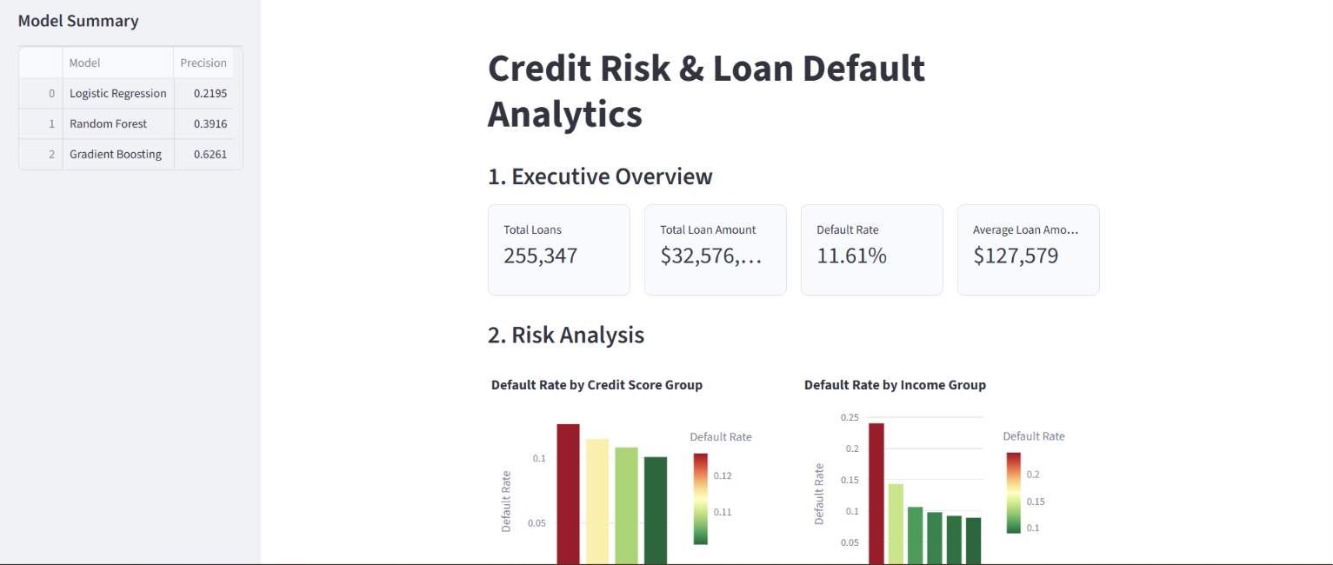
Figure 5. Streamlit dashboard capture showing the executive overview, risk-analysis charts, and model summary.

14. Key Findings
- The cleaned dataset contains 255,347 loans, with 29,653 defaults and an overall default rate of 11.6128%.
- Default rate decreases across credit-score groups from 12.60% for Below 550 to 10.08% for 750+.
- Unemployed has the highest employment-group default rate at 13.55%, while Full-time has the lowest at 9.46%.
- Business has the highest purpose-group default rate at 12.33%, while Home has the lowest at 10.23%.
- Logistic Regression is selected under the project ranking rule, with an F1-score of 0.334099.

15. Conclusion
The project provides an end-to-end credit-risk workflow based on the cleaned loan-default dataset. It combines validated data preparation, descriptive analysis, SQL summaries, leakage-aware feature engineering, model comparison, reusable prediction, and an interactive dashboard. The dashboard uses the saved pipeline so it can serve predictions without retraining models at startup.

16. Future Scope
- Add time-based validation if loan origination dates become available.
- Evaluate calibration and decision thresholds for a specific lending policy.
- Track model drift and prediction performance on newly observed loans.
- Add explainability outputs such as feature contributions for individual predictions.
- Add automated tests for data schema, artifact compatibility, and dashboard prediction inputs.

