Missing values in Data :
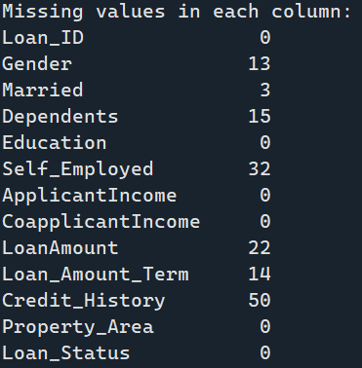

Comparison of accuracy between logistic regression and random forest :
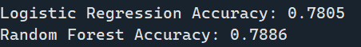

Confusion Matrix :
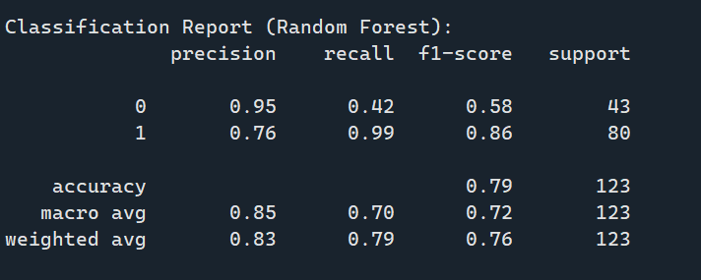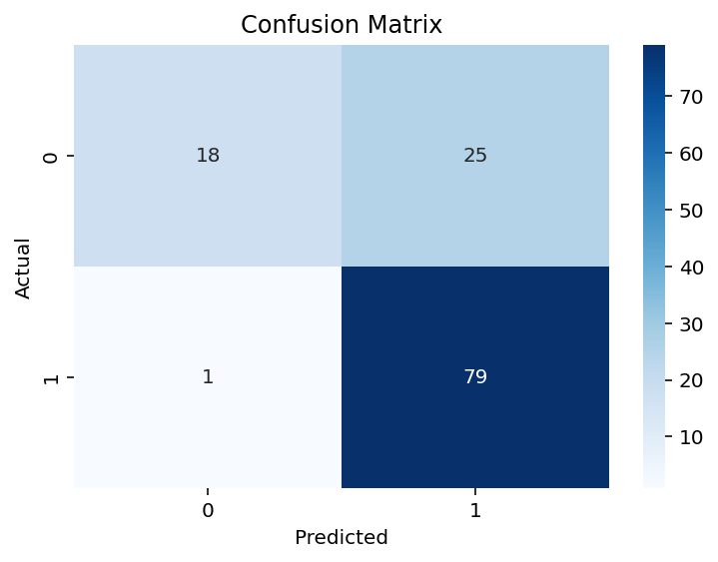

Manual Test :


