**Q2)**

**a)**

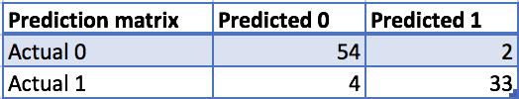

The prediction accuracy is 93.54%.

**b)** Stem plot for class 1

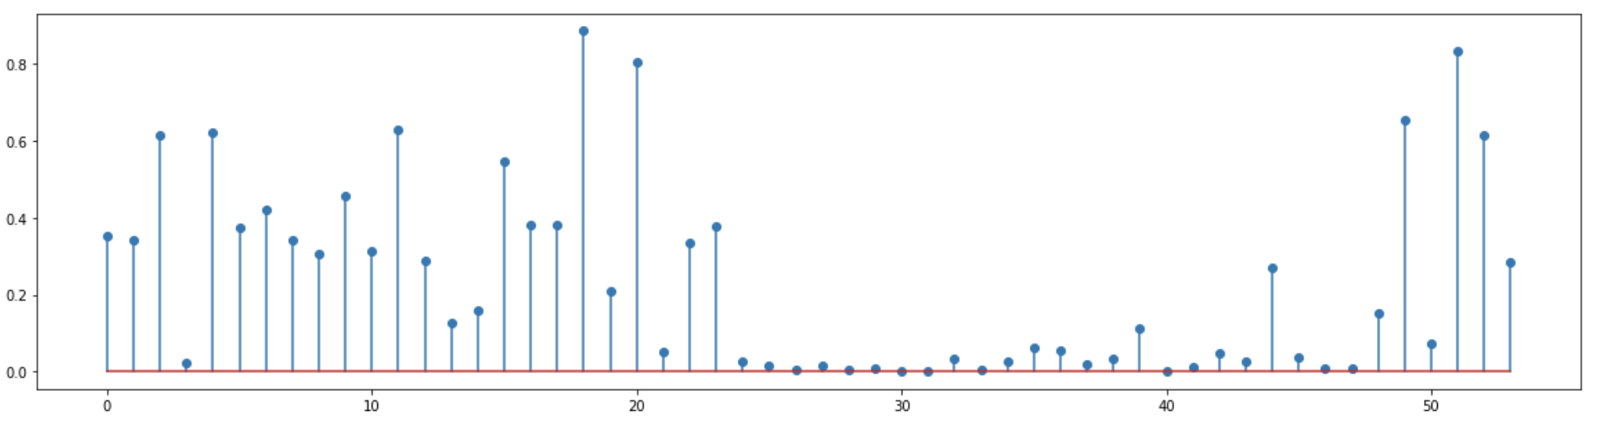

Stem plot for class 0

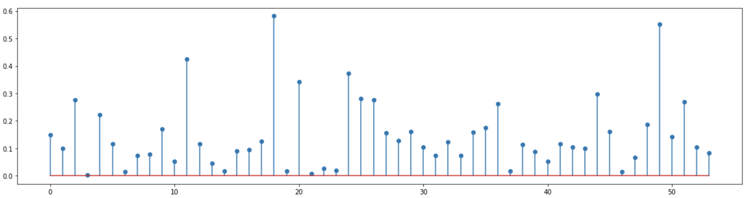

The value for the theta parameters for dimension 16 and 52 indicate that spam mails are more likely to contain “ ! “ and word “free”.

**c)** KNN accuracy plot

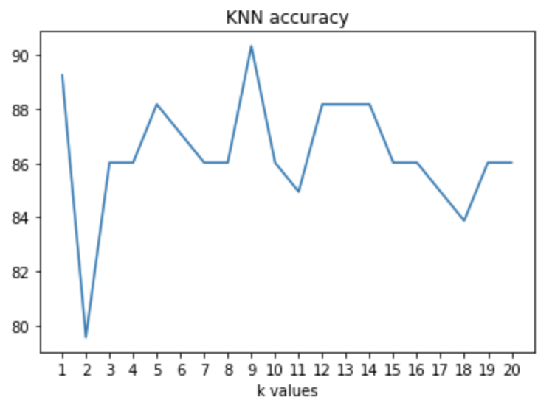

**d)**

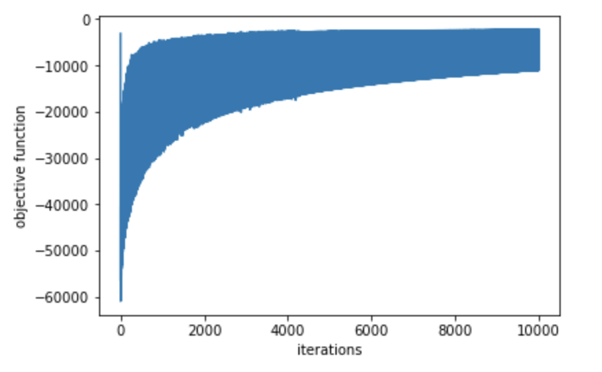

**e)**

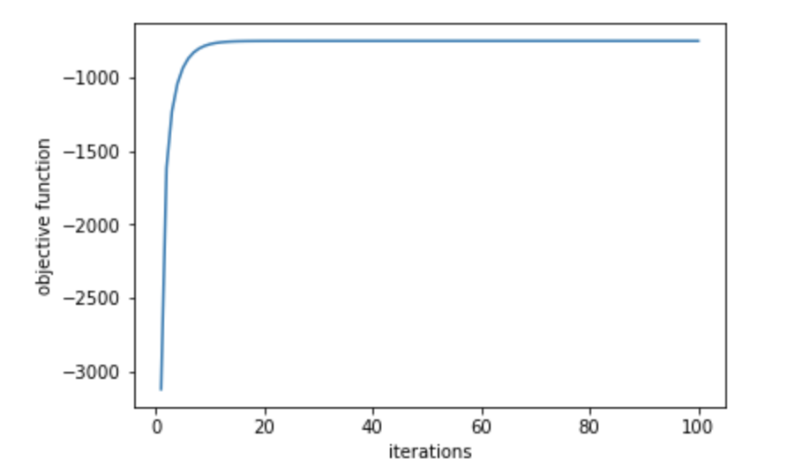

The accuracy for the newton method on test data is 91.39%.