**Ques 1**

1. Implemented the code.

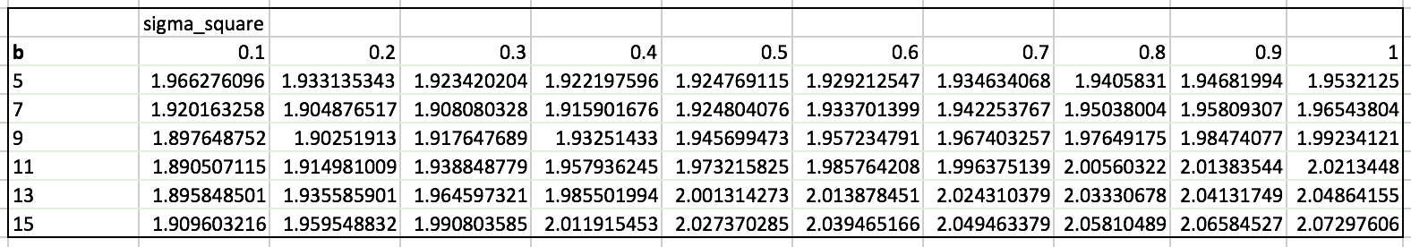

The lowest value of rmse is 1.890507 at b=11 and sigma_square=0.1. The value is better than the 2.2 which has obtained in the first homework. The model is performing better than the approach in first homework.

A potential drawback of the approach is that we need to do a grid search on the parameters of b and sigma square to obtain the best possible value. This is computationally expensive and we may not get the true optimal values after the grid search.

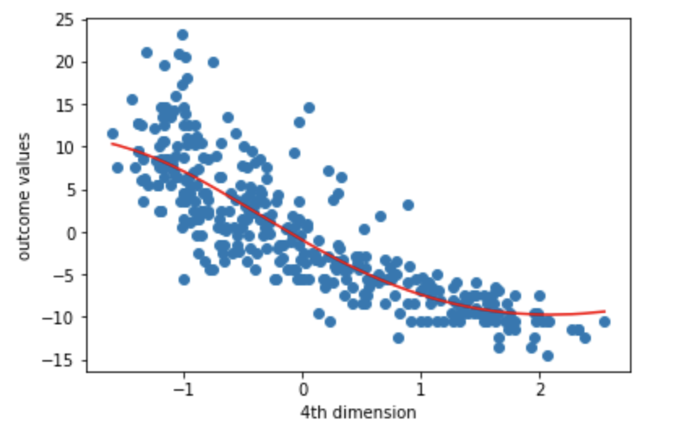

**QUES 2**

a)

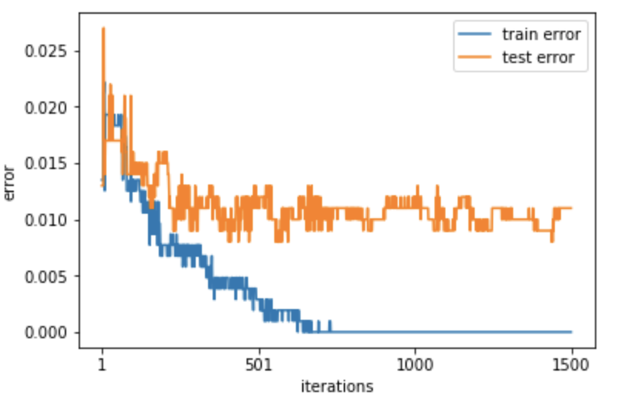

b)

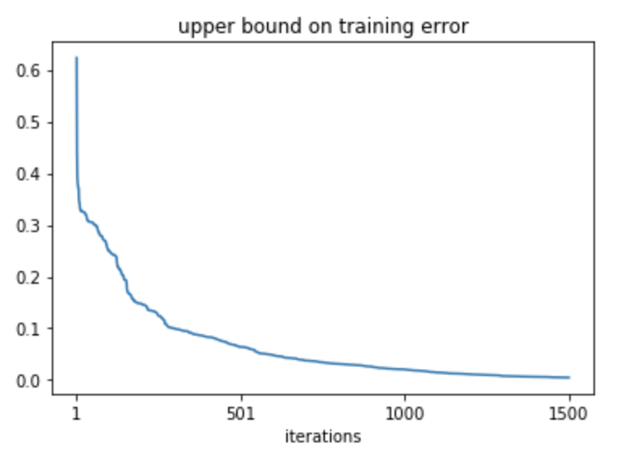

c)

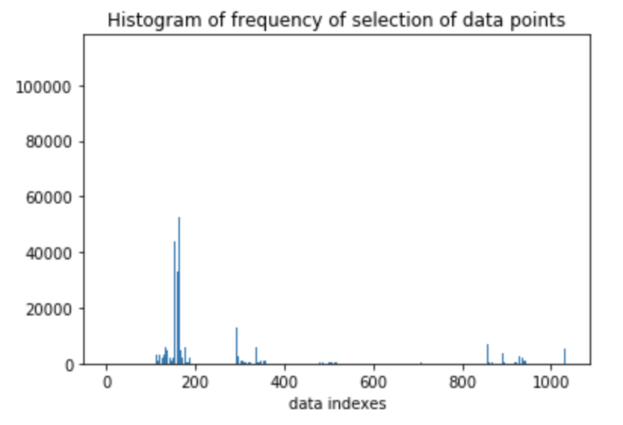

d)

