**Answer 1**

**a)**

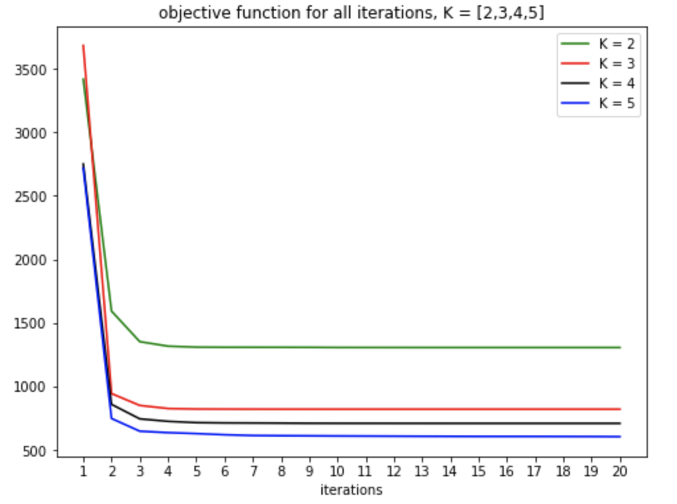

**b)**

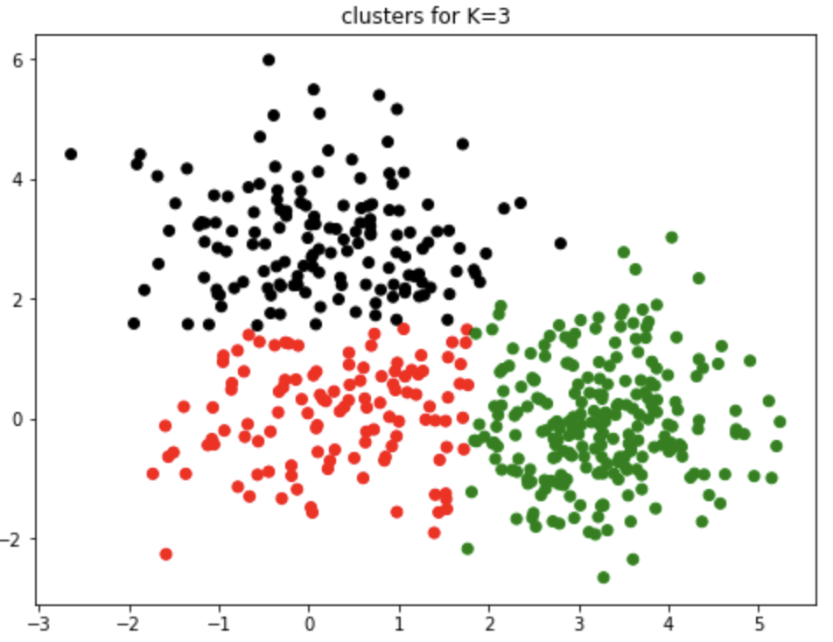

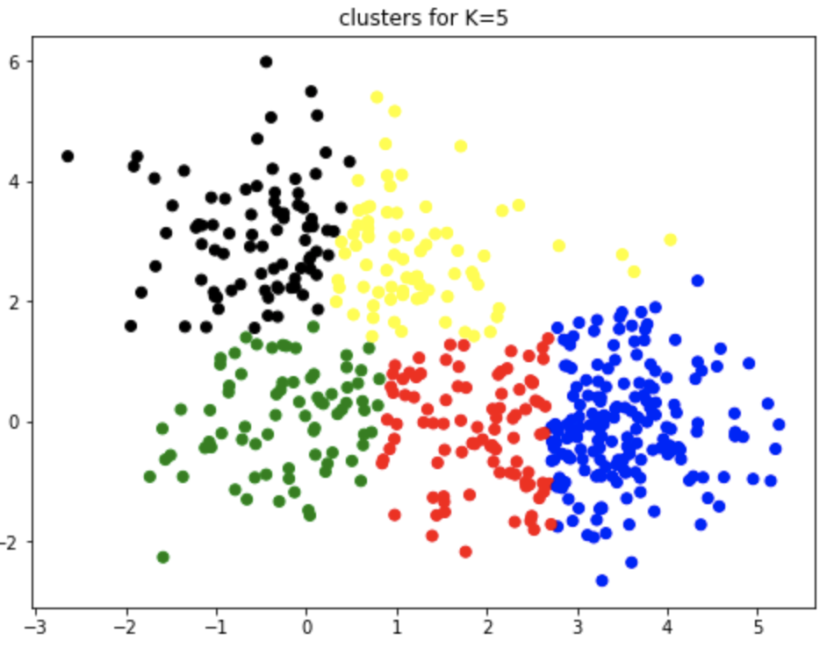

**Answer 2**

**a)**

Objective function for ten iterations of the program.

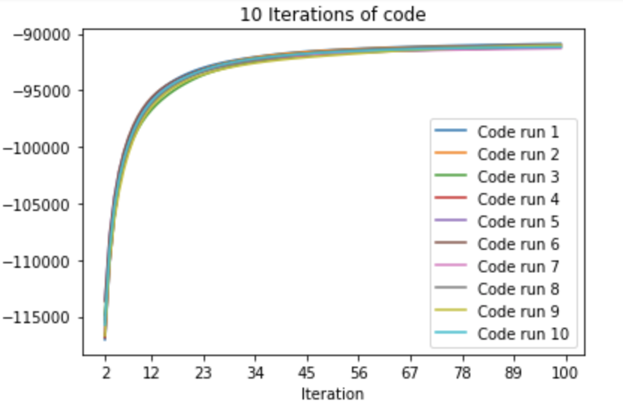

Objective function and test rmse sorted according to decreasing value of objective function.

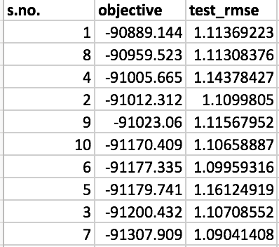

**b)**

List of 10 closest movies for Star Wars, My Fair Lady, GoodFellas.

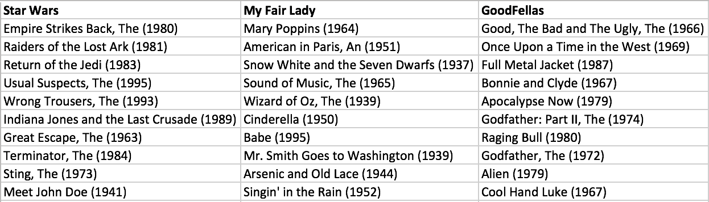

Distance of closest movies.

