**ANS 1 a)**

Top 25 teams for t=10,100,1000,10000 iterations.

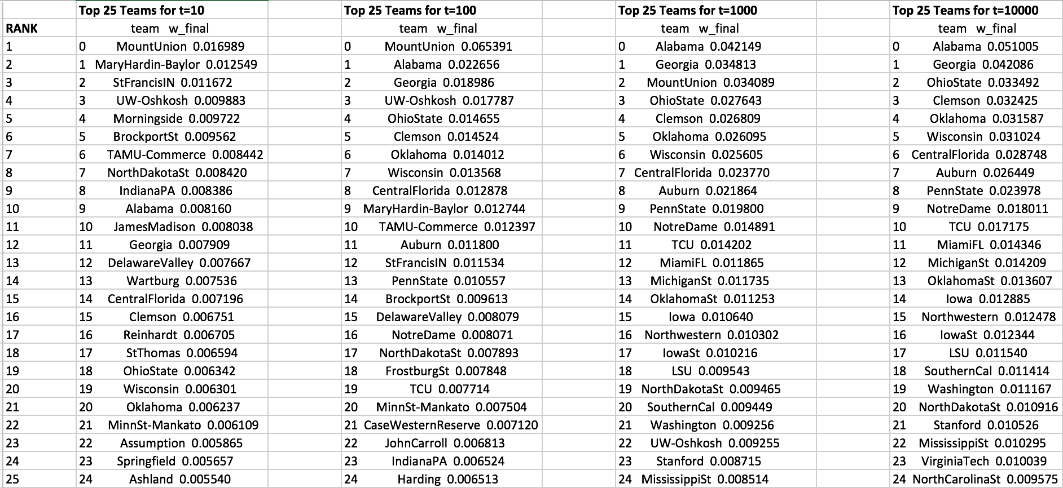

**b)**

Plot of the desired |w(t) – w(inf)| for iteration t

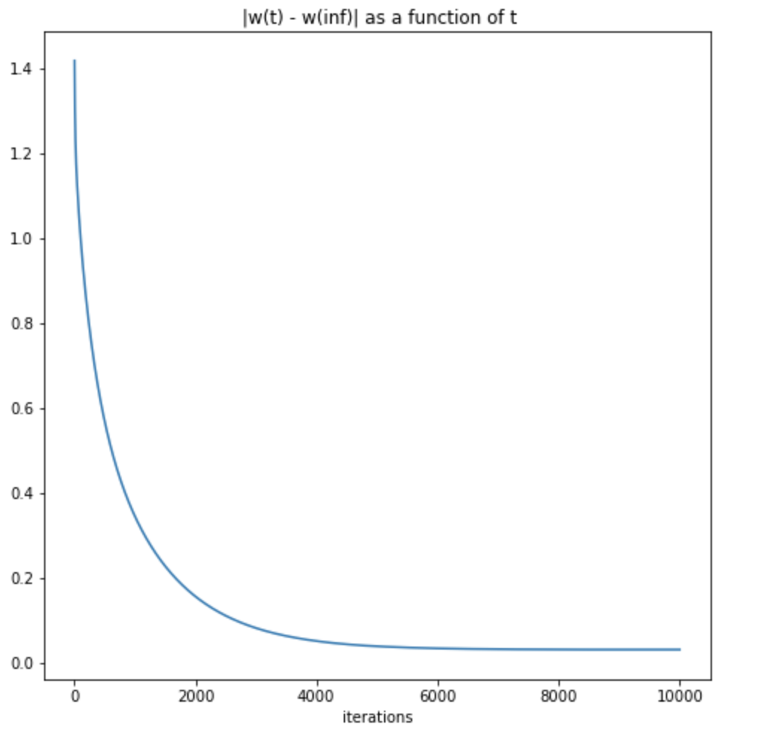

**ANS 2 a)**

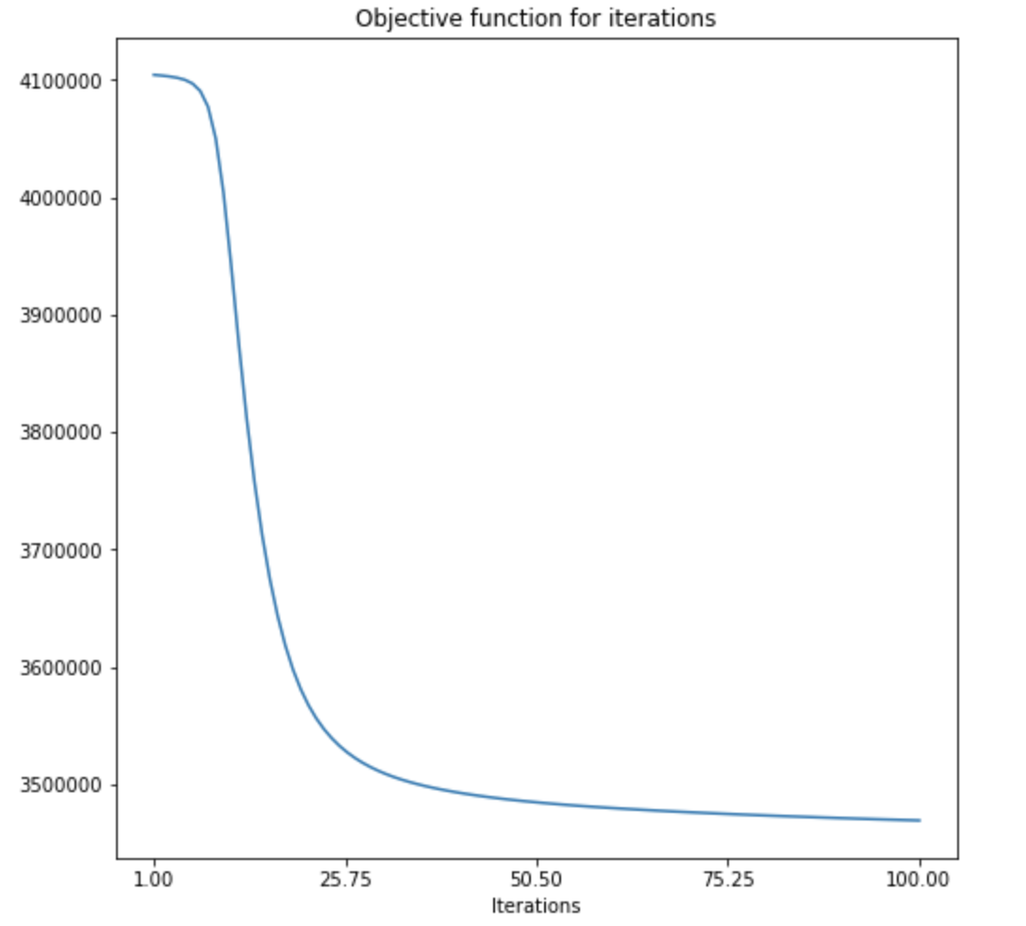

**2 b)**

25 topics with their weights to words.

