Version control System :
Mainly 2 types : CVCS and DVCS

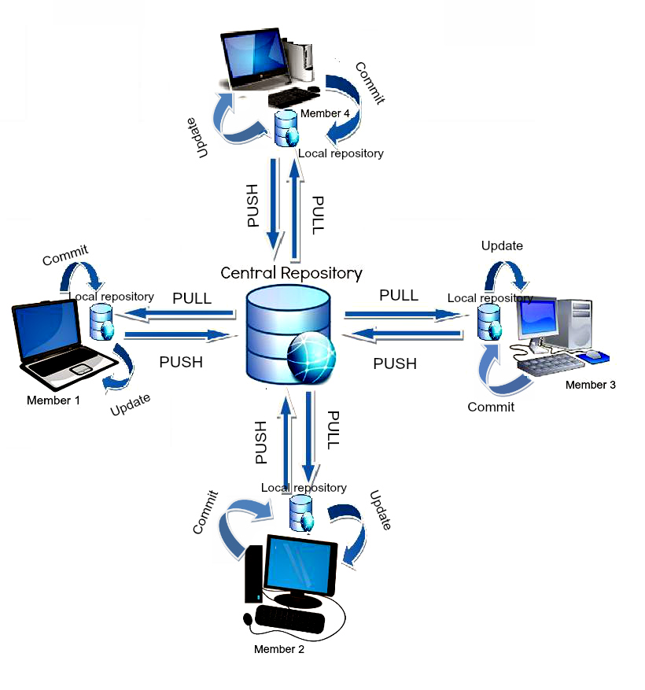
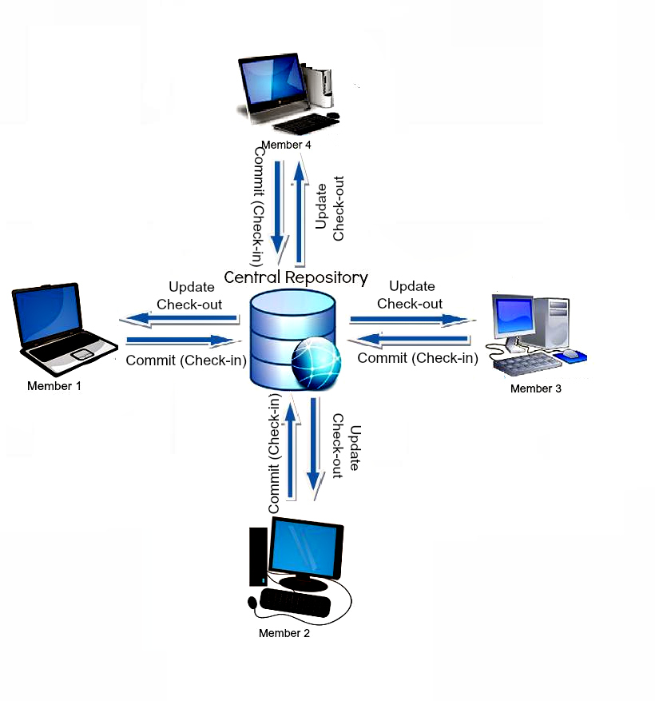

Centralized Version Control is the simplest system with the concept of 1 central repository which servers provides latest code to the all the clients across the globe
Whereas, in a Distributed System, every user has a local copy of the repository in addition to the central repo on the server side.
DVCS is comparatively fast comparing to CVCS as you don’t have to contact the central server for every command. DVCS just takes much time on the first check-out as its mirroring the central repository on your local.

GIT : Distributed version control system, content addresable storage sytem

Main things are blob,tree,commit,reference

Why VCS?
1. Record every changes
2. Able to check any version
3. Easy to read history

Content addresable storage sytem

Each object is stored as key,value as follows:
Key : SHA-1 hash of objcts content
Value : Compressed Content
Hence same content never saved twice

Objects could be blobs,trees . These are stored in ./git/objects
Blobs are for files and trees for repositories. Tree may contains other multipe trees and blobs.
Each object is stored in a folder in .git/object using 1st two letters of the SHA-1 hash key
And in that folder futher 38 alphanumeric SHA key named files are stored contanting the content (code/change in code) in compressed form

echo 'divay' | git hash-object -w –stdin : gives the SHA1 key of divay and is stored ( becoz of -w )

git cat-file -p “sha-1 key on f any blob/tree” : This outputs the content of the blob/tree having this SHA-1 key

git gc : garbage collector

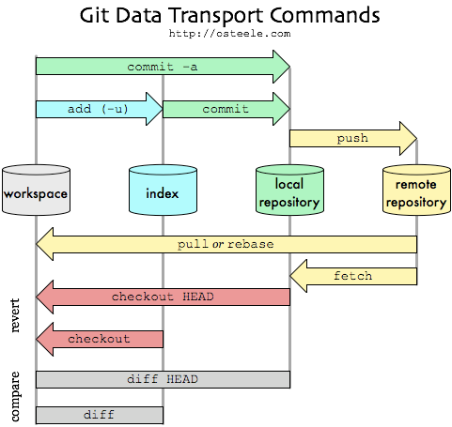

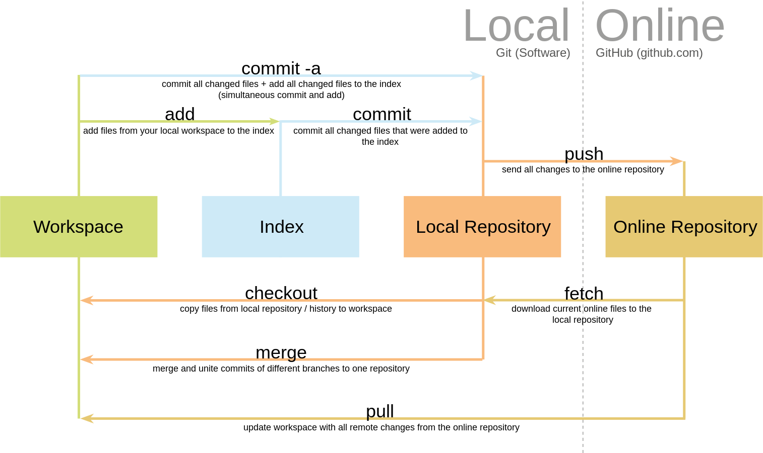

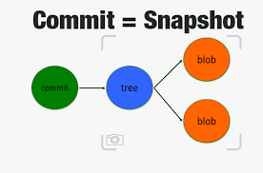

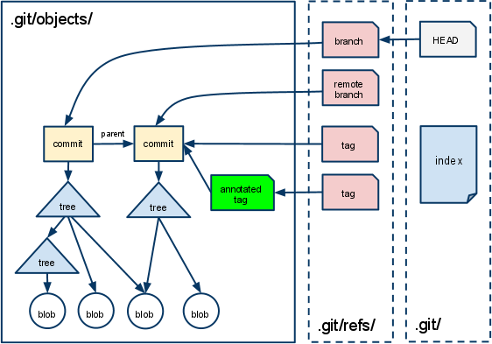

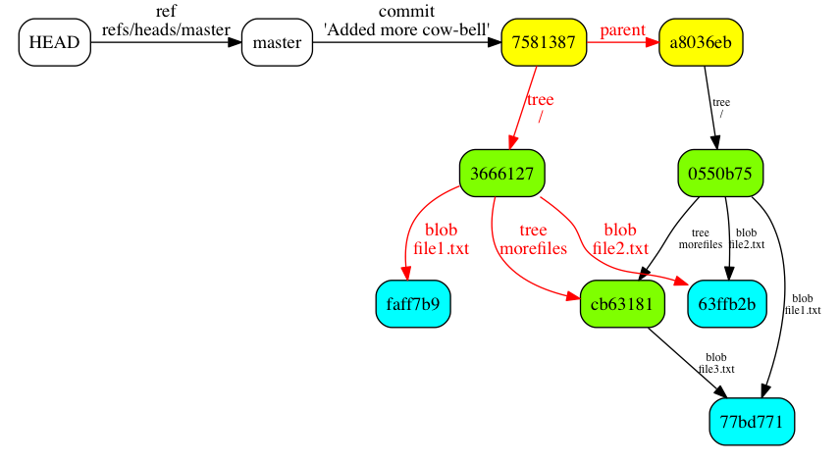

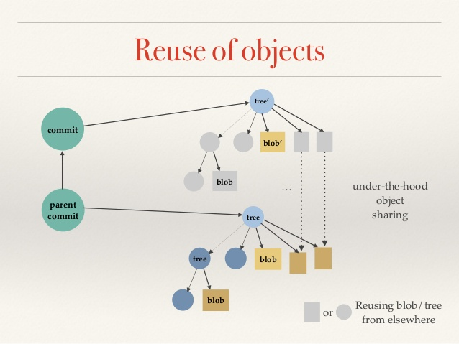

User work flow :

master is something with is default both in local and remote repo

1. git init
Creates .git in your working directory where all the info is present

2. git status
Tells what all files are present in the staging area, i,e what all files are being tracked ( modified or unmodified) or untracked.
It basically checks .git/index file

Git essentially has 4 main statuses for the files in your local repo:
- untracked: The file is new, Git knows nothing about it. If you git add <file>, it becomes:
- staged: Now Git knows the file (tracked), but also made it part of the next commit batch (called the index). If you git commit, it becomes:
- unchanged: The file has not changed since its last commit. If you modify it, it becomes:
- unstaged: Modified but not part of the next commit yet. You can stage it again with git add
- As you can see, a git add will track untracked files, and stage any file.
Also: You can untrack an uncommited file with git rm --cached filename and unstage a staged file with git reset HEAD <file>

3. git add <file name>
Adds the <filename> to the staging area. Basically modifies index]
objects created for all files/dirextories in .git/objects

4. .gitignore
This contains the file you dont want to be tracked

5. git reset <filename>
Will remove file from staing area

6. git commit -m “message”
an oject is created in .git/objects

7.git clone <url> <local location >
clone command downloads the .git file from the remote repo and does all the things to extract the objects and create a full fleshed similar looking repository

8. git remote -v
gives the info of push and fetch urls

9. git branch -a
gives all the branches both local and remote

10. git branch
list all the local branches. With asterick on the current working branch

10. git branch <branchname>
create new branch/workspace with all the contents form the master

10. git pull <remotename> <remote branchname>
FETCHES the changes from <remotebranchename> to the local master ,and then those changes are MERGED to the current working branch

11. git push <remotename> <remotebranchname>
push changes from current working branch to <remotebranch>

12. git checkout <branchname>
gets you that <branchname>

13. git branch –merged
tells what all branches have been merged till now

14. git merge <branchname>
merges the <branchname> with current working branch

15. git branch -d <branchname>
deletes this branch from local

16. git push origin –delete <branchname>
deletes branch from remote even

17. git reset head <commit ID>
goes back to that commit without deleting newer/older commits

18. git reset --hard <commit ID>
goes back to that commit and deletes the all the commits after that.

19. git stash
pushes all the current changes that can be taken up later in the stack

20. git pop
removes all the previous push changes from the stack

https://git-scm.com/book/en/v2/Git-Internals-Git-Objects
https://www.slideshare.net/SeongJaePark1/deep-darkside-ofgit

Dis-adv:

Binary files are a big no: If your project has non-text files that are updated frequently (images for websites or MS Office documents), then git becomes bloated and slow. (I believe it still does better than most systems)
Git is less preferred for handling extremely large files or frequently changing binary files .
GIT does not support ‘commits’ across multiple branches or tags.

IDEAS

.git has large size , what if change some compression algo from gzip to diff one

get a browser intervactive way of handling git commands

