

WFH07 Bluetooth Communication Protocol

Version <A4.0>

Version history

Version | Prepared by | Date of  Preparation | Reviewed by | Date | Status
A1.0 | Yuhui | 2024.03.27 | Tony | 2024.03.29
A3.0 | Yuhui | 2024.11.04 | Tony | 2024.11.11 | Add flashing and remote control
A4.0 | Yuhui | 2024.12.24 | Tony | 2024.12.24 | Modify flashing and remote control

Contents

1. Electronic Hardware Diagram 2

2. Electronic hardware specifications 4

3. Bluetooth working diagram 5

4. Bluetooth technical parameters 5

5. Bluetooth Service Description 6

1. Electronic Hardware Diagram
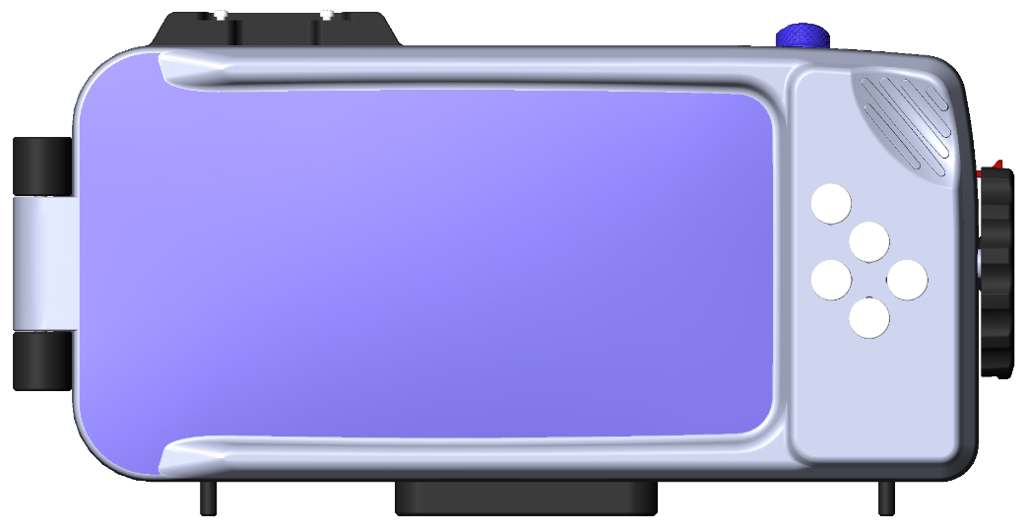

Figure 1

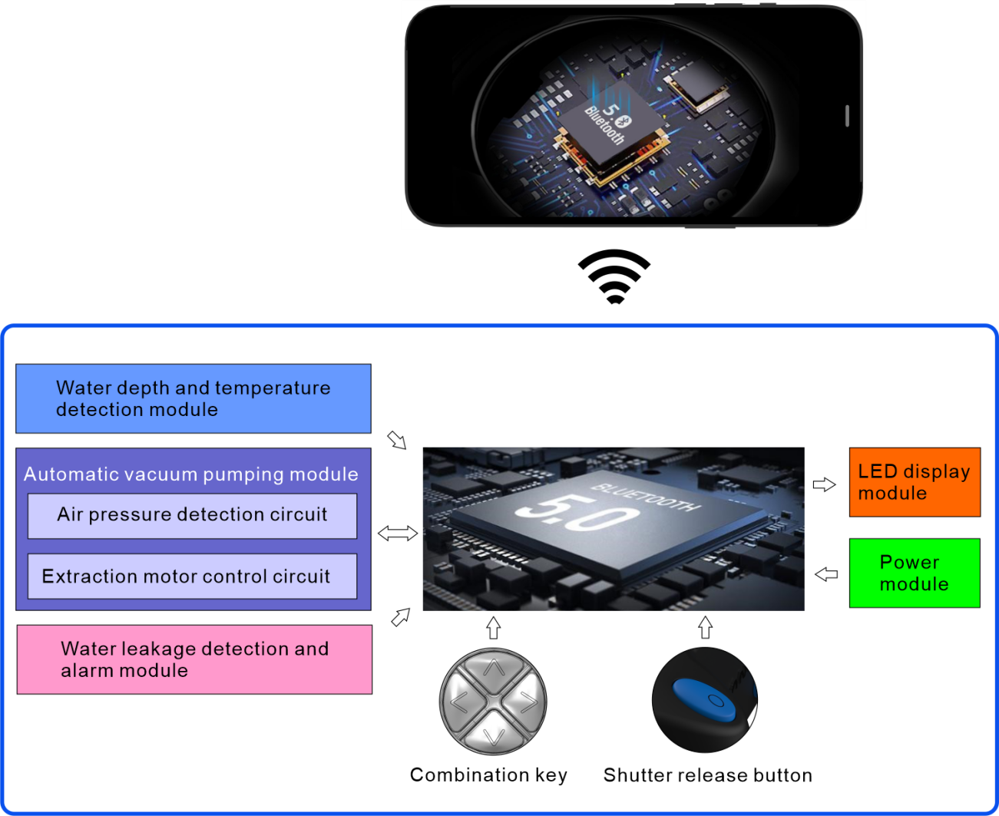

Figure 2



Module | Function | Remarks
Bluetooth Low Energy | Realize data communication and exchange between smart housing and mobile APP according to Bluetooth protocol. | Version: BLE5.0
Power module | Including the power supply voltage regulator control module, lithium battery charge and discharge management module, and lithium battery voltage detection module. Manage the charge and discharge, power stability and voltage detection of lithium battery. | Please refer to  Section 5. 1 for  details.
Automatic vacuum pumping module | Including Extraction motor control circuit and Air pressure detection circuit. By controlling the start and stop of the motor, the air inside the waterproof casing is extracted to form a negative air pressure state, so as to simulate the sealing condition of the casing. During the pumping process, the current air pressure change inside the waterproof case is continuously detected, and data analysis is used to determine whether there is a risk of water leakage. | To predict water  leakage by  calculating air  pressure, refer to  Section 5.4 for  details.
Key module | Including the combination button and shutter button, the currently pressed button information is detected, processed by the Bluetooth module inside the product, and then the information is sent to the mobile phone through Bluetooth wireless transmission in the form of a specific code | The Bluetooth service can obtain data for the key, please refer to Section 5.3 for details.
Water depth and  temperature detection  module | The water pressure and water temperature of the current environment are detected by the water pressure sensor installed in the casing, and the data is wirelessly transmitted to the mobile phone through Bluetooth. | The Bluetooth service can obtain data for the sensor, see section 5.4 for details.
LED display module | The current Bluetooth status, charging status and sealing status of the casing can be indicated by the different states displayed though the LED indicator. | Red light on: charging  Green light on: charging complete  Blue light on: Bluetooth is connected Blue light flashing: Bluetooth is waiting to connect.
Table 1


Remarks：
( 1) The data sent from the casing to the mobile phone via Bluetooth wireless
transmission：
A. Battery level data
B. Key detection data
C. Data of water pressure and temperature detected by water pressure sensor
Data from the barometric sensor
D. Data of device parameters (e.g., manufacturer, firmware version, etc.)
E. Air extraction cover signal
(2) Data sent from mobile phone to the casing through Bluetooth wireless
transmission:
A 、Data of the air extraction motor control command issued from the mobile APP
B、 Data of the solenoid valve control command issued from the mobile APP
C、Data of the Trigger flash control command issued from the mobile APP
D 、OTA firmware upgrade data

(3) How to use this product for automatic vacuum pumping
When the user needs to turn on vacuum detection, the following steps need to be taken:
1. Confirm opening the suction cover for motor exhaust
2. Open the solenoid valve to prevent the exhausted gas from entering the interior of the waterproof shell again
3. Turn on the motor and start pumping air
4. When the specified air pressure(Can use the internal air pressure value of the phone, Hardware can cancel the pressure sensor) is reached, stop pumping and turn off the motor
5. Confirm that the suction cover is closed, and the detection of small waterproof leaks is not accurate
6. Close the solenoid valve so that the waterproof shell can be easily opened when opening the suction cover. Close the solenoid valve in advance to save power
7. Check for more than 5 minutes and determine if there is any air or water leakage based on the air pressure

2. Electronic hardware specifications

Bluetooth | Protocol | Transmitting  power | Communication distance | Reception  sensitivity | Voltage
 | BLE 5.0 | 4dBm | 100m | -95dBm | 1.8~3.6V
Battery | Battery type | Capacity | Voltage | Charge and  discharge  times | Charging time
 | Lithium polymer | 300mah | 3.7V | 500 times | Appro. 2H
Charging type | TYPE C 5V/ 1A
Run time | > 24H (estimated)
Standby time after shutdown | > 60D (estimated)
Electric pumping times | 100 times ( estimated)
Water depth detection | 0~ 1400Kpa Resolution 50 Kpa
Air pressure detection | 30 Kpa ~120 Kpa Resolution 5 Kpa
Times of button use | > 10000 times
Table 2

3. Bluetooth working diagram
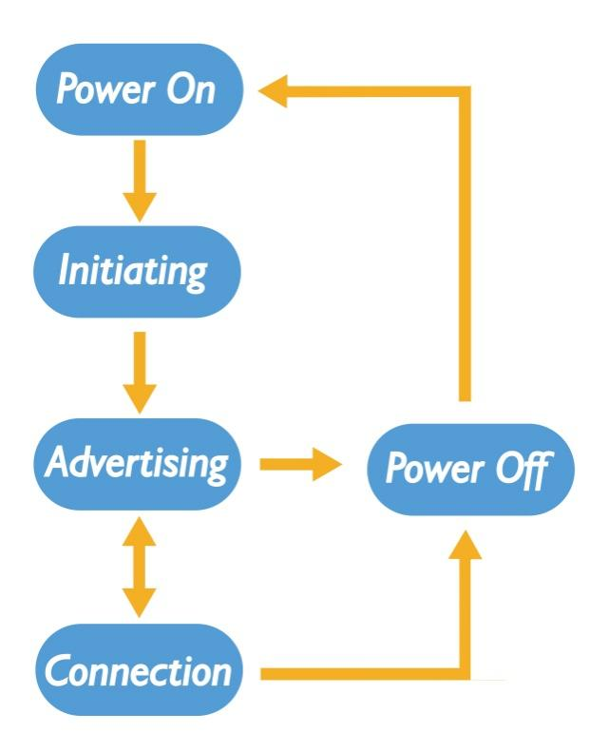
Figure 2

4. Bluetooth technical parameters

4. 1 Bluetooth Advertising Parameters

Advertising parameters | Contents | Remarks
Advertising_Type | Connectable Undirected  Event Type
Advertising_Name | DIVE IT
Advertising_Data | MAC address, 6 bytes
Advertising_Address_Type | Static Device Address
Advertising interval | 200MS
Advertising duration | 180S
Table 3

4.2 Bluetooth connection parameters

Connection parameters | Contents | Remarks
min conn interval  _ _ | Can be specified | Current:25ms
max conn interval  _ _ | Can be specified | Current:125ms
Slave Latency | Can be specified | Current: 0
Supervision Timeout | Can be specified | Current: 4S
Table 4
To modify these parameters, the iPhone must meet the following conditions:
① Max_conn_interval * (Slave Latency + 1) <= 2s
② Min_conn_interval >= 20 ms
③ Min_conn_interval + 20 ms <= max_conn_interval
④ Slave Latency >= 4
⑤ Supervision Timeout <= 6s
⑥ max_conn_interval * (Slave Latency + 1) * 3 < Supervision Timeout

5. Bluetooth Service Description (service)
5. 1 Battery Service

Service type | Bluetooth SIG standard service
Service UUID | 0x180F
Battery level data Characteristic  UUID | 0x2A19
Battery level data  permissions | Read and Notification
Battery data bytes | 1 byte
Data content | 0~ 100 indicates that the current battery level ranges from 0 to 100%
Example | 0x64 indicates that the current Bluetooth battery is 100%
Table 5

5.2 Device information Service

Service type | Bluetooth SIG standard service
Service UUID | 0x180A
UUID (Manufacturer Name Characteristic) | 0x2A29
UUID (Software Revision Characteristic ) | 0x2A28
UUID (Hardware Revision Characteristic) | 0x2A27
UUID (Firmware Revision Characteristic) | 0x2A26
UUID (Serial Number Characteristic) | 0x2A25
Data read permission | Read Only
Example | Manufacturer Name : UMEING
Table 6

5.3 Key service

Service type | Bluetooth private service
Service basis UUID | 0x23, 0xD1, 0xBC, 0xEA, 0x5F, 0x78, 0x23, 0x15, 0xDE, 0xEF, 0x12, 0x12, 0xxx, 0xxx ,0x00, 0x00, 0x00, 0x00
Service UUID | 0x1523
Key Characteristic UUID | 0x1524
Key data permissions | Read and Notification
key data bytes | 1byte
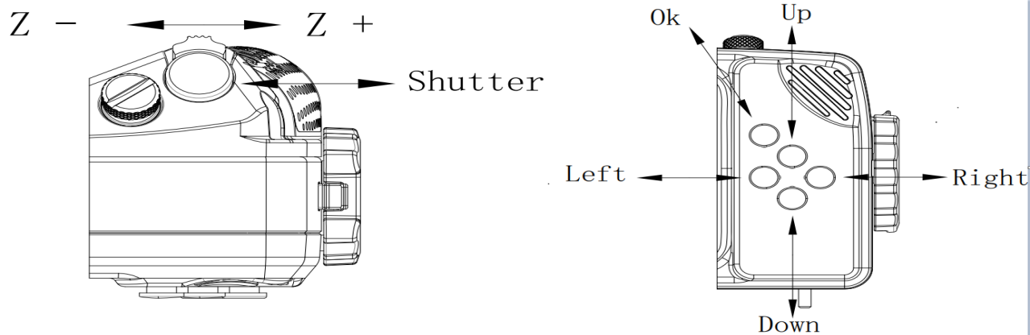

Key value | Item |  | Short Press | Long press
 | Key 1 (right) |  | 0x10
 | Key 2 (shutter) |  | 0x20(Power on)
 | Key 3 (up) |  | 0x30
 | Key 4 (left) |  | 0x40
 | Key 5 (ok) |  | 0x50 | Power off
 | Key 6 (down) |  | 0x61 | 0x60
 | Key 7 (Z+) |  | 0x70
 | Key 8 (Z-) |  | 0x80
Example | Bluetooth notifies the phone that there is 0x10 data, which means Key 1 has been short-pressed.
Trigger flash LED Characteristic UUID | 0x1525
Trigger flash LED data permission | Write
Trigger flash LED data byte | 1byte
 | 0x01(Any number) | Trigger flash once
Example | 0x01 indicates Trigger flash once
Table 7

5.4 Water pressure and temperature sensor, barometric pressure sensor data reporting, vacuuming start indication, Air extraction cover signal service

Service type | Bluetooth private service
Service basis UUID | 0x23, 0xD1, 0xBC, 0xEA, 0x5F, 0x78, 0x23, 0x15, 0xDE, 0xEF, 0x12, 0x12, 0xxx, 0xxx ,0x00, 0x00, 0x00, 0x00
Service UUID | 0x1623
Motor control characteristics UUID | 0x1624
Start data permission | Write
Start data byte | 1 byte
 | 0x01 |  | Vacuuming start (non - 0 data)
 | 0x00 |  | Vacuuming Stop
Example | 0x01 indicate that vacuuming start
Water pressure sensor characteristics UUID | 0x1625
Sensor data permission | Read and Notification
Sensor data bytes | 4 bytes (Little-Endian）
Sensor pressure data value:  32-bit unsigned integer (0.1mba) | 1st byte  (MSB) |  |  |  | 2nd byte |  | 3rd byte |  | 4th byte  (LSB)
 | (LSB) |  |  |  |  |  |  |  | (MSB)
Example | 0x83270000 indicates that the current water pressure is 1011.5mba (0x2783)
Water pressure sensor temperature characteristic UUID | 0x1626
Sensor data permission | Read and Notification
Sensor data bytes | 4 bytes (Little-Endian）
Sensor water temperature data value: 32-bit unsigned integer (0.01℃) | 1st byte  (MSB) |  |  | 2nd byte |  | 3rd byte |  | 4th byte  (LSB)
 | (LSB) |  |  |  |  |  |  | (MSB)
Example | 0x580b0000 indicates that the current water temperature is 29.04 ℃ (0xb58）
Barometric pressure sensor characteristics UUID | 0x1627
Sensor data permission | Read and Notification
Sensor data bytes | 4 bytes (Little-Endian）
Sensor pressure data value:  32-bit unsigned integer（1 pa） | 1st byte  (MSB) |  |  |  | 2nd byte |  | 3rd byte |  | 4th byte  (LSB)
 | (LSB) |  |  |  |  |  |  |  | (MSB)
Example | 0x7f8a0100 indicates that the current barometric pressure is 100991pa (0x18a7f )
Air extraction cover signal characteristics UUID | 0x1628
Permission to report data | Read and Notification
Reported data bytes | 1 byte
Reported data value | 0x00 | Air extraction cover open
 | 0x01 | Air extraction cover close
Example | 0x01 indicates that Air extraction cover close currently
solenoid valve control characteristics UUID | 0x1629
Start data permission | Write
Start data byte | 1 byte
 | 0x01 | solenoid valve open (non - 0 data)
 | 0x00 | solenoid valve Stop
Example | 0x01 indicate that solenoid valve open
Infrared Remote Control characteristics UUID | 0x162A
Start data permission | Write
Start data byte | 1 byte
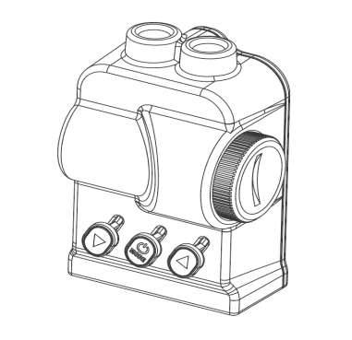 | 0x01 — Increase the brightness of the flashlight  （Equivalent to short pressing the left button on the remote control）  0x02 — Switch the type of flashlight light  （Equivalent to short pressing the middle button of the remote control）  0x03 — Reduce the brightness of the flashlight  （Equivalent to short pressing the right button on the remote control）  0x04 — Flashlight enters sleep mode  （Equivalent to long pressing the middle button of the remote control）  0x05 — The flashlight is starting to wake up  （Equivalent to long pressing the middle button of the remote control again）  0x06 — Flashlight enters focus or flashing mode  (Equivalent to simultaneously pressing the left and right buttons on the remote control)
Example | 0x01 The current LED brightness level of the flashlight has been increased by 1 level
Table 8

