HOUSE BUS
Integrated Systems Architecture
The integrated thermal-electrical design — locked architecture
Companion to the Master Roadmap
Version 0.2 · June 2026

Contents

1. Architecture overview
House BUS is built around one principle: heat is too valuable to waste. Five subsystems share two working fluids — a refrigerant circuit and a glycol coolant loop — and one electrical system, so that the cold produced for the cabin also chills the fridge, and the heat rejected by cooling becomes hot water, a warm drying room, cabin heat, and battery warming. A supervisory controller decides, second by second, where each unit of heat and cold should go, and there is no gas aboard.
Two architectural facts are now locked and shape everything below. First, there is no separate house battery: a single ~300 kWh structural sodium-ion pack forms the floor of the bus, drives the vehicle, and runs the home, stepped from 800 V down to a 48 V house rail, with a software drive-reserve floor that house loads can never deplete. Second, the heat-reuse loop is strictly grade-matched — low-grade recovered heat does low-grade jobs, while high-grade loads stay electric. The diagram shows the whole platform.
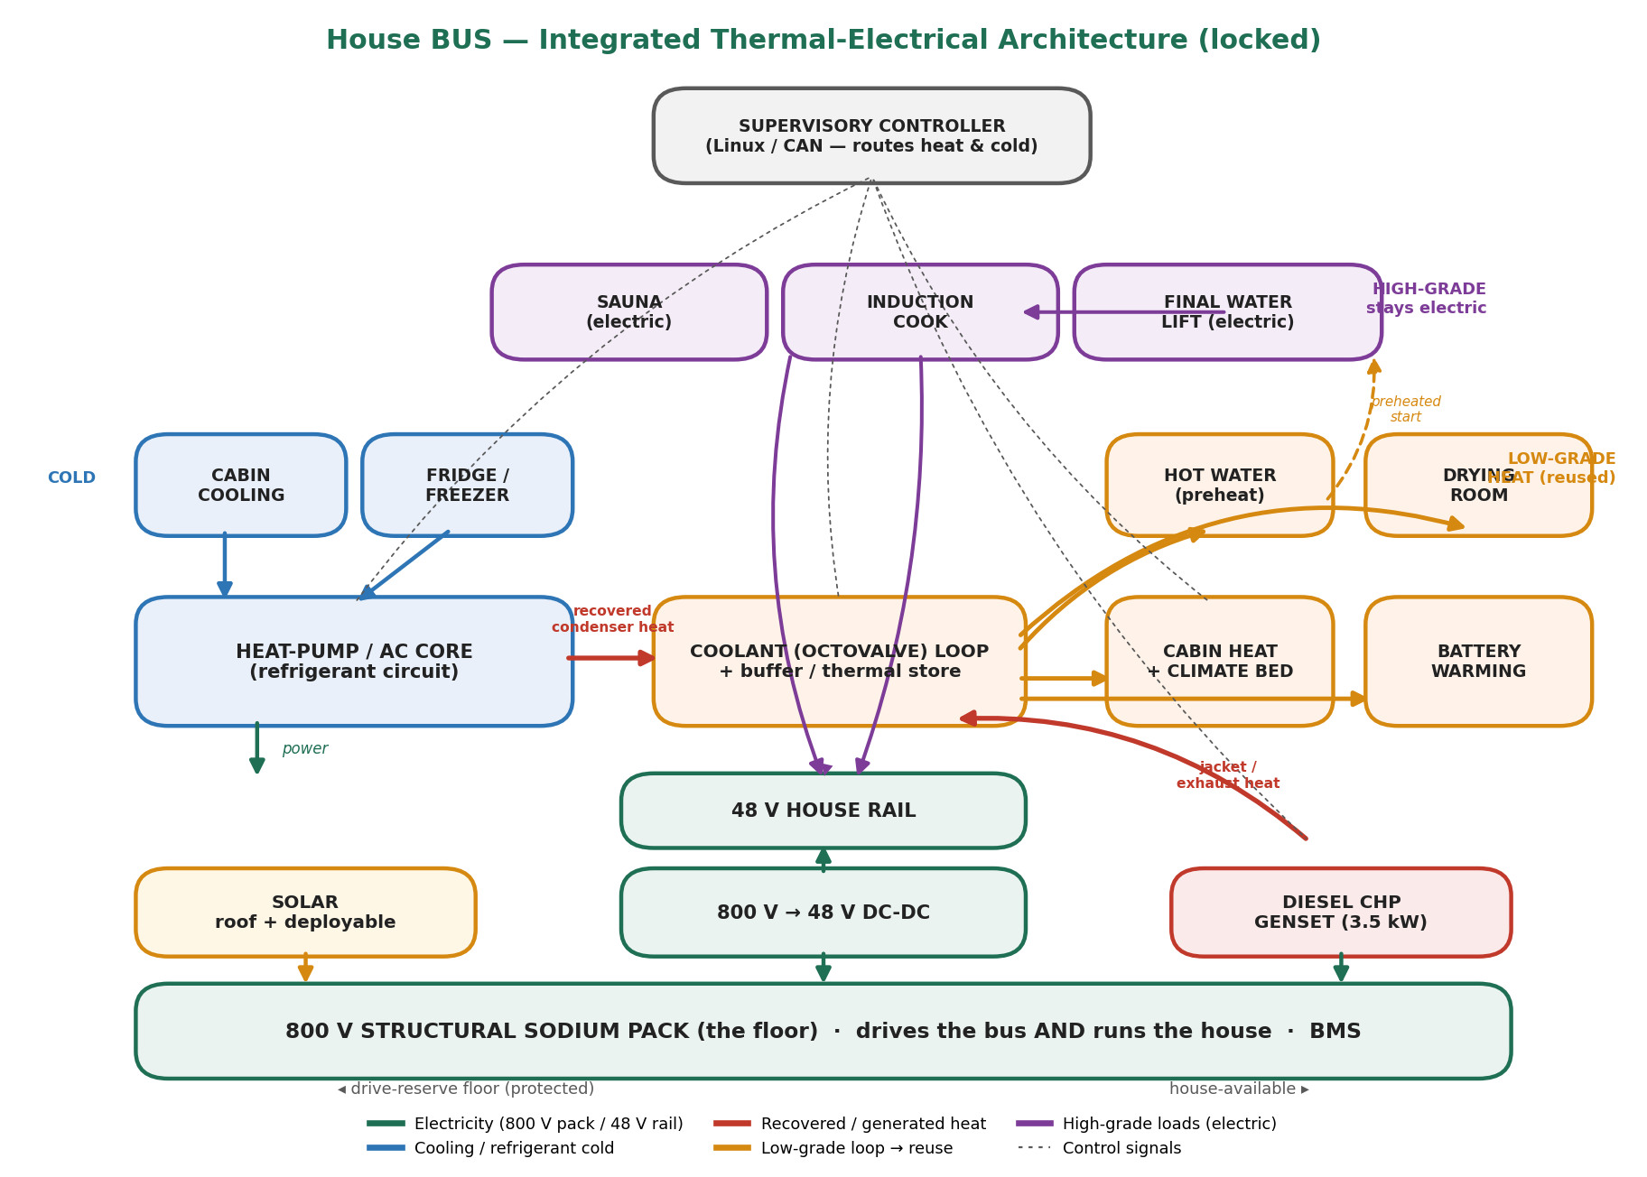
Figure 1 — Locked integrated thermal-electrical architecture. Amber = low-grade reused heat; purple = high-grade electric loads.

Two working fluids, one structural pack
- Refrigerant circuit. A reversible heat-pump / AC core. Cooling absorbs heat from cabin air and the fridge/freezer; the condenser rejects it into the coolant loop, not the sky. Reversed, it pumps heat into the cabin in shoulder seasons.
- Coolant (Octovalve) loop. The heat-distribution network. It collects heat from the condenser and the genset, parks it in a thermal store, and delivers it to the low-grade sinks. Glycol gives freeze protection.
- Structural pack + DC bus. The single ~300 kWh sodium pack feeds an 800 V bus (traction, large thermal loads) and a 48 V house rail via DC-DC, replenished by solar, the diesel CHP, and shore/charge.

2. Electrical subsystem — one shared reservoir
The defining choice is that the traction battery is the house battery. A single structural sodium-ion pack (~300 kWh, 800 V class, forming the bus floor) is the only energy store. This removes a second lithium bank entirely, but it makes one rule non-negotiable: a software drive-reserve floor must always hold back enough energy to actually move the dwelling, so house loads can never strand it.
Element | Role | Design notes
Structural sodium pack | Sole energy store; chassis floor | ~300 kWh, 800 V class; sodium by build time at similar weight to today's LFP; modular for later swap
BMS | Cell protection & telemetry | Charge-temperature lockout; feeds controller SoC/temperature; contactor control
800 V → 48 V DC-DC | Create the house rail | 5–10 kW, >95% efficient; 800 V kept clear of wet zones (SELV 48 V discipline)
Inverter | Few legacy AC loads only | 3–6 kW; most loads native 48 V DC or bucked locally
Solar (roof + deployable) | Daytime charge | ~3.5 kW roof while driving; ~6 kW parked with deployable + side-wall
Diesel CHP genset | Winter charge + heat | 3.5 kW; electricity to pack, waste heat to the loop (see §6)
Drive-reserve floor | Protect mobility | ~80 kWh held back in software; house-available ≈ 190 kWh of 270 usable

3. Heat-pump / AC core (the cold side)
A vapour-compression heat pump moves heat with a COP of roughly 2.5–4, delivering far more cooling or heating than the electricity it draws — the multiplier that makes the whole integration pay.

Cooling mode
- The evaporator cools cabin air (air-conditioning).
- The same cold capacity serves the fridge/freezer via a chilled-coolant cold store, eliminating their separate compressors and letting them ride through compressor-off periods.
- The condenser rejects its heat into the coolant loop — the recovered heat that makes hot water and runs the drying room (§4).

Heating mode
Reversed, the core pumps heat into the cabin at COP well above resistive heating. In deep cold the air-source COP falls and the diesel CHP takes over as the primary heat and charge source (§6).

4. Heat reuse — the hot side, grade-matched
If the heat pump is the heart, the coolant loop is the circulatory system. Its governing design rule is grade-matching: recovered heat is low-grade, so it is routed only to jobs that low-grade heat can actually do. High-grade jobs stay electric — but are started from a preheated point so they draw less.

The grade-matching rule (read this first)
Heat recovered from the AC condenser and refrigeration is low-grade, roughly 30–50 °C. That is the ceiling. Within it the loop does real work; above it, electricity does the job.
Job | Grade needed | How it's served
Hot-water preheat | Low (to ~45 °C) | Loop heat raises tank from inlet toward target — most of the lift, free
Final hot-water lift | High (to 48–50 °C) | Small electric coil finishes from the preheated start — small draw
Drying room | Low (warm dry air) | Loop heat over a coil; warm airflow dries clothes and gear
Cabin heat & climate bed | Low (25–40 °C) | Hydronic delivery; the bed taps the same loop for sleep micro-climate
Battery warming | Low | Gentle heat keeps cells in the charge-safe window in cold
Sauna | High (70–90 °C) | Electric heater — cannot be run from waste heat; preheated air only
Cooking / boiling | High (100 °C+) | Induction; electric — waste heat cannot reach these temperatures
Framed this way the system is honest and robust. The failure mode to avoid is implying waste heat 'runs everything' — it cannot run the sauna, the oven, or a rolling boil. It can, however, make those loads cheaper by handing them a warm starting point.

Hot water — the headline win, and a smaller heater
Cooling the cabin produces abundant rejected heat at the condenser. Instead of venting it, the loop dumps it into the hot-water tank. The cooling has already paid for that heat, so in the cooling season domestic hot water is essentially free; a small electric coil only trims the final few degrees from an already-warm tank. This is a real component win, not just an energy one: instead of an ~11 kW water heater sized to heat cold water from scratch, the recovered heat does most of the lift and the electric coil is sized far smaller — less cost, thinner wiring, lower peak draw, higher overall efficiency. A thermal store decouples the timing — heat is banked in the afternoon when cooling runs and drawn at night for a shower — and lets the compressor run in efficient bursts.
One safety rider: a tank held at the recovered-heat grade (30–50 °C) sits in the Legionella growth band. The same small electric coil periodically pasteurizes the tank above 60 °C, with an anti-scald mixing valve at the outlet — so the efficiency design and the safety fix use one part.
Washing water from condensate. The closed-loop shower and dish water can be topped up from AC condensate, which is nearly mineral-free — ideal for washing (no scale, less soap) and made germ-free by an inline UV stage on the loop. This is human-use water, not drinking water; drinking and cooking water comes from the tank and rainwater. Treatment is matched to use: a particulate filter plus UV for washing; the full train only for the drinking line.

Drying room
A dedicated drying room is fed warm, dry air over a loop coil — recovered heat that would otherwise be wasted dries clothing and gear. In a wet, cold environment this is a genuine quality-of-life system that costs almost nothing to run, because the heat is a by-product the cooling or genset already produced.

Climate-controlled bed
Rather than bolting on a separate Eight Sleep-style appliance, the bed taps the same coolant loop for a temperature-regulated sleep surface. Conditioning a small micro-climate at the body is far cheaper than conditioning the whole cabin, and treating the bed as just another managed loop sink keeps added battery draw minimal.

Thermal storage — the decoupling buffer
A hot buffer tank (and optionally a cold store on the cold side) separates when energy is produced from when it is needed. This is what makes the heat-reuse economics real: the system banks heat when it is available and spends it on demand, while compressor and genset run at their efficient sweet spot and then stop. Buffer sizing is a key output of the energy model.

5. Ventilation - built into the cooling loop
A sealed, super-insulated envelope is exactly why deliberate ventilation is non-negotiable. Two occupants, an induction hob, a shower, transpiring plants, and a combustion genset all load the air with CO2, moisture, and VOCs; without controlled fresh air the cabin becomes a condensation-and-mould box and CO2 climbs enough to degrade sleep.
There is no standalone ERV box. Ventilation is a function of the one large HVAC / compressor unit that already does cabin cooling and heating, battery thermal management, and Octovalve heat routing - it does air handling too. Filtered (HEPA-class) outside air is drawn in both while driving and when parked, and ducted down the side walls inside the insulation so the rear and bedroom get fresh air, not just the front. Because the air passes through the same thermal loop, the incoming fresh air is tempered (heat/coolth recovered) rather than dumped raw into the cabin - the recovery happens in the loop, not in a separate exchanger.
Humidity is handled on the same principle. A dehumidification path pulls warm, moist air from the upper layer of the cabin back toward the front and extracts the water (whether it shares the HVAC loop or runs as a dedicated circuit is still open); a kitchen range hood removes cooking moisture at the source. The controller ties fresh-air rate to a CO2 sensor so ventilation ramps with occupancy. A detection suite - CO from the genset, CO2 for ventilation control, smoke/heat, and a refrigerant-leak sensor if a flammable refrigerant is used - rounds it out. Folding ventilation and dehumidification into the HVAC is the reason that unit must be sized to serve cabin, battery, and the generator together.

6. Diesel CHP genset (winter)
In a cold-weather ski weekend two things happen together: solar collapses and heat demand peaks. A plain generator would charge the pack but waste most of its fuel as tailpipe heat — exactly the waste this project exists to eliminate. So the 3.5 kW diesel genset runs as combined heat and power: it charges the pack and its jacket and exhaust heat are captured into the coolant loop, warming the cabin and the battery.
- Electricity → pack. Holds state of charge through low-solar periods.
- Heat → Octovalve loop. Feeds the same low-grade sinks as the AC condenser; in winter the genset is the dominant heat source and warms the battery so cold-weather charging is safe.
Sized to the winter deficit, not the whole load: the pack alone covers roughly 13 days of ski-weekend use, so the genset is a top-up for longer or colder stays (≈2.3 h/day, ≈2.6 L diesel to hold the pack indefinitely). Safety is paramount — sealed bay, marine-grade exhaust, forced ventilation, redundant CO detection, and controller interlocks. It is the only liquid fuel aboard.

7. Supervisory controls & integration
The hardware is only as good as the logic that coordinates it. A Linux/CAN supervisory controller reads temperatures, pressures, state of charge and demand, and routes heat and cold in priority order.
- Safety: never charge a cold battery; never let a loop freeze; protect the drive-reserve floor; shut down on CO, over-temperature or pressure fault.
- Comfort: hold cabin, hot-water, and sleep-surface setpoints.
- Efficiency: capture and reuse every unit of recoverable heat before any electric top-up; run compressor and genset in buffered bursts.
- Autonomy: manage state of charge to ride out low-sun periods, calling the CHP only when needed.
Build and prove each subsystem standalone, then layer integration on top; the roadmap's gate G1 enforces this. Instrument everything from day one — the data the controller needs to run V1 is the same data that justifies every sizing decision in V2.

8. Interface summary
# | From → To | Carries | Criticality
I1 | AC condenser → coolant loop | Recovered low-grade heat | High — core of heat reuse
I2 | Heat-pump cold → fridge/freezer | Shared cooling | Medium — efficiency gain
I3 | Loop → hot-water preheat | Low-grade heat | High — headline benefit
I4 | Loop → drying room / climate bed | Low-grade heat | Medium — quality of life
I5 | 48 V rail → final water lift / sauna / induction | Electricity | High — high-grade loads stay electric
I6 | Genset → pack | Electricity | High — winter survival
I7 | Genset → coolant loop | Waste heat (CHP) | High — winter heat & battery warming
I8 | Loop → battery warmer | Heat | Critical — safe cold charging
I9 | ERV <-> cabin air | Fresh air + recovered heat | High - air quality & humidity
I10 | Condensate -> UV loop -> wash water | Treated water | Medium - human-use water
I11 | 800 V -> 48 V DC-DC; drive-reserve floor | Electricity + logic | Critical - mobility protected
I12 | Controller -> all | Signals | Critical - coordination

Read next: the re-based Energy & Thermal Model sizes every component above and shows the ~15 kWh/day three-season target and the winter CHP balance; the Master Roadmap sequences how this architecture is built and validated.

