Compile Kermeta Project
This document will present how to compile a Kermeta Project.
You need to update the following jars :
- kermeta.compilo.scala-0.0.2-SNAPSHOT.jar
- language.framework.scala-0.10.0-SNAPSHOTS.jar

Require metamodel URI
If you want to derive a model conforms to a given metamodel you need to require it on a Kermeta file. You can either require a metamodel URI or the ecore file of the metamodel. You need to deploy metamodel plugin before.
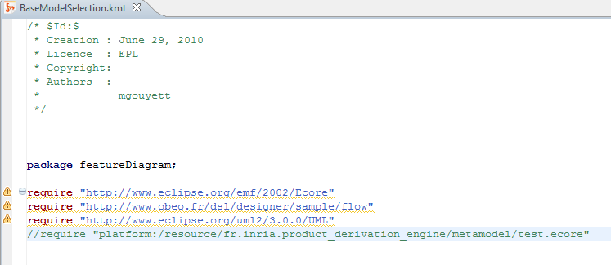

Create Kermeta model file (.km)
We supposed you have a Kermeta project without any errors and a Kermeta main class (it contains mainClass and mainOperation tag). A first step to compile your Kermeta project as a jar is to generate a new executable Kermeta Model file (.km).
So, right click on the Kermeta main class on the Eclipse Package Explorer View -> Kermeta-> Generate km (Kermeta model).
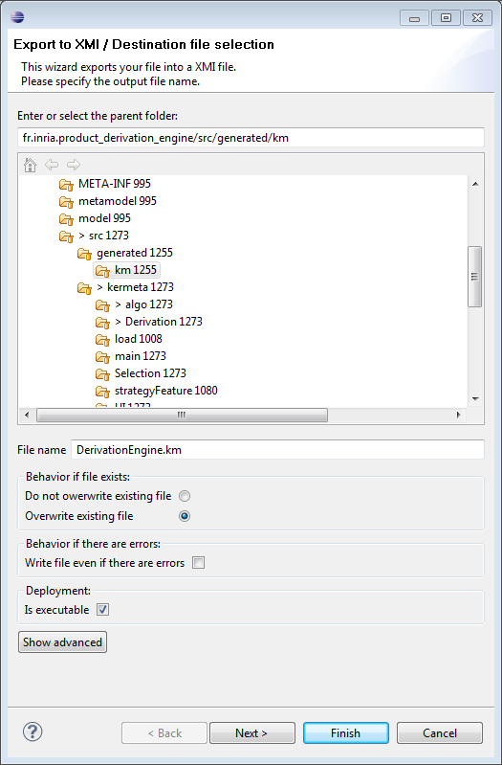
Store it in on the folder src/generated/km (if it does not exists create it) and do not forget to check executable box. A new km file that represent your Kermeta code appears.
Our project should look like this :
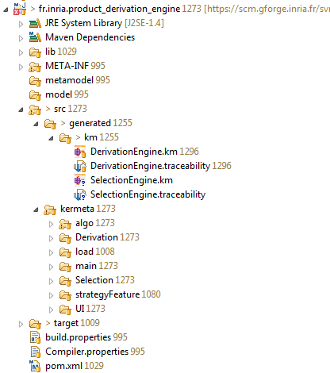

Use Java Project compileProjects
Go to the Java project compileProject and :
- Change all path in the java file Comp.java with your own absolute path to your current workspace.
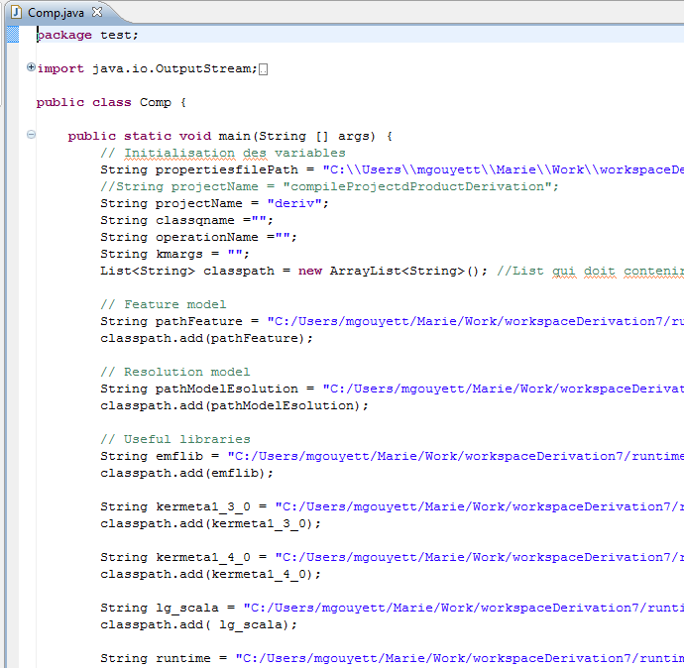
- Change compile propertiesFilePath (first variable of the program) to match with your current workspace
- Select a name for your output project, here “deriv”.
- On the file Compiler.properties on the folder properties change the output.target.folder your own path to our project target folder (here deriv/output)
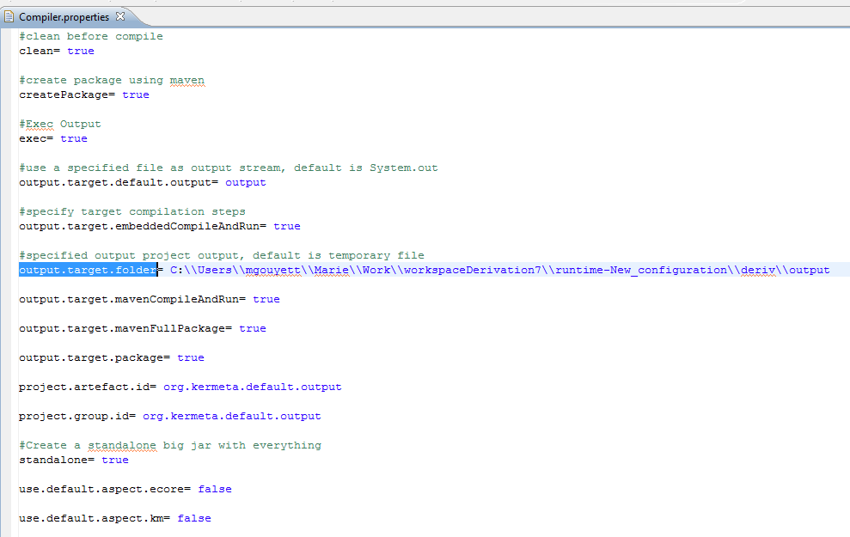
- Add our metamodel jar project on the folder lib of the compileProject project and add it on the java file Comp.java as in the figure above.
- If your metamodel package name does not have the same name as the name of the package in the EMF java project (like in the figure above), you need to change the package name by
// Change package name to adjust ecore model package name and corresponding EMF Java code package
kermeta.utils.TypeEquivalence.packageEquivelence().put("flow","fr.obeo.dsl.designer.sample.flow");
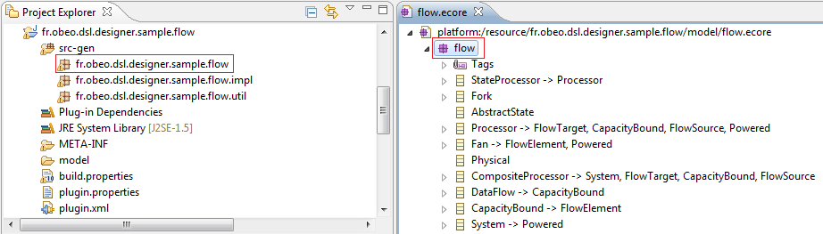
The figure above shows that flow meta-model does not have the same package name as in the EMF generated Java code.
- Change the String kmuri value to the path to your own kermeta model created in the last section.

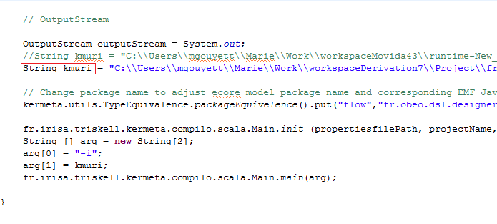
Now, launch Comp.java file. It compiles Kermeta project into a Scala project on deriv/output.

Create application jar
To create the application jar click on the deriv/output folder -> Maven-> Package.
Your deriv project should look like this :
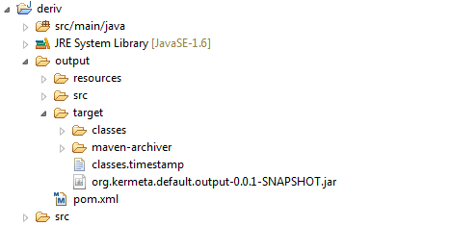

Use your compiled program on a Java project

Create a new Java project and add on its classpath all libraries used in the CompileProject and the org.kermeta.default.output-0.0.1-SNAPSHOT.jar.
To execute deriv, use the following main :
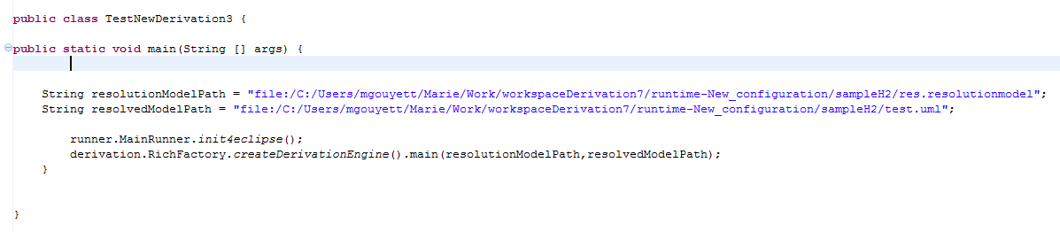
runner.MainRunner.init4eclipse();

// Change this line according to your compiled project derivation.RichFactory.createDerivationEngine().main(resolutionModelPath,resolvedModelPath);

