Kermeta LOGO Demo
The objective a this document is to present a step by step demo for the development of a complete LOGO environment using Kermeta. The environment includes an editor, a simulator and a compiler.
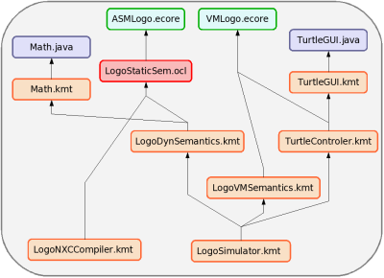

The above figure shows the various units that were defined to implement the environment. The following sections details the construction of each of these units.

Defining the LOGO abstract syntax
