A set of transformations that do not depend
on specific metamodels

A set of transformations that do not depend on specific metamodels 1
1 Introduction 1
2 Containment view API 2
3 Adapters implementation 2
4 Available commands 2
4.1 Overview 3
4.2 Set of commands 3
4.2.1 Hierarchy 3
4.2.2 QualifiedName 3
4.2.3 ToString 3
4.2.4 ToStringDeep 3
4.2.5 Find 3
4.2.6 Replace 3
5 Sample of use 3

Introduction

We present here some model transformations (or also called commands in the following) that can be applied on a view (a view can be seen here as an interface of a metamodel). The chosen view is designed to represent tree-like structures, each element in the tree structure having a name (see Figure 1). This view focuses then on two dimensions: a naming dimension and a hierarchical dimension.

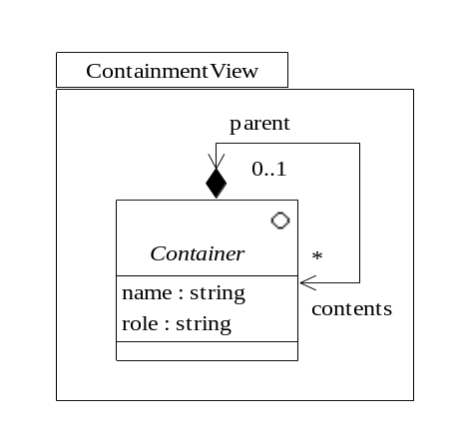
Figure 1 : Container view definition

Once the view is defined, we want to “implement” it: for example, we want the MOF metamodel to be an implementation of the Containment view. In other words, we need to define an adapter that maps the concept of the MOF metamodel to the Containment view concepts. As a matter of fact, many metamodels have a tree like structure with named nodes, so it is likely that many adapters can be defined for many metamodels (see Error: Reference source not found).

ContainmentView
Containment4MOF
Containment4UML
Containment4RDBMS
Containment4FileSystem
Figure 2 : Sample of adapters for the Containment view

It is possible then to define some commands that can be applied to a Container object of Containment view; since this view is a somewhat an interface, all commands can be applied to an implementation of the Containment view adapter, i.e. an adapter. For example, a command that retrieves the hierarchy of a Container object as a set of Container objects can be applied to a MOF model, a UML model, a RDBMS model, and so on.

Containment view API

The API of the Containment view is:

class Container
{
/** */
getName() : Standard::String;

/** */
getRole() : Standard::String;

/** */
getContents () : Standard::Set;

/** */
getParent() : ContainmentView::Container;

/** */
setName (name : Standard::String);

/** */
execute (command : ContainmentView::Command) : Standard::OclAny
{
return command.execute (this);
}
}

class Command
{
execute (container : ContainmentView::Container) : Standard::OclAny;
}
Figure 3 : API of the Containment view
Note the following:
- there is an accessor method for each feature of the class Container (see Figure 1)
- there is only a setter method for the name of a Container object; the naming dimension can be modified which means that corresponding elements in adapters can have name modification
- at this time, there is no possibility to modify the hierarchy dimension
- the purpose of the Containment view is to define commands that acts on Container instances, so these commands could be defined in the Container class definition with one specific method per command. However, it would pollute the Container interface with many distinct kinds of commands. The solution is to reify each command and provide a unique method (named “execute”) in the Container interface that is able to execute an instance of a reified command. It is a kind of a degenerate design pattern Visitor where the traditional “accept” method is called here “execute” and where the traditional node structure in the Visitor pattern is reduced to only one class, the Container one.

Adapters implementation

Available commands

Overview

There are two kinds of commands: commands without side effects on models (i.e. query) and commands with side effects on models (i.e. transformations). The first category is by now bigger in size.

Set of commands

Hierarchy

QualifiedName

ToString

ToStringDeep

Find

Replace

Factory for Command objects

The MTL implementation implies that there is no possibility to use overloading and in particular for constructors. The common practice is to use the “new” method and then call a method (often named “init”) that initializes the object and returns the object; since this method is specific to one type, it can have specific signature.

A convenient way to instantiate Command objects is to use a factory. Such a factory has a method per kind of Command. The API of this factory is given in Figure 4.

library ContainmentCommands;

class CommandFactory
{
/** */
find (name : Standard::String; role : Standard::String) : ContainmentCommands::Find;

/** */
flatten () : ContainmentCommands::Flatten;

/** */
hierarchy () : ContainmentCommands::Hierarchy;

/** */
qualifiedName () : ContainmentCommands::QualifiedName;

/** */
toString (showParent : Standard::Boolean) : ContainmentCommands::ToString;

/** */
toStringDeep () : ContainmentCommands::ToStringDeep;

/** */
replace (
searchExp : Standard::String;
replaceExp : Standard::String;
roleExp : Standard::String
) : ContainmentCommands::Replace;
}
Figure 4 : API of the factory for Command objects

Full sample

library ContainmentTests;

main (args : Standard::Sequence) : Standard::Void
{
// we choose here the container we are interesting in.
theContainer : Containment4MOF::Container;
theContainer := new Containment4MOF::Container().init('../../Models/MOF/UML_model.xmi');

/* theContainer : Containment4UML::Container; */
/* theContainer := new Containment4UML::Container().init('Models/UML/SimpleUml_model.xmi'); */

/* theContainer : Containment4SimpleRDBMS::Container; */
/* theContainer := new Containment4SimpleRDBMS::Container().init('Models/SimpleRDBMS/SimpleRDBMS_model.xmi'); */

new TestingClass().main (theContainer);
}

class TestingClass
{
cmd : ContainmentCommands::CommandFactory;

/** */
main (theContainer : ContainmentView::Container) : Standard::Void
{
// we define a factory for getting Command instances
cmd := new ContainmentCommands::CommandFactory();

// we display a hierarchical representation of the container
theContainer.execute (cmd.toStringDeep()).toOut();

// we search all containers whose name contains '_' and whose role contains 'as'
foreach (c : ContainmentView::Container) in (theContainer.execute (cmd.find('', 'as')))
{
// we show the qualified name of the current container
c.execute (cmd.qualifiedName()).toOut();
}

// we search all containers whose name contains 'visibility' and whose role contains 'Attribute'
// we display for each of them their hierarchy
foreach (c0 : ContainmentView::Container) in (theContainer.execute (cmd.find('visibility','Attribute')))
{
c0.execute (cmd.toString(false)).toOut();
'----------------------------------------------------------------------'.toOut();
foreach (c1 : ContainmentView::Container) in (c0.execute (cmd.hierarchy()))
{
' '.concat (c1.execute (cmd.toString(false)).oclAsType(!Standard::String!)).toOut();
}
''.toOut();
}

// we search all containers whose name contains '_' and whose role can be anything.
// for all found containers, we replace the '_' by a '+'
theContainer.execute (cmd.replace('_', '+', ''));
theContainer.execute (cmd.toStringDeep()).toOut();
}
}
Figure 5 : full example

A command can be either a query (without side effect on models) or a transformation (with side effect)

