INTERNSHIP REPORT
Research & Analytics Internship – Satvify
Customer Loyalty, Retention and Early-Stage Customer Acquisition

Prepared by
Diveshika Yadav
Internship / Academic Session: 2025–26
Research & Analytics Internship
IILM University, Greater Noida

Executive Summary
This internship report presents a research and analytics study conducted for Satvify. The work focuses on customer loyalty, retention and early-stage customer acquisition. Primary data collected through Google Forms was converted into percentage-based pie charts and interpreted to identify customer preferences, behavioural patterns and practical business implications.
Across the survey sets, product quality, customer experience, membership benefits, social media, reviews, discounts and trial-based experiences emerged as important factors. The report also documents the Satvify subscription-plan FAQs supplied during the internship.

Table of Contents
- 1. Introduction
- 2. Objectives
- 3. Organisation / Project Context
- 4. Internship Work and Approach
- 5. Survey Methodology
- 6. Survey Analysis and Pie Charts
- 7. Consolidated Findings
- 8. Recommendations
- 9. Limitations
- 10. Satvify Subscription-Plan FAQs
- 11. Conclusion
- 12. Suggested Viva Questions
- 13. References / Source Documents

1. Introduction
Customer behaviour is influenced by multiple factors such as perceived quality, trust, emotional connection, offers, service experience and convenience. During the internship, survey-based primary research was used to validate research observations related to brand loyalty, customer retention and customer acquisition.
The analysis is organised into three themes: Customer Loyalty, Customer Retention and Early-Stage Customer Acquisition. The survey evidence is presented visually through pie charts, followed by concise interpretations.

2. Objectives
- Understand factors that influence repeat purchase and brand loyalty.
- Identify customer retention strategies that respondents value most.
- Examine how customers discover new brands and what builds trust.
- Evaluate the role of discounts, referral rewards, trials and influencer recommendations.
- Translate survey responses into clear business insights and recommendations.
- Document customer-facing information through a structured FAQ section.

3. Organisation / Project Context
Satvify is described in the supplied FAQ material as a cloud kitchen offering fresh, plant-based, Satvic and wholesome meals delivered to customers. The FAQ material highlights a 100% plant-based and vegan positioning, freshly prepared meals, natural ingredients and the absence of refined sugar, refined oil, maida, preservatives and artificial additives.
The internship research component examined customer behaviour around loyalty, retention and acquisition. This provided a practical analytics framework for turning customer responses into actionable recommendations.

4. Internship Work and Approach
- Reviewed customer-oriented research themes relevant to loyalty, retention and acquisition.
- Collected / worked with primary responses obtained through Google Forms.
- Converted response distributions into percentage-based pie charts.
- Prepared written interpretations for the dominant response in each question.
- Compared findings across loyalty, retention and acquisition themes.
- Developed practical recommendations based on the strongest patterns.
- Structured a customer FAQ resource for the Satvify subscription plan.

5. Survey Methodology
Primary data was collected through Google Forms. The supplied analysis contains three survey sets with different sample sizes. Because the samples differ, the report keeps each survey set separate rather than artificially combining respondent counts.
Survey Set | Responses | Focus
Customer Loyalty | 22 | Repeat purchase, emotional connection, trust, recommendation and loyalty drivers
Customer Retention | 15 | Retention strategies, personalization, subscriptions and purchase drop-off
Early-Stage Customer Acquisition | 23 | Discovery channels, influencers, launch offers, trust and free trials
The samples are small convenience samples, so the results should be treated as directional internship-level insights rather than representative estimates for the entire customer population.

6.1 Customer Loyalty
Sample size: 22 respondents.

L1: Repeat Purchase Frequency
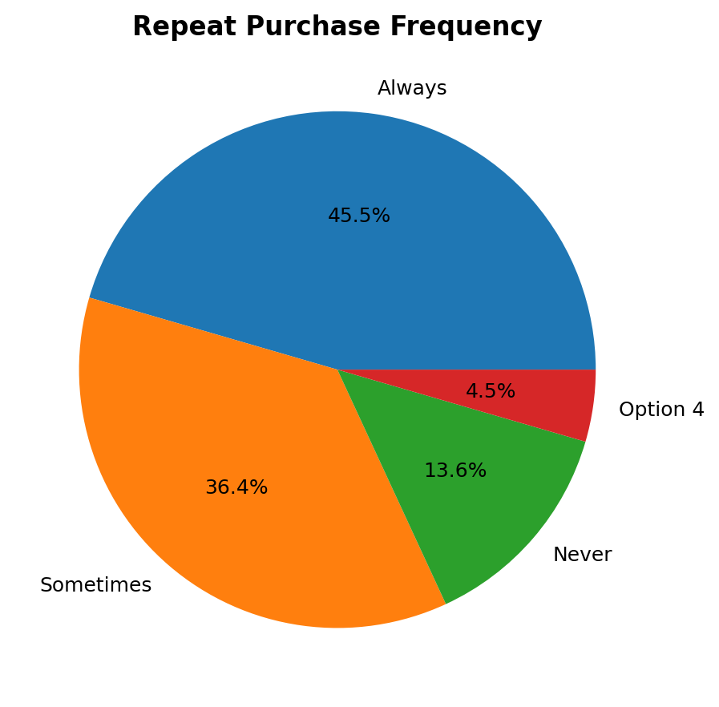
Figure L1 – Repeat Purchase Frequency
Interpretation: 45.5% always purchase from the same brand again, while 36.4% do so sometimes.

L2: Emotional Connection & Buying Decisions
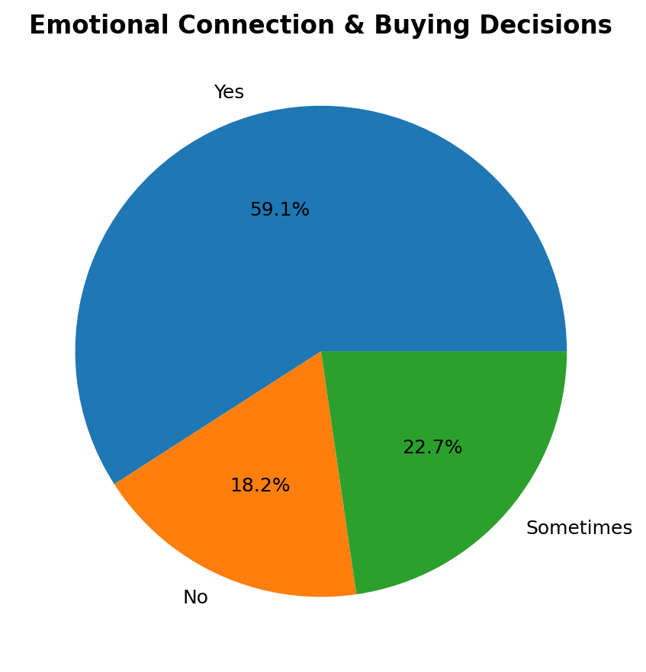
Figure L2 – Emotional Connection & Buying Decisions
Interpretation: 59.1% stated that emotional connection with a brand influences their buying decisions.

L3: Trusted Brand Despite Higher Price
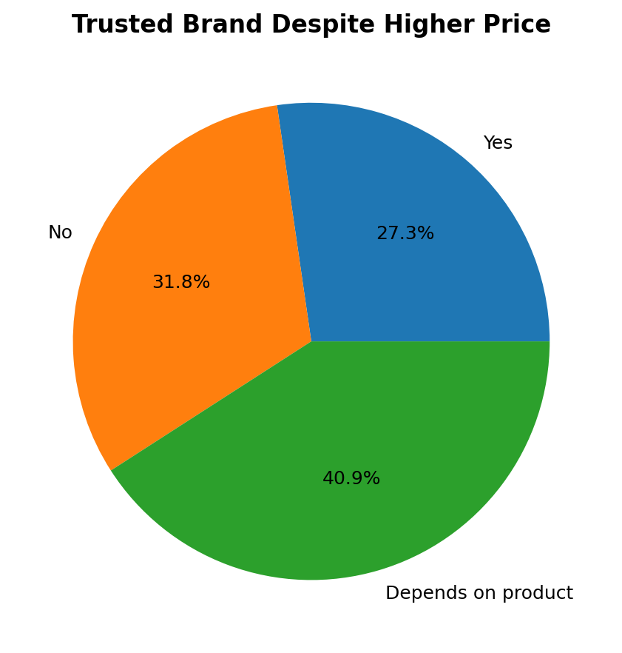
Figure L3 – Trusted Brand Despite Higher Price
Interpretation: 40.9% said choosing a trusted brand at a slightly higher price depends on the product.

L4: Factors Increasing Brand Loyalty
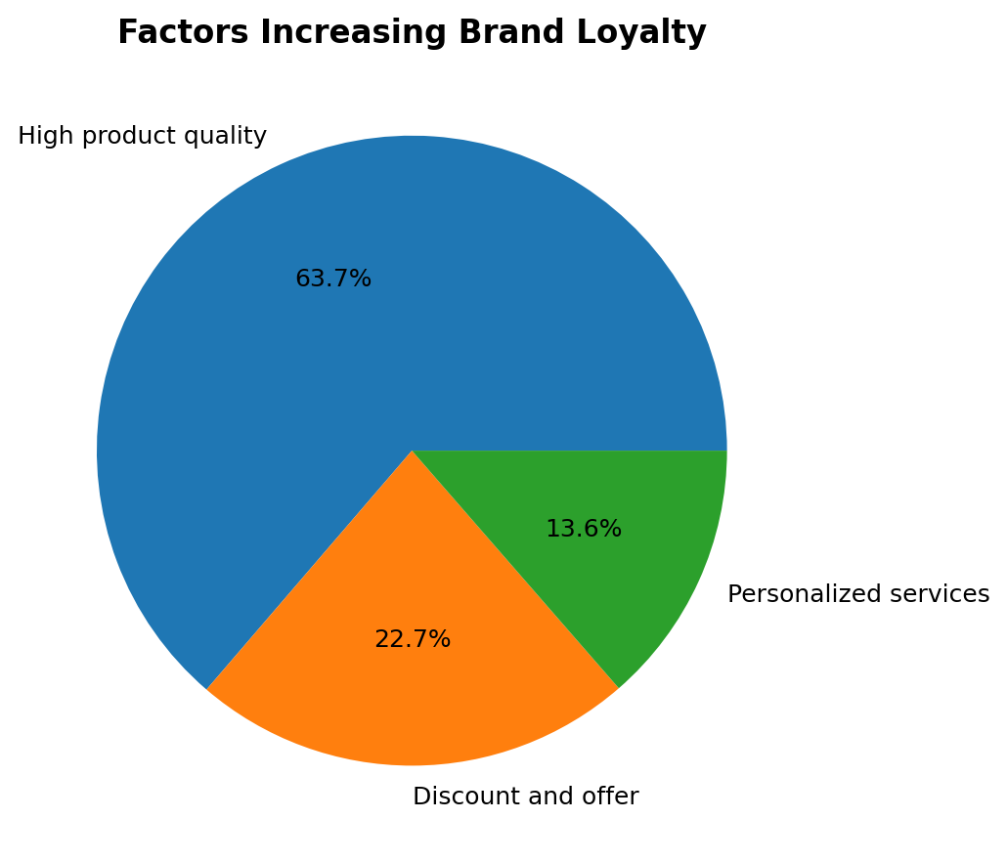
Figure L4 – Factors Increasing Brand Loyalty
Interpretation: High product quality was the strongest loyalty driver at 63.7%.

L5: Likelihood of Recommending Favourite Brand
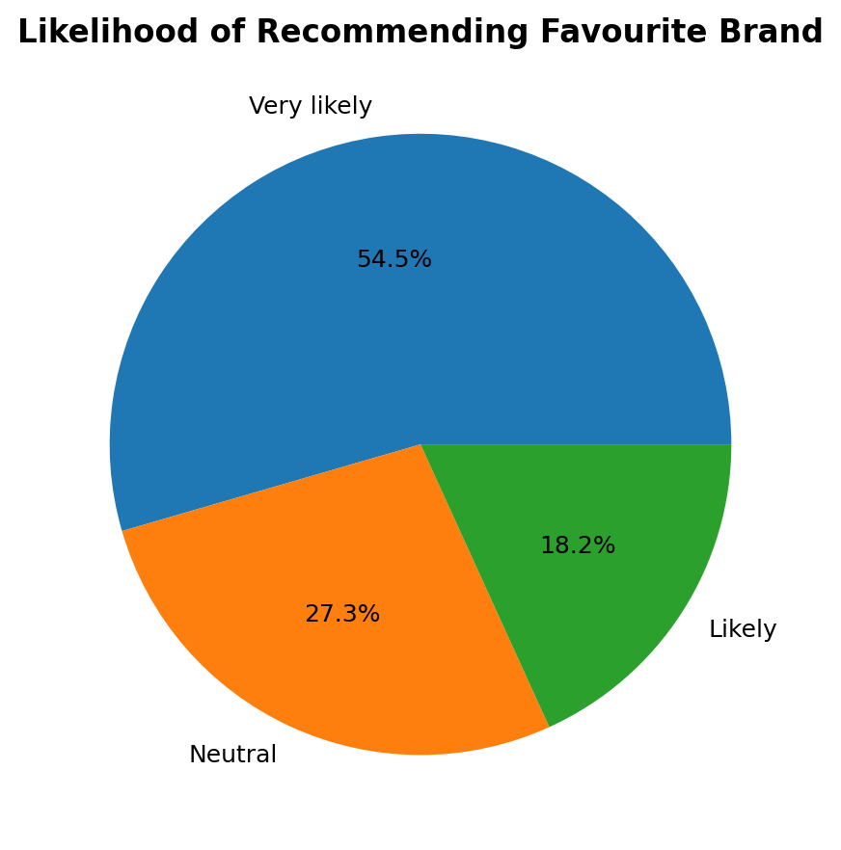
Figure L5 – Likelihood of Recommending Favourite Brand
Interpretation: 54.5% were very likely to recommend their favourite brand to others.

L6: Reasons for Stopping Purchases
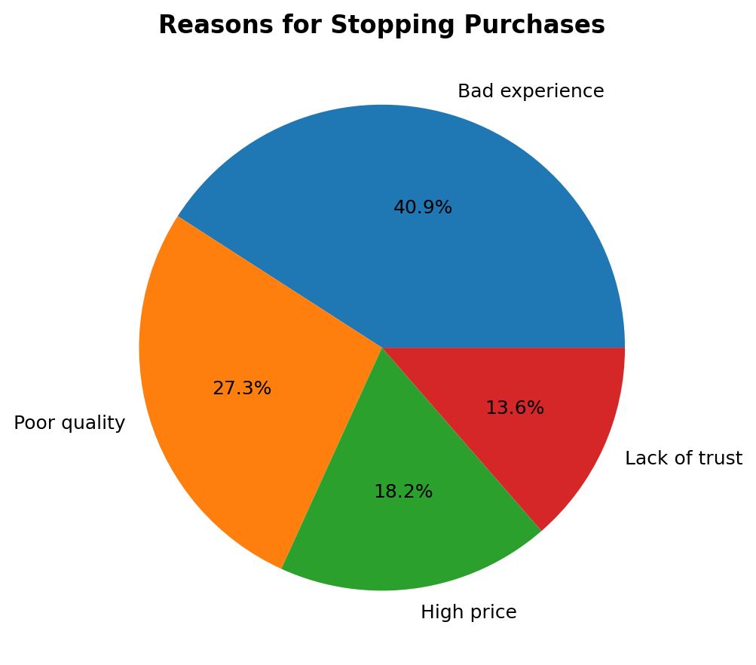
Figure L6 – Reasons for Stopping Purchases
Interpretation: Bad experience was the leading reason for stopping purchases at 40.9%.

6.2 Customer Retention
Sample size: 15 respondents.

R1: Best-Performing Retention Strategy
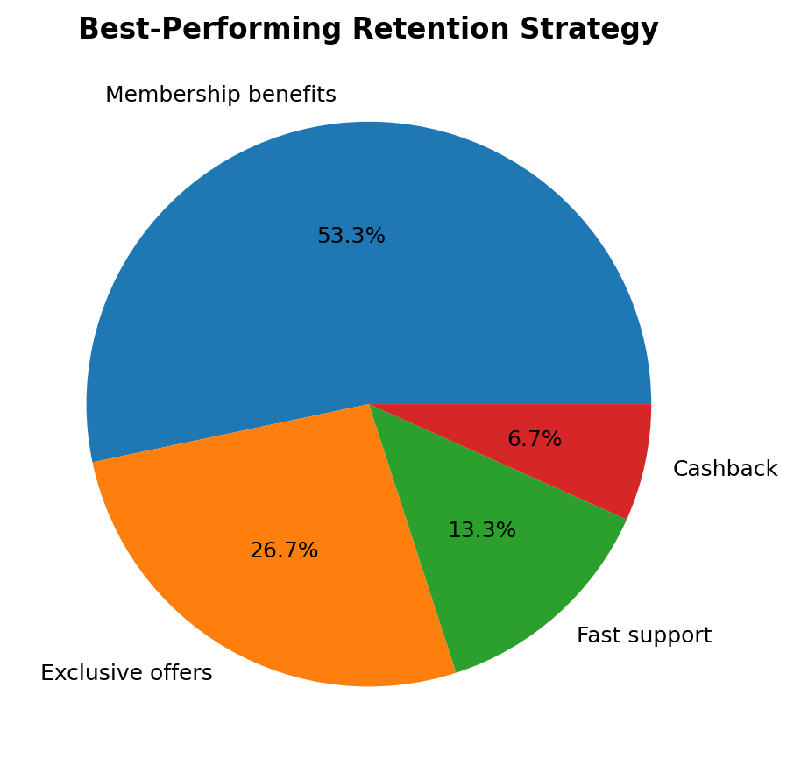
Figure R1 – Best-Performing Retention Strategy
Interpretation: Membership benefits were the most preferred retention strategy at 53.3%.

R2: Personalized Messages / Offers
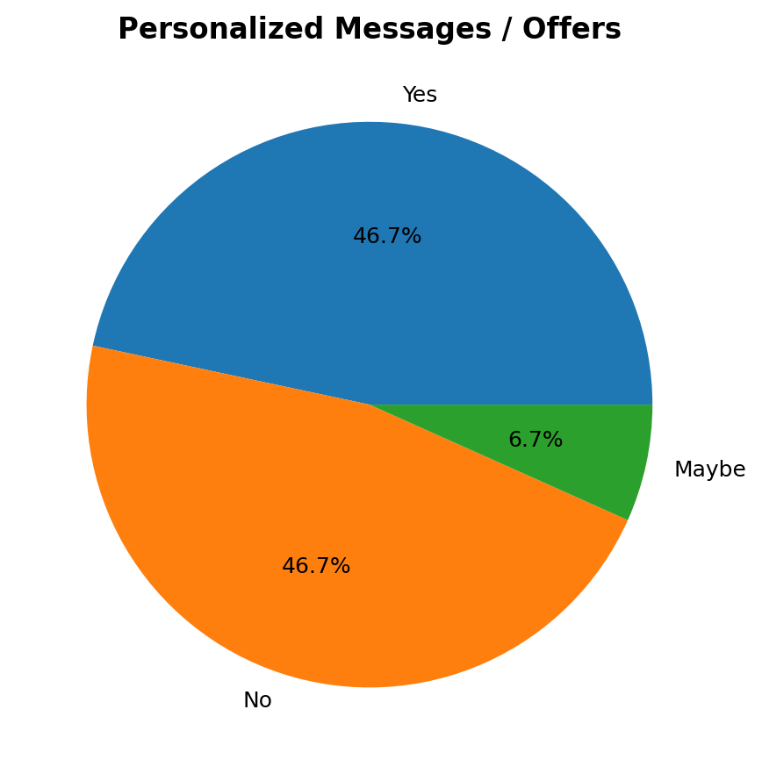
Figure R2 – Personalized Messages / Offers
Interpretation: Personalized messages/offers produced a split response: 46.7% Yes and 46.7% No.

R3: Continued Subscription Because of Special Offers
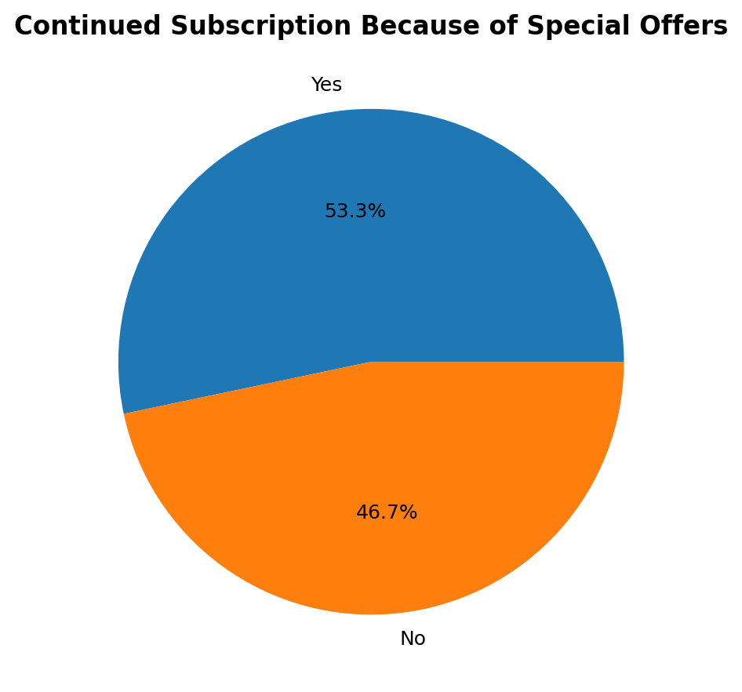
Figure R3 – Continued Subscription Because of Special Offers
Interpretation: 53.3% reported continuing a subscription because of special offers.

R4: Reasons for Stopping Purchases
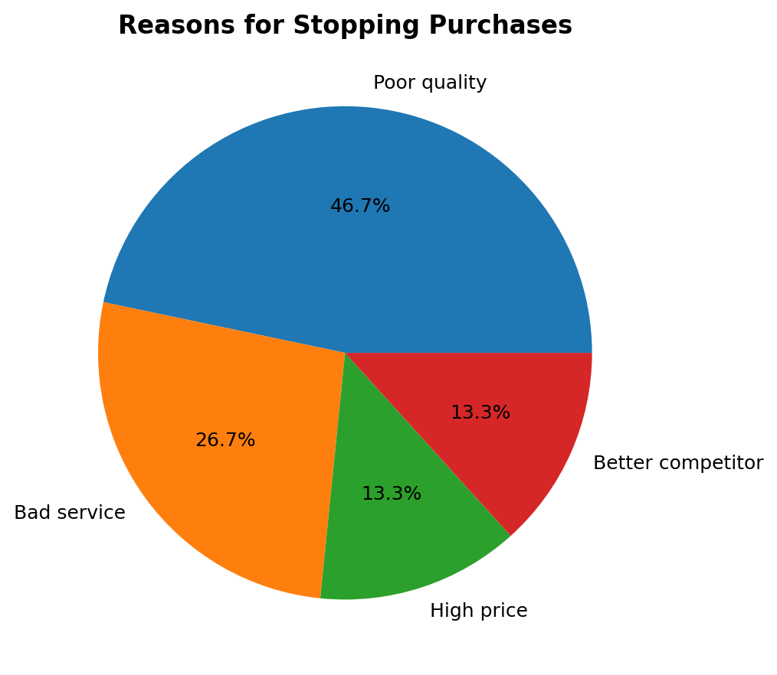
Figure R4 – Reasons for Stopping Purchases
Interpretation: Poor quality was the leading reason for stopping purchases at 46.7%.

6.3 Early-Stage Customer Acquisition
Sample size: 23 respondents.

A1: How New Brands / Products Are Discovered
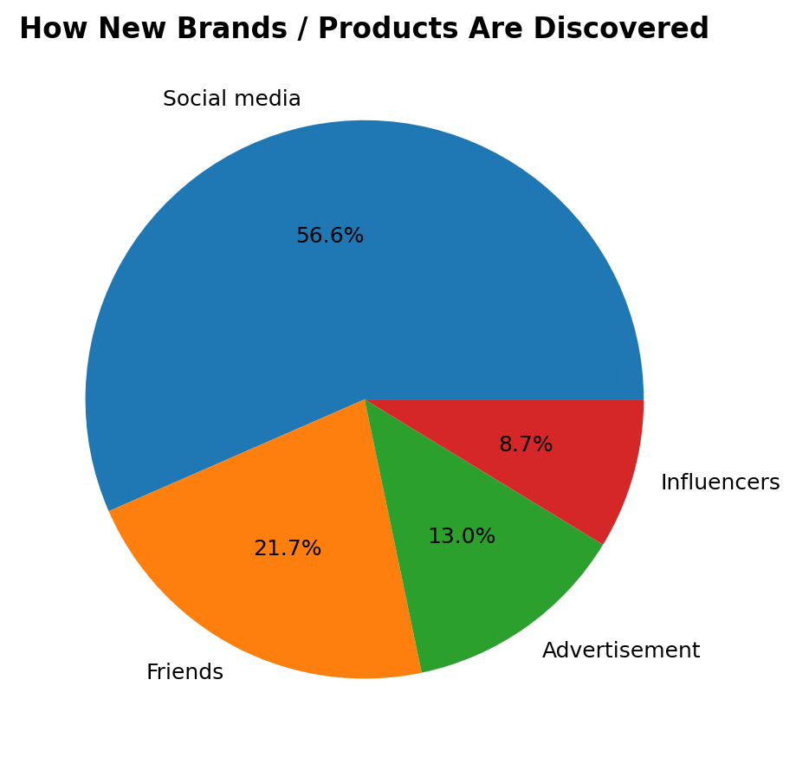
Figure A1 – How New Brands / Products Are Discovered
Interpretation: Social media was the leading channel for discovering new brands/products at 56.5%.

A2: Effect of Influencer Recommendations
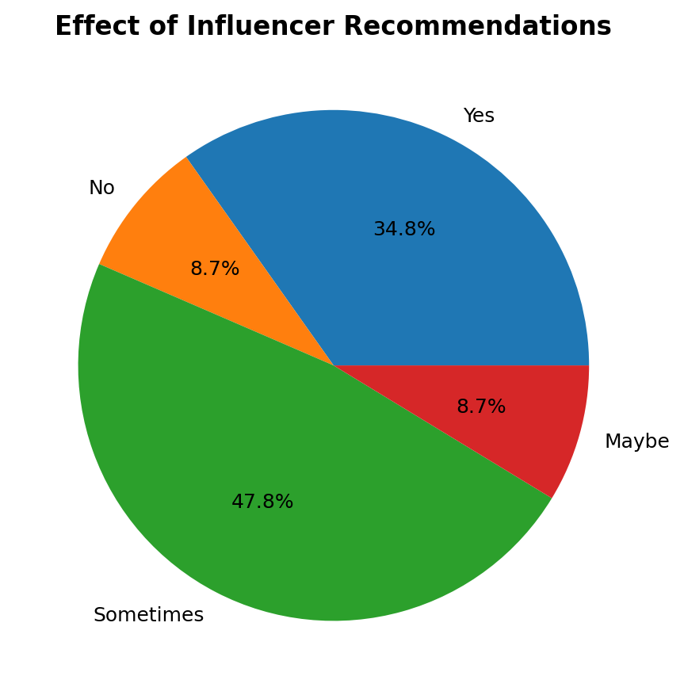
Figure A2 – Effect of Influencer Recommendations
Interpretation: 47.8% said influencer recommendations sometimes affect their buying decisions.

A3: Most Attractive Launch Offer
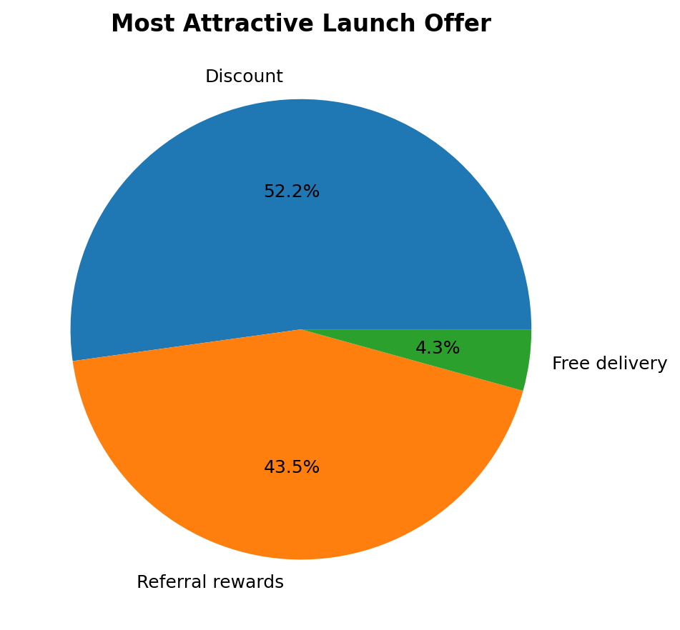
Figure A3 – Most Attractive Launch Offer
Interpretation: Discounts were the most attractive launch offer at 52.2%, followed by referral rewards at 43.5%.

A4: What Builds Trust in a New Brand
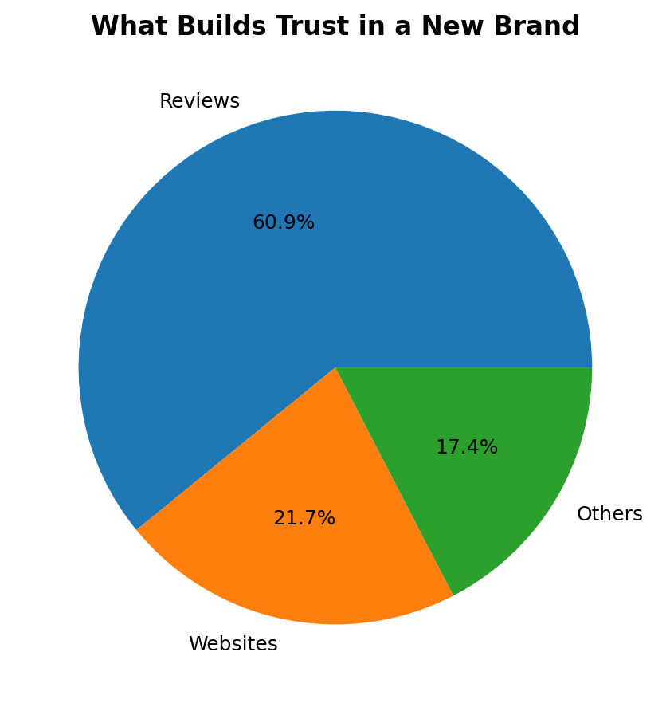
Figure A4 – What Builds Trust in a New Brand
Interpretation: Reviews were the strongest trust-building factor at 60.9%.

A5: Are Free Trials Helpful in Conversion?
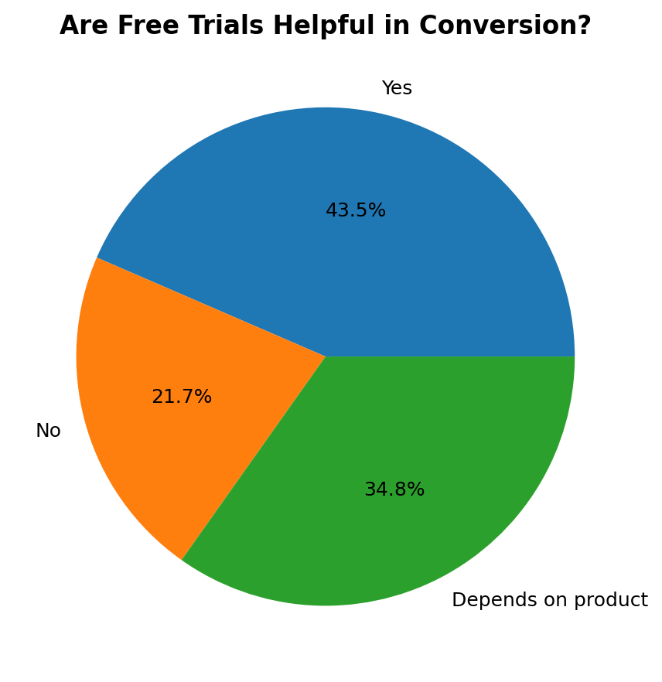
Figure A5 – Are Free Trials Helpful in Conversion?
Interpretation: 43.5% said free trials are helpful in converting them into customers, while 34.8% said it depends on the product.

7. Consolidated Findings
Theme | Evidence / Implication
Product quality | 63.7% selected high product quality as the strongest loyalty driver; 46.7% in the retention survey selected poor quality as the main reason for stopping purchases.
Customer experience | 40.9% identified bad experience as the leading reason for stopping purchases in the loyalty survey.
Retention benefits | Membership benefits were the preferred retention strategy for 53.3% of retention respondents.
Special offers | 53.3% said they had continued a subscription because of special offers.
Social-first acquisition | 56.5% discovered new brands/products through social media.
Social proof | Reviews were the strongest trust-building factor at 60.9%.
Launch incentives | Discounts led launch offers at 52.2%, with referral rewards at 43.5%.
Trials | 43.5% found free trials helpful, while 34.8% said effectiveness depends on the product.
Personalization | Responses to personalized messages/offers were evenly split between Yes and No at 46.7% each.

8. Recommendations
- Prioritise consistent product quality and customer experience.
- Use membership benefits and carefully designed offers to strengthen retention.
- Build acquisition around social media, customer reviews and other forms of social proof.
- Use discounts and referral rewards strategically during launch or acquisition campaigns.
- Offer trials when the product can demonstrate value quickly and clearly.
- Use personalization selectively and make messages genuinely relevant to the customer.
- Track quality complaints and service issues because negative experiences can directly weaken loyalty.

9. Limitations
The survey sets contain only 15–23 respondents and use convenience sampling. The findings therefore provide directional insights rather than statistically representative population estimates. Some questions also belong to different survey sets, so their response counts should not be added together.

10. Satvify Subscription-Plan FAQs
1. What is Satvify?
Satvify is a cloud kitchen serving fresh, plant-based, Satvic and wholesome meals prepared and delivered to customers.
2. Do you use refined sugar, refined oil or refined flour?
No. The supplied FAQ states that Satvify does not use refined sugar, refined oil, refined flour, preservatives or artificial additives.
3. What is Satvic food?
Satvic food is described as food prepared using fresh, natural and minimally processed ingredients.
4. Is all your food vegan?
Yes. The supplied FAQ states that the menu is completely plant-based and dairy-free.
5. What makes Satvify different?
The FAQ highlights 100% plant-based and vegan meals, Satvic positioning, no refined sugar/oil/maida, fresh preparation and natural ingredients.
6. How do I order?
Customers can place an order through WhatsApp or through the Satvify official website.
7. What subscription plans are available?
The supplied FAQ lists Basic, Standard and Premium plans, with different meal frequencies.
8. Can I customise my subscription?
Premium subscribers can access limited customisation such as meal selection, delivery frequency, time slot and smoothie/salad preference.
9. Can I switch between smoothies and salads?
Yes. Depending on the plan, customers can alternate between smoothies and salads and drinks.
10. What are your best-selling items?
The supplied FAQ lists Garden Blossom Salad, Jau-Dropping Bowl and Green Glow Elixir as customer favourites.
11. Are your meals suitable for weight management?
The FAQ says the meals use wholesome ingredients that support a healthy lifestyle; individual results depend on overall diet and routine.
12. Do you offer subscriptions?
Yes. Weekly and monthly subscription plans are offered for smoothies, salads and drinks.
13. Are your meals freshly prepared every day?
Yes. The supplied FAQ states that meals are freshly prepared daily before delivery.
14. How is food quality maintained?
Meals are described as handcrafted, quality checked, hygienically packed and delivered fresh.
15. Can I pause or cancel my subscription?
Yes. Customers should contact Satvify before the next scheduled delivery to request a pause or cancellation.
16. Which areas do you deliver?
Delivery is available within selected service areas; customers can contact Satvify through WhatsApp or the website to check availability.
17. What payment methods do you accept?
The supplied FAQ lists UPI, bank transfer and other available online payment methods.
18. How can I contact Satvify?
Customers can contact Satvify through WhatsApp for orders, subscriptions, support or questions, and through the official website.
19. Do you use preservatives or artificial flavours?
No. The supplied FAQ states that Satvify uses natural ingredients and does not use preservatives or artificial flavours.
20. Who are Satvify meals suitable for?
The FAQ lists busy professionals, students, fitness enthusiasts, families and anyone looking for healthy plant-based meals.

11. Conclusion
The survey-based research provides primary-data support for the major customer-behaviour themes examined during the internship. The strongest patterns point to the importance of product quality and customer experience for loyalty, membership benefits and offers for retention, and social media, reviews and well-designed incentives for acquisition. The findings can help guide practical customer-focused decisions while recognising the limitations of the small samples.

12. Suggested Viva Questions
- Why did you use pie charts for the survey analysis?
- Why were the three survey sets kept separate?
- What was the strongest factor affecting brand loyalty?
- What was the most preferred retention strategy?
- Which channel was strongest for discovering new brands?
- What was the main reason respondents stopped buying from a brand?
- What is the main business implication of the survey?
- What were the major limitations of the research?

13. References / Source Documents
1. Google Forms survey responses supplied for the Satvify internship research.
2. Satvify Subscription-Plan FAQ document supplied during the internship.
3. Satvify Survey Analysis Report prepared for the internship research.

