SATVIFY
Research & Analytics Internship
INTERNSHIP REPORT
Consumer Brand Loyalty & Retention: Survey-Based Research and FAQ Development
Submitted by
Diveshika Yadav
Research and Analytics Intern
Internship Duration: June 1, 2026 – August 29, 2026 (3 Months)
Organization: Satvify

Acknowledgement
I would like to express my sincere gratitude to Satvify and to Ms. Yukti Setia, Founder of Satvify, for giving me the opportunity to work as a Research and Analytics Intern. This internship has been a valuable learning experience that helped me apply my analytical skills to real business problems.
I am thankful for the guidance and support extended to me throughout the internship period, which enabled me to successfully complete the assigned research, survey analysis, and content development tasks.

About the Company
Satvify is an organization focused on delivering value-driven products and services to its customers, with an emphasis on quality, trust, and customer-centric practices. As part of its ongoing efforts to strengthen customer communication and understand consumer behaviour, the company undertakes research initiatives such as customer surveys and knowledge-base development (FAQs) for its official website.

About the Internship
This internship was undertaken in the Research and Analytics domain at Satvify for a period of three months, from June 1, 2026 to August 29, 2026. The internship focused on understanding consumer brand loyalty and retention behaviour through primary survey research, and on improving customer-facing communication through FAQ content for the company website.

Objectives
- To design and conduct surveys to understand factors driving customer brand loyalty and retention.
- To analyze survey responses and represent the findings visually using pie charts.
- To interpret the data and identify the most significant trend for each survey question.
- To create a set of Frequently Asked Questions (FAQs) for Satvify's official website, helping customers understand the services offered by the company.

Roles and Responsibilities
- Designed and conducted two structured surveys — a Customer Retention Survey (15 respondents) and a Brand Loyalty Survey (22–23 respondents) — to study consumer purchasing behaviour.
- Collected and compiled survey responses using Google Forms.
- Converted raw response data into pie chart visualizations for each survey question.
- Analyzed each chart to identify the response category with the highest share and wrote a data-backed interpretation highlighting that finding.
- Compiled the chart interpretations into a structured document for internal reporting.
- Drafted Frequently Asked Questions (FAQs) for the Satvify official website to help customers understand the services provided by the company.

Research Methodology
The research was carried out through primary data collection using structured online questionnaires (Google Forms), circulated to gather first-hand consumer insights on brand loyalty and retention behaviour.
- Survey Tool Used: Google Forms
- Data Visualization: Pie charts generated for each survey question
- Analysis Approach: For every question, the response option with the highest percentage share was identified and highlighted with a written interpretation
- Survey 1 – Customer Retention Survey: 15 respondents, 6 questions
- Survey 2 – Brand Loyalty Survey: 22–23 respondents, 9 questions

Survey 1: Customer Retention Survey — Findings
This survey was conducted among 15 respondents to understand what drives customers to stay loyal to a brand and what causes them to disengage.
Q1. What encourages you to buy again from the same company?
15 responses
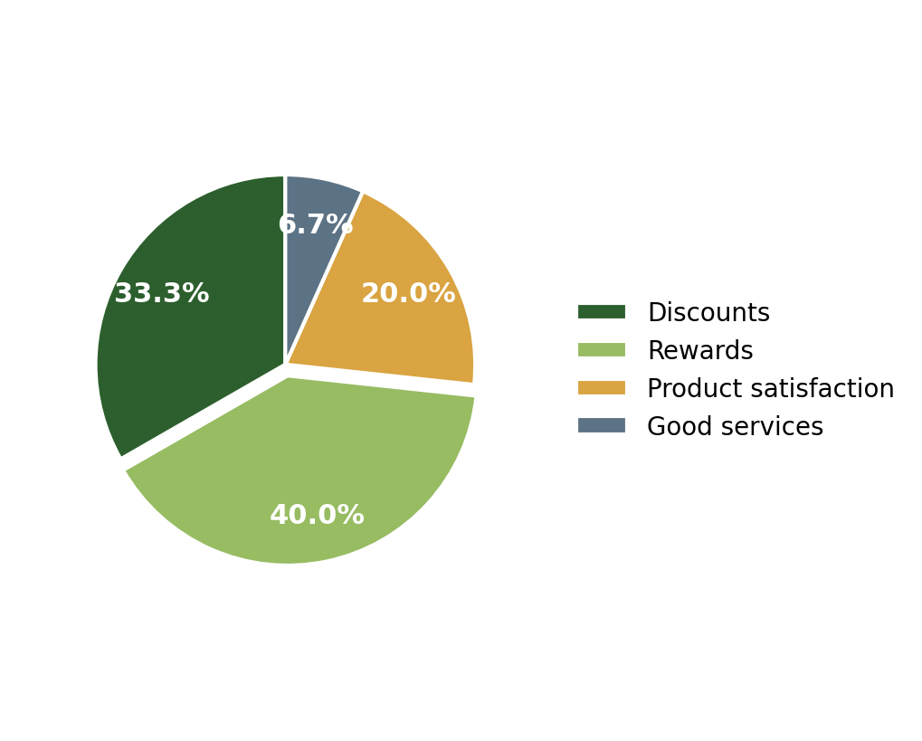
Interpretation: The majority of respondents (40%) stated that rewards encourage them to buy again from the same company.
Q2. Do loyalty programs influence your repeat purchases?
15 responses
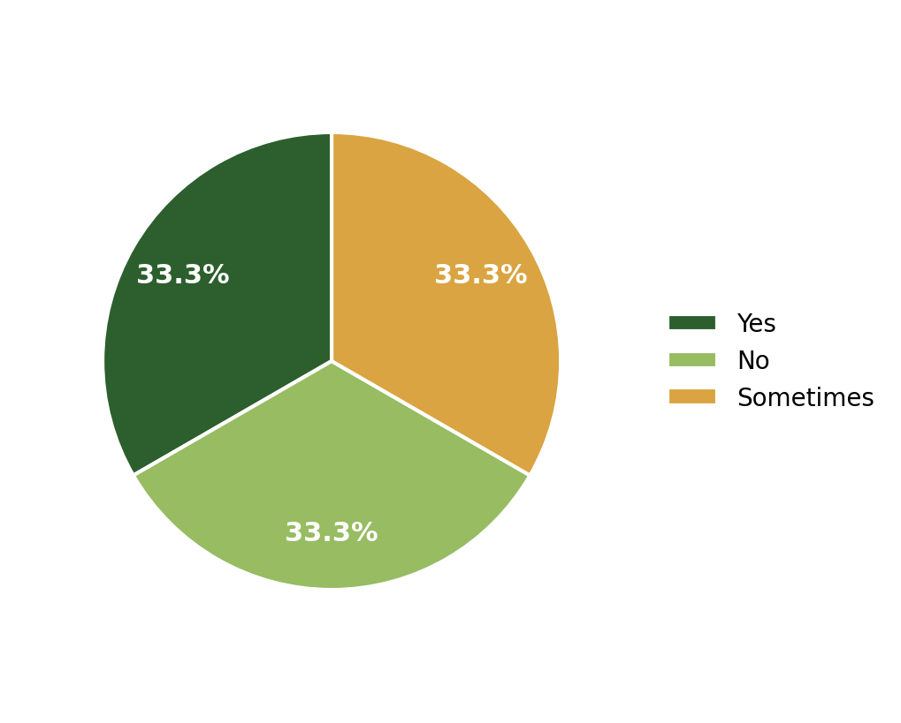
Interpretation: The responses were equally divided, with 33.3% each selecting Yes, No, and Sometimes regarding the influence of loyalty programs on repeat purchases.
Q3. Do personalized messages/offers from brands attract you?
15 responses
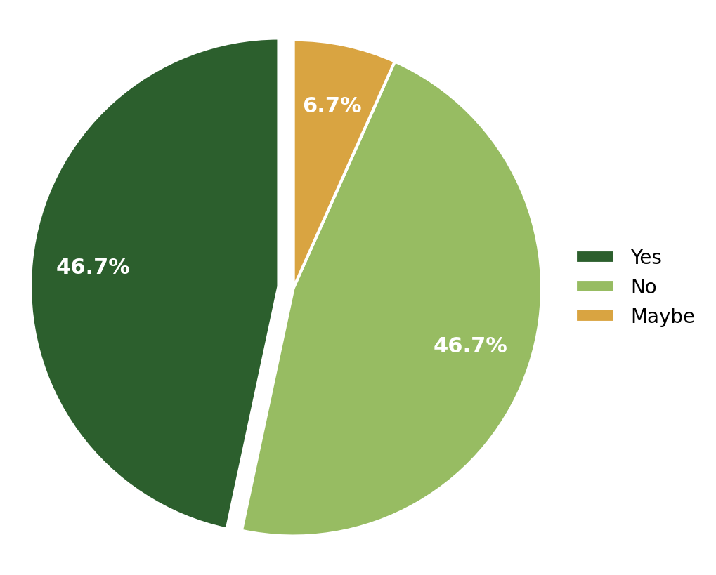
Interpretation: The highest responses were tied: 46.7% of respondents selected Yes and 46.7% selected No regarding whether personalized messages or offers attract them.
Q4. Which retention strategy works best on you?
15 responses
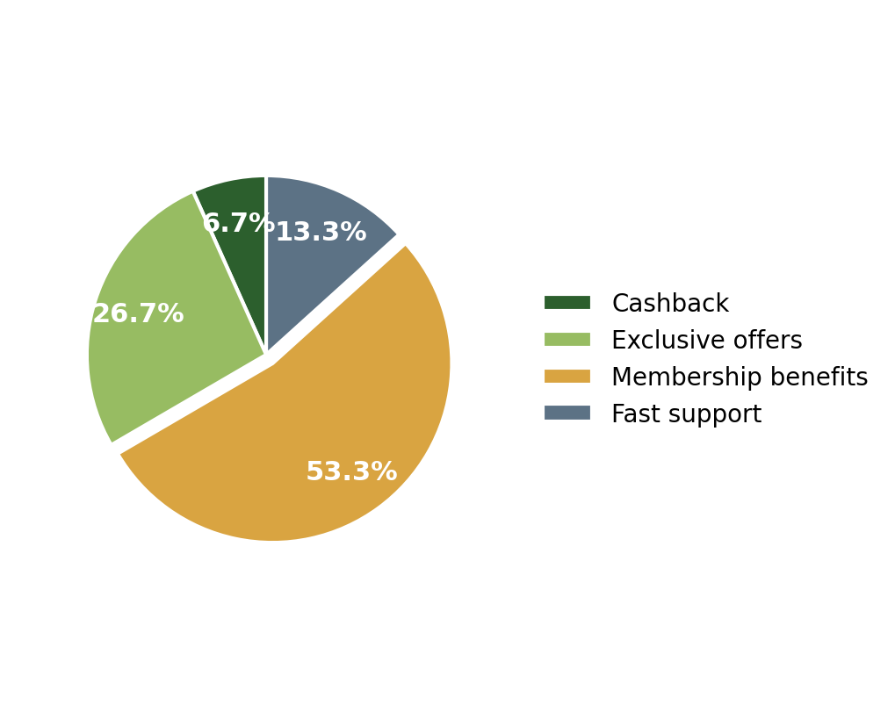
Interpretation: The majority of respondents (53.3%) stated that membership benefits are the retention strategy that works best for them.
Q5. Have you ever continued a subscription because of special offers?
15 responses
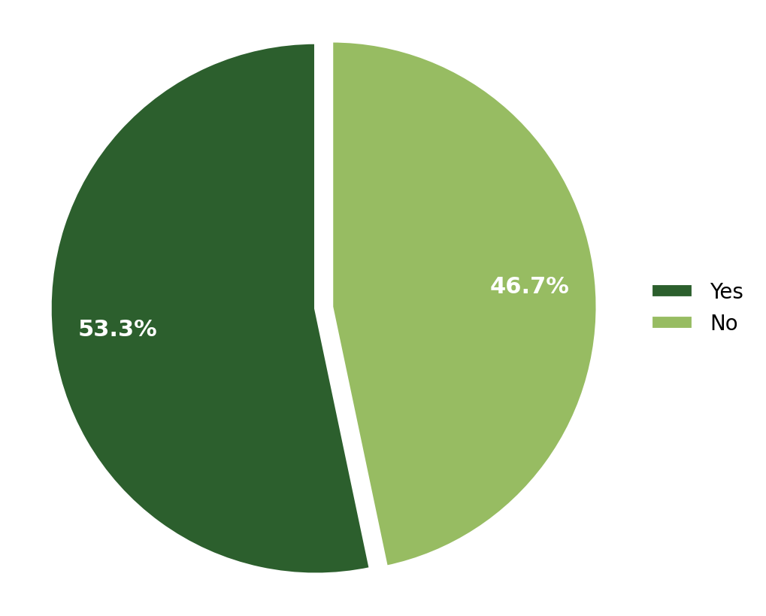
Interpretation: The majority of respondents (53.3%) stated that they have continued a subscription because of special offers.
Q6. What makes you stop buying from a brand?
15 responses
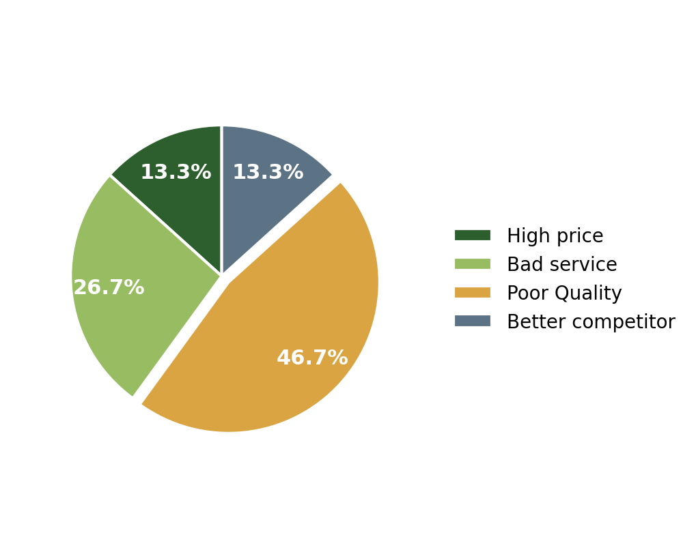
Interpretation: The majority of respondents (46.7%) stated that poor quality is the main reason they stop buying from a brand.

Survey 2: Brand Loyalty Survey — Findings
This survey was conducted among 22–23 respondents to gain a broader understanding of the emotional, behavioural, and trust-related factors influencing brand loyalty.
Q1. How often do you purchase products from the same brand again?
22 responses
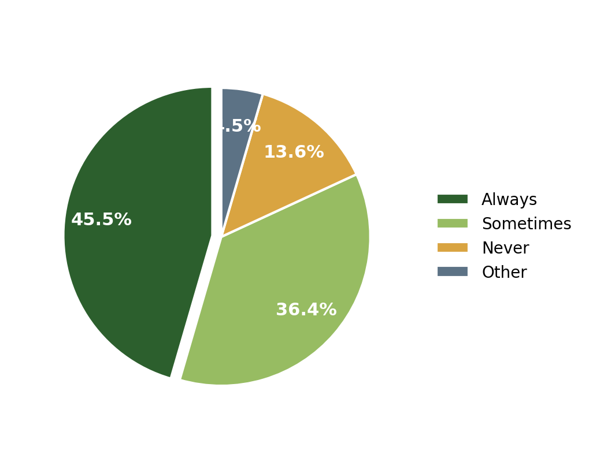
Interpretation: The majority of respondents (45.5%) stated that they always purchase products from the same brand again.
Q2. Does emotional connection with a brand influence your buying decisions?
22 responses
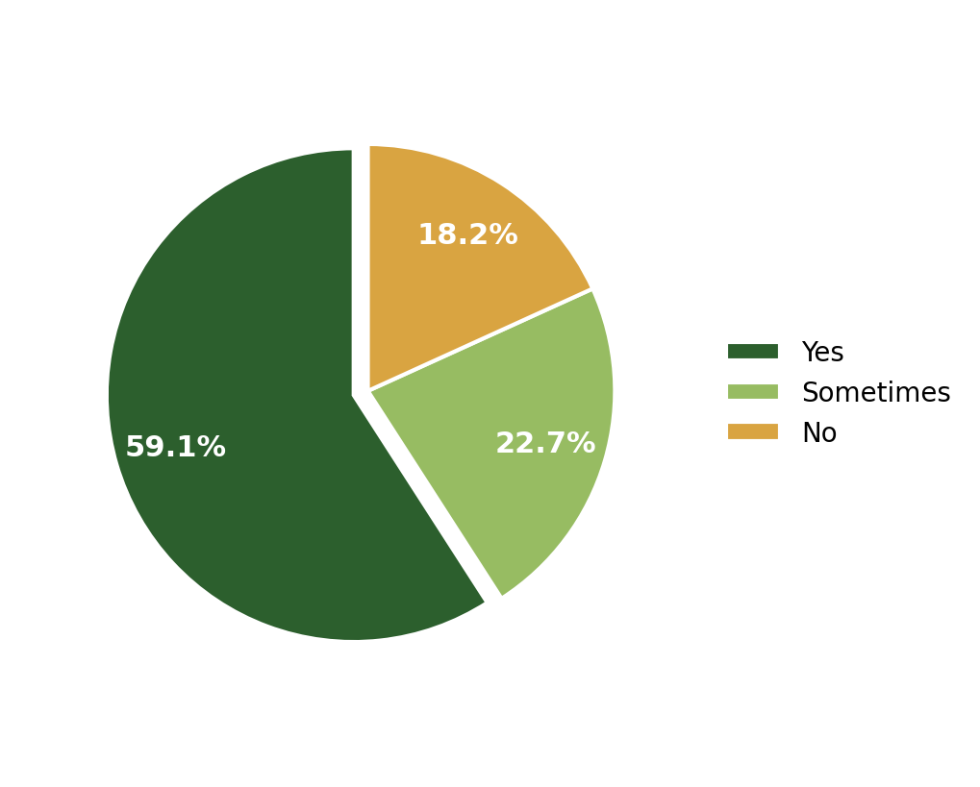
Interpretation: The majority of respondents (59.1%) stated that an emotional connection with a brand influences their buying decisions.
Q3. Would you prefer a trusted brand even if it is slightly expensive?
22 responses
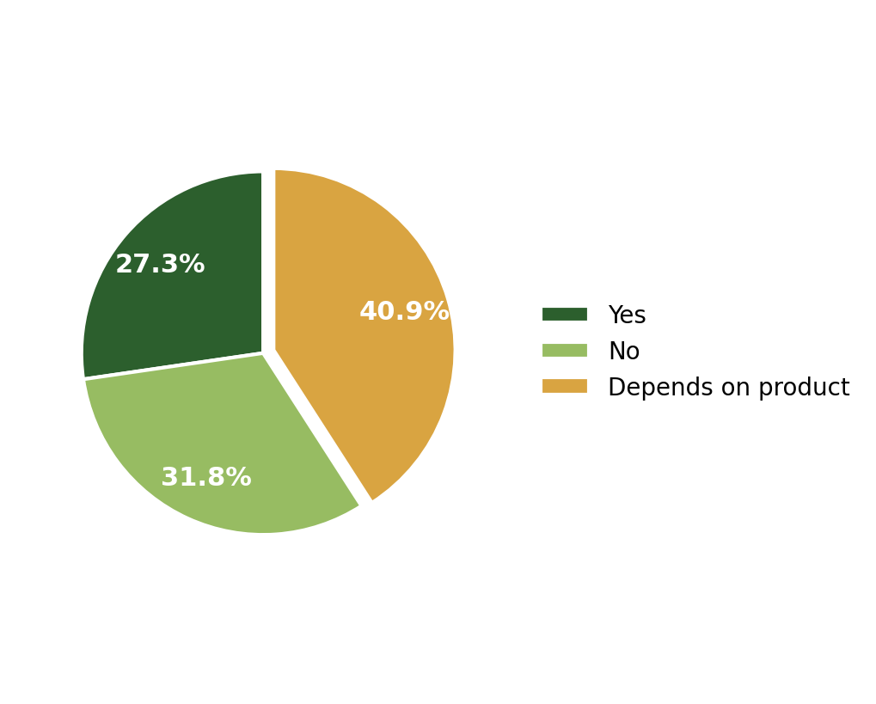
Interpretation: The highest proportion of respondents (40.9%) stated that their preference for a trusted brand, even if it is slightly expensive, depends on the product.
Q4. What factor increases your loyalty towards a brand?
22 responses
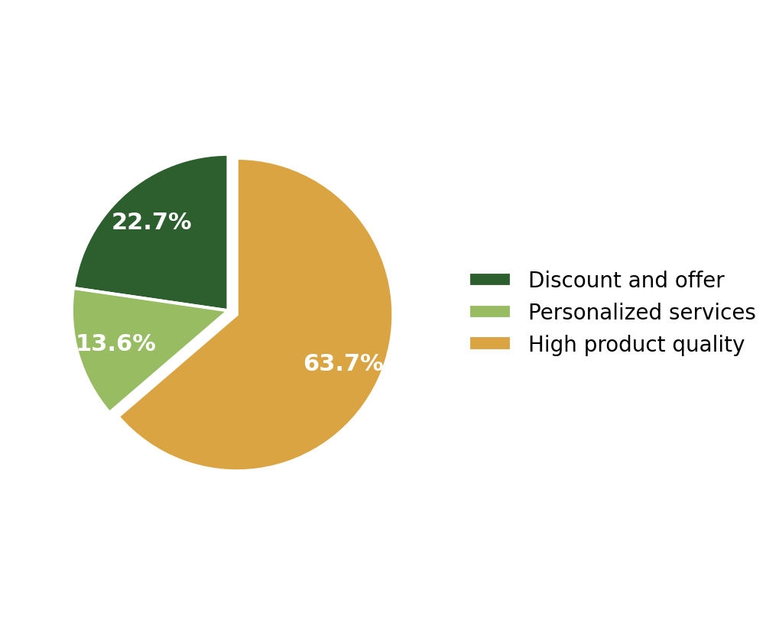
Interpretation: The majority of respondents (63.6%) stated that high product quality increases their loyalty towards a brand.
Q5. How likely are you to recommend your favourite brand to others?
22 responses
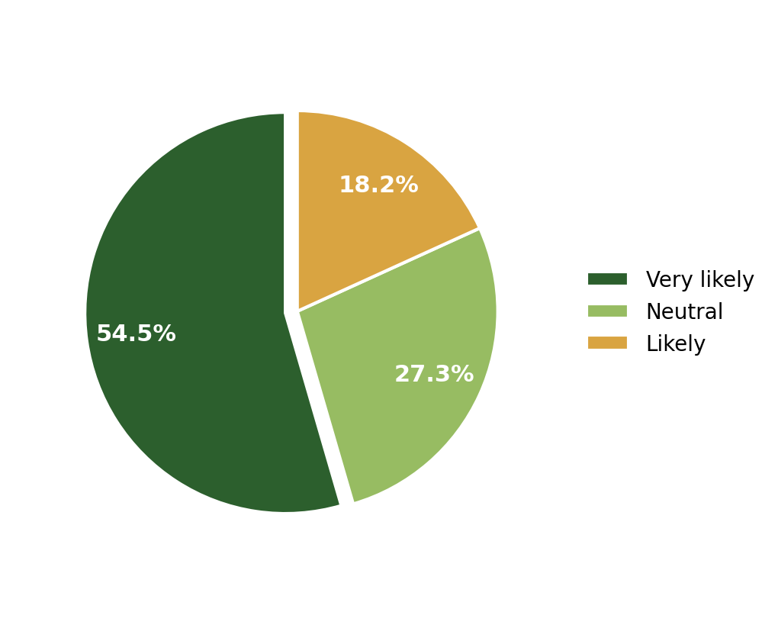
Interpretation: The majority of respondents (54.5%) stated that they are very likely to recommend their favourite brand to others.
Q6. What makes you stop buying from a brand?
22 responses
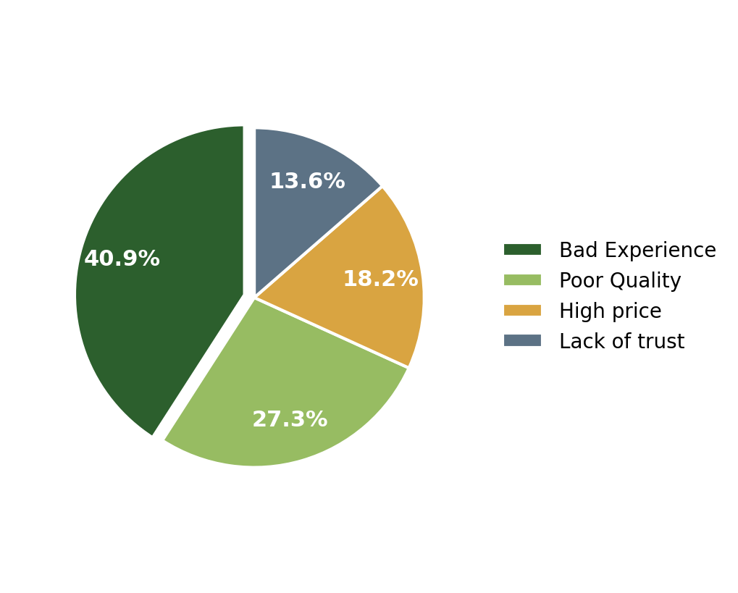
Interpretation: The highest proportion of respondents (40.9%) stated that a bad experience makes them stop buying from a brand.
Q7. How do you usually discover new brands/products?
23 responses
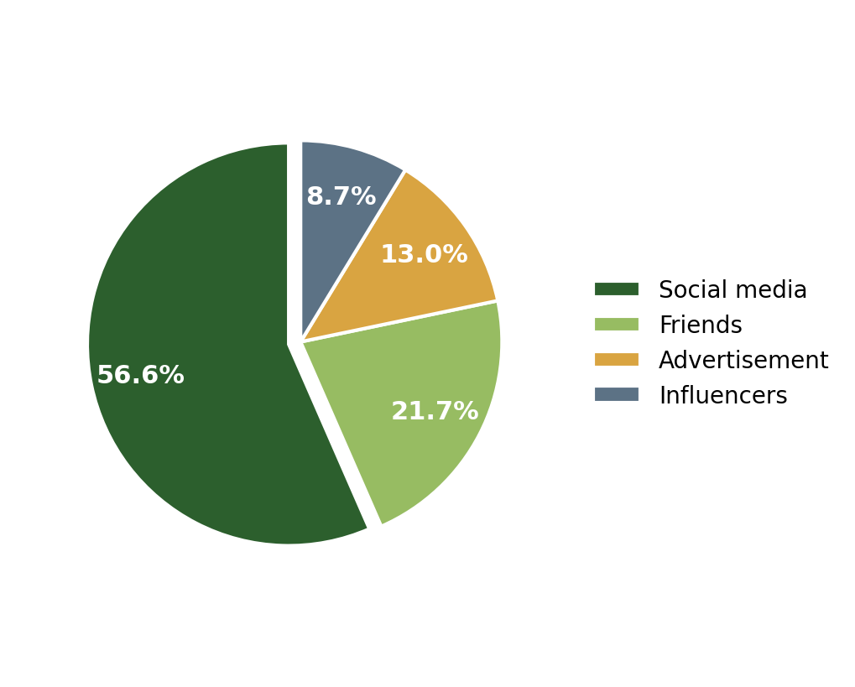
Interpretation: The majority of respondents (56.5%) stated that they usually discover new brands or products through social media.
Q8. What builds trust in a new brand?
23 responses
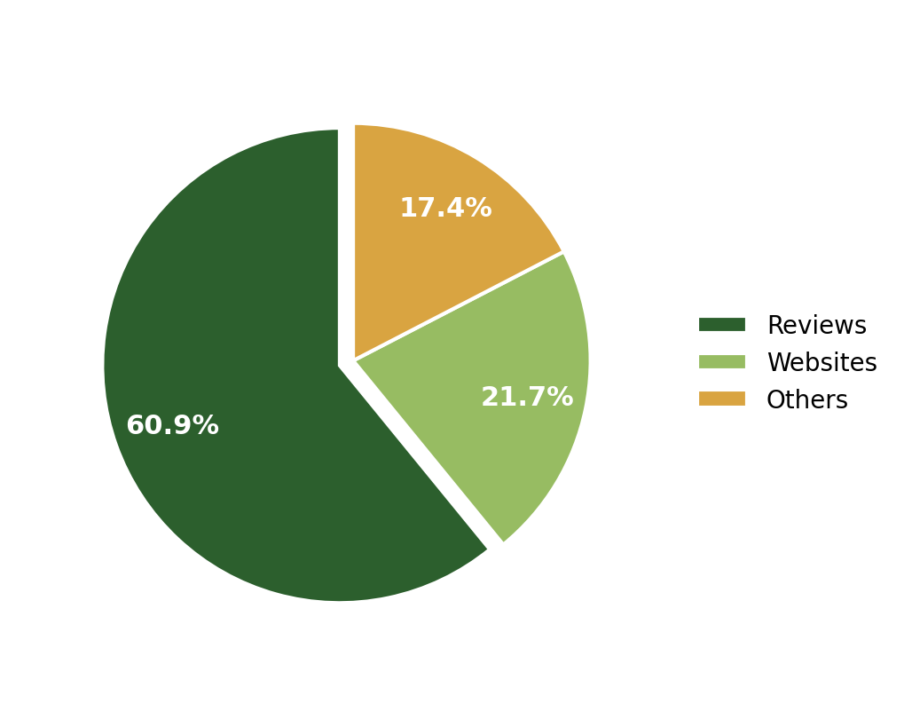
Interpretation: The majority of respondents (60.9%) stated that reviews are the most important factor in building trust in a new brand.
Q9. Are free trials helpful in converting you into a customer?
23 responses
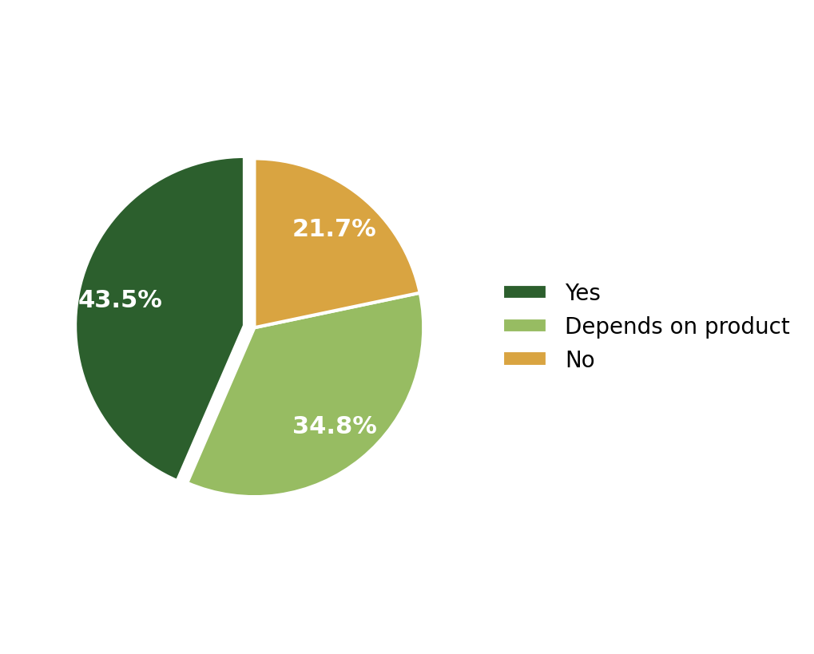
Interpretation: The largest proportion of respondents (43.5%) stated that free trials are helpful in converting them into customers.

FAQ Development for Satvify Website
As part of the internship, a set of Frequently Asked Questions (FAQs) was prepared for publishing on Satvify's official website. The objective of this task was to proactively address common customer queries regarding the services provided by Satvify, improving customer clarity and reducing repetitive support queries.
- Identified common customer concerns and information gaps regarding Satvify's services.
- Drafted clear, concise, and customer-friendly FAQ content.
- Structured the FAQs for direct use on the company's official website.
- Incorporated feedback and corrections shared by the reporting manager before final submission.

Key Insights
- Rewards, membership benefits, and special offers are the strongest levers for encouraging repeat purchases and continued subscriptions.
- Poor quality and bad experiences are the leading reasons customers disengage from a brand — more influential than pricing alone.
- Emotional connection plays a major role in purchase decisions, with a majority of respondents confirming its influence.
- High product quality is the single strongest driver of brand loyalty, ahead of discounts or personalization.
- Social media and online reviews are now the primary channels through which customers discover and build trust in new brands.
- Free trials meaningfully assist in converting prospective customers, reinforcing the value of low-risk trial-based marketing.

Skills and Learning Outcomes
- Practical experience in designing structured survey questionnaires for primary research.
- Hands-on skills in data visualization using pie charts to communicate survey findings clearly.
- Improved ability to interpret quantitative data and translate it into actionable, written insights.
- Experience in creating customer-facing content (FAQs) aligned with business and brand communication goals.
- Strengthened research, analytical thinking, and professional documentation skills.

Conclusion
The internship provided valuable hands-on exposure to research and analytics in a real business context. Through the design and analysis of two consumer surveys, key drivers of brand loyalty and customer retention were identified, including the importance of product quality, rewards, emotional connection, and trust. Additionally, contributing to the company's website FAQs allowed for practical application of research findings into customer-facing communication. Overall, this internship strengthened my analytical, research, and communication skills and gave me a clearer understanding of how data-driven insights support business decision-making.

Annexure: Internship Completion Certificate
