**Name: Divesh Oree**

**Student Number: N01060689**

**Course Name: Hardware Production Tech (CENG 317)**

**Section Number: ONA**

**Date: 2016-10-04**

**Week 5: The Budget Submission**

In this week 5, I have managed to purchase my raspberry pi 3 from Amazon.ca for CAD$112.00 including tax. I am supposed to receive it on Tuesday 2016-10-04 around 8pm. I already had a Logitech webcam so I will use probably use that in order to scan the barcode strips. The raspberry kit already includes a 32 GB Micro SD card so I will manage to save off from that. The barcode strips stickers will still be needed for the student card and the item. From what I found out from the manufacturers and library department, it will cost around 5cents because the paper fabrics will be stickers. For the time beginning, I just have a sample.

Note: There has been an update on the raspberry pi arrival due to the weather condition

Please find below some pictures:

Print screen shot of the Raspberry Pi 3 order:

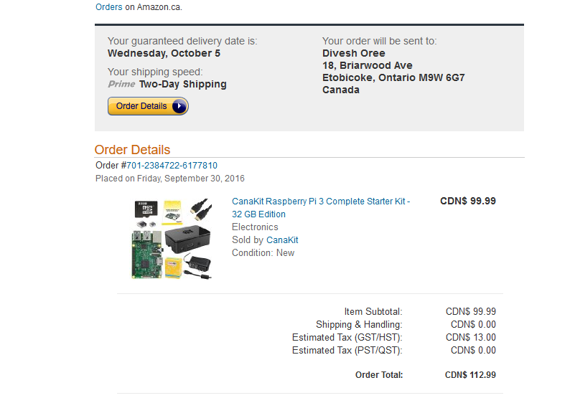

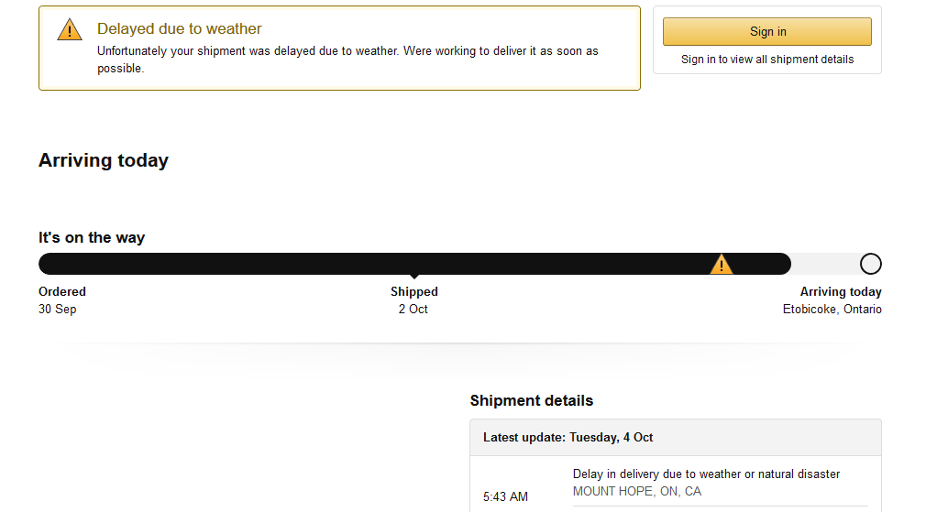

Picture of the webcam:

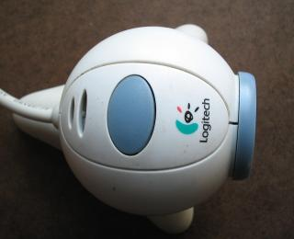

Sample of the barcode strips:

* Student Number

C:\Users\Ash\AppData\Local\Microsoft\Windows\INetCacheContent.Word\studentnumber.png

* Part Number

C:\Users\Ash\AppData\Local\Microsoft\Windows\INetCacheContent.Word\partnumber.png

**Next Step:**

I have already received my parts for the PCB. Now my step will be soldering my PCB this week on Thursday 2016-10-06.

