**🍕SQL PIZZA SALES ANALYSIS🍕**

## **KPI’s**

1. **Total Revenue**

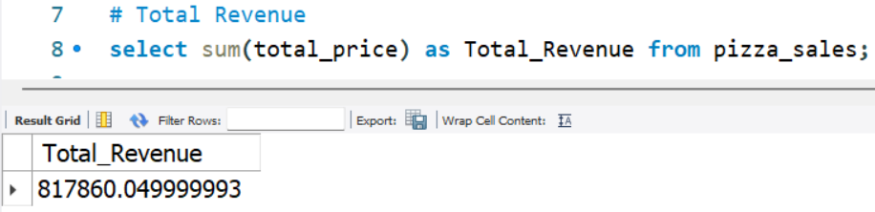

1. **Average Order Value**

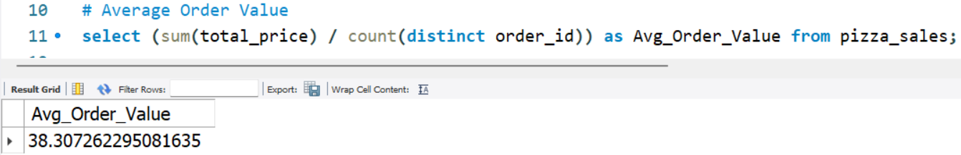

1. **Total Pizzas Sold**

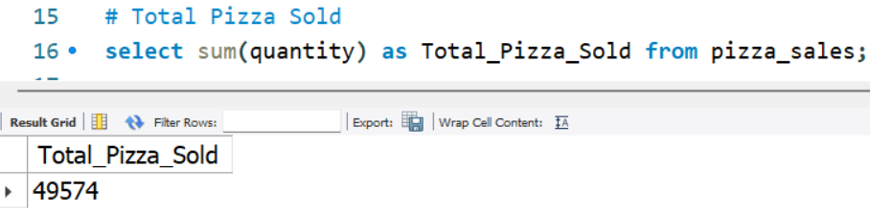

1. **Total Orders**

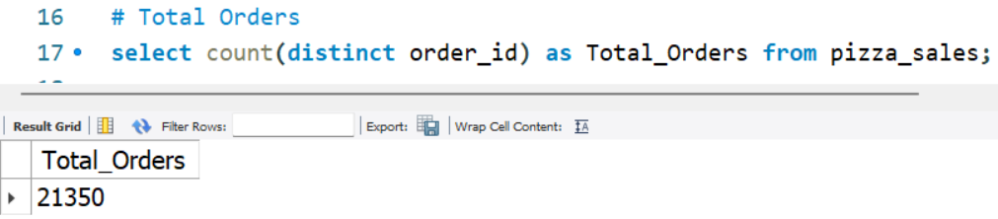

1. **Average Pizzas Per Order**

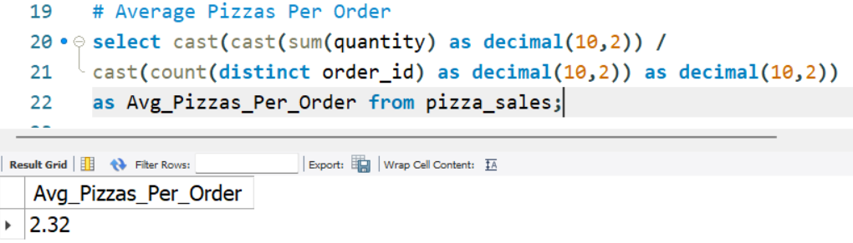

## **Daily Trend for Total Orders**

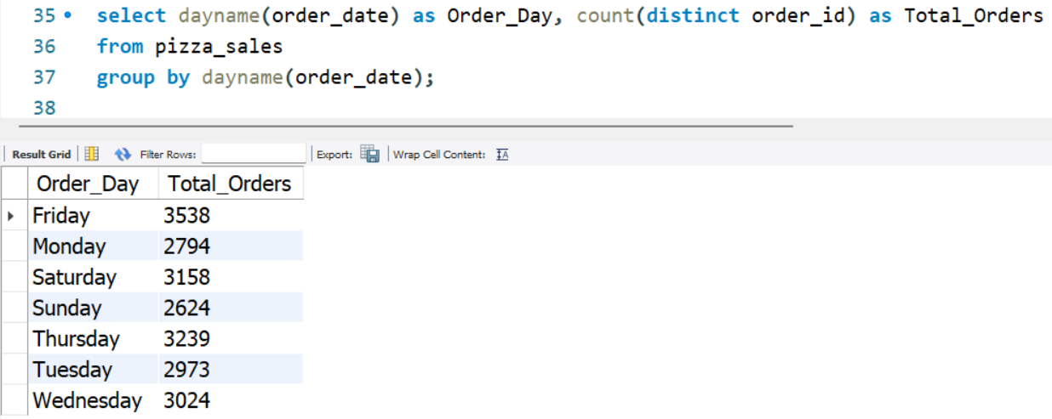

## **Hourly Trend for Orders**

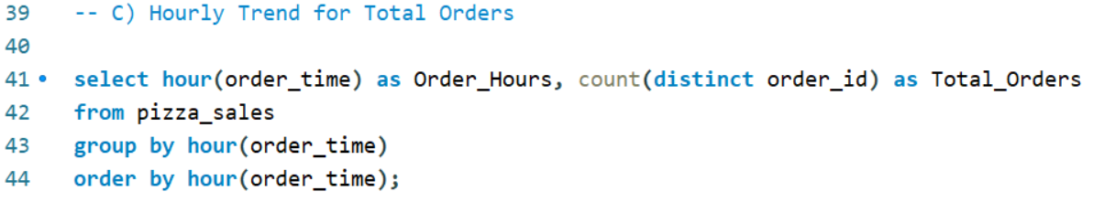

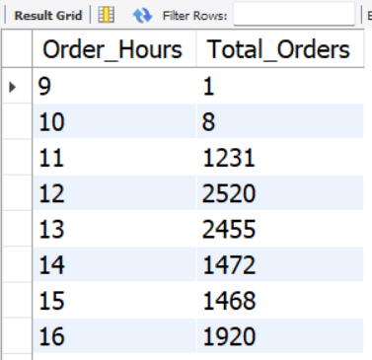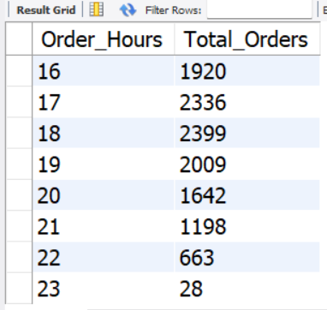

## **Percentage of Sales by Pizza Category**

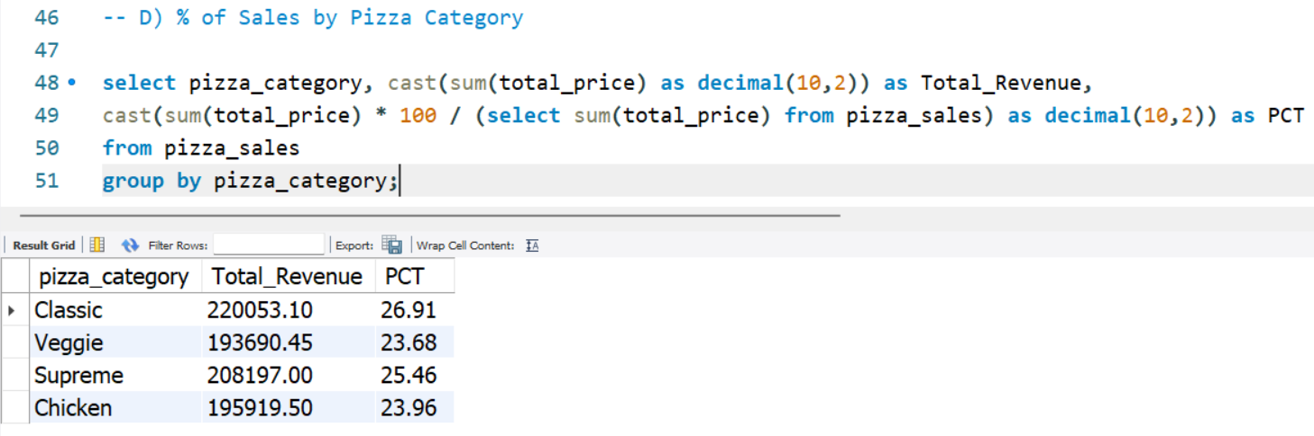

## **Percentage of Sales by Pizza Size**

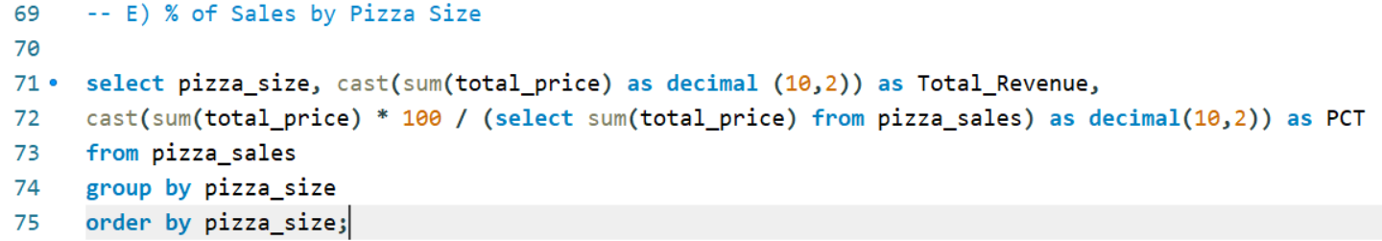

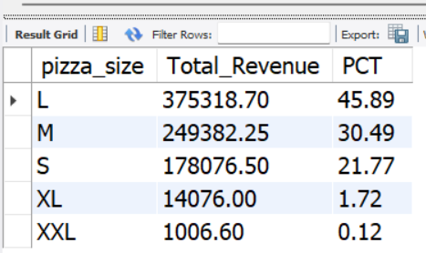

## **Total Pizza Sold by Pizza Category**

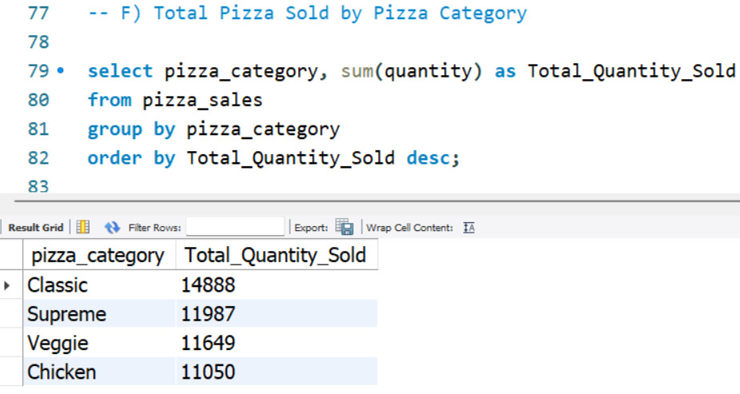

## **G. Top 5 Best Sellers by Total Pizzas Sold**

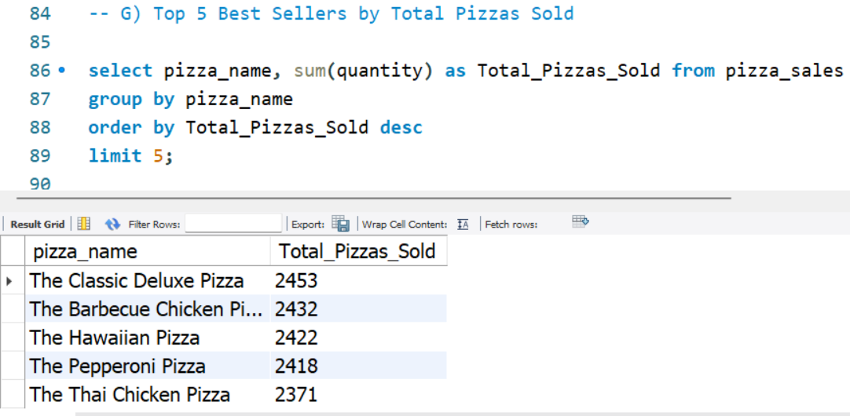

## **H. Bottom 5 Worst Sellers by Total Pizzas Sold**

