**December the 4th meeting**

What we have done:

* Characterizing the neuron block by playing on the parameters while using the design that gave us spikes during the meeting with Aishwarya.
* Try to run the pre-loaded example (very first design) while connecting the ground pin of the board to a ground 🡪 No excitation
* No excitation either when using a waveform implemented in the software, only when sending a signal from the Digilent module and read it the same way.
* Need to slightly modify the Na channel value (a few mV) after each programming to observe spikes: between 1.3V (excited state) and 1.4V (ground state) 🡪 Need to be connected to the Digilent to play with its value. This modifies the frequency of the spikes we observe (decreasing Na channel value leads to an increase in spikes number).

What we can do now:

* Try to understand the influence of other parameters on the excitability of the neuron (especially the activation threshold) 🡪 Role of the input signal
* Characterize the refractory period and excitability of the neuron (plot histograms).

Post-meeting report:

* To better understand the influence of the input signal on the activation of the neuron, we wanted to find a square input that goes above and below the activation threshold (we expect to see spikes only during half a period).
  + Input signal: constant value at 0V 🡪 Still an excitation, we must be above the threshold, we need to increase its value.
* Leaving a constant 0V input signal, we modify the other parameters. Our goal is to find a set of parameters for which we don’t see spikes anymore (i.e we are below the threshold). Once that’s done, we’ll modify the input until we see spikes again, thus measuring the value of the threshold:
  + K channel value: influence the amplitude of spikes. When EK = 1.5V (instead of 1.1V), we obtain spikes more than twice higher (0.37V). No more spikes but kind of noise for EK = 0.9V. Flat signal at EK = 0.8V.

We didn’t get an excitable signal by modifying the input signal (frequency, amplitude, offset).

* + Vref value: at 1V (instead of 0.85V) we lose the excitable behavior.

At 0.75V, almost no spikes at offset 0V. But, when we increase the offset of the input signal, we start seeing regular spikes again. But, still, it wasn’t very easy to determine a threshold. So, we decided to lower even further Vref.

At 0.35V, we think we have found the correct combination of values! For this value of Vref, no spikes were seen for an offset < 500mV. And regular and periodic spikes appear for an offset > 600mV. We believe this means that we have set the threshold to a value between 500 and 600mV.

* + Other remarks:
    - The amplitude of the input signal has an influence on the side of the peaks. When the amplitude increases, the size of the peaks increases a little. When it decreases, the size of the peaks decreases by a lot. The minimum value of amplitude for which peaks are seen is around 50mV. We chose to work with an amplitude of 100mV.
    - The value of ENa is very delicate. Every time the Digilent module is plugged/unplugged, or the card is reprogrammed etc. it is necessary to reset the value of ENa so that we can see the expected excitable behavior of the neuron (not too excitable, but excitable). Here we worked with ENa=1.319V
    - 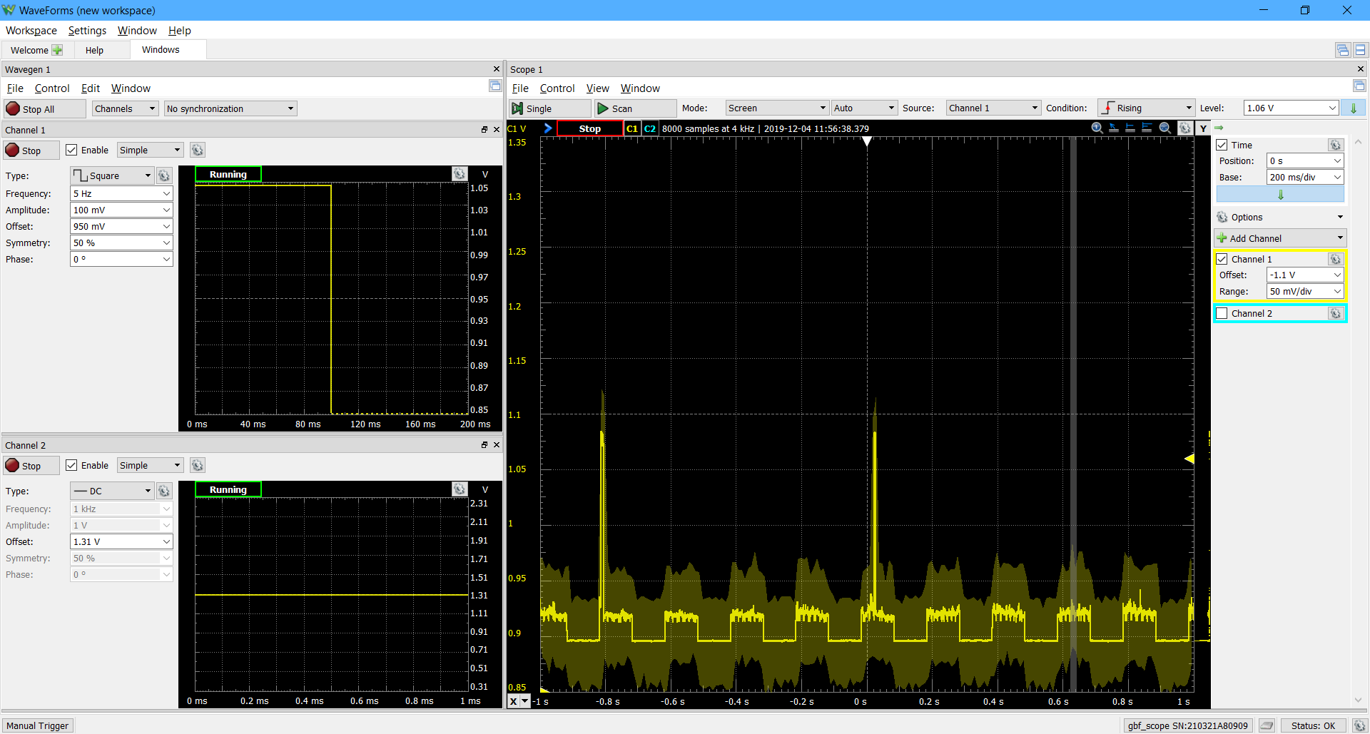The symmetry of the square signal is very important. For 50% we obtained the following (here Vref at 0.75V but same observations for other values of Vref):

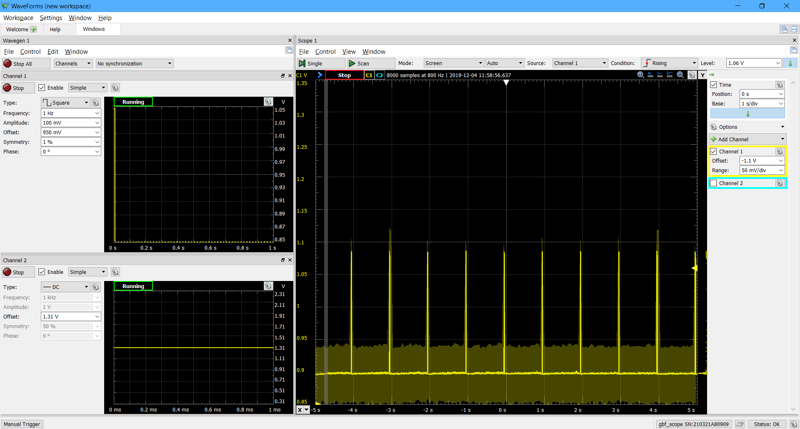For 1% we obtained this:

We were able to measure the refractory period of the neuron by using a symmetry of 1. Indeed, at more than 50%, the neuron never goes back to ground state while the input signal is in a high plateau. We think this means that the neuron hasn’t been able to repolarize, and thus cannot spike several times when the input signal stays high.

* + The refractory period we measured is around 200ms. So, we decided to work with a frequency between 1 and 5Hz. Above 5Hz we obtained the following:

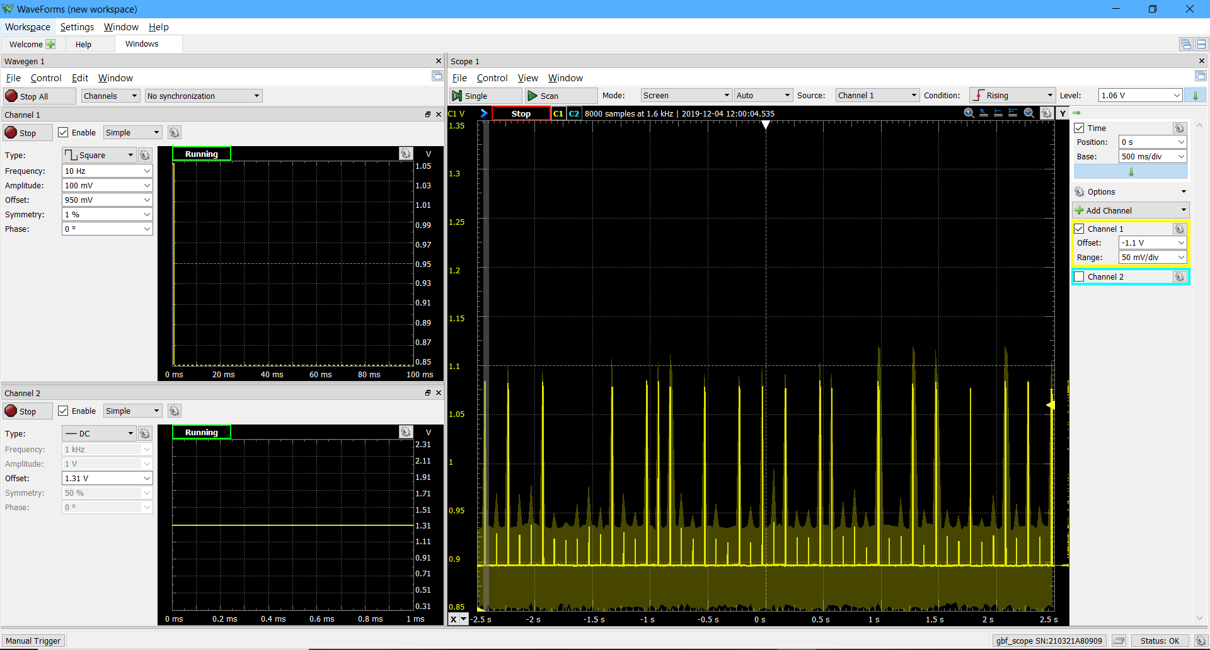

* To reproduce our experiment (that gave a neuron that behaved as expected), we can use the following set of values (will probably need some finetuning every time we start an experiment, especially ENa):
  + Input signal:
    - Frequency = 1Hz
    - Offset = 600 mV (to see spikes; and <500mV to avoid spiking)
    - Amplitude = 100 mV
    - Symmetry = 1%
  + ENa = 1.319 V
  + EK = 1.1V
  + Vref = 0.35V
    - * 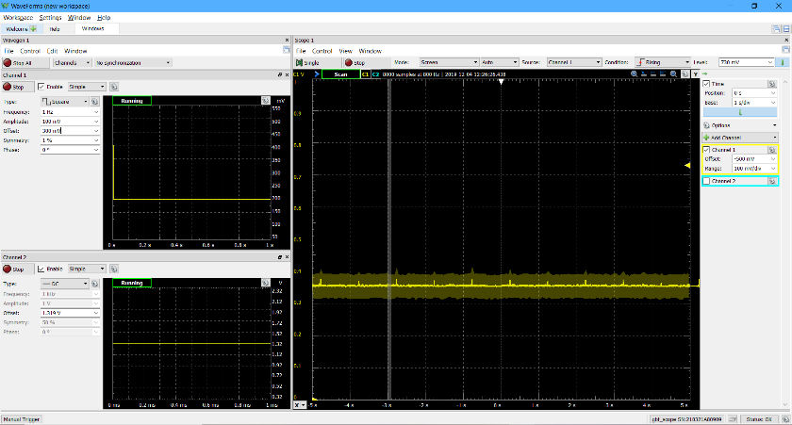threshold at around 500-600mV and refractory period of ~200ms

