**05.Practicle Name :-Demonstrate to alter table (add column,delete column,rename ,modify column).**

**Name:- Chaudhari Rishikesh Ramesh**

**Roll No:-14 Batch:-B1 Div:-A**

use college_data;

Select*from dbo.student;

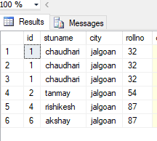

**alter table** student add age int,course varchar (60);

**alter table** student add age int,subject varchar (60);

**alter table** student add age int,course1 varchar (60);

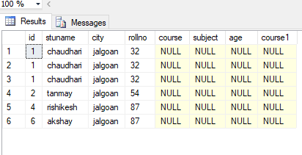

**alter table** student drop column age;

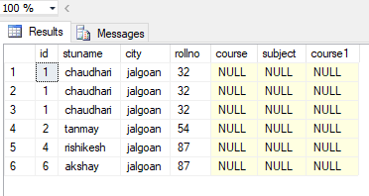

**alter table** student **alter column** course1 char (10);

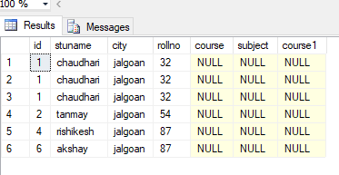

insert into student(course,subject,course1)

values('10','rushikesh','1020506070');

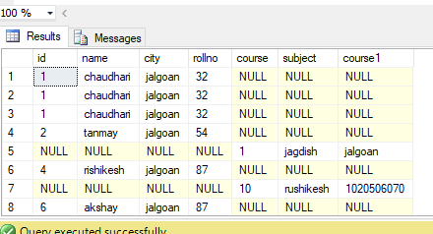

**Exec SP_Rename 'dbo.student.stuname','name','column';**

