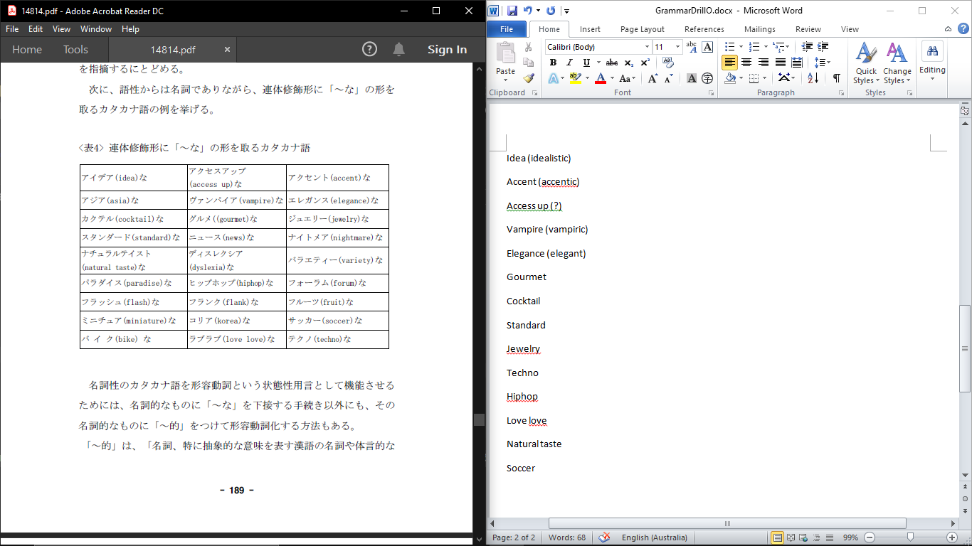Grammar Drill:

Adjectives, Tenses, Wh q’s

SOV, Simple noun phrases

Using the above pictures and the words provided, describe what you see:

[Worksheet answer be like:]

A small cat

Gourmet sushi

Clever person

An active dog

Use the correct ‘connecter’ (copula) for the following sentences, the first one has been done for you:

A silver cat -no

A homely person -na

A white building

A big dog -no

Re-write the following sentence to say ‘a historical book’:

Create 3 sentences on your own from the adjectives provided:

|  |  |  |
| --- | --- | --- |
| Clever | Gorgeous | Silver |
| Snob | Tough | Smart |
| Challenging | Homely | Moody |
| Miniature | Grey | Cute |
| Active | Gold | Big |
| Small | Black | White |

Answer the following questions:

名前は何ですか。

どこから来ましたか。

何歳ですか。

Past tense or present tense?

言いました

行った

来ます

ありました

寝る

Look at the following pictures, write down what the speaker did or will do from their perspective:

I woke up and did some excerise

I will watch tv and fall asleep

I danced and ate