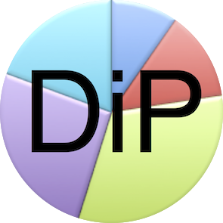

Divided Party (DiP) Fundraising

This confirms Dr/Mr/Mrs/Ms …......................................... (ID no: …............................................) has permission to do fundraising for DiP. His/her name can be confirmed on the website of DiP at:
https://www.dividedparty.org/DiP/Fundraisers.html.
For enquiries contact Marquard Pienaar at:
Tel: +27(0)824477125
Email: info@dividedparty.org
DiP Website: https://www.dividedparty.org

For amounts higher than R100, Divided Party (DiP) ERC20 brand tokens will be issued in return for the donation. When R20'000'000 will have been raised the tokens will represent 48% of the DiP brand value. The amounts are tax deductible. If the fundraiser raised more than R4'000 per month, Africahead Ipparts (AFA) ERC20 tokens may be issued. AFA amounts are not tax deductible, though.

Signature
M.D. Pienaar
Head of DiP

Name | Tel no | DiP or AFA | Email | Comments

