Bananas Under Pressure: Disease, Ripening and Biofortification
A. Sample (1) and B. Example (2)
(1) Fictional Institute of Tropical Fruit; (2) Example University. This is a made-up sample paper for trying Athetize. Some of its claims are deliberately wrong.

Abstract
Bananas are a staple food and a major traded fruit. This short review summarises three pressures on the crop: Fusarium wilt, the practice of induced ripening, and efforts to raise the nutritional value of the fruit. It is a sample document and is not a contribution to the literature.

1. Introduction
Around 85% of global banana production is consumed in local markets, and only about 15% enters international trade [1]. Trade is nonetheless large: exports from Ecuador reached a record volume of 6.4 million tonnes in 2017 [9]. The cultivated bananas derive mainly from Musa acuminata, with Musa balbisiana contributing through hybridization [8]. Archaeological evidence proves that bananas were first domesticated at a single site in New Guinea exactly 10,000 years ago [5]. A ripe banana contains about 422 mg of potassium.
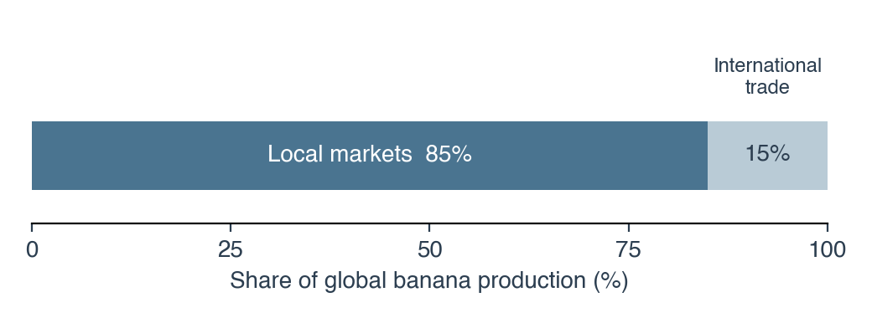
Figure 1. Where the world's bananas go: share of global production consumed in local markets and entering international trade [1].

2. Fusarium wilt
The early export trade was based entirely on the cultivar Gros Michel, which proved highly vulnerable to race 1 strains of the pathogen [1]. The strain now spreading, tropical race 4 (TR4), was confined to East and Southeast Asia for more than 20 years, but since 2010 it has reached Vietnam, Laos, Myanmar, India and Pakistan, the Middle East and Mozambique [2]. The pathogen persists as chlamydospores that survive in soil for more than 50 years [2]. Fungicide soil drenches now give reliable control of TR4 in commercial plantations [2].
Genetic resistance is the most promising answer. In a 3-year field trial, a transgenic Cavendish line carrying the RGA2 gene remained free of disease, which shows that the approach is ready for commercial planting [3]. The resistance gene was isolated from a TR4-resistant diploid banana [6].

3. Induced ripening
Bananas are harvested green and ripened close to the market. Commercial calcium carbide contains traces of arsenic and phosphorus hydride, and its use as a ripening agent is prohibited in most countries [4]. Most studies find that bananas ripened with ethylene are nutritionally inferior to naturally ripened fruit [4].

4. Nutrition and biofortification
Field-grown transgenic Cavendish lines exceeded the pro-vitamin A target of 20 µg/g dry weight, and one line reached 55 µg/g [6]. Bananas are also used as a sports food. In trained cyclists, bananas supported 75-km time-trial performance as well as a 6% carbohydrate drink [7]. Eating bananas during exercise therefore improves endurance performance compared with sports drinks [7].
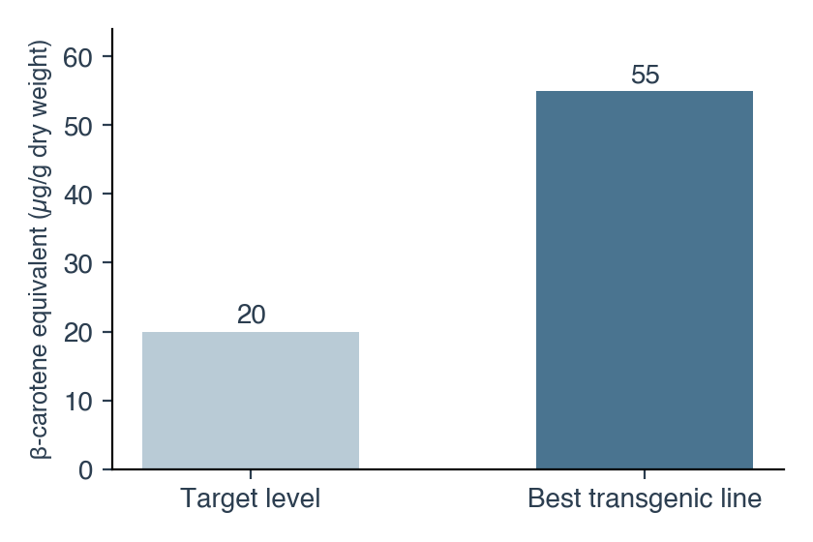
Figure 2. Pro-vitamin A (β-carotene equivalent) in fruit of the best transgenic line compared with the target level [6].

5. Conclusion
Disease pressure, post-harvest handling and nutrition each shape the future of the crop. Resistant cultivars and careful ripening practice remain the main tools available to growers.

References
[1] Ordonez, N., Seidl, M. F., Waalwijk, C., Drenth, A., Kilian, A., Thomma, B. P. H. J., Ploetz, R. C., Kema, G. H. J. (2015). Worse comes to worst: Bananas and Panama disease—when plant and pathogen clones meet. PLoS Pathogens, 11(11), e1005197. doi:10.1371/journal.ppat.1005197
[2] Dita, M., Barquero, M., Heck, D., Mizubuti, E. S. G., Staver, C. P. (2018). Fusarium wilt of banana: Current knowledge on epidemiology and research needs toward sustainable disease management. Frontiers in Plant Science, 9, 1468. doi:10.3389/fpls.2018.01468
[3] Dale, J., James, A., Paul, J.-Y., Khanna, H., Smith, M., Peraza-Echeverria, S., Garcia-Bastidas, F., Kema, G., Waterhouse, P., Mengersen, K., Harding, R. (2019). Transgenic Cavendish bananas with resistance to Fusarium wilt tropical race 4. Nature Communications, 8, 1496. doi:10.1038/s41467-017-01670-6
[4] Maduwanthi, S. D. T., Marapana, R. A. U. J. (2019). Induced ripening agents and their effect on fruit quality of banana. International Journal of Food Science, 2019, 2520179. doi:10.1155/2019/2520179
[5] Perrier, X., De Langhe, E., Donohue, M., Lentfer, C., Vrydaghs, L., Bakry, F., et al. (2011). Multidisciplinary perspectives on banana (Musa spp.) domestication. Proceedings of the National Academy of Sciences, 108(28), 11311–11318. doi:10.1073/pnas.1102001108
[6] Paul, J.-Y., Khanna, H., Kleidon, J., Hoang, P., Geijskes, J., Daniells, J., et al. (2017). Golden bananas in the field: elevated fruit pro-vitamin A from the expression of a single banana transgene. Plant Biotechnology Journal, 15(4), 520–532. doi:10.1111/pbi.12650
[7] Nieman, D. C., Gillitt, N. D., Henson, D. A., Sha, W., Shanely, R. A., Knab, A. M., Cialdella-Kam, L., Jin, F. (2012). Bananas as an energy source during exercise: a metabolomics approach. PLoS ONE, 7(5), e37479. doi:10.1371/journal.pone.0037479
[8] Simmonds, N. W., Shepherd, K. (1955). The taxonomy and origins of the cultivated bananas. Journal of the Linnean Society of London, Botany, 55(359), 302–312. doi:10.1111/j.1095-8339.1955.tb00015.x
[9] Food and Agriculture Organization of the United Nations (2018). Banana Market Review 2017. Rome: FAO. https://www.fao.org/fileadmin/templates/est/COMM_MARKETS_MONITORING/Bananas/Documents/web_Banana_Review_2018_Final_DV.pdf

