• **Disease_symptom_and_patient_profile_dataset.csv**(text/csv) - 20514 bytes, last modified: 4/24/2025 - 100% done

Saving Disease_symptom_and_patient_profile_dataset.csv to Disease_symptom_and_patient_profile_dataset (1).csv

Dataset shape: (349, 10)

First 5 rows:

Disease Fever Cough Fatigue Difficulty Breathing Age Gender \

0 Influenza Yes No Yes Yes 19 Female

1 Common Cold No Yes Yes No 25 Female

2 Eczema No Yes Yes No 25 Female

3 Asthma Yes Yes No Yes 25 Male

4 Asthma Yes Yes No Yes 25 Male

Blood Pressure Cholesterol Level Outcome Variable

0 Low Normal Positive

1 Normal Normal Negative

2 Normal Normal Negative

3 Normal Normal Positive

4 Normal Normal Positive

Column names: ['Disease', 'Fever', 'Cough', 'Fatigue', 'Difficulty Breathing', 'Age', 'Gender', 'Blood Pressure', 'Cholesterol Level', 'Outcome Variable']

Data types:

Disease object

Fever object

Cough object

Fatigue object

Difficulty Breathing object

Age int64

Gender object

Blood Pressure object

Cholesterol Level object

Outcome Variable object

dtype: object

Missing values:

Disease 0

Fever 0

Cough 0

Fatigue 0

Difficulty Breathing 0

Age 0

Gender 0

Blood Pressure 0

Cholesterol Level 0

Outcome Variable 0

dtype: int64

Duplicate rows: 49

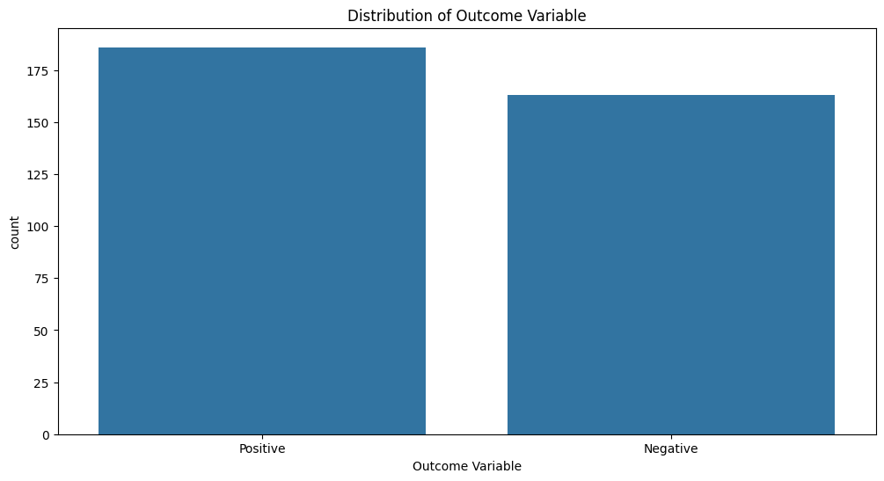

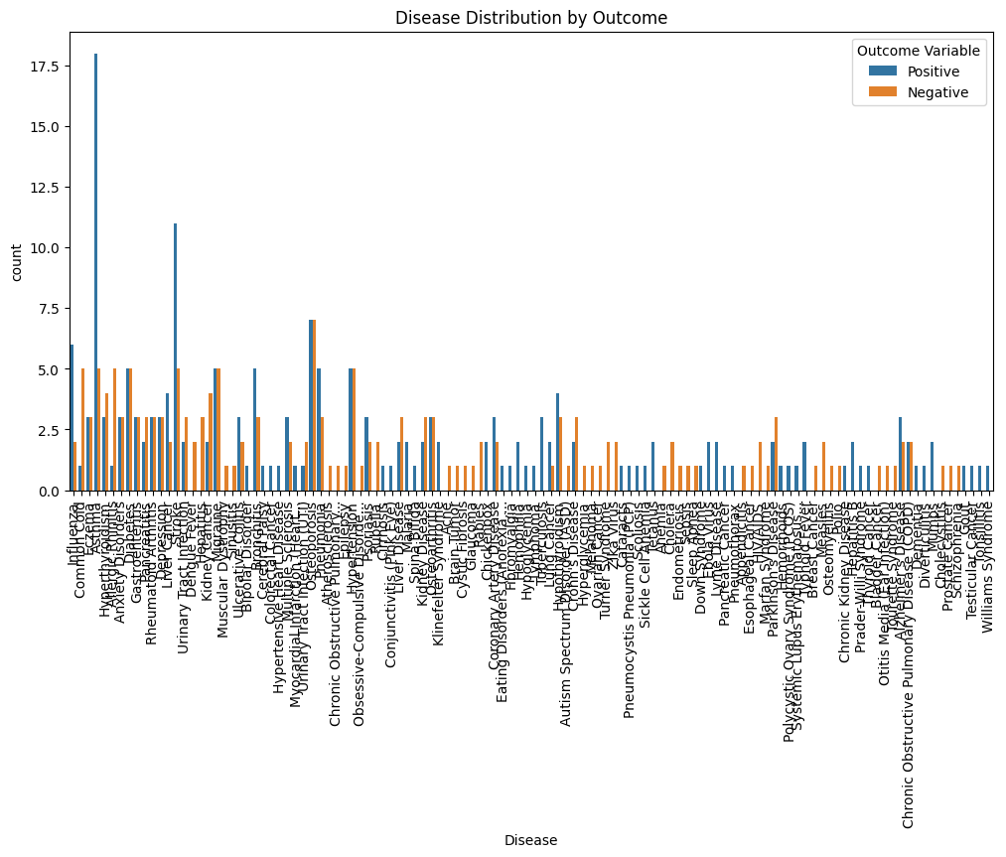

Model trained with accuracy: 0.80

Classification Report:

precision recall f1-score support

Negative 0.84 0.72 0.78 36

Positive 0.77 0.87 0.82 39

accuracy 0.80 75

macro avg 0.81 0.80 0.80 75

weighted avg 0.80 0.80 0.80 75

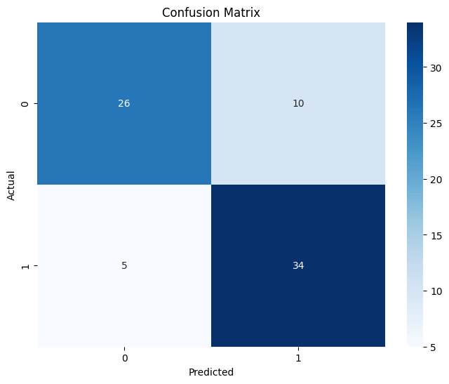

Model saved to healthcare_predictor.pkl

Launching local interface...

/usr/local/lib/python3.11/dist-packages/gradio/interface.py:415: UserWarning: The `allow_flagging` parameter in `Interface` is deprecated.Use `flagging_mode` instead.

warnings.warn(

It looks like you are running Gradio on a hosted a Jupyter notebook. For the Gradio app to work, sharing must be enabled. Automatically setting `share=True` (you can turn this off by setting `share=False` in `launch()` explicitly).

Colab notebook detected. To show errors in colab notebook, set debug=True in launch()

* Running on public URL: [https://49d427626c8dc58c34.gradio.live](https://49d427626c8dc58c34.gradio.live/)

This share link expires in 1 week. For free permanent hosting and GPU upgrades, run `gradio deploy` from the terminal in the working directory to deploy to Hugging Face Spaces (<https://huggingface.co/spaces>)

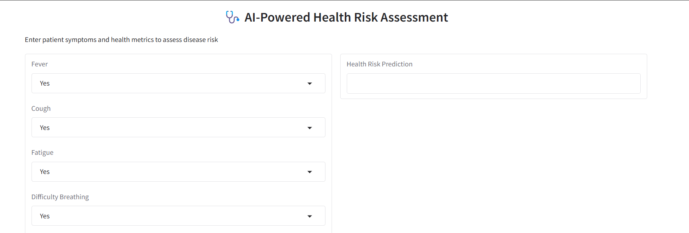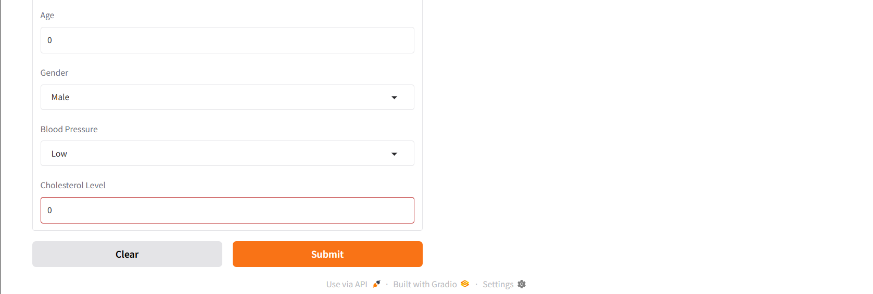

To get a public URL, please set up ngrok with your auth token.

Error: Error: credential propagation was unsuccessful