AI STUDYBUDDY
AI-Powered Study Assistance and Recommendation API
TEAM MEMBERS
1. Diviia Srii D
2.Kaviya K
3.Jayachitra M
4.Velankanni P
PROJECT DOCUMENT
1. Introduction
AI StudyBuddy is a backend project designed to provide study-related assistance through APIs. The project includes AI-powered study assistance and recommendation functionality and is tested through API requests and responses. The backend is developed using Node.js and Express.js, with AI functionality used to provide personalized study support.
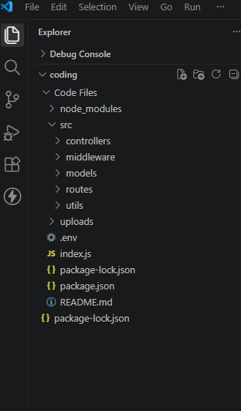
2. Problem Statement
Students may find it difficult to organize their study activities, understand study requirements, and receive personalized study guidance. An AI StudyBuddy application can simplify this process by accepting student details and providing useful study assistance through an API.
3. Objectives
- To develop a backend system for study-related functionality.
- To provide personalized study assistance using AI.
- To accept student information through REST API requests.
- To test API requests and responses using Thunder Client.
- To handle successful and unsuccessful API requests properly.
4. Technologies Used
- Node.js
- Express.js
- JavaScript
- MongoDB / MongoDB Atlas
- AI service used in the actual project
- Thunder Client
- Visual Studio Code
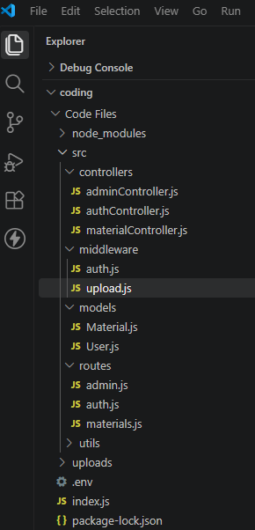
5. Project Workflow
The basic workflow of the AI StudyBuddy project is:
- Create and organize the backend code files.
- Configure the project and required packages.
- Start the backend server.
- Create and configure API endpoints.
- Send requests through Thunder Client.
- Process the student request in the backend.
- Use AI functionality where required.
- Return the response in JSON format.
- Verify the output in Thunder Client.
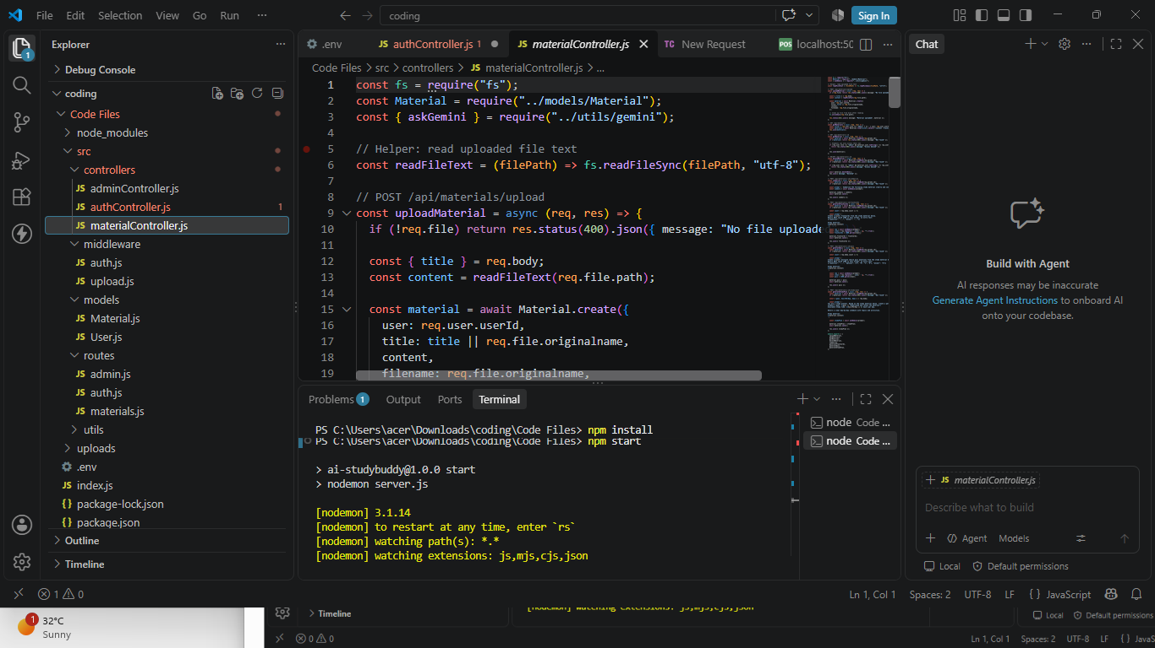
6. API Implementation
The project uses RESTful APIs to communicate with the backend. API requests contain the required student or study-related input data, and the backend processes the request and returns a JSON response.
- HTTP methods such as GET and POST are used according to the implemented API.
- Request data is sent in JSON format where required.
- The backend validates the required input.
- The API returns a response indicating success or failure.
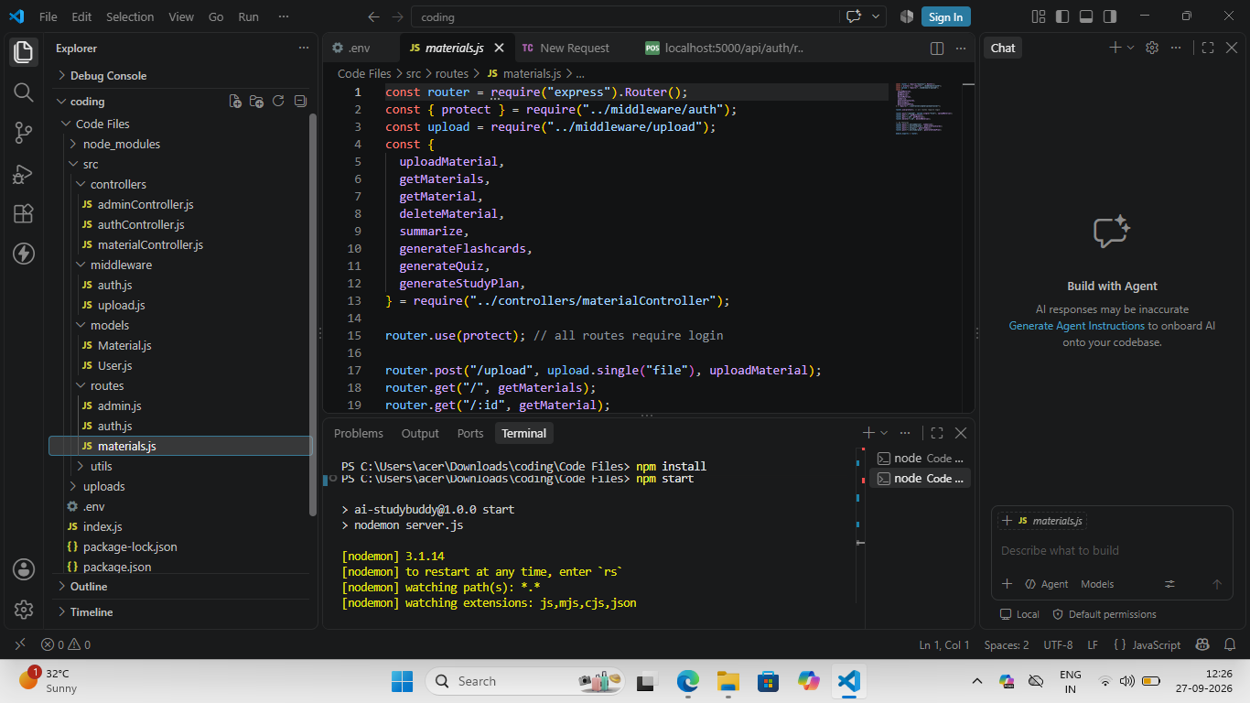
7. AI-Powered Study Assistance
The AI StudyBuddy feature accepts study-related information provided by the user. The backend processes the required information and sends it to the AI service where applicable. The AI functionality then returns personalized study assistance, recommendations, or other study-related responses.
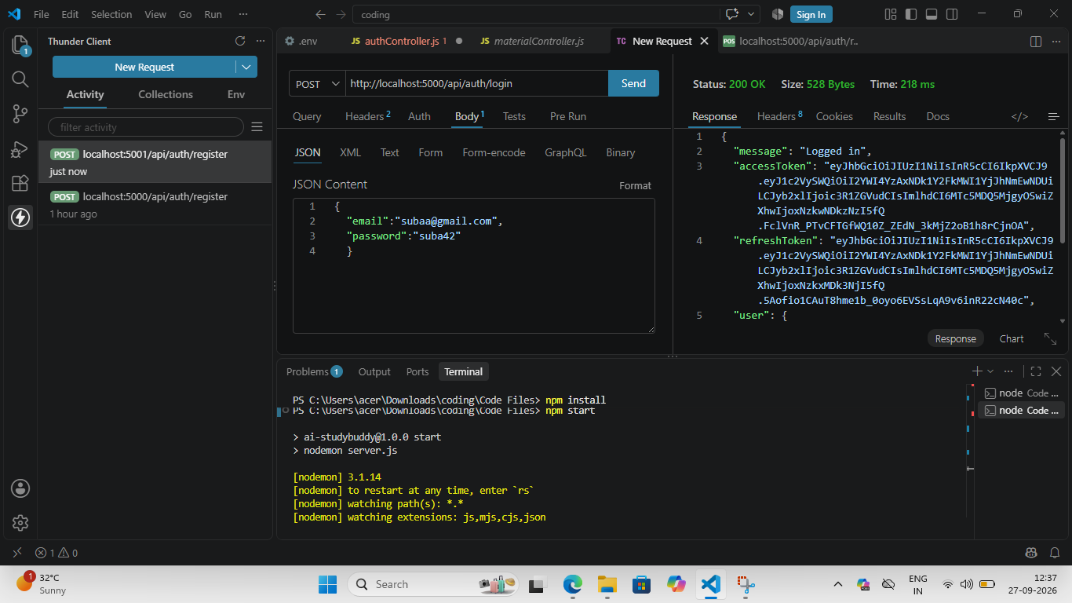
8. API Testing Using Thunder Client
Thunder Client is used to test the implemented APIs. Each request is checked by providing the required input and verifying the JSON response returned by the backend.
For each API screenshot, make sure the screenshot clearly shows the HTTP method, API URL, request body (if applicable), and response.
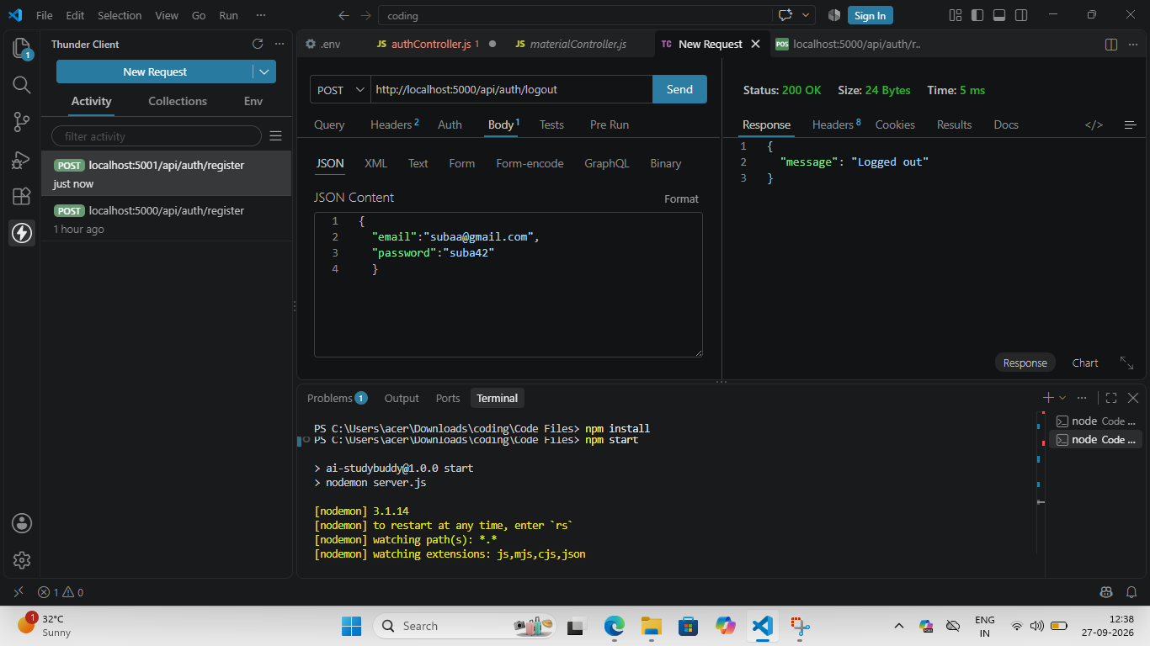
9. Successful Output
The completed API requests return the expected JSON responses. The successful AI StudyBuddy request demonstrates that the backend receives study-related information, processes it, and returns an AI-generated or study-related response.
10. Error Handling
The backend also handles invalid or incomplete requests by returning an appropriate error response. This helps identify missing or incorrect input during API testing.
11. Result
The AI StudyBuddy project was implemented and tested successfully. The backend APIs can receive requests, process the required study-related data, and return JSON responses. The AI StudyBuddy feature provides personalized study assistance based on the information supplied by the user.
12. Conclusion
AI StudyBuddy demonstrates the development and testing of a backend study assistance application with AI-powered functionality. The project provides a structured API-based approach for processing study information and generating useful personalized responses.
13. Future Enhancements
- Add more AI-powered study features.
- Add personalized study timetable generation.
- Add quiz and practice-question generation.
- Add progress tracking and performance analysis.
- Develop a user-friendly frontend application.
Screenshot Checklist
- Project / folder screenshot
- VS Code / project files screenshot
- Project workflow or server-running screenshot
- API code / route screenshot
- AI StudyBuddy Thunder Client request and response screenshot
- Thunder Client API testing screenshot
- Successful final output screenshot
- Error response screenshot (optional)
Note: Insert your own screenshots in the marked places. Use only screenshots that belong to your actual AI StudyBuddy project.

