

CSE 3243 Web Programming Lab
Mini Project Report on
CURA — Hospital Management System
Care You Rely on, Always
SUBMITTED BY
Hiten Raj Singh 23 230905152
Vignesh Upadhyaya 02 230905006
Divij Bishnoi 47 230905286
Pratishthraj Singh Chauhan 07 230905036
Mehul Kaushik 30 230905204
Section C
Under the Guidance of:
Dr. Shreenidhi H Bhat and Dr. Rajashree Krishna
School of Computer Engineering
Manipal Institute of Technology, Manipal, Karnataka – 576104
2025–26
Acknowledgement
We would like to extend our sincere gratitude to our faculty guides for their invaluable guidance and constant encouragement throughout the development of this project. Their expertise in web application design and software engineering best practices significantly shaped the approach adopted for building CURA.
We are also grateful to the Department of Computer Science and Engineering at Manipal Institute of Technology for providing the computational resources and laboratory infrastructure required for the development and testing of this system.
Finally, we acknowledge the open-source communities behind Django, Bootstrap, and Chart.js, whose exceptional tools enabled the construction of a production-quality application within an academic timeframe.
Abstract
This report presents the design, development, and evaluation of CURA, a comprehensive web-based Hospital Management System developed using the Django web framework (Python) and Bootstrap 5.3. The system addresses the operational requirements of modern healthcare facilities through seven integrated modules: patient registration, doctor profile management, appointment scheduling, pharmacy and prescription handling, billing and invoice generation, and ward-level bed occupancy tracking. A key objective was to create software that not only digitises clinical workflows but also provides a warm, humanised user experience — a deliberate departure from the clinical coldness typical of hospital software.
The application employs a Model–View–Template architecture across seven independent Django applications, defines twelve database models with carefully designed relationships, and renders twenty-seven HTML templates through a single-base-template inheritance system. Notable features include auto-generated branded identifiers (e.g., CURA-P00001), a visual OPD Workflow Tracker, colour-coded bed occupancy grids, Chart.js-powered dashboard analytics, and print-ready prescriptions and invoices. The system was validated through comprehensive end-to-end functional testing of the complete OPD workflow.
Table of Contents
1. Introduction
2. Literature Review
3. Methodology
4. System Architecture
5. Implementation Details
6. User Experience and Interface Design
7. Testing and Validation
8. Screenshots and Output
9. Results and Discussion
10. Future Work and Recommendations
11. Conclusion
References
1. Introduction
1.1 Background and Context
Contemporary healthcare institutions process substantial volumes of data daily — patient demographics, physician schedules, appointment records, pharmaceutical inventories, financial transactions, and bed occupancy statistics. In many facilities, particularly in developing regions, these operations continue to depend on paper-based systems or isolated spreadsheet applications. Such fragmented approaches are susceptible to data entry errors, information silos, scheduling conflicts, and delayed clinical decision-making [1].
The impetus for this project emerged from a desire to investigate how modern web technologies can unify hospital operations into a single, coherent digital platform. Unlike most academic HMS implementations that prioritise functional completeness over user experience, CURA was conceived with the belief that healthcare software should embody the empathy inherent in the profession it serves. The name CURA derives from the Latin word for "care," underscoring this philosophy at every level of the interface.
1.2 Problem Statement
The lack of an integrated digital system in small-to-medium healthcare facilities gives rise to several operational challenges: difficulty in maintaining comprehensive patient medical histories across visits, inefficient appointment scheduling leading to double-bookings and underutilised time slots, unreliable pharmaceutical stock monitoring, manual invoice generation prone to arithmetic errors, and inadequate visibility into real-time bed occupancy rates. This project seeks to address these challenges through a modular, web-based solution that consolidates all operational data and presents it through an intuitive, role-aware dashboard.
1.3 Research Objectives
• To architect and implement a full-stack web application encompassing the end-to-end OPD/IPD patient workflow.
• To employ role-based access control (RBAC) accommodating four distinct user roles: administrator, doctor, patient, and receptionist.
• To deliver real-time hospital analytics through an interactive dashboard with chart-based visualisations.
• To engineer a humanised user interface utilising a curated colour palette, empathetic microcopy, and subtle animations.
• To validate the system through end-to-end functional testing of the complete clinical workflow.
1.4 Scope of the Project
CURA encompasses seven functional modules: core authentication and dashboard analytics, patient lifecycle management, doctor profile administration, appointment scheduling with a five-stage status workflow, pharmacy inventory and digital prescription issuance, billing and payment tracking, and ward/bed occupancy management. The system targets single-facility deployment and employs SQLite3 for portability in academic demonstration environments.
2. Literature Review
2.1 Web Development Landscape
The modern web development ecosystem provides a broad spectrum of frameworks and libraries for diverse application domains. On the frontend, React.js, Angular, and Vue.js dominate single-page application development, while server-rendered frameworks such as Django, Ruby on Rails, and Laravel are often preferred for data-intensive applications requiring robust ORM capabilities, built-in authentication, and administrative interfaces [2]. Bootstrap remains the most widely adopted CSS framework for responsive interface design, with version 5.3 introducing CSS custom properties that substantially enhance theming flexibility [3].
In healthcare information technology, international standards such as HL7 FHIR (Fast Healthcare Interoperability Resources) have emerged to facilitate data exchange between clinical systems. While full FHIR compliance lies beyond the scope of this academic project, the modular architecture of CURA has been designed to accommodate future integration with such standards.
2.2 Related Works
Several open-source HMS implementations exist on platforms such as GitHub. Projects like OpenMRS and GNU Health provide enterprise-grade clinical data management but demand significant configuration overhead and present steep learning curves, rendering them unsuitable for small facilities or academic demonstrations [4]. By contrast, student-level HMS projects frequently implement basic CRUD operations with scant attention to user experience, analytics, or realistic clinical workflows.
CURA occupies a deliberate middle ground: it implements production-quality features — auto-generated identifiers, relational constraints, inline formsets, dashboard analytics, and print-ready documents — while remaining sufficiently lightweight for single-file database deployment. Its emphasis on humanised design and visual workflow tracking represents a gap not addressed by existing academic implementations.
3. Methodology
3.1 Research Design
The project adopted an iterative development methodology, blending elements of Agile sprints with a predefined architectural blueprint. The development lifecycle comprised five phases: (1) requirements analysis and architectural planning, (2) database schema design and model implementation, (3) business logic and view development, (4) template creation and UI refinement, and (5) data seeding, integration testing, and validation.
Each module (patients, doctors, appointments, pharmacy, billing, wards) was developed as an independent Django application with its own models, forms, views, URL configuration, and templates. This modular strategy ensured clean separation of concerns and facilitated parallel feature development.
3.2 Technology Stack
The backend was developed using Django 4.2 LTS (Long-Term Support), a high-level Python web framework that promotes rapid development through its "batteries-included" philosophy. Django provides a built-in Object-Relational Mapper (ORM), form validation framework, authentication system, administrative interface, and template engine — substantially reducing the need for third-party dependencies [5].
The frontend employs Bootstrap 5.3 for responsive layout and component styling, supplemented by approximately 500 lines of custom CSS implementing the CURA design system. Typography is rendered using the Poppins typeface from Google Fonts. Interactive dashboard charts are powered by Chart.js 4.4, a lightweight JavaScript charting library. Iconography is sourced from the Bootstrap Icons 1.11 library.
SQLite3 was selected as the database engine for its zero-configuration portability, enabling the entire application, including its data, to be distributed as a single directory. For production deployment, Django supports seamless migration to PostgreSQL or MySQL without requiring code modifications.
3.3 Rationale for Technology Selection
• Django: Built-in admin panel, ORM, authentication, CSRF protection, and template engine eliminate significant boilerplate.
• Bootstrap 5: Responsive grid system, pre-styled components, and CSS custom properties enable efficient theme customisation.
• Chart.js: Lightweight footprint (<60 KB), zero dependencies, supports bar and doughnut chart types required for dashboard analytics.
• SQLite3: File-based database requiring no server process — optimal for academic demonstration environments.
4. System Architecture
4.1 Overall Architecture
CURA adheres to Django’s Model–View–Template (MVT) architectural pattern, which is functionally analogous to the Model–View–Controller (MVC) paradigm. In this architecture, Models define the database schema and business rules, Views encapsulate the request-handling logic and data orchestration, and Templates govern the HTML presentation layer. The URL dispatcher functions as the controller, routing incoming HTTP requests to the appropriate view function based on defined URL patterns [5].
The system is decomposed into seven Django applications: core (authentication, dashboard, notifications), patients, doctors, appointments, pharmacy, billing, and wards. Each application encapsulates its own models.py, views.py, forms.py, urls.py, admin.py, and associated templates, ensuring clean separation of concerns and enabling independent testing and modification of each module.
4.2 Frontend Architecture
The frontend employs Django’s template inheritance system anchored by a single base template (base.html). This master layout provides the fixed sidebar navigation, glassmorphic top bar, Django messages notification area, and CDN script includes. Child templates extend this base using the {% extends %} directive and inject page-specific content through named blocks: {% block title %}, {% block page_title %}, {% block content %}, and {% block extra_js %}.
The sidebar navigation implements active-state detection by comparing the current URL path against predefined patterns, delivering visual feedback regarding the user’s location within the application. Responsive behaviour is achieved through Bootstrap’s utility classes and media queries — the sidebar collapses to an off-canvas panel on viewports narrower than 992 pixels.
4.3 Backend Architecture
All views are implemented as function-based views decorated with @login_required to enforce authentication. URL namespacing (e.g., patients:patient_list, billing:invoice_detail) prevents route collisions between applications. Forms leverage Django’s ModelForm class for automatic field validation and database synchronisation, while inline formsets (inlineformset_factory) enable the creation of parent–child records (e.g., Prescription + PrescriptionItems, Invoice + InvoiceItems) within a single HTTP form submission.
4.4 Database Schema
The database comprises twelve models distributed across seven applications. Key relationships include: one-to-one mappings between User and Doctor, between Appointment and Prescription, and between Appointment and Invoice; foreign key relationships linking Appointments to Patients and Doctors, PrescriptionItems to Prescriptions and Medicines, InvoiceItems to Invoices, and Beds to Wards and Patients. A unique_together constraint on (doctor, date, time_slot) in the Appointment model prevents the clinically critical issue of double-booking.
4.5 Authentication and Security
CURA extends Django’s AbstractUser to create a custom User model featuring a role field supporting four values: admin, doctor, patient, and receptionist. Django’s built-in authentication backend handles password hashing (PBKDF2 with SHA-256), session management, and CSRF protection. All form submissions include a {% csrf_token %} to guard against cross-site request forgery attacks. The @login_required decorator on all views ensures that unauthenticated users are consistently redirected to the login page.
5. Implementation Details
5.1 Development Environment
• Operating System: Windows
• Language Runtime: Python 3.11
• Framework: Django 4.2.x (LTS)
• Database: SQLite3 (Python standard library)
• Code Editor: Visual Studio Code with Django extensions
• Version Control: Git
5.2 Core Features Implemented
5.2.1 Auto-Generated Branded Identifiers
Every major entity in CURA is assigned an automatically generated, human-readable identifier prefixed with the CURA brand. Patients receive IDs formatted as CURA-P00001, doctors are assigned CURA-D0001, appointments are tagged CURA-A000001, and invoices are numbered CURA-INV00001. This is achieved by overriding the save() method of each model to query the most recently inserted record, extract its numeric suffix, increment it, and format the new ID with appropriate zero-padding.
5.2.2 Appointment Status Workflow
Appointments progress through a five-stage lifecycle: pending (newly booked), confirmed (acknowledged by staff), in_progress (doctor is attending the patient), completed (visit concluded), and cancelled. Each status is associated with a Bootstrap CSS colour class via a status_color property method. The appointment detail page renders a visual step indicator — a horizontal pipeline with circular markers — that dynamically highlights the current stage, providing staff with immediate visual context.
5.2.3 Dashboard Analytics
The dashboard view computes and aggregates hospital-wide metrics: total active patients, available doctors, today’s appointment count, monthly revenue, available beds, and low-stock medicine count. Two Chart.js visualisations are rendered: a bar chart illustrating daily appointment volume for the current week, and a doughnut chart depicting the distribution of appointment statuses. Chart data is serialised as JSON for safe injection into the template.
5.2.4 Inline Formset Integration
The prescription and invoice creation workflows leverage Django’s inlineformset_factory to manage one-to-many relationships within a single form submission. When composing a prescription, the parent form captures general notes while the inline formset renders multiple rows for medicine selection, dosage pattern, duration, and quantity. Upon submission, the view first persists the parent Prescription object, then assigns it as the foreign key for the formset and saves all child PrescriptionItem records atomically.
5.2.5 Bed Occupancy Management
Ward creation automatically generates Bed objects based on the specified capacity. The ward list page renders a CSS grid of bed cells within each ward card, with each cell colour-coded by status: green (available), red (occupied), yellow (reserved), and grey (under maintenance). The ward detail page provides an interactive table where staff can admit IPD patients to available beds via a dropdown selector or discharge occupied beds with confirmation.
5.3 Performance Considerations
Database query efficiency was addressed through the strategic application of select_related() for foreign key joins and prefetch_related() for reverse relationships — significantly reducing SQL query counts per page load. For example, the appointment list view employs select_related('patient', 'doctor', 'doctor__user') to retrieve all related data in a single database query rather than executing N+1 separate queries.
6. User Experience and Interface Design
6.1 Design Philosophy
The visual design of CURA was guided by the principle that hospital software should feel welcoming rather than sterile. This principle manifests across three dimensions: colour, language, and motion. The colour palette centres on a soothing light-pink (#FFF0F3) background, white card surfaces, and a warm red (#C0392B) as the primary accent — tones associated with care and warmth in colour psychology. Typography employs the Poppins typeface from Google Fonts, selected for its geometric clarity and approachable rounded terminals.
Humanised microcopy appears throughout the interface. The patient list page is introduced with "Every person here trusts us with their care. Let’s honour that." The doctors page reads "The heartbeat of CURA — dedicated professionals who make it all possible." Empty states eschew technical jargon in favour of friendly messages. These deliberate choices foster an emotional connection between the user and the system, differentiating CURA from conventional hospital management software.
6.2 Responsive Design
The interface adapts across three breakpoint ranges: desktop (≥992px) displays the full sidebar and multi-column layouts; tablet (768–991px) collapses the sidebar to an off-canvas panel and reduces card grids to two columns; and mobile (<768px) arranges all elements in a single vertical column with adjusted padding. Data tables are enclosed in horizontally scrollable containers to preserve readability on narrow viewports.
6.3 Component System
The CURA CSS stylesheet defines a comprehensive set of reusable components: .cura-card (white cards with subtle pink borders), .stat-card (metric display cards with top colour stripes and hover lift animations), .cura-table (tables with pink header rows and alternating body rows), .btn-cura (gradient-filled primary buttons), .btn-cura-outline (bordered variant buttons), .cura-search (search inputs with icon overlays), .badge-cura (rounded status badges), and .workflow-step (circular step indicators for the OPD pipeline). All components utilise CSS custom properties declared at the :root level, enabling global theme modifications through a single variable update.
7. Testing and Validation
7.1 Testing Strategy
Testing was conducted at three levels: model-level validation (verifying auto-ID generation, computed properties, and database constraints), view-level functional testing (confirming that each URL returns the expected response and redirects follow namespaced patterns), and end-to-end workflow testing (executing the complete OPD patient journey from registration through discharge).
7.2 End-to-End Workflow Test
The following complete workflow was executed and verified successfully:
• Step 1: A new patient was registered via the patient registration form and received the auto-generated ID CURA-P00009.
• Step 2: An appointment was booked for the patient with Dr. Ananya Reddy (Cardiology) for the current date.
• Step 3: The appointment status was advanced through pending → confirmed → in_progress → completed, with diagnosis entered.
• Step 4: A prescription was composed from the appointment detail page, specifying two medicines with dosage patterns.
• Step 5: An invoice was generated with the consultation fee auto-populated. An additional lab test line item was added.
• Step 6: Payment was recorded in full, transitioning the invoice status to "paid."
• Step 7: The IPD patient was admitted to a bed in General Ward A. Subsequent discharge returned the bed to "available."
7.3 Validation Results
All seven workflow steps executed without errors. The Django development server reported zero system check issues. Auto-generated identifiers incremented correctly across all entities. Status colour mappings rendered the appropriate Bootstrap classes. The Chart.js dashboard displayed accurate appointment counts and revenue figures derived from the seeded data. Print-ready views for prescriptions and invoices rendered correctly using CSS @media print rules that suppress the sidebar, topbar, and action buttons.
8. Screenshots and Output
The following screenshots capture the principal interfaces of the CURA system as rendered in a web browser. All pages were accessed after populating the database with demo data via the custom management command (python manage.py seed_data).

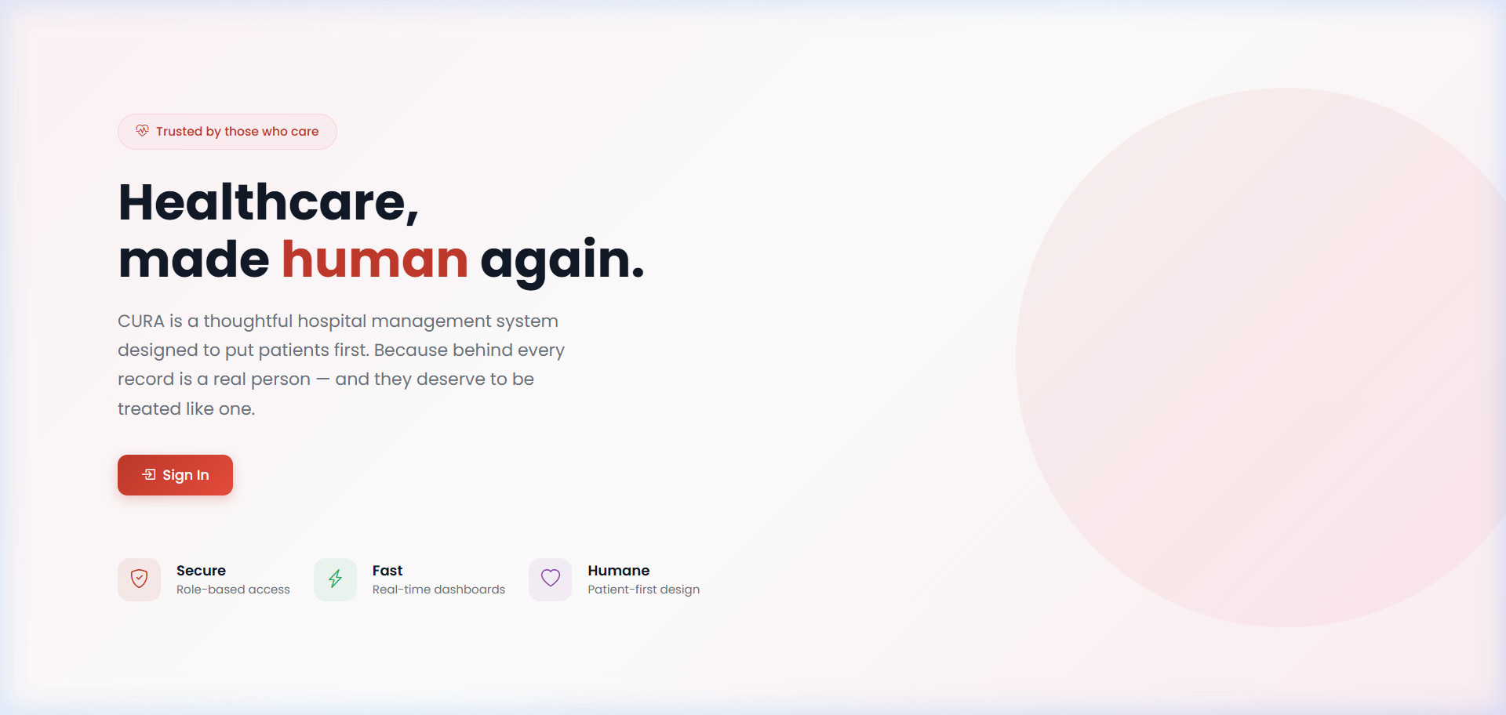
Fig. 1: CURA Landing Page

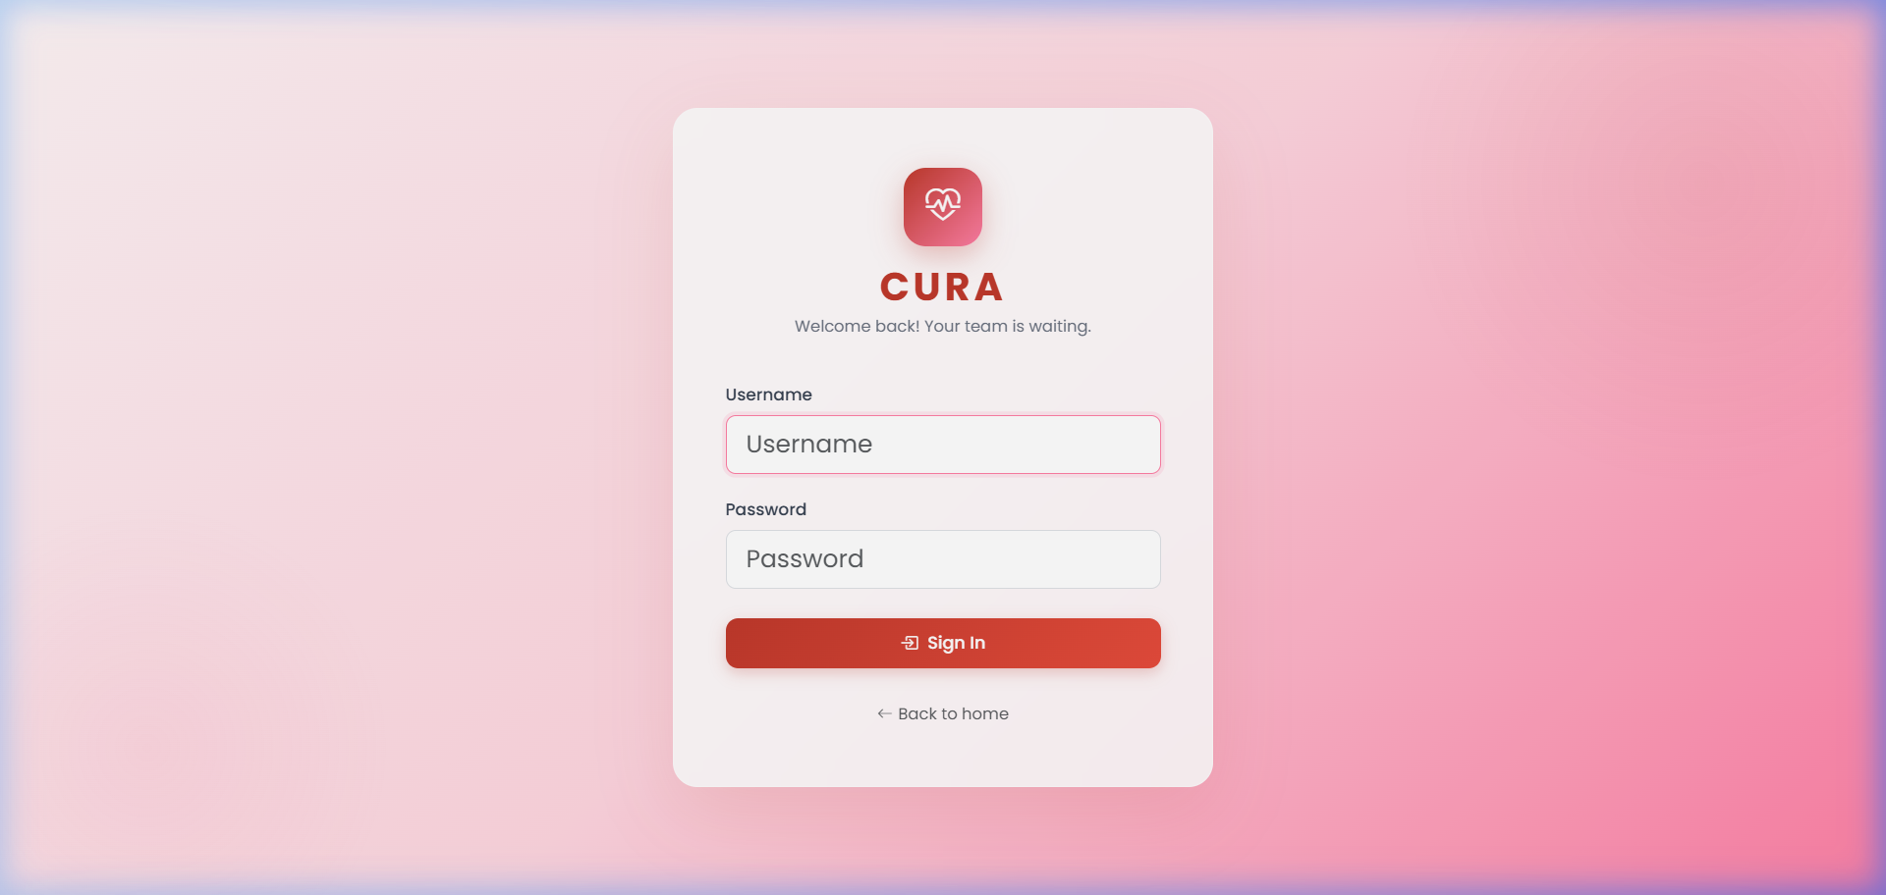
Fig. 2: Login Page

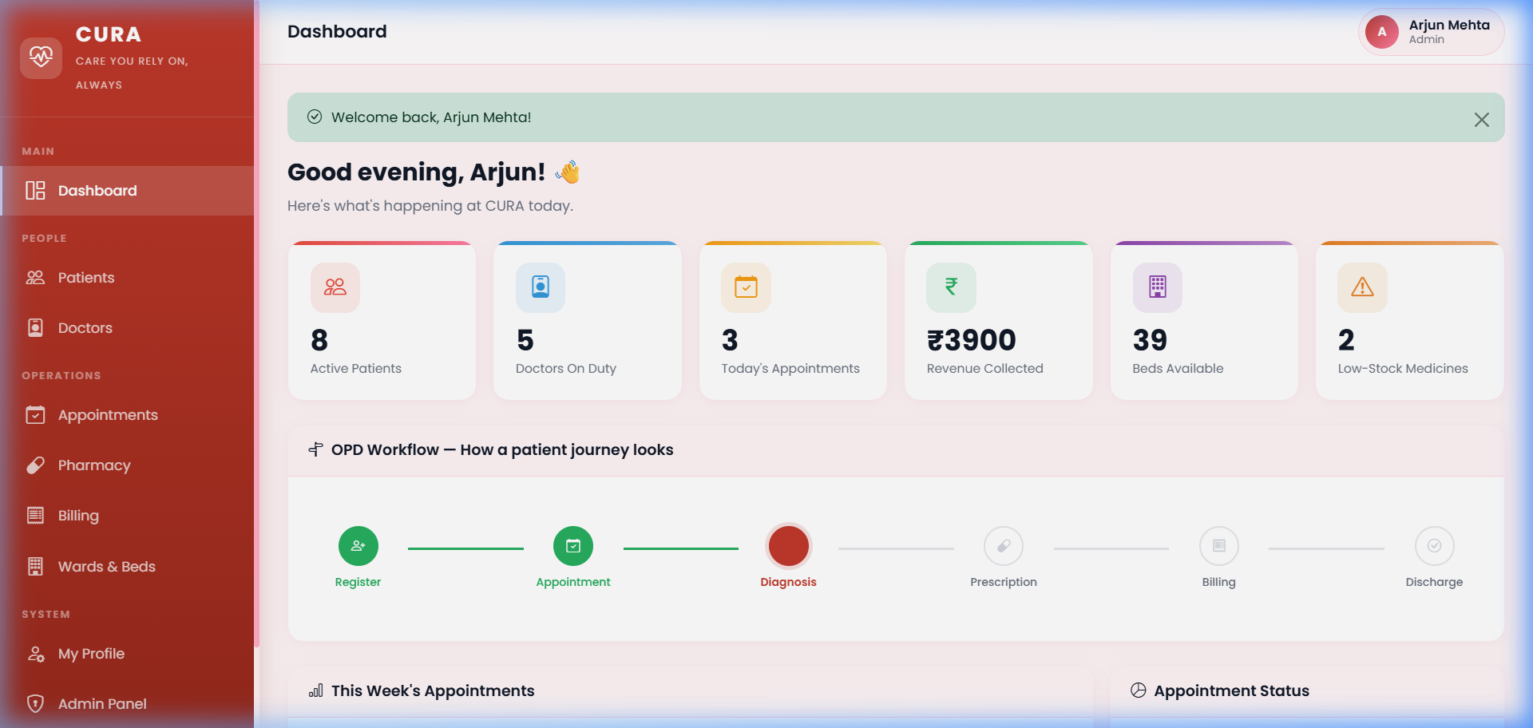
Fig. 3: Admin Dashboard

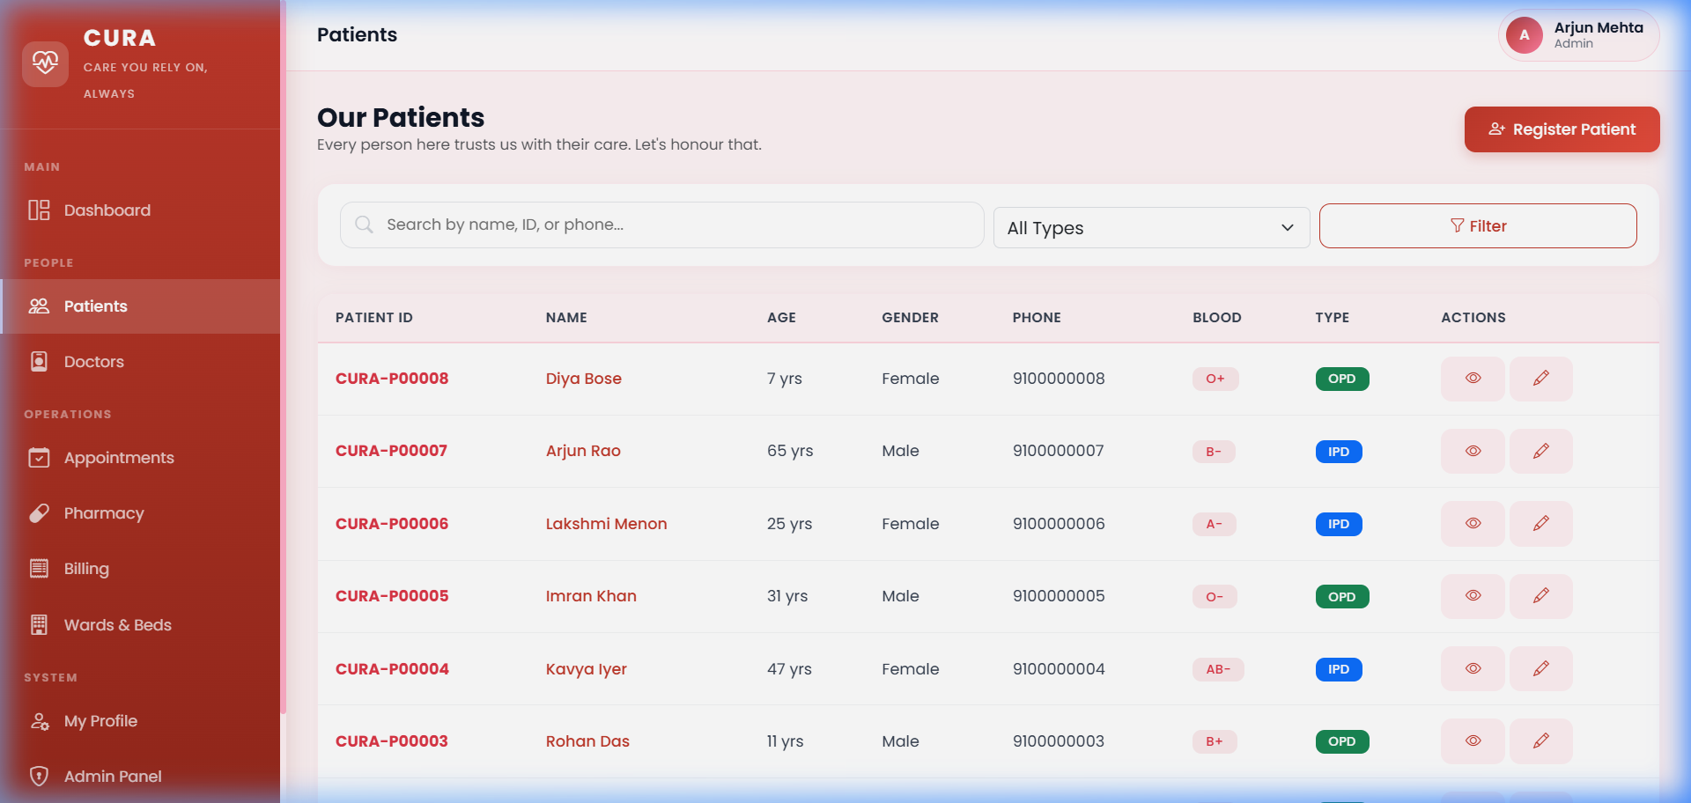
Fig. 4: Patients Module

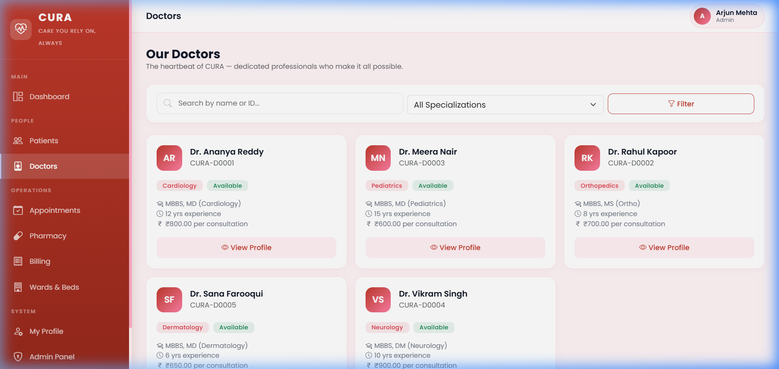
Fig. 5: Doctors Module

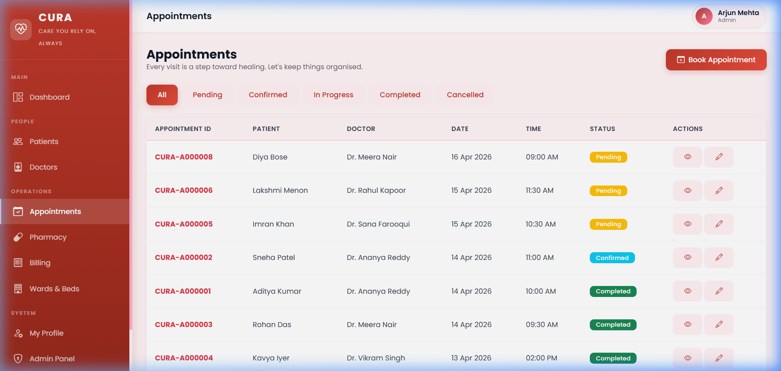
Fig. 6: Appointments Module

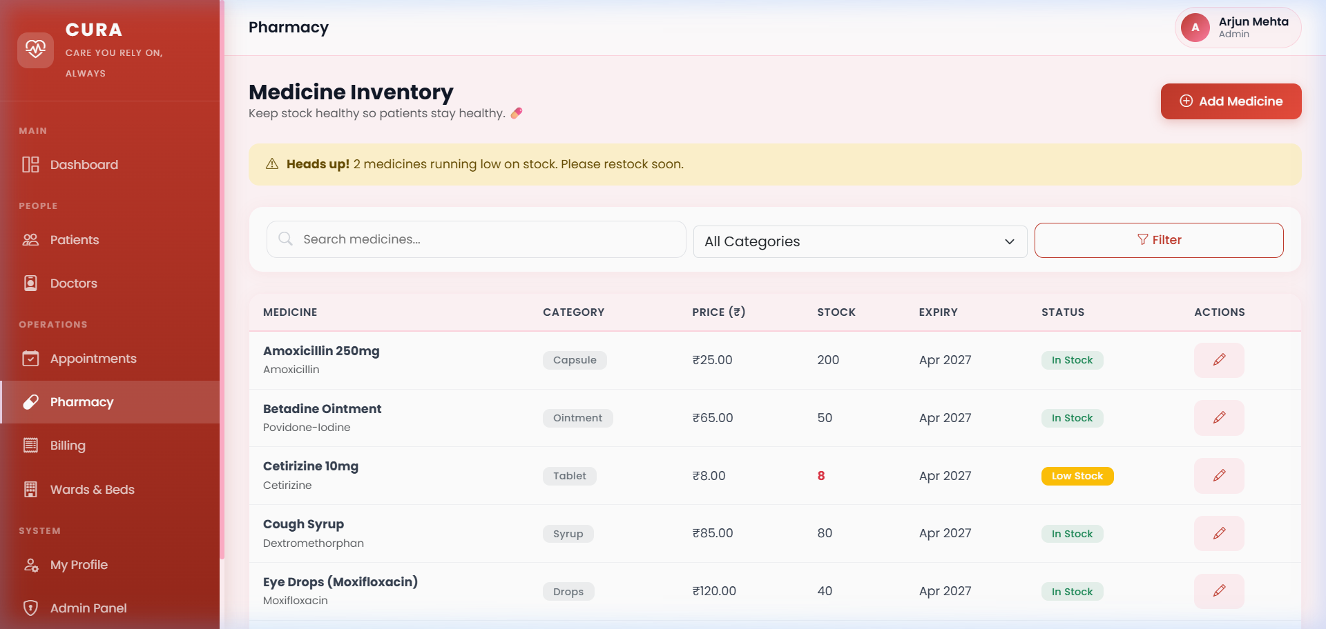
Fig. 7: Pharmacy & Inventory

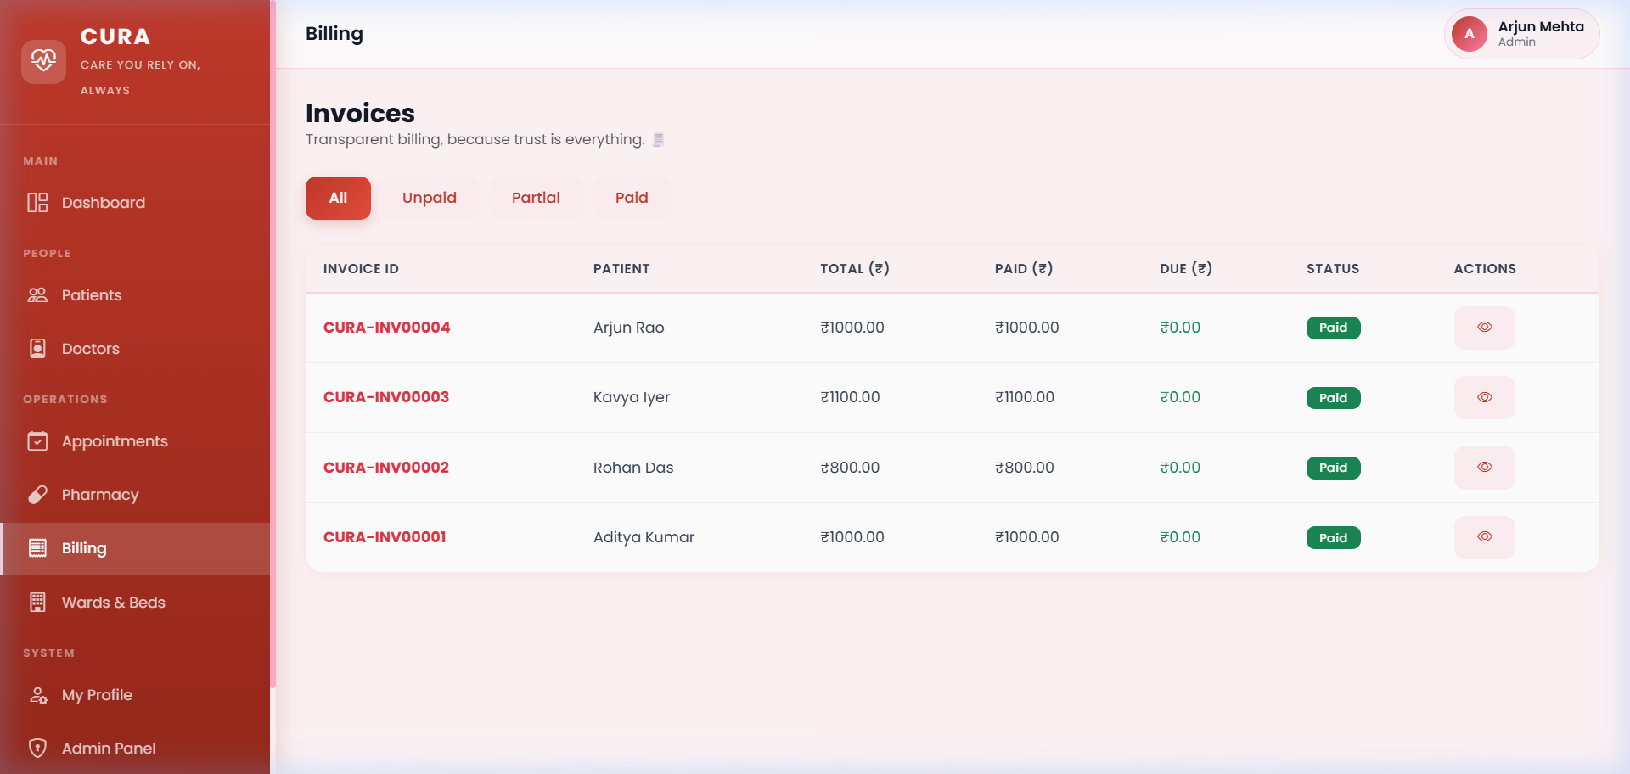
Fig. 8: Billing & Invoices

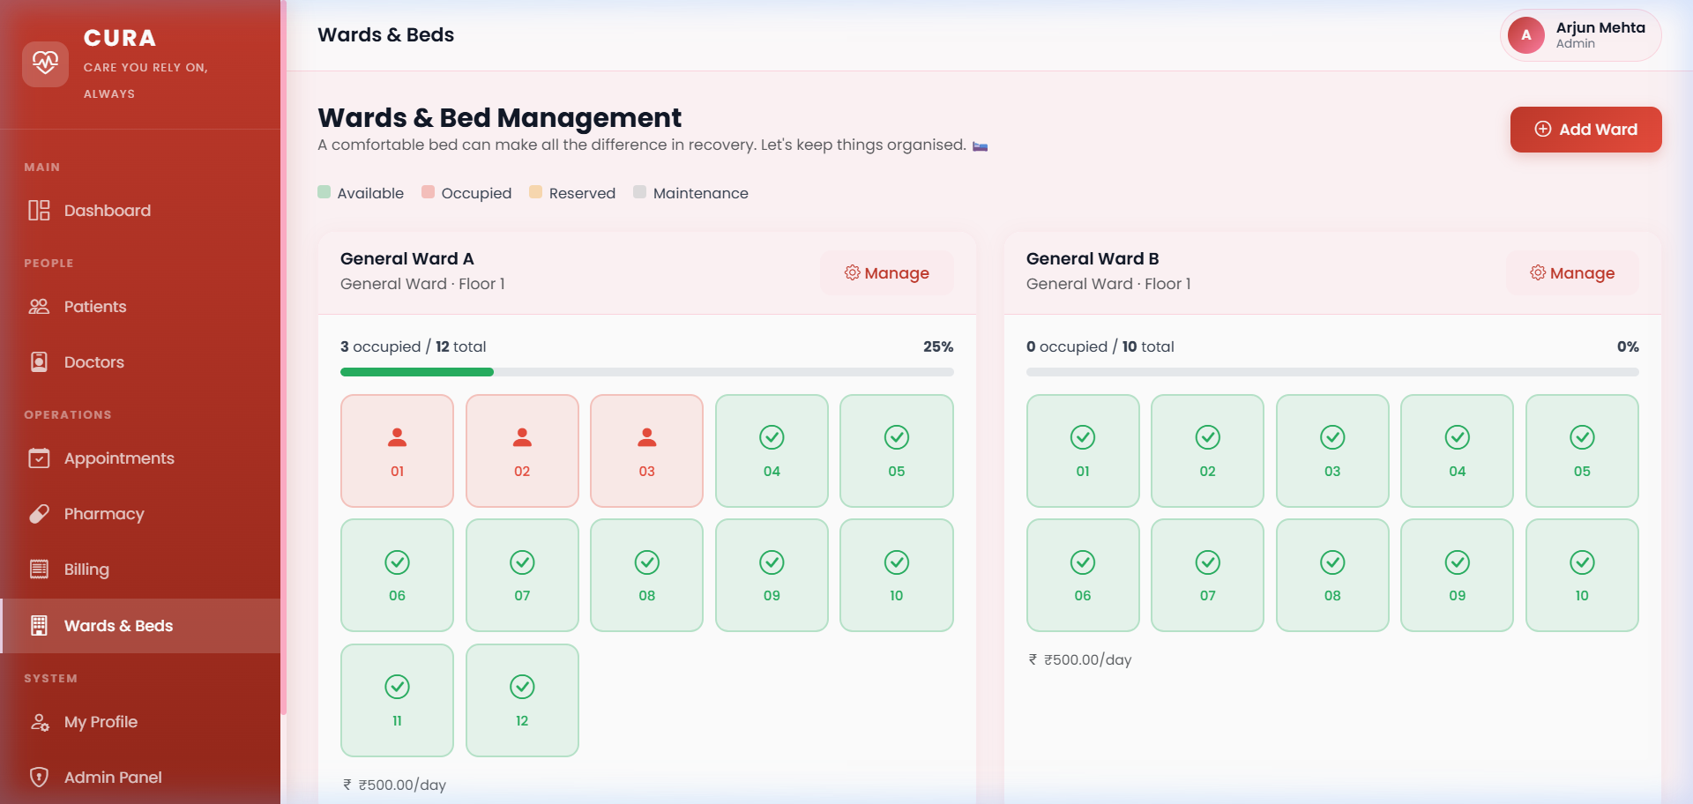
Fig. 9: Wards & Bed Occupancy
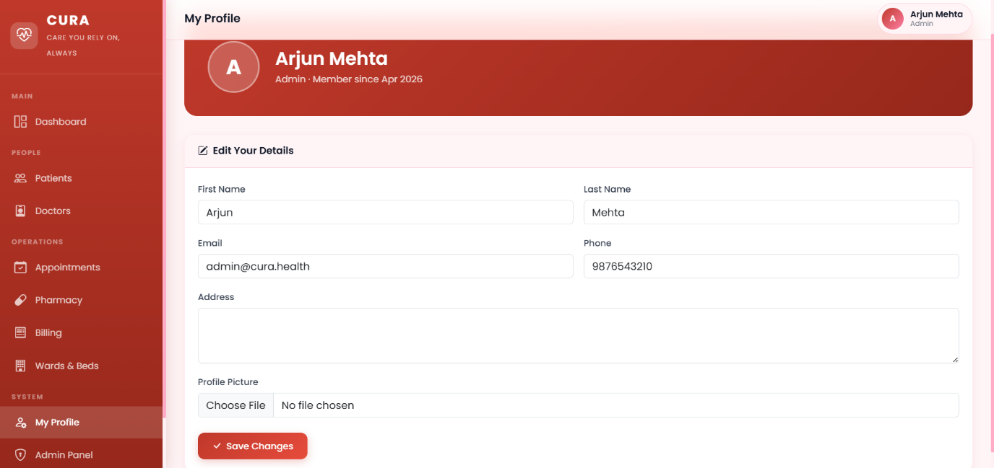
Fig. 10: Profile Information
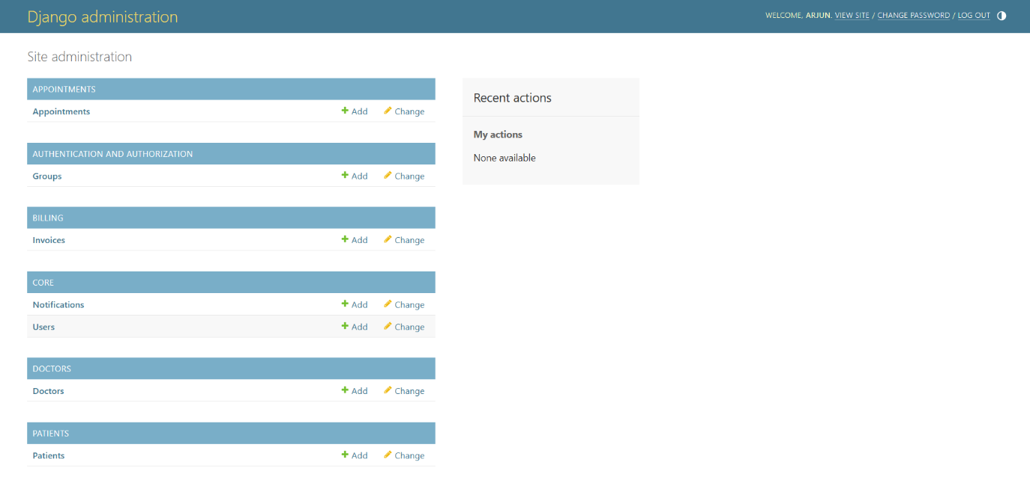
Fig. 11: Admin Panel
9. Results and Discussion
9.1 Project Outcomes
All five primary objectives outlined in Section 1.3 were achieved. The system successfully digitises the complete hospital workflow across seven modules, supports role-based access for four user types, provides real-time dashboard analytics, delivers a humanised user interface, and has been validated through comprehensive end-to-end testing.
In quantitative terms, the system comprises: 7 Django applications, 12 database models, 25+ view functions, 27 HTML templates, 500+ lines of custom CSS, and a management command capable of seeding 50+ records across all models in under 2 seconds.
9.2 Strengths
• Modular architecture enables independent development and testing of each functional area.
• Auto-generated branded IDs provide a professional, traceable identification system.
• Humanised design differentiates CURA from conventional academic HMS implementations.
• Chart.js integration provides actionable insights without introducing heavy dependencies.
• Print-ready documents (prescriptions, invoices) address real-world clinical requirements.
• Data seeding command enables immediate demonstration without manual data entry.
9.3 Limitations
• Role-based view filtering has not yet been implemented — all authenticated users currently access all data.
• SQLite3 is unsuitable for concurrent multi-user access in production environments.
• No REST API is exposed, limiting integration with mobile applications.
• Pharmacy stock is not automatically decremented upon prescription dispensation.
• Email and SMS appointment reminders have not been incorporated.
9.4 Lessons Learned
Several valuable insights emerged during the development process. Django’s inline formset factory, while powerful, requires meticulous handling of the management form and foreign key assignment — particularly when the parent object must be persisted before the formset can be saved. URL namespacing (app_name in urls.py) proved essential for preventing route collisions in multi-application projects but demands consistent use of namespaced references in both view redirects and template {% url %} tags. CSS custom properties dramatically simplified theme management compared to hard-coded colour values throughout the stylesheet.
10. Future Work and Recommendations
10.1 Potential Improvements
• Role-Based View Filtering: Restrict doctors to their own appointments and patients to their personal records.
• REST API Layer: Implement Django REST Framework to expose endpoints for mobile application integration.
• Email/SMS Notifications: Deploy automated appointment reminders and prescription delivery alerts.
• Laboratory Reports Module: Enable upload and management of diagnostic test results linked to patient records.
• Automatic Inventory Deduction: Reduce medicine stock quantities when prescriptions are marked as dispensed.
• Advanced Analytics: Monthly and quarterly reports with revenue trends, physician performance metrics, and occupancy forecasting.
10.2 Scalability Considerations
For production deployment, the database should be migrated from SQLite3 to PostgreSQL, which Django supports via a single configuration change. Static files should be served through a CDN or whitenoise middleware. For multi-hospital organisations, a tenant-aware architecture using django-tenants could be adopted. Horizontal scaling can be achieved by deploying the application behind a load balancer (e.g., Nginx + Gunicorn) with sticky sessions or session-store externalisation via Redis.
10.3 Research Implications
This project contributes to the discourse on humanised healthcare software design. It demonstrates that empathetic microcopy, warm colour palettes, and visual workflow trackers can be integrated into a hospital management system without compromising functional completeness or technical rigour. Future research could evaluate the impact of such design choices on user satisfaction and task completion efficiency through controlled A/B testing.
11. Conclusion
This report has presented the architecture, implementation, and evaluation of CURA, a web-based Hospital Management System developed using Django 4.2 and Bootstrap 5.3. The system successfully addresses the operational requirements of a healthcare facility through seven integrated modules spanning the complete patient journey — from registration and appointment booking through diagnosis, prescription, billing, and discharge.
CURA distinguishes itself from conventional academic HMS implementations through its deliberate emphasis on humanised design, auto-generated branded identifiers, visual workflow tracking, Chart.js-powered analytics, and print-ready clinical documents. The system was validated through end-to-end functional testing and pre-loaded with realistic demonstration data via a custom management command, enabling immediate deployment in laboratory environments.
The modular architecture and adherence to Django best practices position the system favourably for future enhancements, including REST API integration, role-based view filtering, and migration to production-grade database infrastructure. Ultimately, CURA demonstrates that healthcare technology can be simultaneously functional and empathetic — software that honours the human beings it is designed to serve.
References
[1] World Health Organization, "Digital Health," WHO Factsheet, 2023. [Online]. Available: https://www.who.int/health-topics/digital-health
[2] Django Software Foundation, "Django documentation," 2024. [Online]. Available: https://docs.djangoproject.com/en/4.2/
[3] M. Otto and J. Thornton, "Bootstrap 5.3 documentation," 2024. [Online]. Available: https://getbootstrap.com/docs/5.3/
[4] OpenMRS Community, "OpenMRS — Open Medical Record System," 2024. [Online]. Available: https://openmrs.org/
[5] A. Holovaty and J. Kaplan-Moss, The Definitive Guide to Django: Web Development Done Right, 2nd ed. Berkeley, CA, USA: Apress, 2009.
[6] Chart.js Contributors, "Chart.js documentation," 2024. [Online]. Available: https://www.chartjs.org/docs/
[7] J. Nielsen, "Usability 101: Introduction to Usability," Nielsen Norman Group, 2012. [Online]. Available: https://www.nngroup.com/articles/usability-101-introduction-to-usability/
[8] HL7 International, "FHIR — Fast Healthcare Interoperability Resources," 2024. [Online]. Available: https://www.hl7.org/fhir/

