I added the table oid in a variable and invoked the log_open_file() and log_close_file() functions in both sel and join functions.

Variable to store oid in sel()

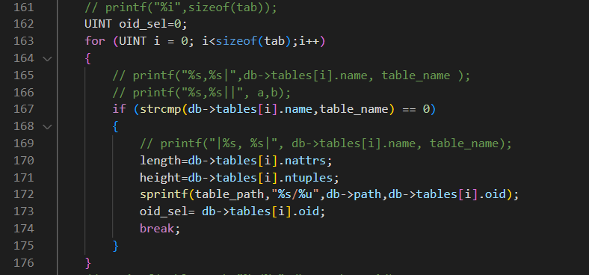

Invoking log_open_file()



Invoking log_close_file()



Variables to store oid in join()

Invoking log_open_file()

Invoking log_close_file()

