RBC Risk Analytics Project

Project Overview
This project analyzes client demographics and transaction behavior to identify potential financial risk patterns. Using two datasets (Clients and Transactions), a simple risk‑scoring model was created to flag high‑risk clients, high‑risk countries, and high‑risk transaction types. The goal is to simulate how a bank’s risk or AML team evaluates unusual activity.

Methodology (How the Analysis Works)
The analysis was performed in Python using Pandas.
Steps included:
- Loading the Clients and Transactions datasets
- Merging both datasets on client_id
- Creating a risk-scoring model based on:
- High‑value transfers
- International transactions
- ATM withdrawals
- ﻿﻿Aggregating total risk per client
- Summarizing risk by country and transaction type
This produced a ranked list of high-risk clients and patterns across regions and transaction types.

Key Insights & Finding
Top High-Risk Clients:
Clients 14, 12, 3, 45, 38, and 10 show the highest total risk scores.

Risk by Country:
USA shows the highest risk exposure, followed by India and the UK.

Risk by Transaction Type:
Transfers contribute the most to overall risk, followed by ATM withdrawals.

These patterns indicate that high-value international transfers are the primary drivers of risk in this dataset.

Visuals of Output

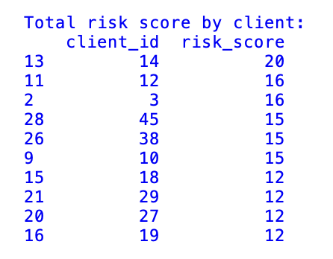

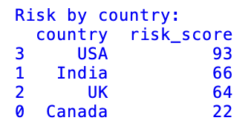
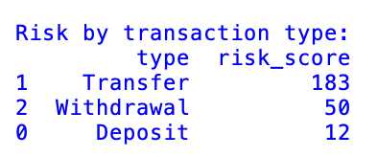

Conclusion
This analysis demonstrates how a simple risk‑scoring model can highlight unusual client behavior and potential financial risk patterns. By combining demographic data with transaction activity, the model identifies high‑risk clients, high‑risk countries, and high‑risk transaction types. These insights can support early detection of suspicious activity and help guide further investigation by risk or AML teams.

Next Steps/Future Work
- Add visual dashboards to better communicate risk patterns
- Incorporate more features such as transaction frequency, velocity, and device data
- Apply machine learning models (e.g., anomaly detection) for deeper insights
- Build an interactive interface for real‑time risk scoring
- Integrate alerts for high‑risk clients or transactions

Visual Dashboard
Figure 1 – Risk Score by Country
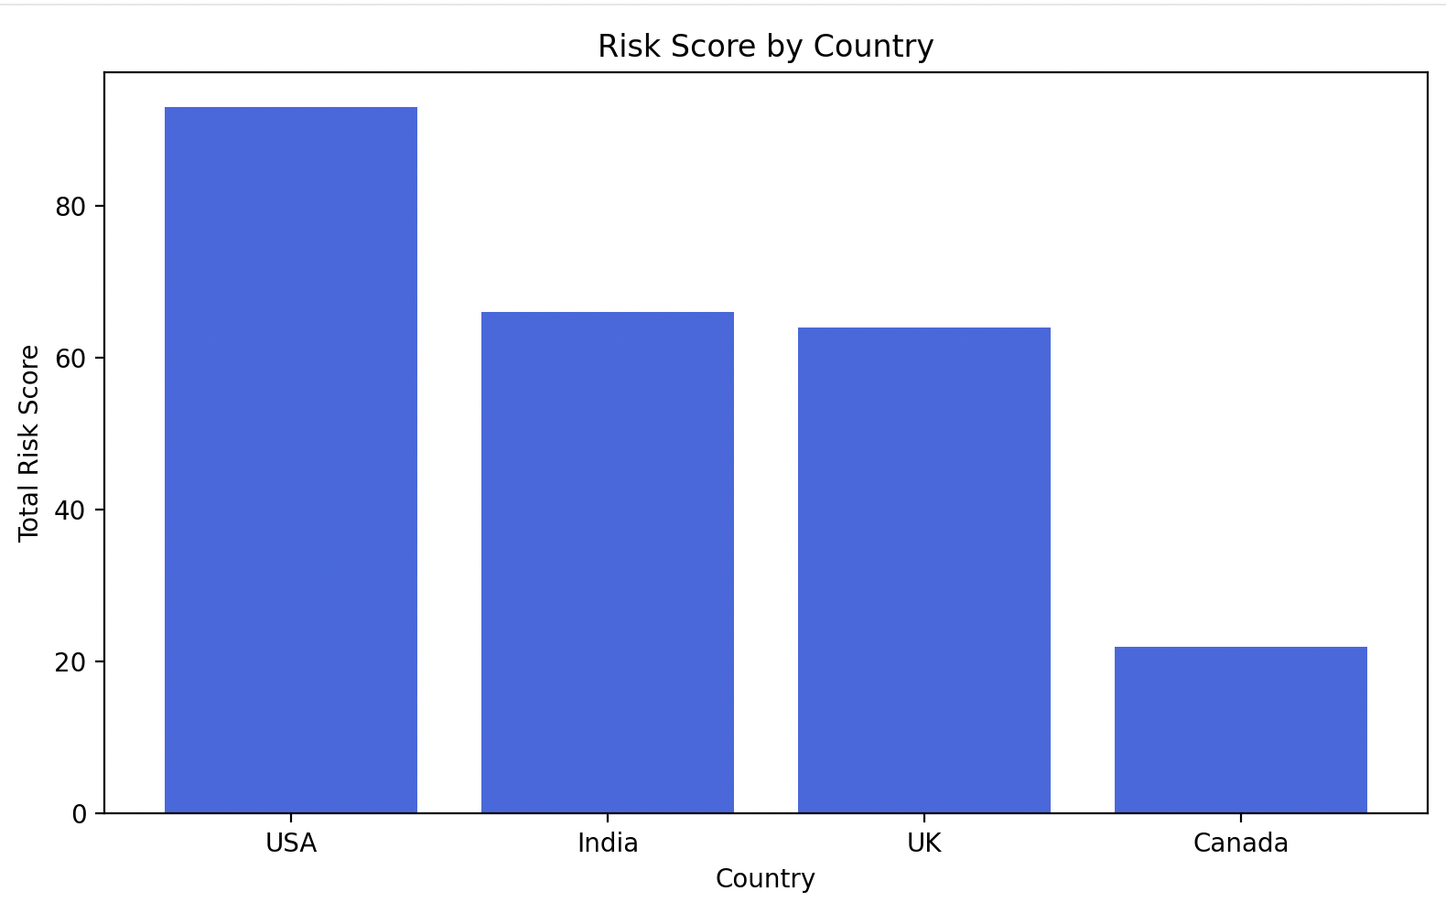
Figure 2 – Risk Score by Transaction Type
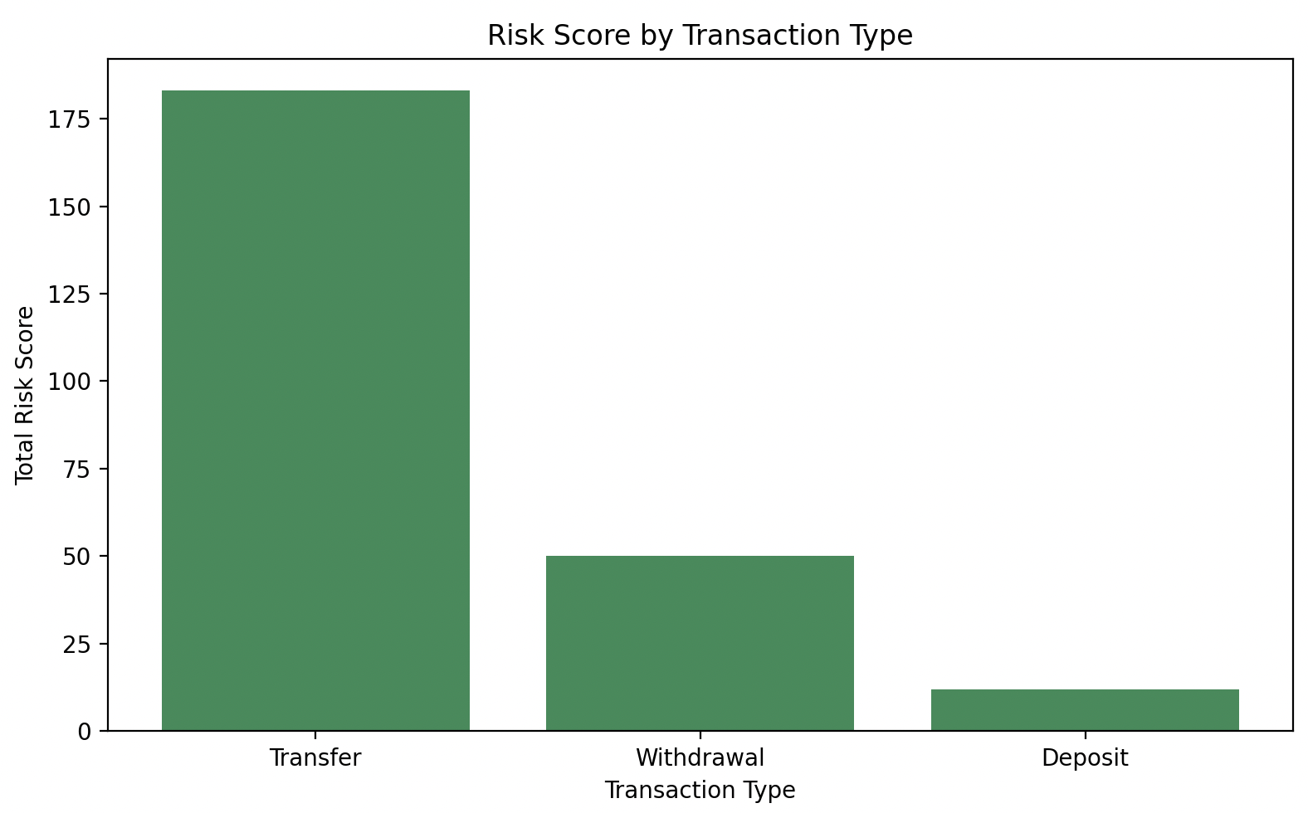

Figure 3 - Top 10 High‑Risk Clients
