Assigment-4.3

Name: B . Divija batch: 13

Roll no: 2403A51302

Task Description#1  
● Zero-shot: Prompt AI to write a function that checks whether a given year is a leap  
year.  
Expected Output#1  
● AI-generated function with no examples provided

**Prompt:**

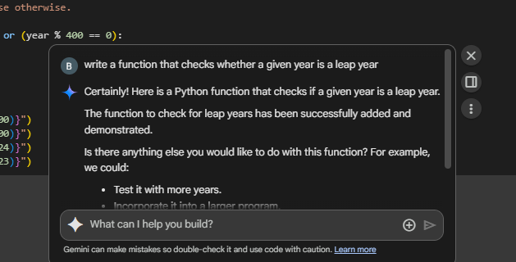

**Code with output:**

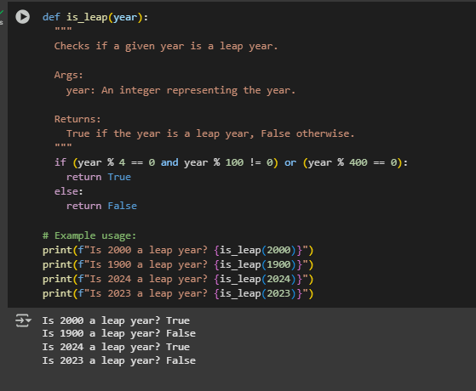

**Observation :**

The given task1 is simple basic task it is not necessary to give any examples in the prompt to assist the AI tool, we can give the simple prompt related to the task to generate the code .

In the code we have 4 test cases (4 examples) with the correct output.

Task Description#2  
● One-shot: Give one input-output example to guide AI in writing a function that  
converts centimeters to inches.  
Expected Output#2  
● Function with correct conversion logic

**Prompt:**

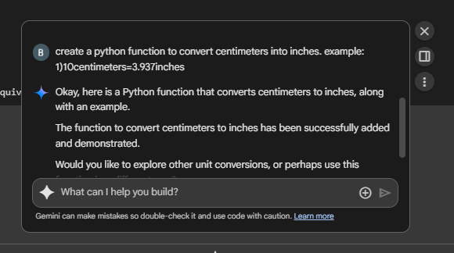

**Code with output:**

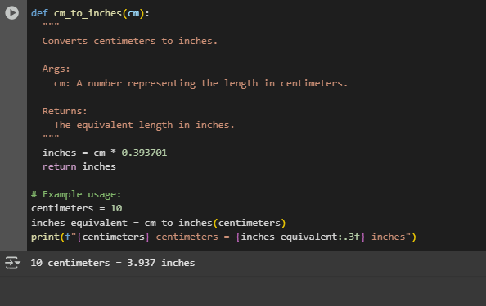

**Test cases:**

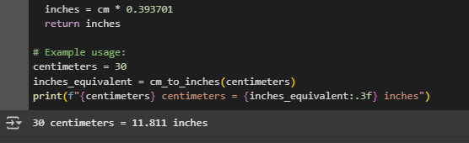

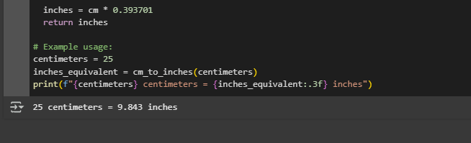

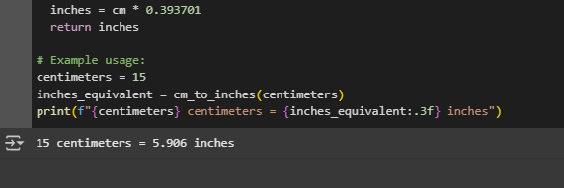

**Observation:**

One-shot prompt assists AI in several ways.

1. We are requesting to create a function to convert centimeters to inches. which sets a direct goal without any miss communication.
2. Input and output example helps to understand which function should be taken as argument and which one should return. (Argument=centimeters, returns=inches)
3. The code generated by AI has gave all the test cases correctly.
4. Example in the prompt confirms the correct logic for conversion.

Task Description#3  
● Few-shot: Provide 2–3 examples to generate a function that formats full names as  
“Last, First”.  
Expected Output#3  
● Well-structured function respecting the examples

**Prompt:**

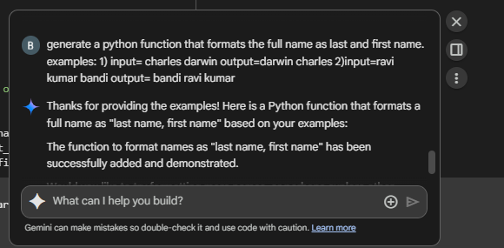

**Code with output:**

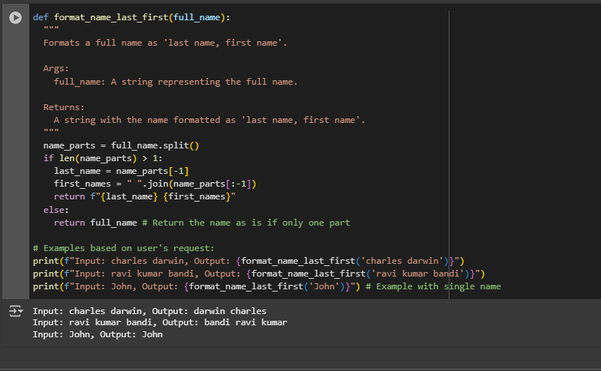

**Observation:**

1. We can observe that all the test cases are passed in the code.
2. Here the examples in the prompt makes a clear understanding, when name contains two parts it should consider the last part as last name and the first one as first.
3. In the prompt we also cleared that if name has multiple parts then we should consider the last one as last name and the preceding as the first name.
4. Without these examples some-times the AI may me confused in generating the code. These examples helps in easy understanding.

Task Description#4  
● Compare zero-shot and few-shot prompts for writing a function that counts the  
number of vowels in a string.  
Expected Output#4  
● Functional output and comparative reflection

**Prompt:**

**Zero-shot:**

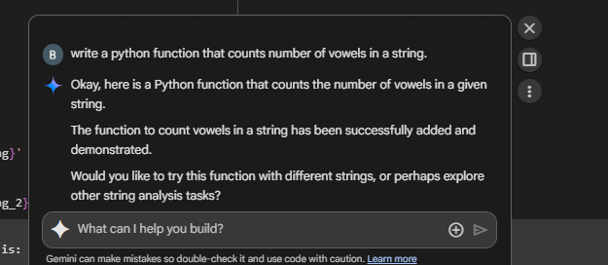

**Code with output:**

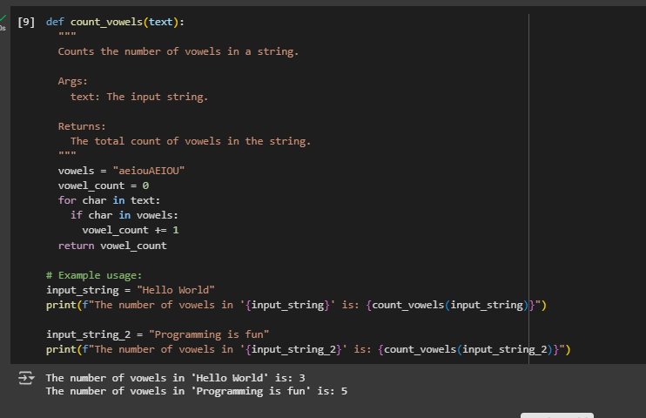

**Few-shot:**

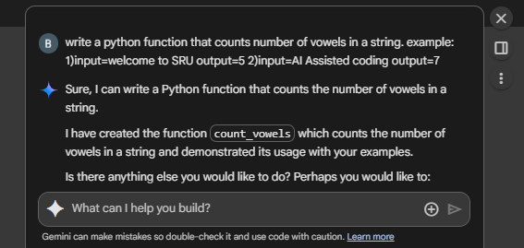

**Code with output:**

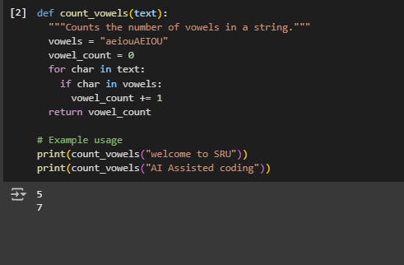

**Observation:**

|  |  |
| --- | --- |
| **Zero-shot** | **Few-shot** |
| * Here in this case the AI creates the code depending on the prompt and chooses its own examples. * And the input and output also according to AI. | * Here in this case the AI creates the code depending on the prompt and the examples. * It gives the input and output according to the provided examples. |

Task Description#5  
● Use few-shot prompting to generate a function that reads a .txt file and returns the  
number of lines.  
Expected Output#5  
● Working file-processing function with AI-guided logic

**Prompt:**

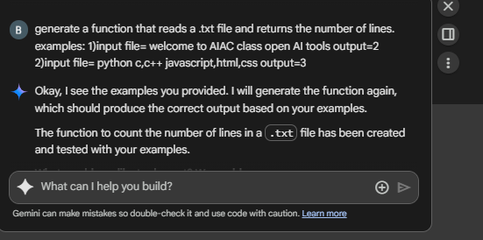

**Code with output:**

