**AIAC**

**Assignment 4.2**

**Name :** B. Divija **Batch:13**

**Branch: CSE**

**Task Description#1**

* **Zero-shot:** Prompt AI with only the instruction — Write a Python function to generate the Fibonacci sequence up to n terms

**Expected Output#1**

* A working function without using any sample inputs/outputs.

Prompt:

Write a Python function to generate the Fibonacci sequence up to n terms.

**Code:**

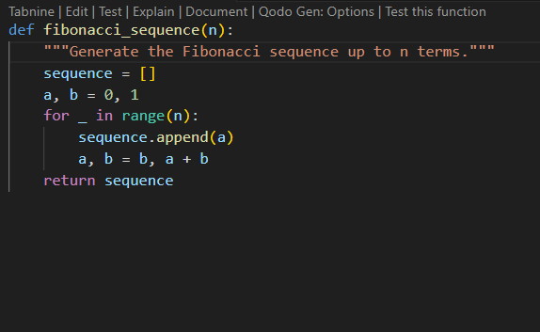

**Test case:**

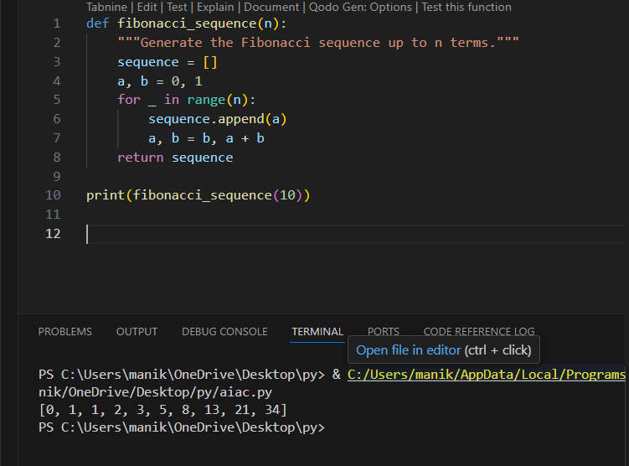

**Task Description#2**

* One-shot: Provide one example: Input: 100, Output: 37.78 to help AI generate a function that converts Fahrenheit to Celsius.

**Expected Output#2**

* A correct conversion function guided by the single example.

**Prompt:**

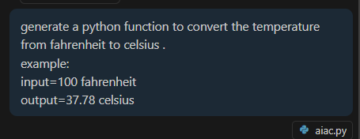

**Code with output:**

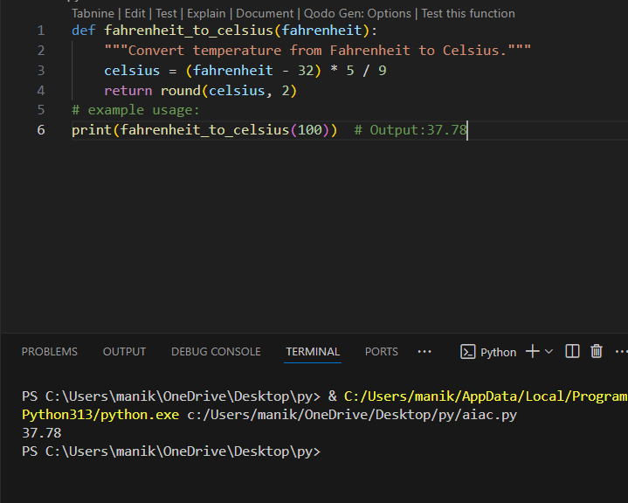

**Task Description#3**

* **Few-shot:** Give 2–3 examples to create a function that extracts the domain name from an email address.

**Expected Output#3**

* Accurate function that returns only the domain portion of an email (e.g., @gmail.com).

**Prompt:**

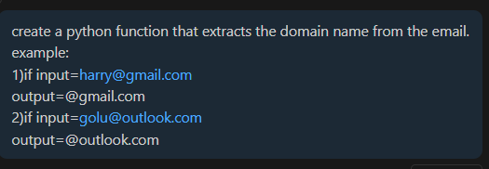

**Code with output:**

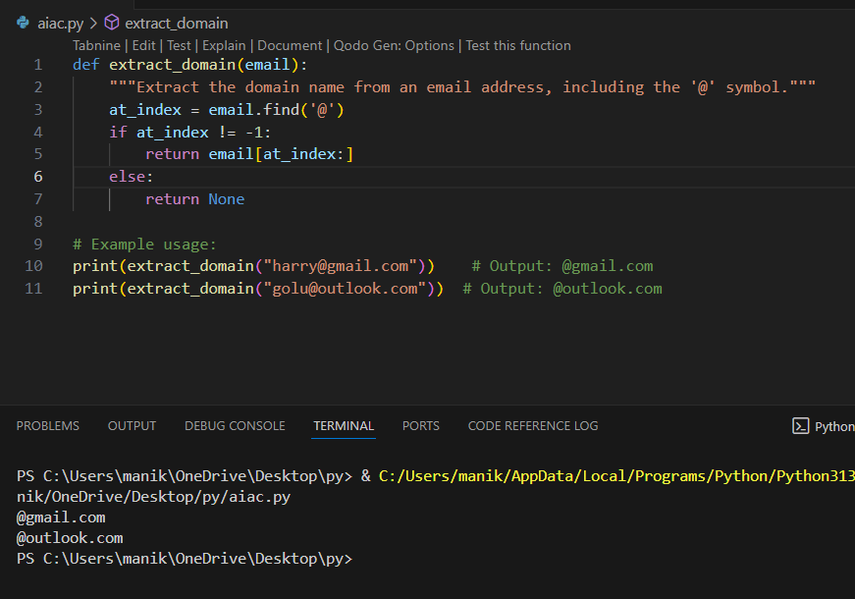

**Task Description#4**

* Compare zero-shot vs few-shot prompting for generating a function that checks whether a word is a palindrome, ignoring punctuation and case.

**Expected Output#4**

* Output comparison + student explanation on how examples helped the model.

**Zero-shot:**

**Prompt:**

**Generate a python function to check the given word is a palindrome or not.**

**Code with output:**

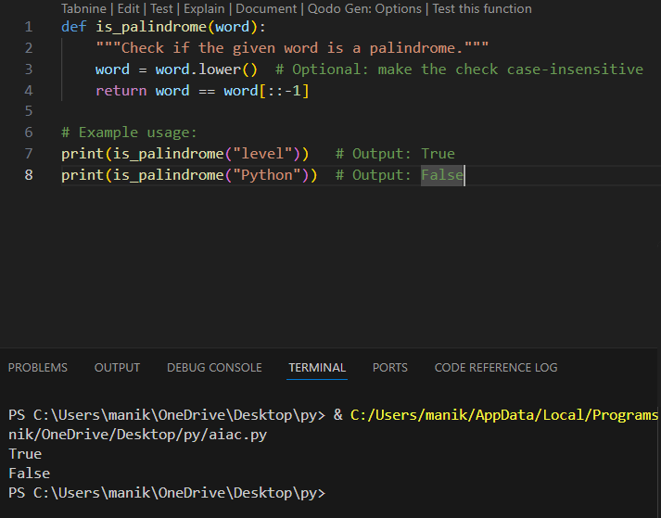

**Few-shot:**

**Prompt:**

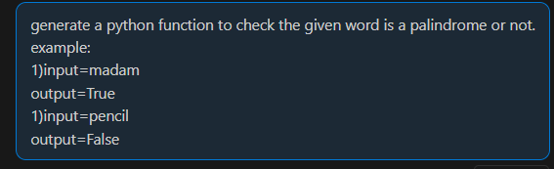

**Code with output:**

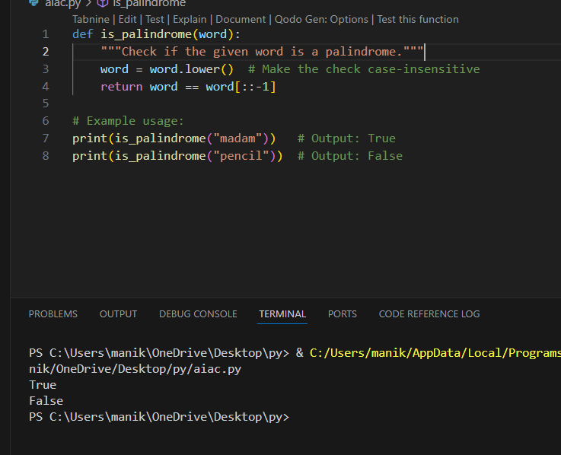

|  |  |
| --- | --- |
| **Zero-shot** | **Zero-shot** |
| **No need of examples in prompt** | **2-5 examples are needed I prompt** |
| **Relies only on task description** | **Learns from both task and examples** |
| **Good for simple tasks** | **Helpful for complicated tasks** |
| **Some times it may misinterprets** | **Examples over comes the misinterpretion.** |
|  |  |

**Observation:**

According to the task the AI will generate the same code with both the prompts but in some cases Zero-shot prompt may not give the accurate code with the task description it is good for simple programs, but for the complicated programs we need to give few examples to assist the AI so that it generates an accurate code in such cases Few-shot prompt is used.

**Task Description#5**

* Use few-shot prompting with 3 sample inputs to generate a function that determines the maximum of three numbers without using the built-in max() function.

**Expected Output#5**

* A function that handles all cases with correct logic based on example patterns.

**Prompt:** 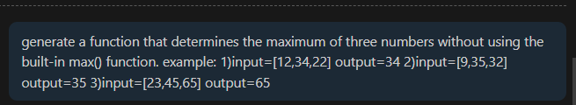

**Code with output:**

