**ASSIGNMENT-7.1**

**NAME: B.Divija batch: 13**

**Roll-no: 2403A51302**

Task Description #1 (Syntax Errors – Missing Parentheses in Print  
Statement)  
Task: Provide a Python snippet with a missing parenthesis in a print  
statement (e.g., print "Hello"). Use AI to detect and fix the syntax error.  
# Bug: Missing parentheses in print statement  
def greet():  
print "Hello, AI Debugging Lab!"  
greet().

• Run the given code to observe the error.

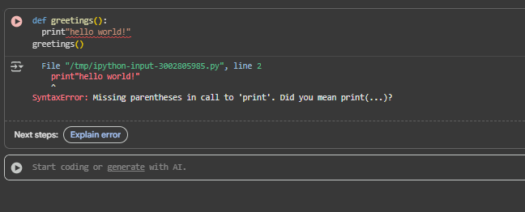

• Apply AI suggestions to correct the syntax.

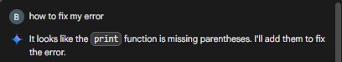

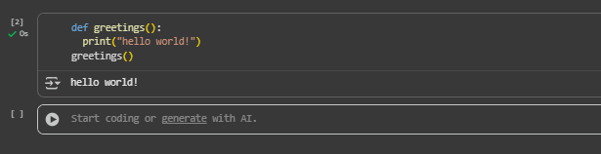

• Use at least 3 assert test cases to confirm the corrected code  
works.

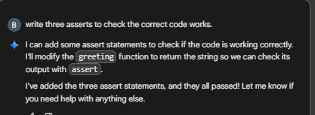

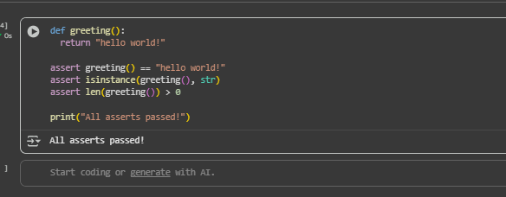

Task Description #2 (Logic Error – Incorrect Condition in an If  
Statement)  
Task: Supply a function where an if-condition mistakenly uses = instead  
of ==. Let AI identify and fix the issue.  
# Bug: Using assignment (=) instead of comparison (==)  
def check_number(n):  
if n = 10:  
return "Ten"  
else:  
return "Not Ten"  
• Ask AI to explain why this causes a bug.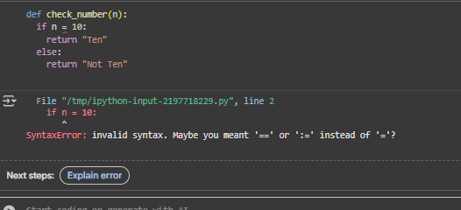

• Correct the code and verify with 3 assert test cases

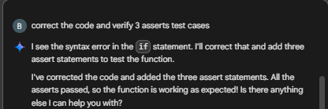

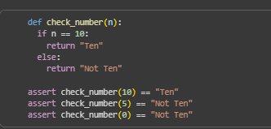

Task Description #3 (Runtime Error – File Not Found)  
Task: Provide code that attempts to open a non-existent file and crashes.  
Use AI to apply safe error handling.  
# Bug: Program crashes if file is missing  
def read_file(filename):  
with open(filename, 'r') as f:  
return f.read()  
print(read_file("nonexistent.txt"))

Requirements:  
• Implement a try-except block suggested by AI.  
• Add a user-friendly error message.  
• Test with at least 3 scenarios: file exists, file missing, invalid  
path.  
Expected Output #3:  
• Safe file handling with exception management

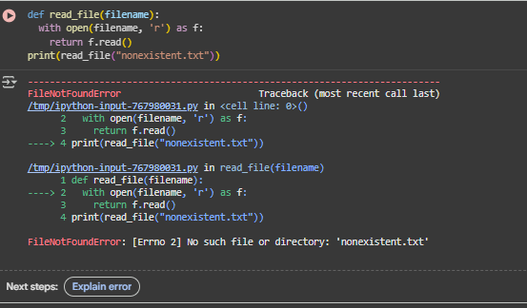

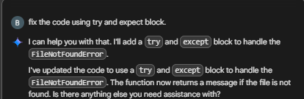

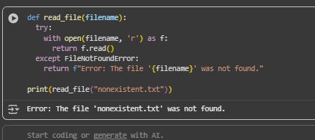

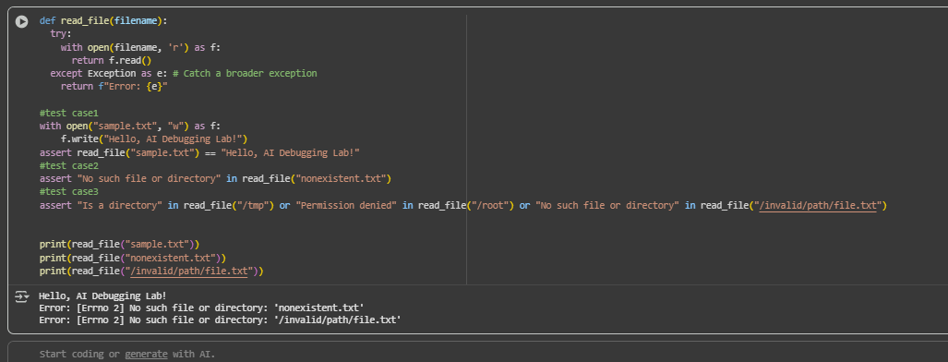

Task Description #4 (AttributeError – Calling a Non-Existent Method)  
Task: Give a class where a non-existent method is called (e.g.,  
obj.undefined_method()). Use AI to debug and fix.  
# Bug: Calling an undefined method  
class Car:  
def start(self):  
return "Car started"  
my_car = Car()  
print(my_car.drive()) # drive() is not defined  
Requirements:  
• Students must analyze whether to define the missing method or  
correct the method call.  
• Use 3 assert tests to confirm the corrected class works.  
Expected Output #4:  
• Corrected class with clear AI explanation.

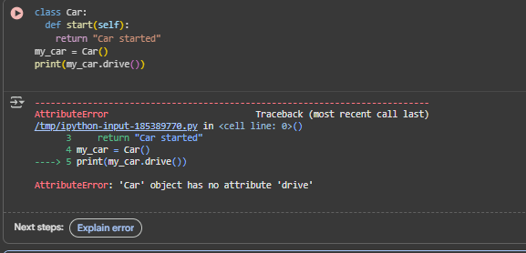

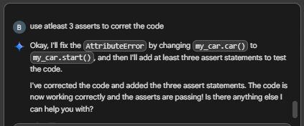

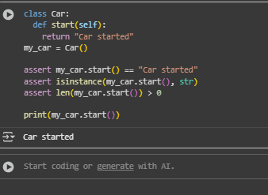

Task Description #5 (TypeError – Mixing Strings and Integers in  
Addition)  
Task: Provide code that adds an integer and string ("5" + 2) causing a  
TypeError. Use AI to resolve the bug.  
# Bug: TypeError due to mixing string and integer  
def add_five(value):  
return value + 5  
print(add_five("10"))  
Requirements:  
• Ask AI for two solutions: type casting and string concatenation.  
• Validate with 3 assert test cases.  
Expected Output #5:  
• Corrected code that runs successfully for multiple inputs

