**Data Visualization Final Project**

The world population significantly grows each year. The Microsoft Excel data represented the world population per country. The world population data helps policymakers and other stakeholders to predict life expectancy, health requirements and mortality rates, or even the age structure. The Excel documents included the world population for each country which when imported to Tableau helped generate visualizations. However, the data needed cleaning before generating the visualizations to help Tableau properly generate the population per country. During the cleaning, I had certain unrecognized locations, for instance, the data had Korea, South Korea, and North Korea. While Tableau correctly identified South Korea and North Korea, it could not place Korea as a country. The Excel file also had a country by the name Monserrat which was not recognized, so the locations remained unknown.

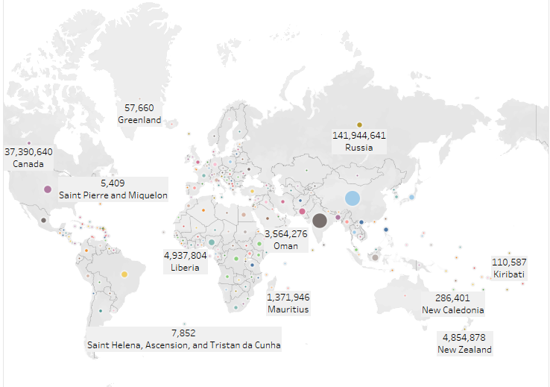

Figure 1: *Page 1 Global Population*

Figure 1 above illustrated the first page that entailed the world’s population. I used population labels and country labels to show the country name and total population for the given population. Not all countries’ names and total population labels fit on the chat, except for the countries with the leading populations in the respective continents. Russia easily fit because it had a total population of 141,944,641, and the size of the country fit the details. Most countries had a smaller size that their country names or population totals barely fit.

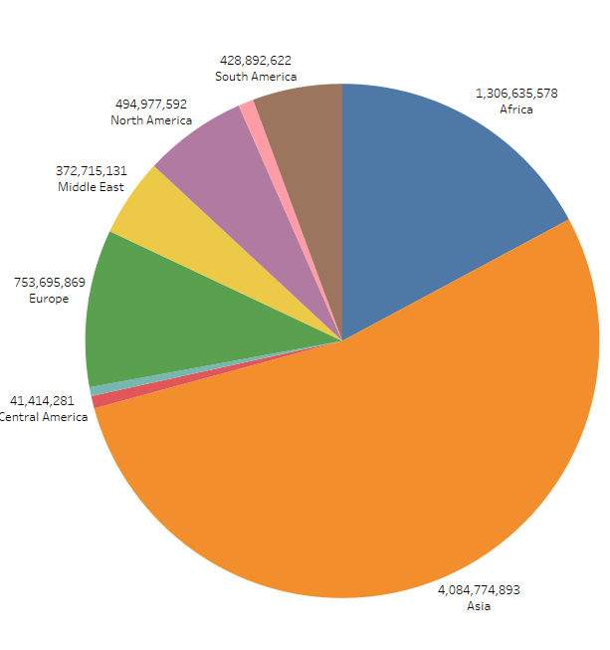

Figure 2: *Page 2 World Population by Continent*

I used a pie chart to summarize the total population for every continent. The data in figure 2 had multiple continent total populations, some of which did not properly appear. The disparity between the total populations for the largest continent and the lowest continent populations made it difficult for the small continents to get noticed from the pie chart. However, the pie chart produced a visually appealing summary unlike other charts like bar charts or line charts. According to Stirrup et al. (2017), users needed less explanation about the pie chart to understand the distinction between the continents that had large or small populations. Since the pie chart represented information from nine (9) regions, it was difficult for some continent details to appear or get visible from far.

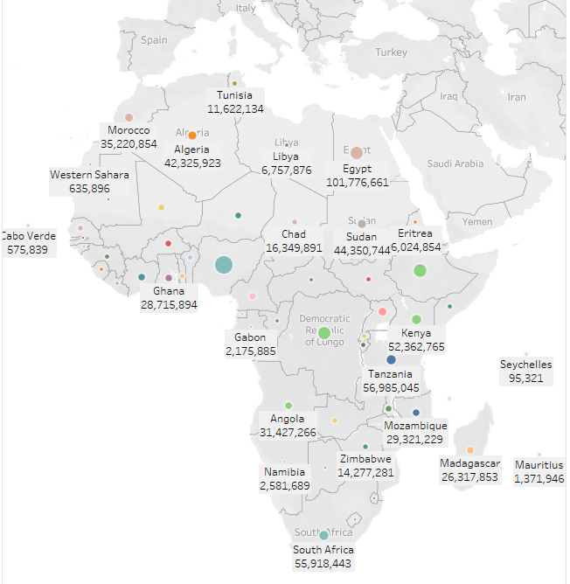

Figure 3: *Page 3 Population for Africa*

The chart in figure 3 above shows the Map visualization for Africa. I used labels for country names and population totals with different colors to distinguish the countries. Countries small in size were not visible from the chart, except for the countries with large sizes that could display their information within visible details.

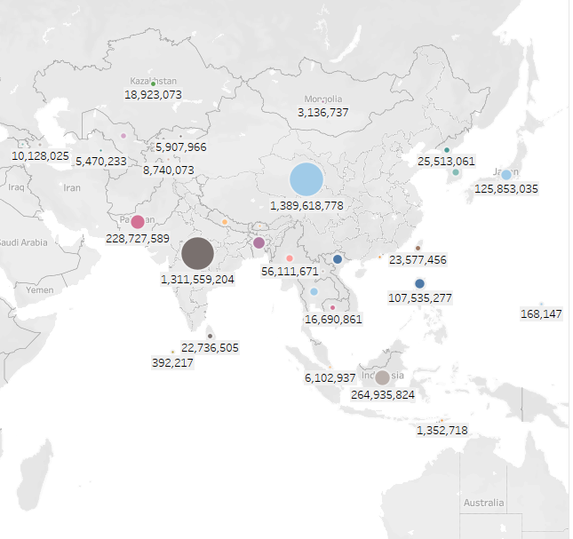

Figure 4: *Page 4 Asia Population*

Figure 4 summarized the Asian population using the Asia Map tool. Everyone can easily understand the map and recognize most countries. I used labels that distinguished countries with large total populations. Countries that had large balls signified large populations compared to countries that had small balls. The two largest countries represented countries that had over 1.3 billion citizens.

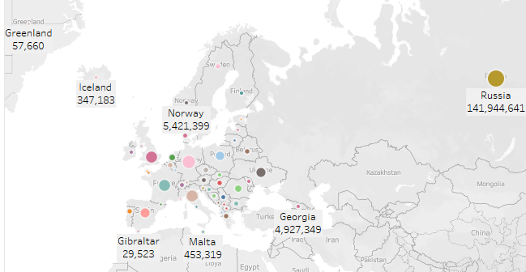

Figure 5: *Page 5 Europe Population*

I had difficulties illustrating countries on the map with Russia in the neighborhood yet other countries in Europe had fewer population sizes and land sizes. Russia had a larger total population compared to the entire population country population which made European countries look smaller. The nearest country populations were Norway and Georgia which had 5.4 and 4.9 million respectively. Russia had over 141 million people which made the Europe population data look cluttered.

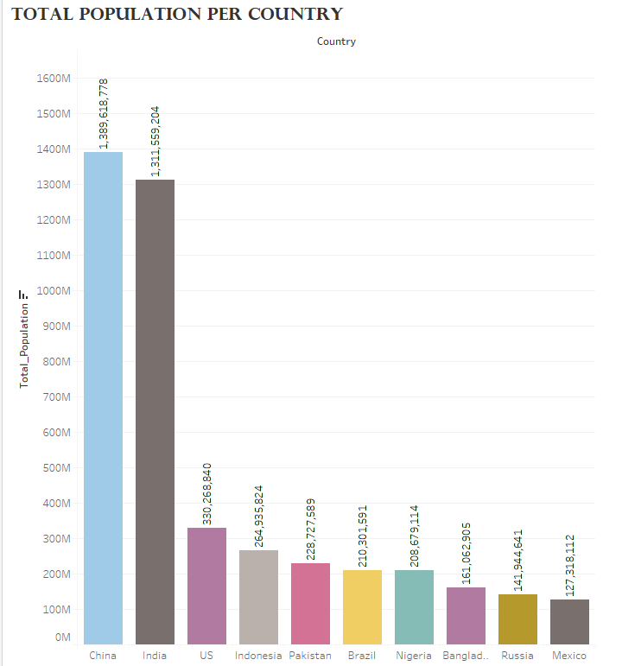

Figure 6: *Page 6 Top 10 Country Populations*

The final chart in the Tableau visualization was the top 10 countries. I chose the bar chart because it could neatly represent the populations if the variables were few. For instance, capping the population to 10 countries allowed the visualization clearly illustrate each country and its total population. According to Stirrup et al. (2017), using more data like 20 or more countries could result in a messy bar chart that could confuse most viewers. China and India had the largest population sizes over 1 billion. The large discrepancy between the top 2 country populations and their following country populations affected the bar chart’s neatness. The US for instance had 330 million people, which is almost a billion less compared to the two top countries. I used different colors to distinguish the countries, however, audiences with color blindness might have challenges identifying the red or purple, or pink colors. Mexico ranked the tenth most populous country in the dataset after China, India, the US, Indonesia Pakistan, Brazil, Bangladesh, and Russia. The bar chart could not fit Bangladesh properly on the horizontal axis.



**References**

Stirrup J. Nandeshwar A. & Ohmann A. (2017). *Tableau: creating interactive data visualizations*. Packt Publishing. http://sbiproxy.uqac.ca/login?url=https://international.scholarvox.com/book/88843543.