AegisCore: An Intelligent API Security Monitoring and Threat Intelligence Platform

Maddipati Pallavi
Department of Computer
Science and Engineering,
Koneru Lakshmaiah
Education Foundation,
Bowrampet, Hyderabad-
500043, Telangana, India.
2420030373@klh.edu.in

Harshini S R
Department of Computer
Science and Engineering,
Koneru Lakshmaiah
Education Foundation,
Bowrampet, Hyderabad-
500043, Telangana, India.
2420030113@klh.edu.in

Abstract:
A modern application ecosystem relies on public, partner and internal application programming interfaces (APIs). As API inventories expand, the attack surface becomes harder to monitor, while static security rules may fail to recognize evolving, behavior-driven threats. This paper presents AegisCore, an intelligent API security monitoring and threat intelligence platform designed to provide continuous visibility into API activity and support the prioritization of suspicious events. The proposed architecture collects gateway and application activity, streams events for preprocessing, extracts behavioral features, and applies machine-learning-based anomaly detection to identify deviations from established API behavior. Suspicious events are enriched using threat indicators such as IP addresses, request patterns and endpoint behavior. A risk-scoring stage combines anomaly and contextual signals to support severity-based prioritization, while a security dashboard presents traffic trends, anomalies, targeted endpoints, alerts and API health metrics. The design follows a modular, microservices-oriented approach using Java, Spring Boot, Spring Cloud, Spring Cloud Gateway, Eureka, REST APIs and Apache Kafka, with JWT, role-based access control and CORS as security mechanisms. The presentation defines the system architecture and workflow but does not provide quantitative evaluation results; therefore, this paper describes the proposed design and expected outputs without claiming measured detection accuracy or performance.
Index Terms—API security, anomaly detection, threat intelligence, risk scoring, microservices, behavioral analytics, security monitoring.

G Divija Medha
Department of Computer
Science and Engineering,
Koneru Lakshmaiah
Education Foundation,
Bowrampet, Hyderabad-
500043, Telangana, India.
2420030481@klh.edu.in

Dr. Venkateshwari K
Department of Computer
Science and Engineering,
Koneru Lakshmaiah
Education Foundation,
Bowrampet, Hyderabad-
500043, Telangana, India.
ketinenivenkateswari@klh.edu.in

I. INTRODUCTION
Application programming interfaces are a central part of modern software systems. They allow web applications, mobile clients, partner platforms and internal services to exchange data and invoke business functions. This connectivity improves flexibility and supports microservices-based development, but it also increases the number of entry points that must be protected. Public, partner and internal endpoints may expose sensitive backend functionality when authentication, authorization, inventory management or monitoring is inconsistent.
API threats are not limited to fixed attack signatures. Credential abuse, injection attempts, unusual request bursts and misuse of legitimate endpoints can change as applications and user traffic evolve. Static rules may become less effective when normal traffic baselines shift or when malicious behavior is distributed across multiple endpoints. In addition, isolated alerts often lack sufficient context for security teams to determine which events deserve immediate attention.
AegisCore is designed to address these challenges by combining continuous API activity collection, behavioral anomaly detection, threat-intelligence correlation, risk scoring and dashboard-based investigation. Rather than treating every event as an independent alert, the platform aims to associate request behavior with endpoint and threat context. Its microservices-oriented design separates collection, processing, detection, intelligence, alerting and visualization so that the platform can be adapted to API-driven environments.
The main contributions of the proposed platform are: (1) a continuous monitoring workflow for gateway and application activity; (2) behavioral analysis to highlight deviations from normal API usage; (3) contextual enrichment using suspicious IPs, request patterns and endpoint behavior; (4) a unified risk level to help prioritize events; and (5) a dashboard-oriented view of traffic, anomalies, alerts and API health.

II. LITERATURE SURVEY
Baye et al. [1] discuss machine-learning-based API traffic analysis for enterprise environments. Their approach uses traffic-related features, including bandwidth and requests per token, and applies a support vector machine for binary classification. The work supports the use of machine learning for identifying abnormal API traffic in microservice environments. The project presentation notes that dataset scarcity led to the use of synthetic data, indicating a need for broader validation with real-world traffic.
The OWASP API Security Top 10 [2] provides a taxonomy of API-specific security risks, including authorization and authentication weaknesses, resource-consumption issues, server-side request forgery, security misconfiguration, API inventory concerns and unsafe API consumption. It offers a practical foundation for identifying and prioritizing risks. However, it is a risk-awareness framework and does not itself provide continuous machine-learning-based anomaly detection.
Tanveer et al. [3] describe a context-aware machine-learning and natural-language-processing pipeline for real-time anomaly detection and risk assessment in cloud API traffic. The approach combines numerical anomaly detection with log analysis using rules, TF-IDF and character-level models. It connects request-level and log-level observations with business risk. The presentation identifies broader deployment validation and scalability across diverse real-world API environments as areas requiring further work.
Zhang et al. [4] present TAD-LLM, an API traffic anomaly detection approach based on a large language model. The method uses S2GS data transformation, prompt optimization and LoRA fine-tuning to analyze API traffic and detect complex attacks. It illustrates the potential of contextual language-model analysis, while computational overhead and the availability of suitable domain-specific traffic data remain important considerations.
Aharon et al. [5] propose a classification-by-retrieval framework for few-shot anomaly detection of API injection attacks. The method uses API-specific FastText embeddings and approximate-nearest-neighbor retrieval, and is reported in the presentation as evaluated on CSIC 2010 and ATRDF 2023. It addresses the scarcity of labeled normal API requests, although its focus on injection attacks leaves broader attack categories and more varied production environments for future evaluation.

III. PROBLEM DEFINITION AND RESEARCH GAP
Modern applications expose growing collections of APIs across public, partner and internal environments. Monitoring these endpoints consistently is difficult, and static rule-based controls may not detect novel or behavior-driven misuse. Security events are also frequently fragmented across gateway logs, application logs and threat indicators. Without correlation and prioritization, security teams may face large volumes of alerts with limited context.
The gap addressed by AegisCore is the need for an integrated platform that moves beyond isolated API security checks. The proposed system combines continuous monitoring, behavioral anomaly detection, threat-intelligence correlation, risk scoring and visualization in one modular workflow. Its novelty, as framed in the project presentation, lies in combining adaptive API behavior baselines with threat context and explainable risk-oriented dashboard views.

IV. PROPOSED SYSTEM ARCHITECTURE
AegisCore follows a staged architecture that processes API activity from request handling to security analysis and visualization. API requests first pass through the API Gateway, where routing and security controls such as JSON Web Tokens (JWT), role-based access control (RBAC) and Cross-Origin Resource Sharing (CORS) are applied. Relevant gateway and application information is then collected for analysis.
Collected events are streamed through a message-broker layer and passed to data processing. This stage cleans, validates and transforms raw logs into structured security data. Feature extraction derives behavioral indicators such as request frequency, endpoint usage and authentication patterns. The anomaly-detection module compares incoming behavior with established normal patterns and identifies suspicious deviations.
Suspicious activity is enriched by threat-intelligence analysis using indicators such as source IP addresses, attack patterns and endpoint behavior. The risk-scoring module combines anomaly and contextual signals to assign a severity level. High-risk events can then be communicated through alerts and presented on the security dashboard for monitoring and investigation. The architecture separates collection, processing, detection, intelligence, alerting and visualization into modular components.
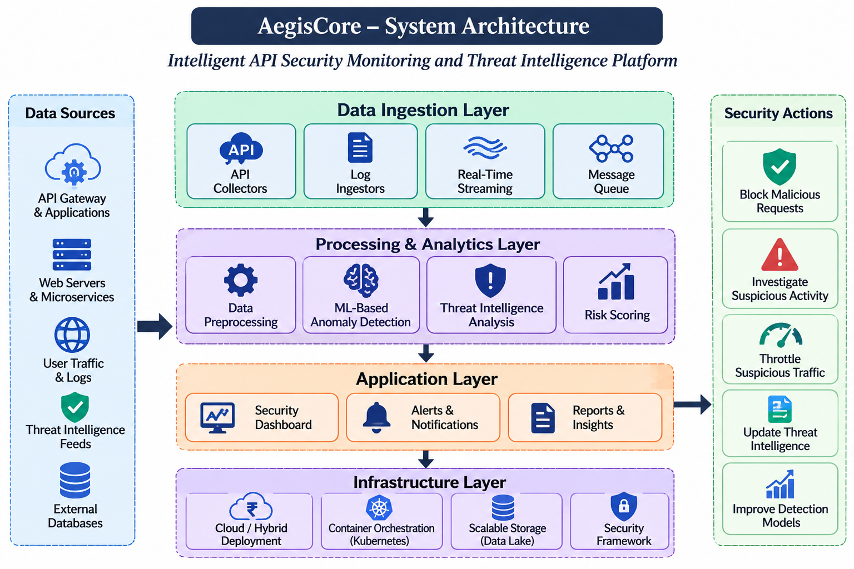

V. SYSTEM METHODOLOGY
A. API Traffic Collection. Collect gateway and application activity, including source IP address, endpoint, HTTP method, response status and timestamp.
B. Data Preprocessing. Clean, validate and transform raw API logs into a consistent structured representation suitable for downstream analysis.
C. Feature Extraction. Derive behavioral indicators such as request frequency, endpoint usage and authentication patterns from the processed events.
D. Anomaly Detection. Compare incoming API behavior with established normal patterns and flag deviations that may indicate suspicious activity. The presentation specifies machine-learning-based anomaly detection but does not identify a particular algorithm or training dataset.
E. Threat-Intelligence Correlation. Enrich suspicious events using IP indicators, attack patterns, endpoint behavior and related threat context.
F. Risk Scoring. Combine anomaly scores and contextual security signals to determine an event risk level and support prioritization.
G. Alerting and Visualization. Generate security alerts and display traffic trends, anomalies, risk levels, targeted endpoints and API health metrics through the dashboard.
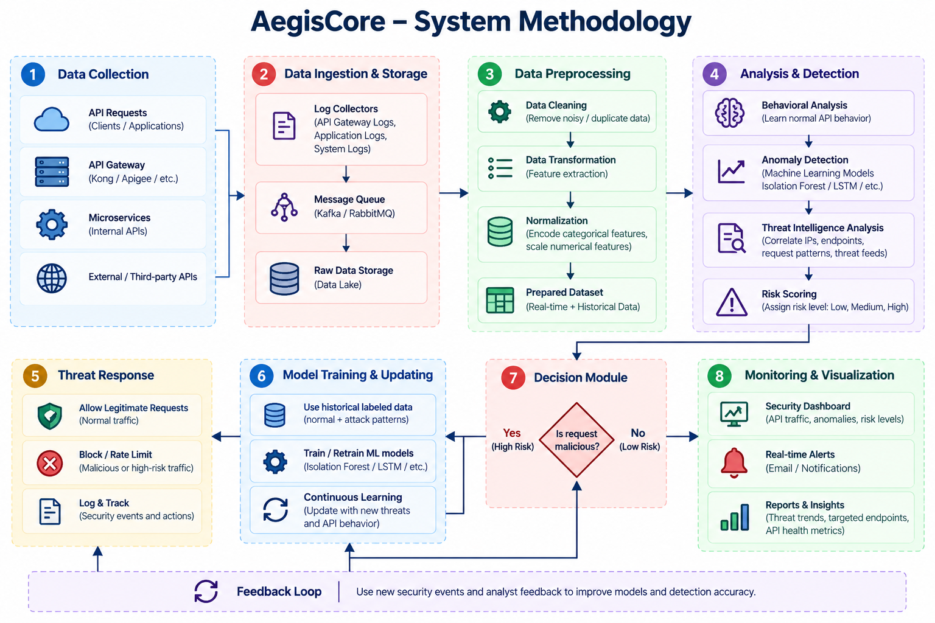

VI. TECHNOLOGY STACK AND IMPLEMENTATION
The backend and microservices layer is based on Java, Spring Boot and Spring Cloud. Spring Cloud Gateway is identified for API gateway routing, while Eureka Server provides service discovery and REST APIs support communication between services. JWT, RBAC and CORS are the security mechanisms listed in the presentation. Apache Kafka is used for event streaming and communication between processing components.
The security analytics layer uses machine-learning-based anomaly detection and feature-based API behavioral analysis. Postman is identified for API testing, and Semgrep is included for security-oriented code analysis. The frontend dashboard is intended to visualize API traffic trends, detected anomalies, targeted endpoints, alerts, risk levels and API health metrics. The supplied presentation does not identify a specific frontend framework, source-code filenames, a named machine-learning algorithm or deployment configuration; these implementation details should be added only after they are confirmed from the actual project.

VII. RESULTS AND DISCUSSION
The project presentation describes the intended dashboard outputs and the processing workflow. The expected monitoring view includes API traffic trends and API health metrics, while the security view highlights detected anomalies, targeted endpoints, risk levels and alerts. The methodology provides a path from raw gateway and application events through preprocessing, feature extraction, anomaly detection, threat-intelligence enrichment and risk scoring.
The presentation does not include numerical results such as detection accuracy, precision, recall, F1-score, false positive rate, throughput or detection latency. It also does not provide a quantified comparison against a baseline system. Accordingly, no measured performance improvement is claimed in this paper. A complete experimental evaluation should use representative API traffic, clearly defined attack scenarios and labeled test data, and report both detection quality and runtime performance. Screenshots from the working dashboard can be inserted here to document the actual interface.
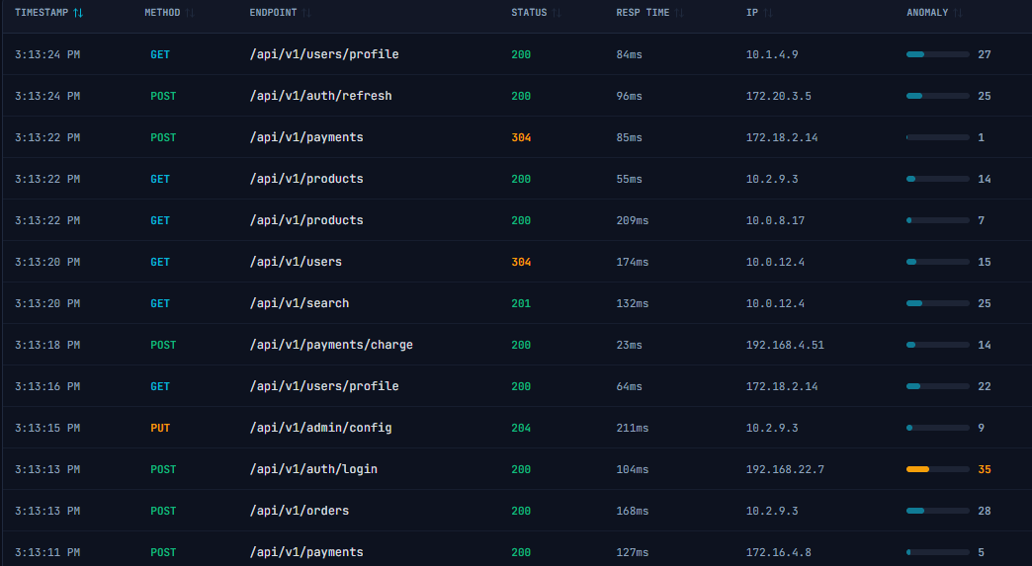
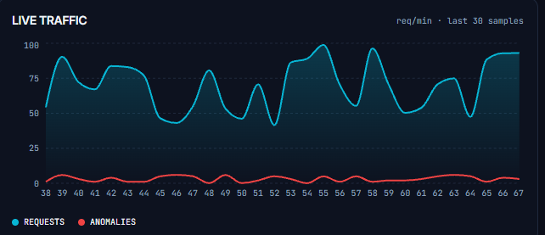

VIII. CONCLUSION AND FUTURE SCOPE
This paper presented AegisCore, an intelligent API security monitoring and threat intelligence platform intended to improve visibility and prioritization in modern API ecosystems. The proposed workflow combines continuous activity collection, data preprocessing, behavioral feature extraction, machine-learning-based anomaly detection, threat intelligence correlation, risk scoring and dashboard visualization. Its modular design uses Java and Spring-based microservices, gateway and service-discovery components, Kafka-based event streaming and security controls including JWT, RBAC and CORS. The approach aims to provide richer context than isolated static security checks and to help security teams focus on potentially high-impact events.
Future work includes validating the detection approach on larger and more diverse real-world API datasets; extending coverage to additional attack categories; evaluating scalability under high-volume distributed traffic; integrating additional threat-intelligence sources; and measuring precision, recall, false-positive rate and detection latency. Further work may also improve adaptive baseline learning, explainability of risk scores and dashboard investigation features. These items are proposed directions and are not presented as completed capabilities.

REFERENCES
[1] Baye et al., “API Security in Large Enterprises: Leveraging Machine Learning for Anomaly Detection,” IEEE ISNCC, 2021. Full author list, page range and DOI/URL were not supplied in the project presentation.
[2] OWASP Foundation, “OWASP API Security Top 10,” 2023. https://owasp.org/www-project-api-security/
[3] Tanveer et al., “Context-Aware ML/NLP Pipeline for Real-Time Anomaly Detection and Risk Assessment in Cloud API Traffic,” 2025, as cited in the project presentation. Full publication metadata and URL were not supplied.
[4] Zhang et al., “TAD-LLM: API Traffic Anomaly Detection Based on Large Language Model,” 2024, as cited in the project presentation. Full publication metadata and URL were not supplied.
[5] Aharon et al., “A Classification-by-Retrieval Framework for Few-Shot Anomaly Detection to Detect API Injection Attacks,” 2024/2025, as cited in the project presentation. Full publication metadata and URL were not supplied.

