EDI GANTT AND PERT CHART

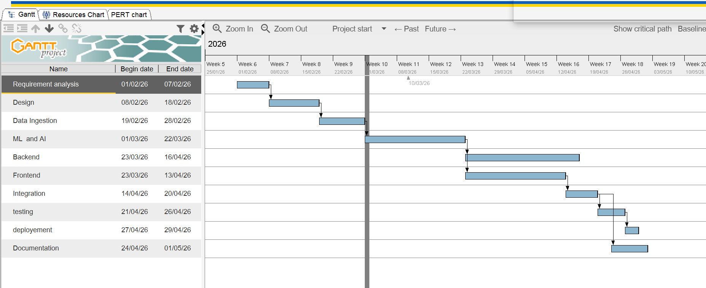

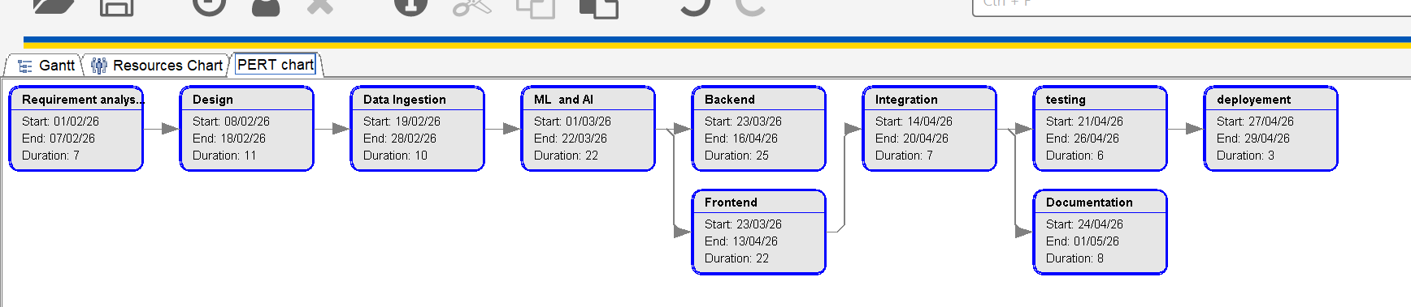

Task ID | Activity | O | M | P | TE
T1 | Requirement Analysis | 5 | 7 | 9 | 7.0
T2 | Design | 9 | 11 | 13 | 11.0
T3 | Data Ingestion | 8 | 10 | 12 | 10.0
T4 | ML and AI | 20 | 22 | 24 | 22.0
T5 | Backend | 23 | 25 | 27 | 25.0
T6 | Frontend | 20 | 22 | 24 | 22.0
T7 | Integration | 5 | 7 | 9 | 7.0
T8 | Testing | 4 | 6 | 8 | 6.0
T9 | Deployment | 1 | 3 | 5 | 3.0
T10 | Documentation | 6 | 8 | 10 | 8.0

- Take M = given duration
- Assume:
  - O = M − 2
  - P = M + 2
- Then calculate
TE = (O + 4M + P) / 6

