Tutorial 7: Agile Simulation
Agile User Stories, Product Backlog, Sprint Backlog & Burndown Chart
Project: AI-Powered Incident Knowledge Management Platform

Project Overview
Project Name: AI-Powered Incident Knowledge Management Platform
Goal: Engineers, admins, and ML subsystems should be able to submit incident tickets, automatically classify and cluster them, retrieve similar incidents, generate runbooks and postmortems using LLMs, and query historical knowledge through a RAG chat assistant — all visualized via an analytics dashboard.

Step 1 — Write Agile User Stories

Agile User Story Format
As a <user role>
I want <functionality>
So that <business value>

User Stories
Story ID | User Role | I Want To... | So That...
US1 | Engineer | submit a new incident ticket | incidents are recorded and tracked in the system
US2 | ML System | automatically classify tickets by service, severity, and type | incidents are organized for faster resolution
US3 | Engineer | search for similar past incidents using natural language | I can find relevant resolutions without manual searching
US4 | Engineer | view AI-generated runbooks for recurring incidents | I can resolve common issues faster
US5 | Engineer | chat with the RAG assistant about historical incidents | I can query knowledge in natural language
US6 | Admin | view analytics dashboards with incident trends and ML metrics | I can monitor system performance and resolution patterns
US7 | ML System | generate postmortem reports from incident timelines | knowledge is captured automatically after incidents are resolved
US8 | Engineer | review and approve AI-generated runbooks before publishing | knowledge quality is maintained with human oversight

Step 2 — Estimate User Stories (Story Points)
Fibonacci Scale used: 1, 2, 3, 5, 8
Story points are assigned based on complexity, effort, and uncertainty of each feature.

Story ID | Description | Story Points
US1 | Ticket submission | 3
US2 | ML ticket classification | 8
US3 | Semantic incident search | 5
US4 | Runbook generation | 8
US5 | RAG chat assistant | 8
US6 | Analytics dashboard | 5
US7 | Postmortem report generation | 5
US8 | Runbook review & approval | 3
Total Backlog Effort | 45 points

Step 3 — Product Backlog
The Product Backlog is a prioritized list of all features. Stories are ordered based on:
- Business value and user impact
- Technical dependencies between modules
- Risk and complexity

Priority | Story | Points | Rationale
1 | Ticket Submission (US1) | 3 | Foundation for all other features
2 | ML Ticket Classification (US2) | 8 | Required before search/clustering
3 | Semantic Incident Search (US3) | 5 | Depends on embeddings from US2
4 | Runbook Generation (US4) | 8 | Depends on clustering (US2)
5 | RAG Chat Assistant (US5) | 8 | Depends on embeddings + LLM (US4)
6 | Analytics Dashboard (US6) | 5 | Depends on stored data
7 | Postmortem Report Generation (US7) | 5 | Depends on LLM module (US4)
8 | Runbook Review & Approval (US8) | 3 | Final step — human oversight

Note: US1 forms the data foundation, US2 enables all ML features, US3 depends on US2 embeddings, US4 depends on US2 clustering, US5 depends on US4 LLM module, US6 and US7 depend on stored data and the LLM module respectively, and US8 is the final human-oversight step.

Step 4 — Sprint Backlog
Sprint Velocity = 20 points
Sprint Duration = 2 Weeks
Stories are selected from the Product Backlog in priority order until the velocity of 20 points is reached. All 45 points are covered across 3 sprints.

Sprint 1 (Stories: US1, US2, US3 | Total: 16 points)
Story ID | Story | Points
US1 | Ticket Submission | 3
US2 | ML Ticket Classification | 8
US3 | Semantic Incident Search | 5
Sprint 1 Total | 16 points

US4 (8 pts) would exceed the 20-point velocity limit if added to Sprint 1 (16 + 8 = 24), so it moves to Sprint 2.

Sprint 2 (Stories: US4, US5 | Total: 16 points)
Story ID | Story | Points
US4 | Runbook Generation | 8
US5 | RAG Chat Assistant | 8
Sprint 2 Total | 16 points

US6 (5 pts) would bring Sprint 2 to 21 points, exceeding velocity, so it moves to Sprint 3.

Sprint 3 (Stories: US6, US7, US8 | Total: 13 points)
Story ID | Story | Points
US6 | Analytics Dashboard | 5
US7 | Postmortem Report Generation | 5
US8 | Runbook Review & Approval | 3
Sprint 3 Total | 13 points

Sprint 3 covers the remaining 13 points. Total across all sprints: 16 + 16 + 13 = 45 points (full backlog covered).

Step 5 — Task Breakdown (Sprint Backlog Tasks)
Each user story is broken down into developer tasks with estimated hours. All 8 user stories are detailed below.

US1: Ticket Submission — US1
Task (for: Ticket Submission — US1) | Hours
Design ticket submission form (Frontend) | 4
Create REST API endpoint for ticket ingestion | 5
Set up PostgreSQL schema for ticket storage | 4
Validate and clean ticket input | 3
Unit testing for submission flow | 3
Total | 19 hours

US2: ML Ticket Classification — US2
Task (for: ML Ticket Classification — US2) | Hours
Preprocess and clean ticket text data | 4
Train supervised classification model (service/severity/type) | 8
Integrate classification model into FastAPI endpoint | 5
Store predicted labels back to PostgreSQL | 3
Unit and integration testing for classification pipeline | 4
Total | 24 hours

US3: Semantic Incident Search — US3
Task (for: Semantic Incident Search — US3) | Hours
Set up text embedding pipeline using pre-trained model | 5
Configure and populate FAISS/Chroma vector database | 4
Build similarity search API endpoint (top-k retrieval) | 4
Wire similarity results to frontend incident detail view | 3
Test retrieval accuracy and tune similarity threshold | 3
Total | 19 hours

US4: Runbook Generation — US4
Task (for: Runbook Generation — US4) | Hours
Run clustering algorithm on resolved ticket embeddings | 5
Detect recurring incident clusters above threshold | 3
Build LLM prompt template for runbook drafting | 4
Integrate LLM API call and store generated runbook | 4
Display generated runbook in frontend review interface | 3
Total | 19 hours

US5: RAG Chat Assistant — US5
Task (for: RAG Chat Assistant — US5) | Hours
Build vector retrieval pipeline for RAG context assembly | 5
Design LLM prompt combining retrieved context and user query | 4
Create FastAPI chat endpoint (query → retrieve → generate) | 5
Build chat UI (message history + input box in React) | 4
Integration and end-to-end testing of RAG pipeline | 3
Total | 21 hours

US6: Analytics Dashboard — US6
Task (for: Analytics Dashboard — US6) | Hours
Design dashboard layout and wireframes (React) | 3
Build incident trend chart using stored ticket data | 4
Create ML metrics panel (model accuracy, confidence avg) | 4
Develop summary cards (open/resolved/total counts) | 3
Connect dashboard to backend analytics API endpoints | 3
Total | 17 hours

US7: Postmortem Report Generation — US7
Task (for: Postmortem Report Generation — US7) | Hours
Extract ticket timeline data from PostgreSQL per incident | 3
Build LLM prompt template for postmortem drafting | 4
Integrate LLM API and store generated postmortem | 4
Display postmortem in knowledge base review interface | 3
Test generated postmortem quality and approval flow | 3
Total | 17 hours

US8: Runbook Review & Approval — US8
Task (for: Runbook Review & Approval — US8) | Hours
Build review UI showing runbook content with edit option | 4
Implement Approve/Reject action buttons and backend handlers | 3
Update runbook status to Published/Rejected in database | 3
Log approval decision with reviewer name and timestamp | 2
Unit test approval workflow and status transitions | 2
Total | 14 hours

Step 6 — Create Board in Trello
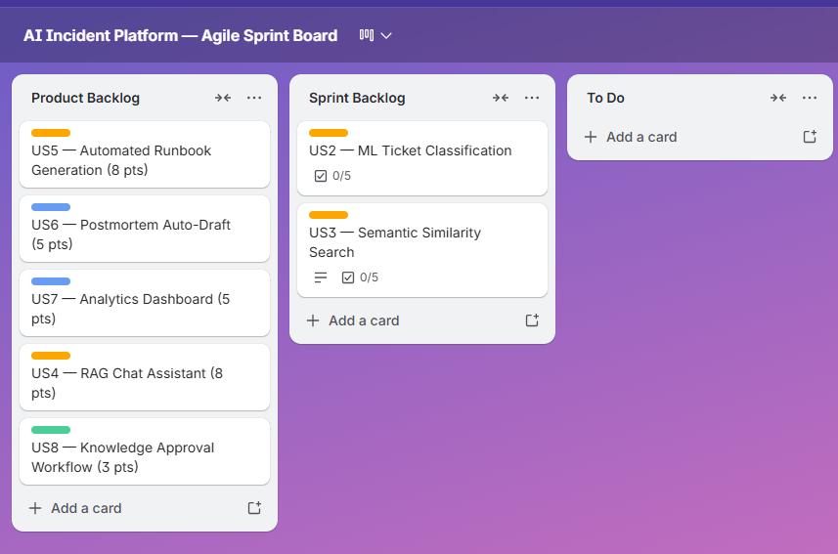

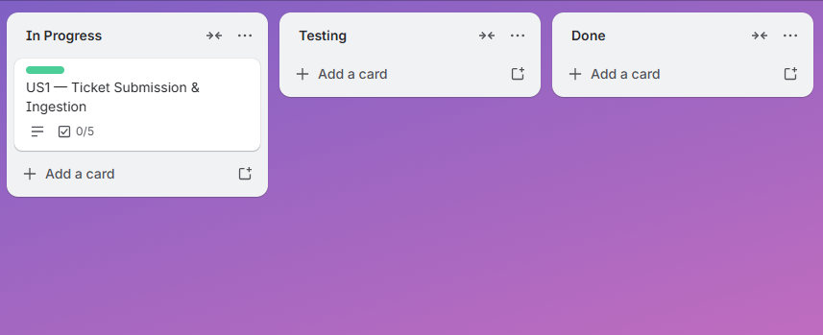

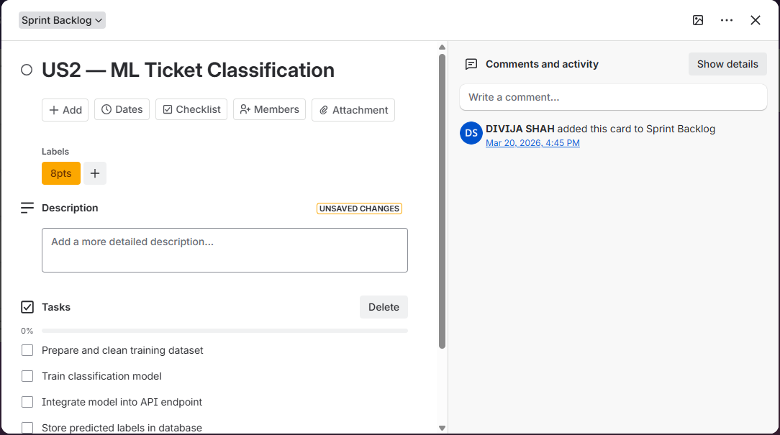

Step 7 — Create Burndown Chart

Sprint-1:
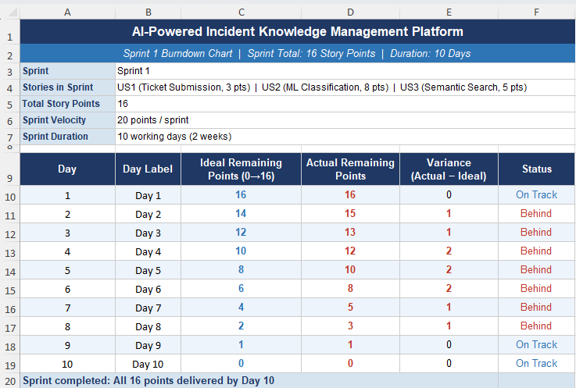

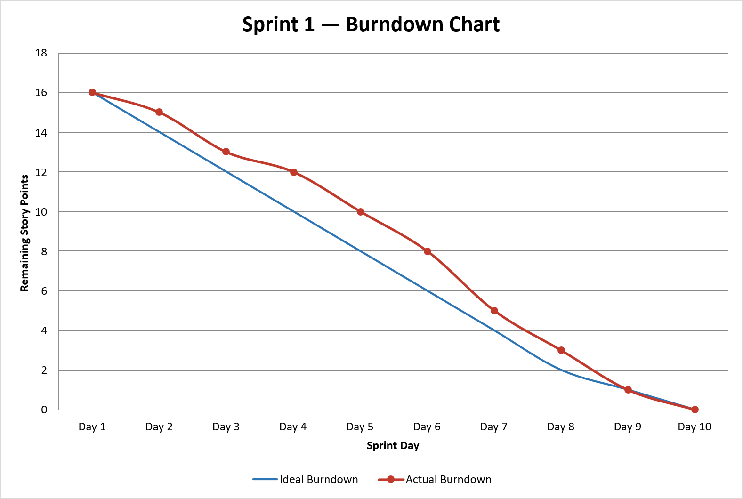

Sprint-2:

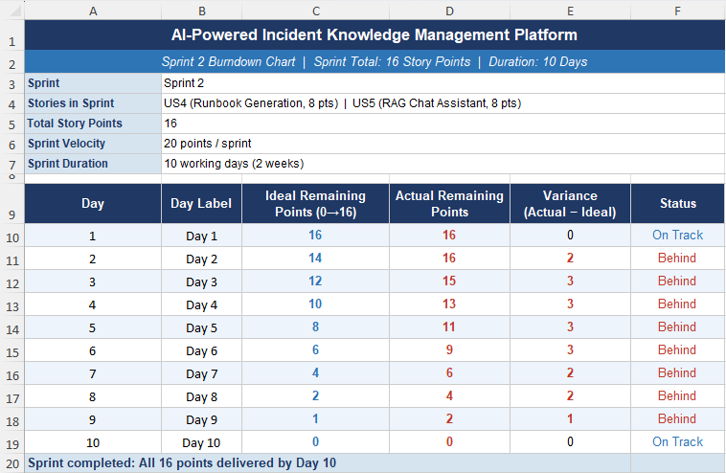

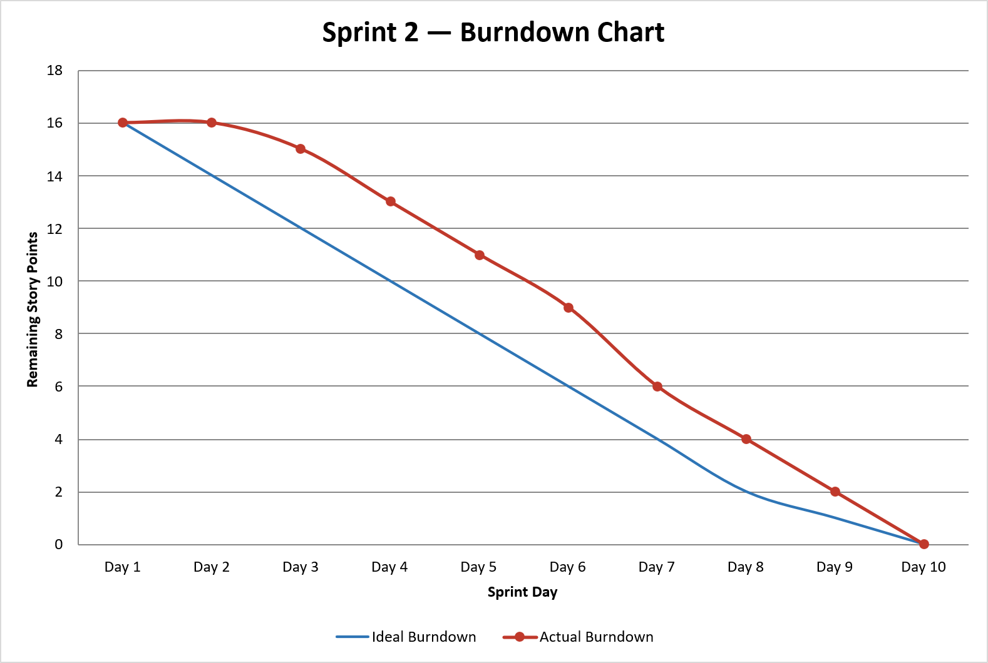

Sprint-3:

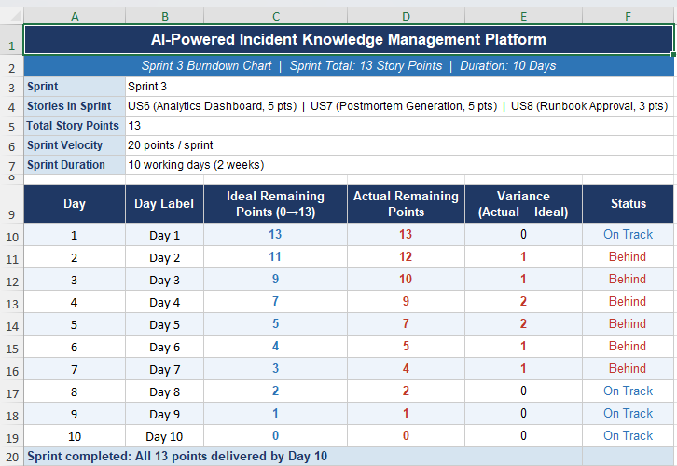

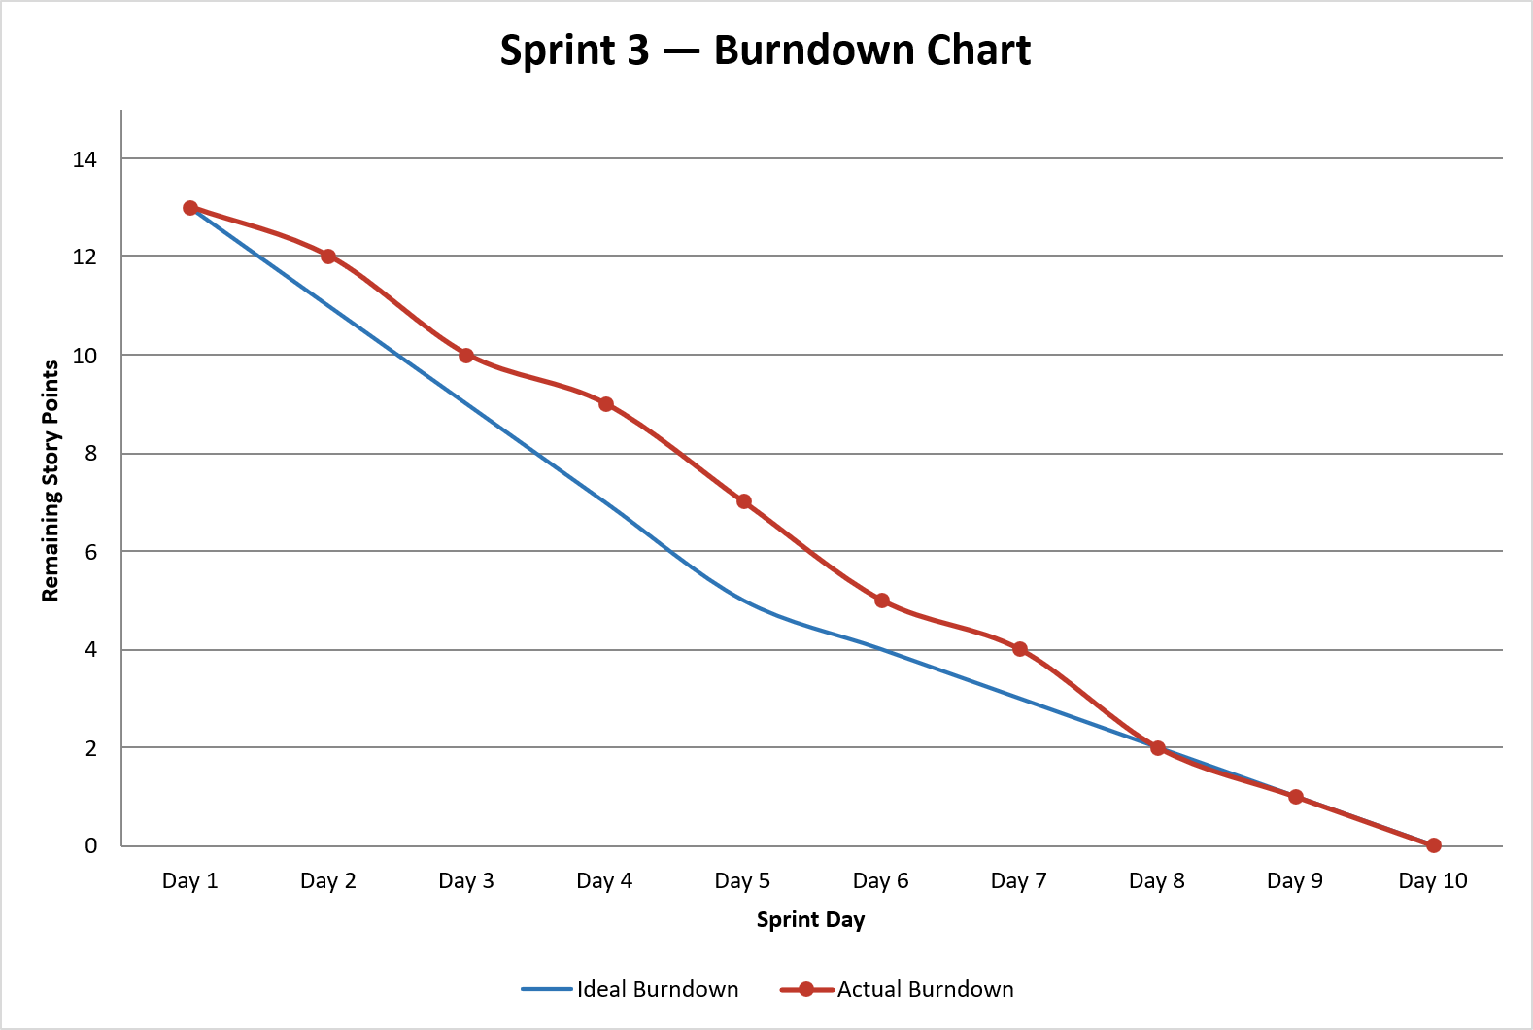

All Sprints Summary:

