Sprint Planning
- The product backlog was created with all user stories (US1–US8) along with their assigned story points using the Fibonacci sequence.
- An assumed team velocity of 20 story points per sprint was considered for planning purposes.
- Based on this velocity, user stories were distributed across three sprints such that the total story points in each sprint did not exceed the team capacity.
Sprint Distribution:
- Sprint 1: US1, US2, US3 → Total = 16 story points
- Sprint 2: US4, US5 → Total = 16 story points
- Sprint 3: US6, US7, US8 → Total = 13 story points

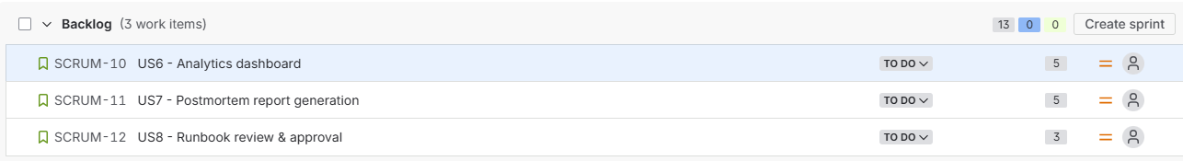
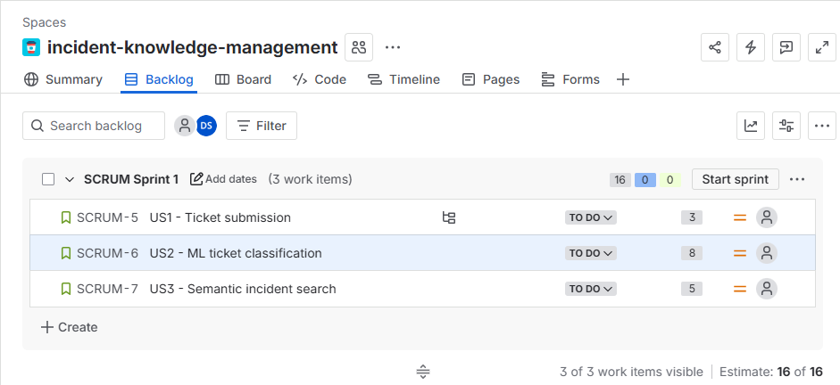
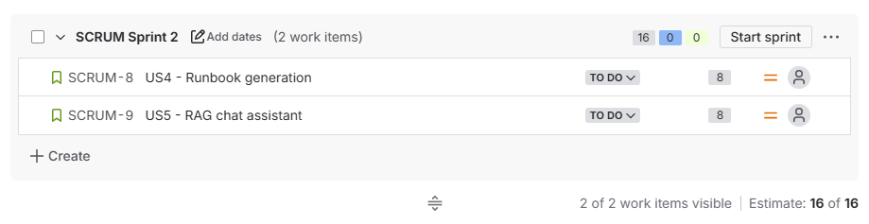
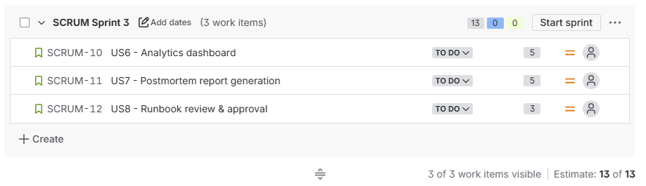

Sprint Execution (Simulation)
- Since the project was not actually developed, sprint execution was simulated in Jira.
- User stories were moved across workflow stages: To Do → In Progress → Done to represent progress.
- All planned user stories in each sprint were assumed to be completed successfully.

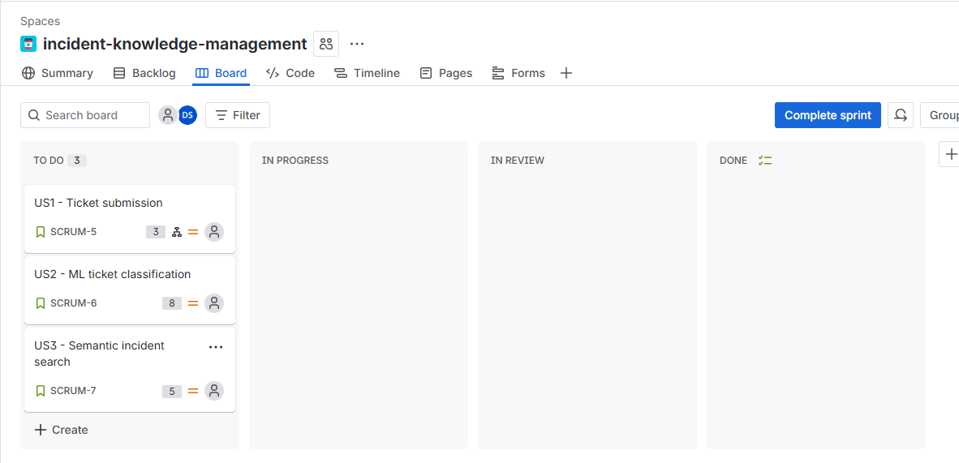
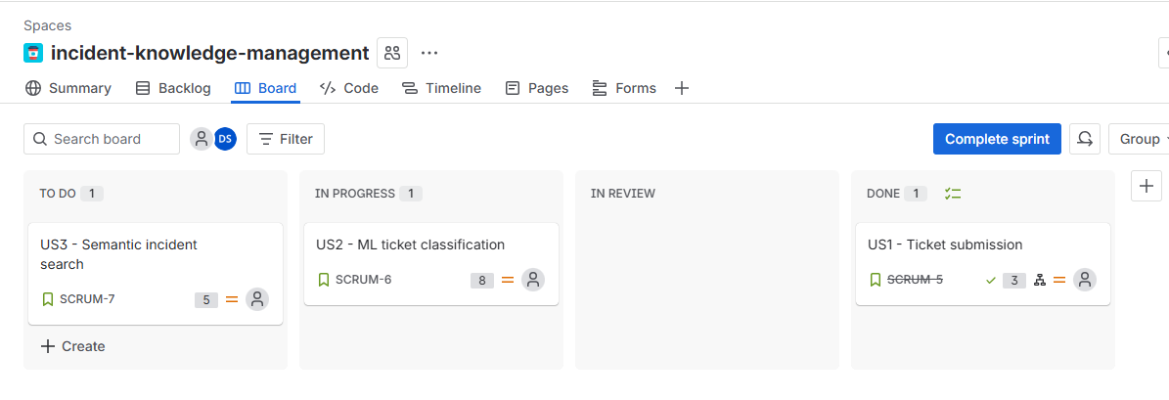
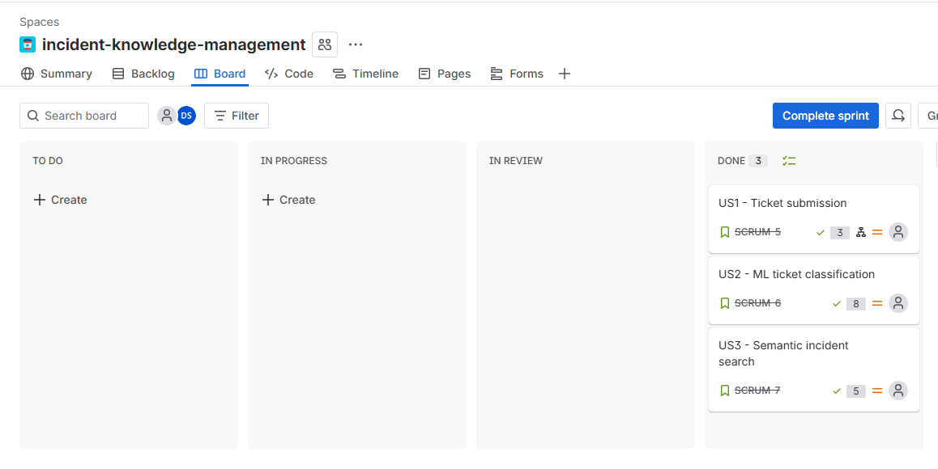
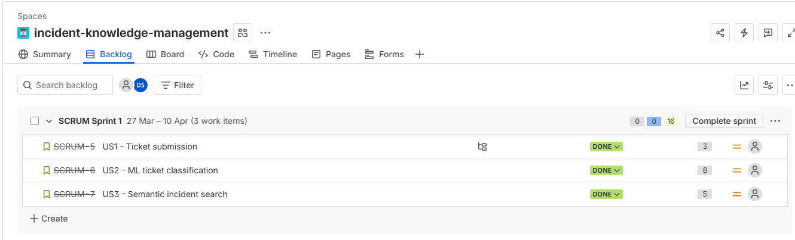

Velocity Calculation
- Velocity is defined as the total number of story points completed in a sprint.
- Based on the simulation, all planned story points were considered completed in each sprint.
Velocity per Sprint:
- Sprint 1 Velocity = 16 story points
- Sprint 2 Velocity = 16 story points
- Sprint 3 Velocity = 13 story points

Average Velocity
- The average velocity was calculated using the formula:
Average Velocity = (16 + 16 + 13) / 3 = 15 story points (approx)
- This indicates that the team can realistically complete around 15 story points per sprint.

Conclusion
- Sprint planning was performed using an assumed velocity of 20 story points.
- Actual (simulated) velocity was slightly lower at approximately 15 story points.
- This demonstrates that initial estimates may differ from actual outcomes and highlights the importance of adjusting future sprint plans based on observed velocity.

