Project Proposal

(i.)

Application Name: Apartment Homes

Team Members:

Archana Yadawa – ayadawa@gmail.com

Lingfang Gao – lingfang.gao@gmail.com

Sandeep Samra – ssamra1094@gmail.com

Daksha Divakar – dakshadivak@gmail.com

Sridivya Kondapalli – sridivya20@gmail.com

Our application will be a platform for apartment searching. This application will allow users to easily search for apartments according to their requirements/expectations. It will filter out options for users and provide them with the best apartment choices. All information inputted by users will be saved in a domain database.

(ii.) The domain for this project involves modeling apartments and their attributes, areas of town and their various characteristics. Some of these characteristics include: VTA bus lines, nearby stores and schools, distance from various landmarks etc.

(iii.) This application will be applicable to most people. Specifically, college students, workers, new residents, foreigners, and people trying to find an apartment. In general, this application will be an easy way for people to find their desired apartment. Therefore, anyone looking for an apartment will benefit from using our application.

(iv.) Our system will model many key aspects to make our application as accessible as possible. For example, users will be able to search for the best price and enter their desired location. Users will also be able to filter certain criterias they are looking for, so that the suggested apartments provided will be close matches to the users desired choices. This way the users won’t have to look through a huge list of choice that don’t satisfy their minimal requirements; overall, making apartment searching as accessible as possible. After the users filter out their desired specifications, there will be a list of related apartments shown that will display the price, size (sqft), availability, location, floor plan, etc. However, there are some aspects that our system will not model. These aspects include: crime rates and leasing information.

(v.)

Ground Rules:

1. All Ideas are accepted with open minds.

2. Every team decision must be mutual between all members of the group.

3. For every team meeting a facilitator, recorder, and participant roles must be established (continuously changing during meetings).

4. Every team member must participate during every meeting

5. Everyone must be respectful and understanding of everyone’s personal lives.

Team Meeting Requirements/Rules:

1. Establish facilitator, participant, and recorder roles for that particular meeting.

2. Everyone must arrive in a timely manner in order to finish on time.

3. Everyone must participate in every team meeting

4. All opinions and ideas are respected and taken into consideration,

5. Meeting notes will be shared on a google doc by recorder.

(vi.)

Other “value-added” facilities that our system can support:

1. Crime rate of the area around apartments

2. Distance of schools from the apartment complex

3. VTA bus lines

4. Availability of different utilities such as laundry, gas heating, AC, gym in the apartments

5. Distance from various landmarks such as Adventure Parks, Zoo, Beaches, etc.

ER Diagram:

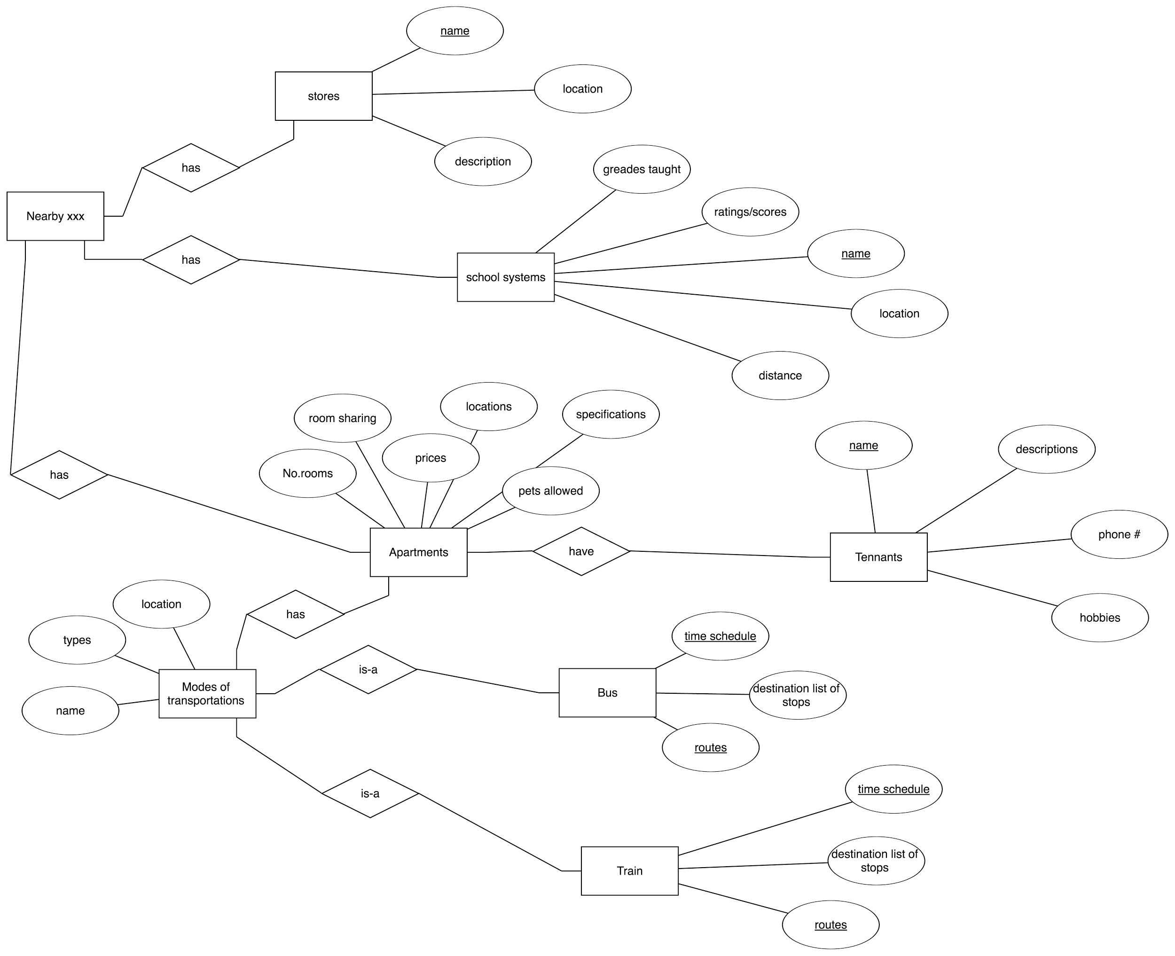

5. Explanations

Entity : Stores

Each store has a name, location and description.

Entity: School Systems

Each school system has the grades that are taught, rating or scores, its name, location and distance.

Entity: Nearby XXX

Within a certain distance from the apartment of interest, there are some schools and stores.

Entity: Apartments

Each apartment has a specific number of rooms, an option to allow room sharing or not, a price, location, specification, and can either allow pets or not. An apartment has some schools and stores within a certain distance. An apartment can also have tenants and a certain mode of transportation that is accessible.

Entity: Tenants

Each tenant has a name, description, phone number and hobbies.

Entity: Modes of Transportation

Each mode of transportation has a location, type and name. The mode of transportation is either a bus or train.

Entity: Bus

Each bus has a time schedule, a destination list of stops, and routes.

Entity: Train

Each train has a time schedule, a destination list of stops, and routes.

6. Constraints and Restrictions that our Domain can pose are:

* Our domain would not be giving details like size of bedrooms and restrooms.
* The domain would also not show the list of small scale restaurants, stores, etc.
* Since the project is combining both apartments homes and bus lines, keeping balance of equal information for both might be hard.
* The crime rates for different areas would not be accurate because these factors can always vary.