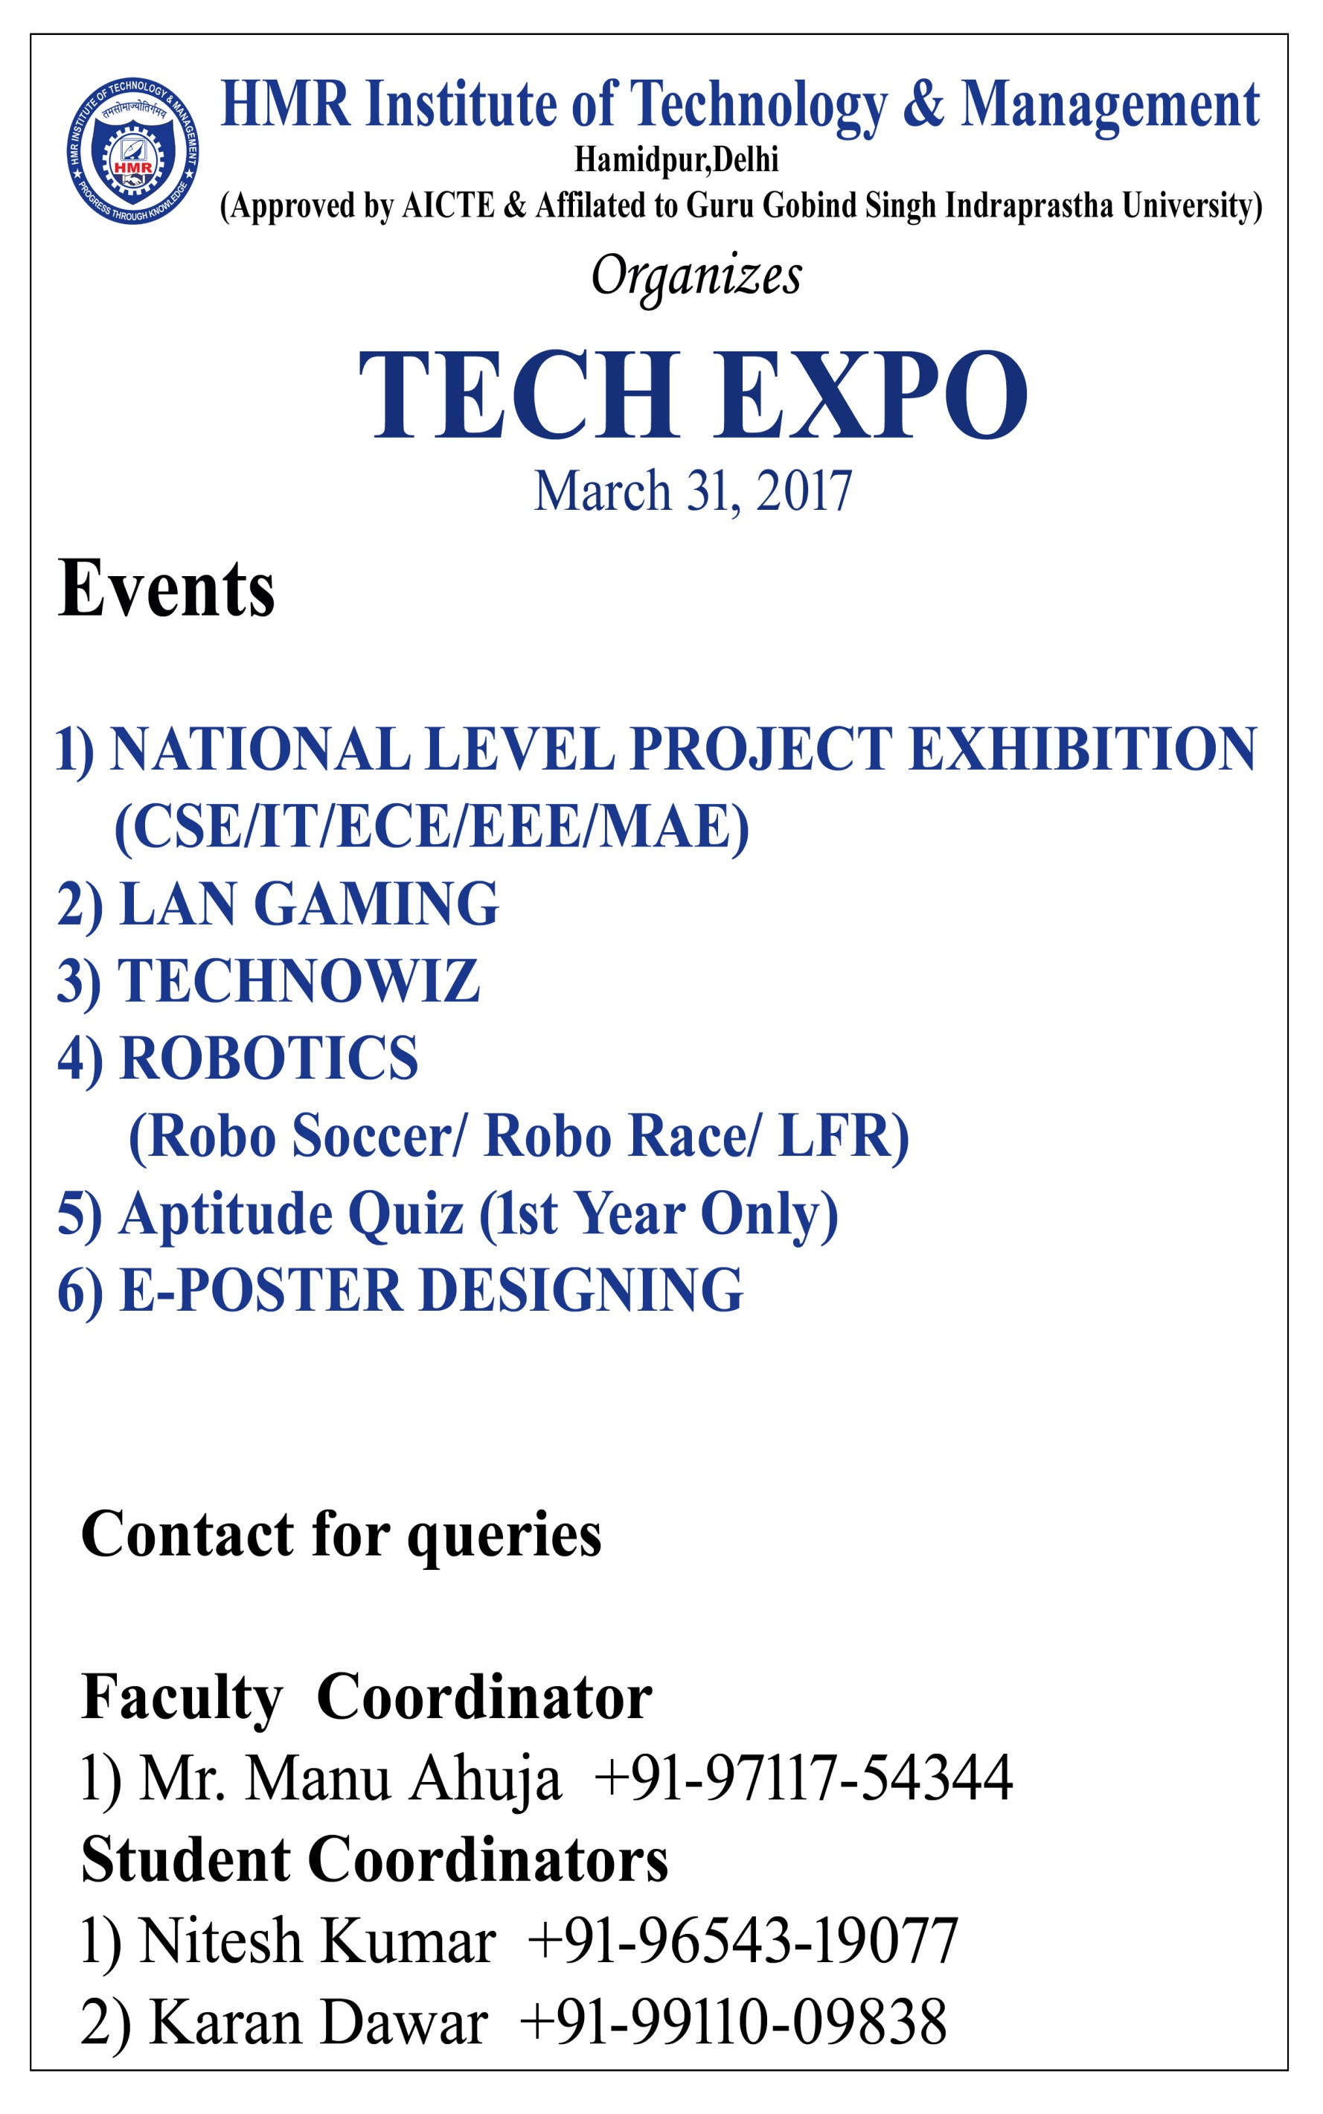

**SYNOPSIS OF MINOR PROJECT**

**Date :** August 14, 2017

**Minor Project Title :** Next Word Prediction Model

**Name of Guide :** Mrs. Chitra Nasa

|  |  |  |  |
| --- | --- | --- | --- |
| Programme :- **B.Tech CSE** | | Year/Semester :- **7th Semester** | |
| S.No | Enrollment No. | Name | Signature |
| 1) | 11813302714 | Shivani Singh |  |
| 2) | 12813302714 | Divyanka Latwal |  |
| 3) | 30413302714 | Karan Dawar |  |

**Minor Project Summary :**

**Resource Requirement :**

**Schedule of Minor Project work Completion :**

Signature of Student(s) Signature of Guide Signature of Proctor

**Approval by Board of Faculty**

|  |  |  |
| --- | --- | --- |
| Member | Signature | Remark(Approved/Not Approved) |
|  |  |  |

**Content**

1. **Abstract**
2. **Introduction**
3. **Objective Of Project**
4. **Technology Used**
5. **Reference**

**Abstract**

In recent years there has been an increasing interest in technology applications for students with high-incidence disabilities including those with writing difficulties. Writing is a very complex skill and students may experience difficulties with any of its aspects: from mechanics to written content expression. However, it is evident that computer-related technologies may enable those students to bypass their deficits and support them though all stages of the writing process

**Introduction**

Natural language processing (NLP) is a field of [computer science](https://en.wikipedia.org/wiki/Computer_science), [artificial intelligence](https://en.wikipedia.org/wiki/Artificial_intelligence) and [computational linguistics](https://en.wikipedia.org/wiki/Computational_linguistics) concerned with the interactions between [computers](https://en.wikipedia.org/wiki/Computer) and [human (natural) languages](https://en.wikipedia.org/wiki/Natural_language), and, in particular, concerned with programming computers to fruitfully process large [natural language corpora](https://en.wikipedia.org/wiki/Corpus_linguistics). NLP is not any use for word prediction but things like spam detection, POS tagging, NER, sentiment analysis, machine translation, summarization, the Turing test, and more.

**Objective of Project**

Next word prediction model is an application which is trained on large amount of text data to predict next word based on previous words. Main objective is to build Word Prediction Software for Students with Writing Difficulties. To build intelligent computers which can interact with human being like a human being.

**Technology Used**

R Language

Shiny Server ( Use for Deployment of Project / For GUI Purpose )

**References**

[**https://nlp.stanford.edu**](https://nlp.stanford.edu)

[**https://www.ncbi.nlm.nih.gov**](https://www.ncbi.nlm.nih.gov)