# 

**S.I.E.S College of Arts, Science and Commerce (Autonomous)**

**Sion(W), Mumbai – 400 022.**

**CERTIFICATE**

This is to certify that Miss./Mr SAHAYA DIVINA

Roll No. FCS2425088 has successfully completed the necessary course of experiments in  the subject of Programming with C during the academic year 2024-2025 complying with the requirements of University of Mumbai, for the course of

FYBSC Computer Science [Semester-II].

Prof. In-Charge

**Manoj Singh**

**(**Programming with C**)**

Examination date:

Examiner’s Signature & Date

Head of the Department College Seal

**Prof. Manoj Singh**

**Index Page**

|  |  |  |
| --- | --- | --- |
| **Sr no** | **Title** | **Date** |
| **1** | Basic Programs (Variables, Operators):  A. Write a program to find the addition, subtraction, multiplication, and division of two numbers.  B. Write a program to find the area of rectangle, square and circle.  C. Write a program to find the volume of a cube, sphere, and cylinder. |  |
| **2** | Programs to demonstrate data input and output functions |  |
| **3** | Conditional statements and loops  A. Write a program to check whether the number is even or odd.  B. Write a program to check whether the number is positive, negative or zero.  C. Write a program to find the sum of squares of digits of a number.  D. Write a program to reverse the digits of an integer. |  |
| **4** | Programs on Functions. |  |
| **5** | Recursive functions  1. Write a program to find the factorial of a number using a recursive function.  2. Write a program to find the sum of natural numbers using a recursive function. |  |
| **6** | Arrays  A. Write a program to find the largest value that is stored in the array.  B. Write a program using pointers to compute the sum of all elements stored in an array.  C. Write a program to arrange the ‘n’ numbers stored in the array in ascending and descending order. |  |
| **7** | Pointers  A. Write a program to demonstrate the use of pointers.  B. Write a program to perform addition and subtraction of two pointer variables. |  |
| **8** | Programs on File Handling  A. Write a program to Create a File, Write in it, And Close the File.  B. Write a program to Open a File, Read from it, And Close the File |  |

Practical No:1

Aim: Basic Programs (Variables, Operators):

A. Write a program to find the addition, subtraction, multiplication, and division of two numbers.

B. Write a program to find the area of rectangle, square and circle.

C. Write a program to find the volume of a cube, sphere, and cylinder.

**CODE:**

A. Write a program to find the addition, subtraction, multiplication, and division.

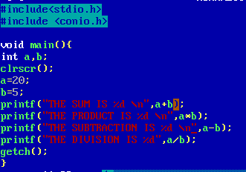

**Output:**

**CODE:**

B. Write a program to find the area of rectangle, square and circle.

.Area of the rectangle

**Output:**



. Area of the square.

**Output:**



. Area of circle.

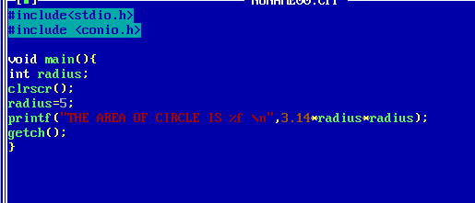

**Output:**



Practical No:2

Aim:

A. Programs to demonstrate data input and output functions.

B. Programs to manipulate strings.

**CODE**:

1. Programs to demonstrate data input and output functions.

**Output:**



Practical No:3

Aim: Conditional statements and loops

A. Write a program to check whether the number is even or odd.

B. Write a program to check whether the number is positive, negative or zero.

C. Write a program to find the sum of squares of digits of a number.

D. Write a program to reverse the digits of an integer.

**CODE:**

A. Write a program to check whether the number is even or odd.

**OUTPUT:**

**CODE:**

B. Write a program to check whether the number is positive, negative or zero.

**OUTPUT:**



**CODE:**

C. Write a program to find the sum of squares of digits of a number.

**OUTPUT:**



**CODE:**

D. Write a program to reverse the digits of an integer.

**OUTPUT:**

Practical No:4

Aim: Programs on Functions.

**CODE:**

**OUTPUT:**

Practical No:5

Aim: Recursive functions

1. Write a program to find the factorial of a number using a recursive function.

2. Write a program to find the sum of natural numbers using a recursive function.

**CODE:**

1. Write a program to find the factorial of a number using a recursive function.

**OUTPUT:**



**CODE:**

2. Write a program to find the sum of natural numbers using a recursive function.

**OUTPUT:**



Practical No:6

Aim: Arrays

A. Write a program to find the largest value that is stored in the array.

B. Write a program using pointers to compute the sum of all elements stored in an array.

C. Write a program to arrange the ‘n’ numbers stored in the array in ascending and descending order.

**Code:**

A. Write a program to find the largest value that is stored in the array.

**Output:**



**Code:**

1. Write a program using pointers to compute the sum of all elements stored in an array.

**Output**



C. Write a program to arrange the ‘n’ numbers stored in the array in ascending and descending order.

**Output:**



Practical No:7

Aim: pointers

A. Write a program to demonstrate the use of pointers.

B. Write a program to perform addition and subtraction of two pointer variables.

**Code:**

A. Write a program to demonstrate the use of pointers.

**Output:**

**Code:**

B. Write a program to perform addition and subtraction of two pointer variables.

Output:

Practical No:10

Aim: File handling

A. Write a program to Create a File, Write in it, And Close the File.

B. Write a program to Open a File, Read from it, And Close the File.

**Code:**

1. Write a program to Create a File, Write in it, And Close the File.

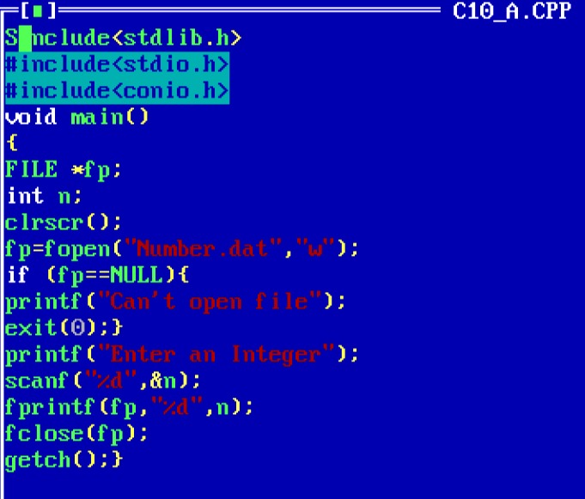

Output:



**Code:**

1. Write a program to Open a File, Read from it, And Close the File

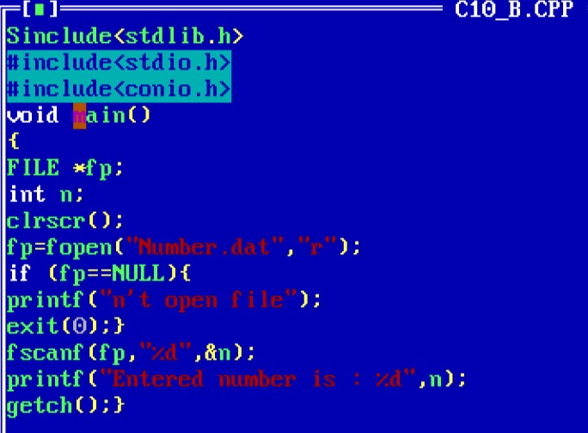

**Output:**

