Google Maps Add API (POST):

This API Will add new place into Server

**Complete URL :** [https://rahulshettyacademy.com](https://rahulshettyacademy.com/)**/maps/api/place/add/json?key=** **qaclick123**

**Base URL**: [https://rahulshettyacademy.com](https://rahulshettyacademy.com/)

**Resource**: /maps/api/place/add/json

**Query Parameters**: key=qaclick123

**Http Method**: POST

**Sample Body** :

{

  "location": {

    "lat": -38.383494,

    "lng": 33.427362

  },

  "accuracy": 50,

  "name": "Frontline house",

  "phone_number": "(+91) 983 893 3937",

  "address": "29, side layout, cohen 09",

  "types": [

    "shoe park",

    "shop"

  ],

  "website": "http://google.com",

  "language": "French-IN"

}

**Sample Response**

{

    "status": "OK",

    "place_id": "928b51f64aed18713b0d164d9be8d67f",

    "scope": "APP",

    "reference": "736f3c9bec384af62a184a1936d42bb0736f3c9bec384af62a184a1936d42bb0",

    "id": "736f3c9bec384af62a184a1936d42bb0"

}

Google Maps get Place  API   (GET):

**This API Will get existing place details from Server**

**Complete URL :** http://rahulshettyacademy.com/maps/api/place/get/json?place_id=xxxx&key=qaclick123

**Base URL**: [https://rahulshettyacademy.com](https://rahulshettyacademy.com/)

**Resource**: /maps/api/place/get/json

**Parameters**:

**key**=qaclick123

**place_id=**  (place_id value comes from Add place response – see screen shot below)

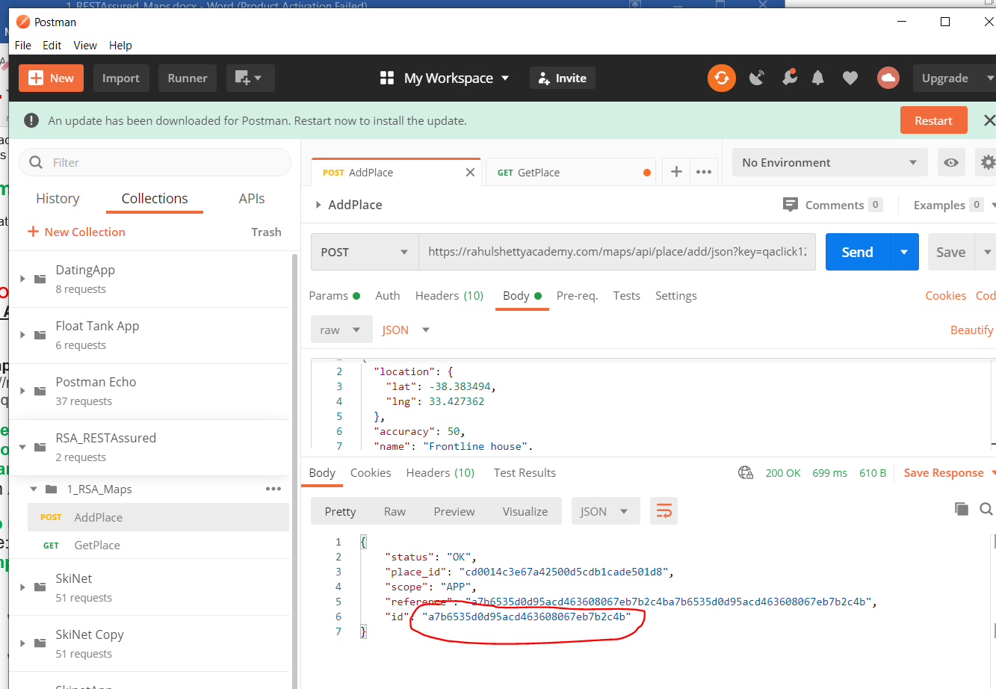

**Http request**: GET

Note: Key value is hardcoded and it is always qaclick123

**Sample Response for the Provided Place_Id**

{

     "location":{

     "lat" : -38.383494,

     "lng" : 33.427362

     },

     "accuracy":50,

     "name":"Frontline house",

     "phone_number":"(+91) 983 893 3937",

     "address" : "29, side layout, cohen 09",

     "types": ["shoe park","shop"],

     "website" : "http://google.com",

     "language" : "French-IN"

}

Google Maps Delete API (POST):

This API Will delete existing place from Server

**Complete URL**: https://rahulshettyacademy.com/maps/api/place/delete/json?key=qaclick123

**Base URL**: https://rahulshettyacademy.com

**Resource**: /maps/api/place/delete/json

**Query Parameters:**

key=qaclick123

**Http request** : POST

**Sample Body** :

{

    "place_id":"928b51f64aed18713b0d164d9be8d67f"   //(This value comes from Add place response)

}

**Sample Response**

{

    "status": "OK"

}

Google Maps Put Place API  (PUT):

This API Will update existing place in Server with new values

**Complete URL :** http://rahulshettyacademy.com/maps/api/place/get/json?place_id=xxxx&key=qaclick123

**Base URL** : [https://rahulshettyacademy.com](https://rahulshettyacademy.com/)

**Resource**: /maps/api/place/update/json

**Query Parameters**:

**Key**=qaclick123

**place_id** //(place_id  value comes from Add place response)

**Http Method**: PUT

Note: Key value is hardcoded and it is always qaclick123

**Sample Request:**

{

"place_id":"8d2573bdf6ceec0e474c5f388fa917fb",

"address":"70 winter walk, USA",

"key":"qaclick123"

}

**Sample Response for the Provided Place_Id**

{

     "location":{

     "lat" : -38.383494,

     "lng" : 33.427362

     },

     "accuracy":50,

     "name":"Frontline house",

     "phone_number":"(+91) 983 893 3937",

     "address" : "29, side layout, cohen 09",

     "types": ["shoe park","shop"],

     "website" : "http://google.com",

     "language" : "French-IN"

}