[1] Create a new folder for you NightWatch project

[2] Open Visual Studio Code and navigate to folder created in step [1].

[3] Create a new file called:-

nightwatch.js

[4] Add this line to the nightwatch.js file:-

require("./node_modules/nightwatch/bin/runner.js");

[5] Open integrated terminal and type:-

npm init

Update the ‘package.json’ file ‘scripts > test’ section as follows:-

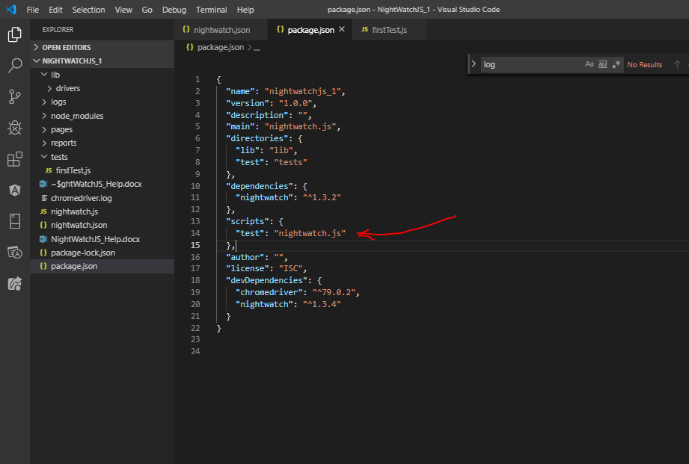

[6] Then install NightWatchJS:-

npm install nightwatch --save

[7] in your project create the following 3 folders:-

lib

pages

tests

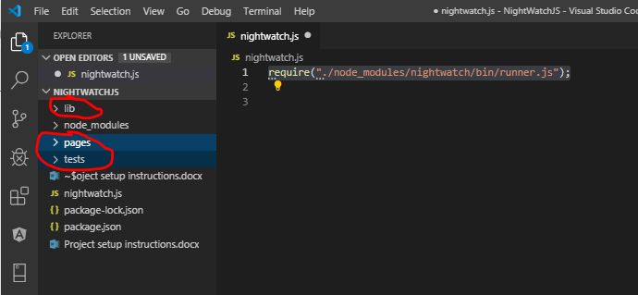

[8] Under the ‘lib’ folder create another folder called ‘drivers’.

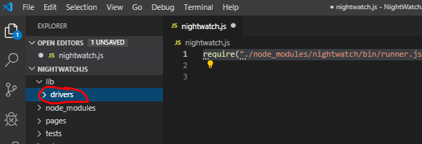

[9] Download ‘Selenium Standalone Server’ from this web address:-

<https://selenium.dev/downloads/>

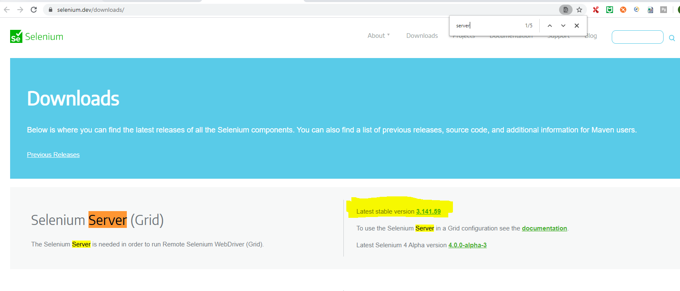

[10] Download the Chrome driver from here:-

<https://chromedriver.chromium.org/downloads>

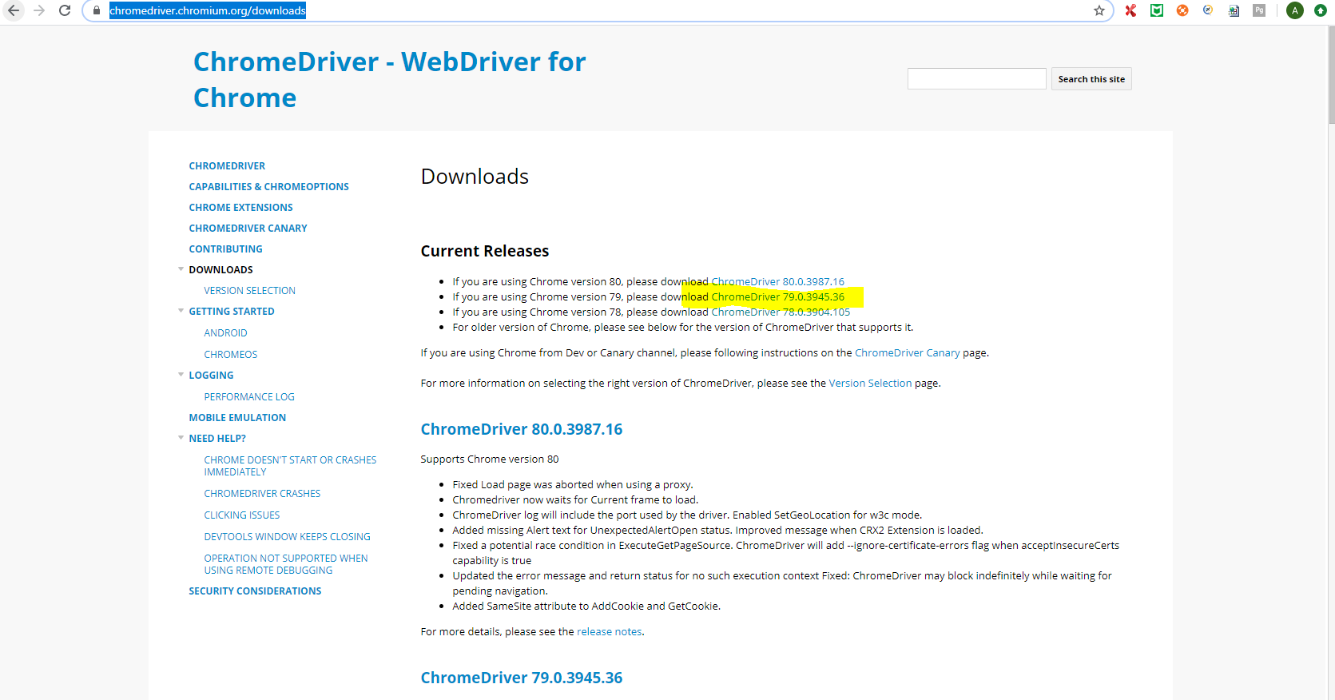

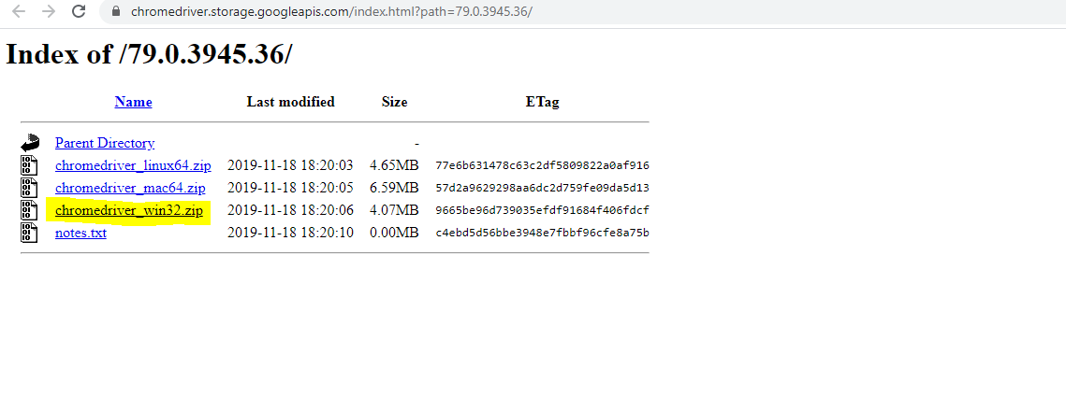

[11] When both files are downloaded extract the Chromedriver .zip file. Then copy the files to the ‘lib -> drivers’ folder:-

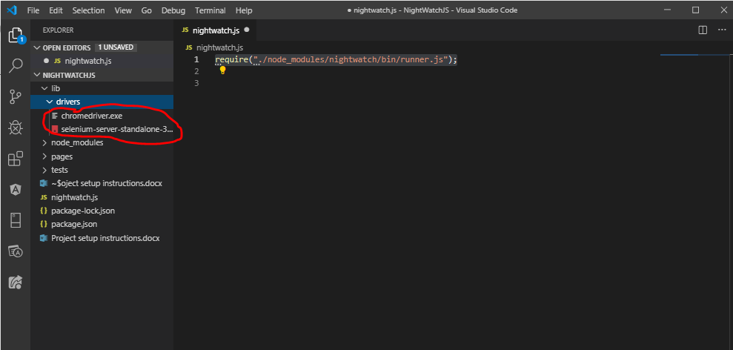

[12] Create a ‘nightwatch.json’ file:-

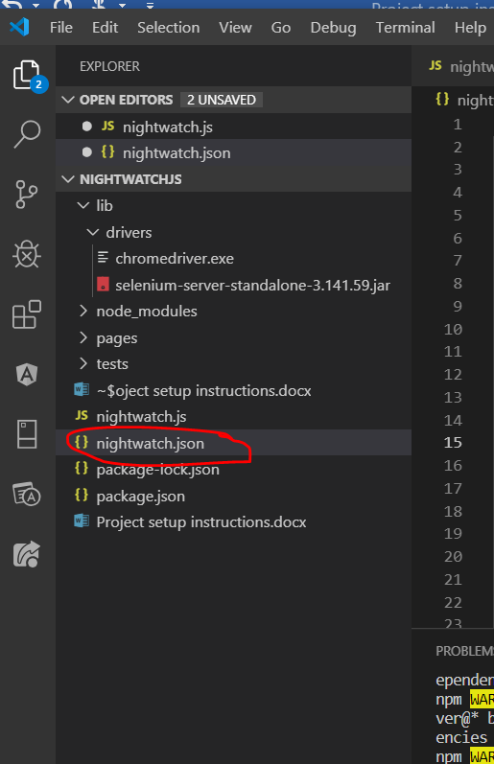

[13] Add the following content to the file:-

{

  "src_folders": ["tests"],

  "output_folder": "reports/XMLReports",

  "custom_commands_path": "",

  "custom_assertions_path": "",

  "page_objects_path": "pages",

  "selenium": {

    "start_process": true,

    "server_path": "lib/drivers/selenium-server-standalone-3.141.59.jar",

    "start_session": true,

    "log_path": "log/",

    "host": "127.0.0.1",

    "port": 4444,

    "cli_args": {

      "webdriver.chrome.driver": "lib/drivers/chromedriver.exe"

    }

  },

  "test_settings" : {

      "chrome": {

          "launch_url": "http://localhost",

          "selenium_port": 4444,

          "selenium_host": "localhost",

          "silent": true,

          "screenshots": {

            "enabled": false,

            "path": "screenshots/Chrome/"

          },

          "desiredCapabilities": {

            "browserName": "chrome",

            "chromeOptions": {

              "args": [

                "disable-web-security",

               "ignore-certificate-errors",

               "--test-type"

              ],

              "w3c": false

            },

            "loggingPrefs": {"driver": "INFO", "server": "OFF", "browser": "INFO"}

          }

        },

    "edge" : {

      "desiredCapabilities": {

        "browserName": "MicrosoftEdge"

      }

    }

  }

}

You will need to change the following to the selenium standalone server version number:-

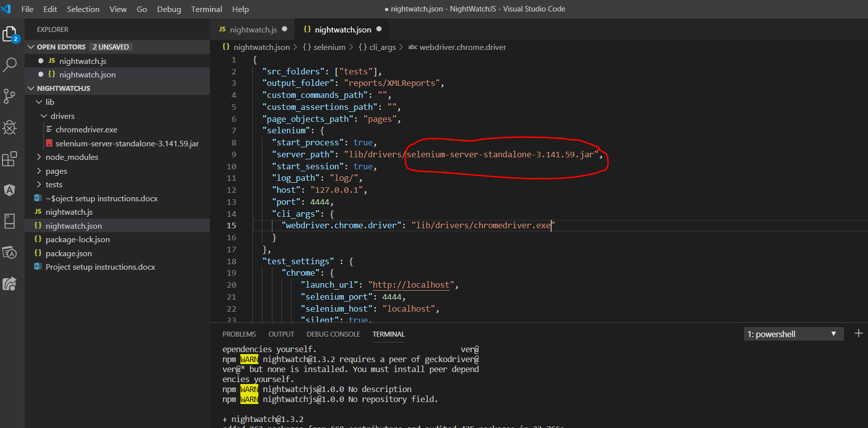

[14] Under the ‘test’ folder create the following file:-

firstTest.js

module.exports = {

  tags: ['hacker'],

  'My first test case'(browser) {

    browser

      .url('https://news.ycombinator.com/')

      .waitForElementVisible('.hnname')

      .assert.containsText(".hnname", "Hacker News")

  }

}

[15] Run tests by typing:-

node nightwatch -e chrome -a hacker

[16] Create a .gitignore file – this contains all files you do not want to commit to Git:-

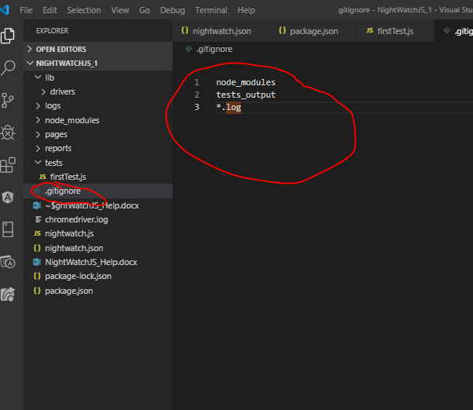

node_modules

tests_output

*.log

[17] To run a single test case type the following into the integrated terminal:-

Add a tag to testcase:-

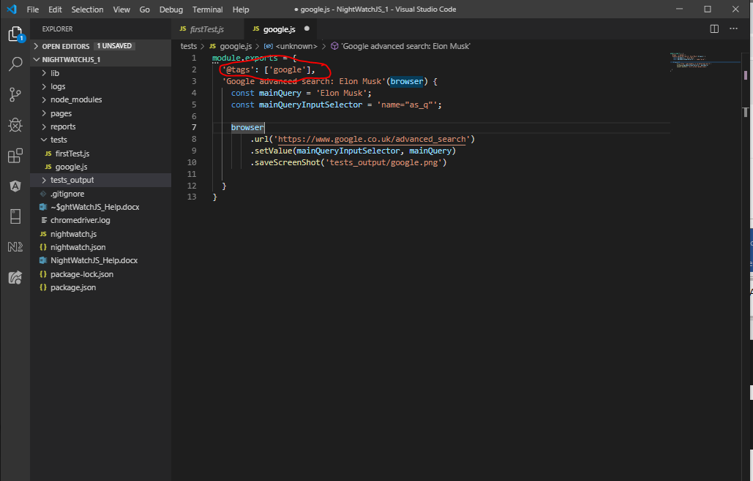

Then run test from command line like this:-

npm test -- --tag google

To find out where something is installed type the following:- (this example to find the location of where NightWatchJS is installed)

*npx which nightwatch*

[18] Debugging NightWatch:-

Enter the following line into package.json file:-

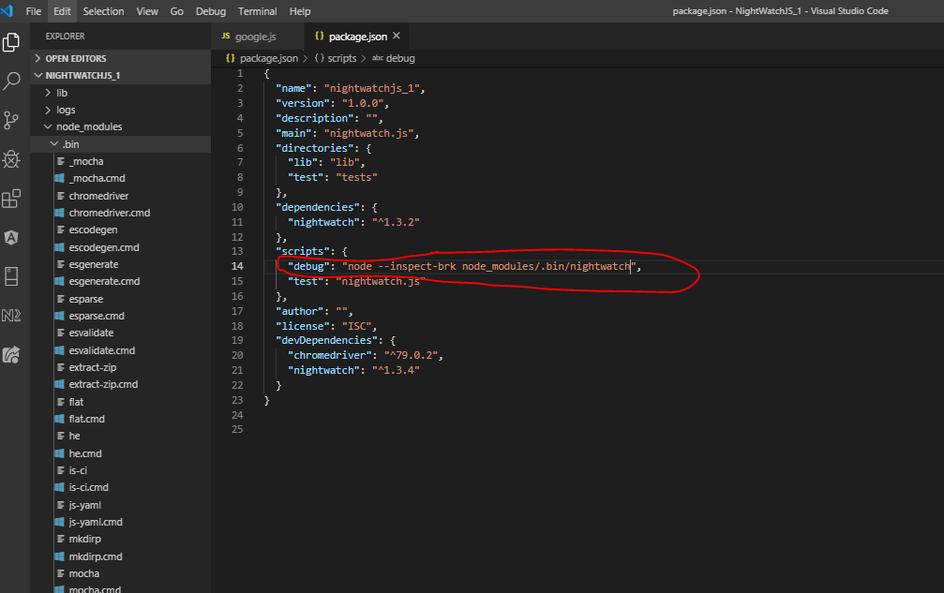

  "scripts": {

    "debug": "node --inspect-brk node_modules/.bin/nightwatch",

    "test": "nightwatch.js"

  },

To run debug mode type the following into the integrated terminal:-

npm run debug

Then open a Chrome browser and enter the following <url:->

<chrome://inspect/#devices>

Click the ‘inspect’ link:-

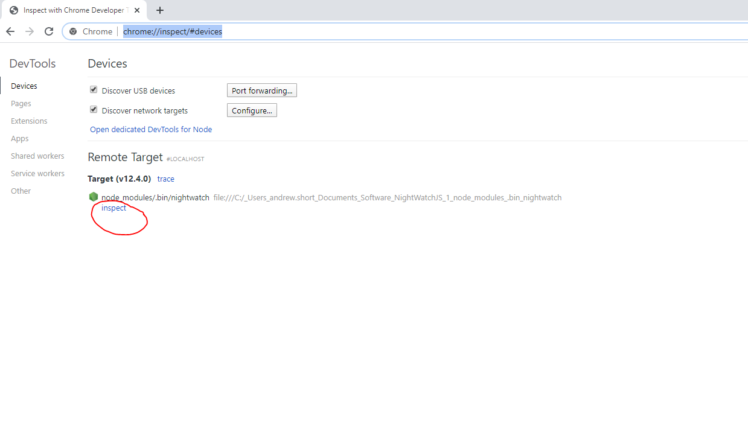

This brings up the following:-

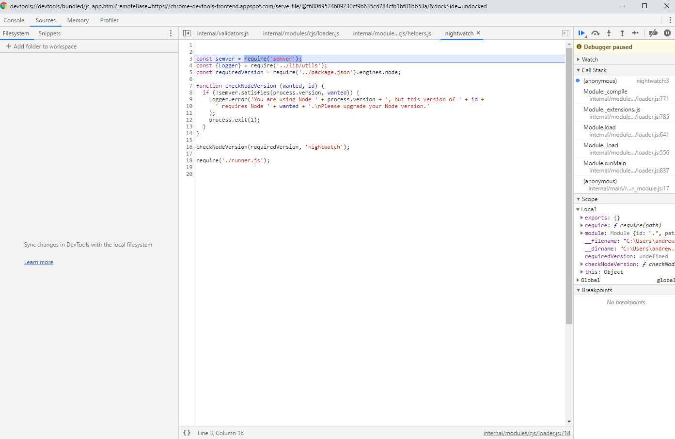

Add a debugger statement in your code so that when clicking the ‘Play’ icon the code stops at the debugger statement:-

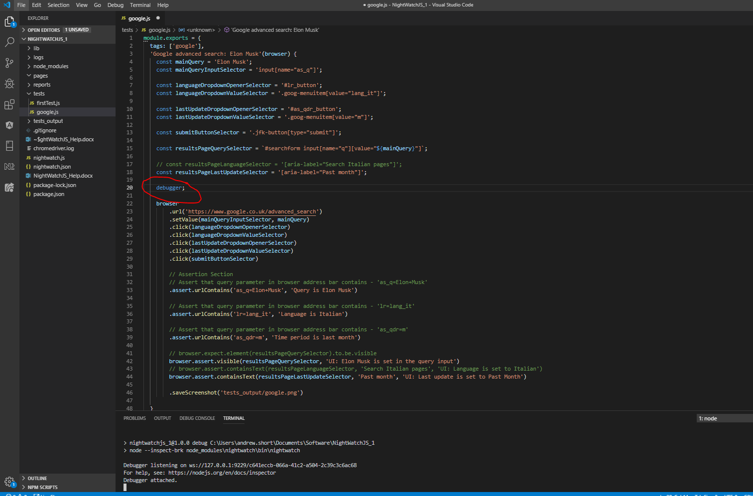

Click the play icon:-

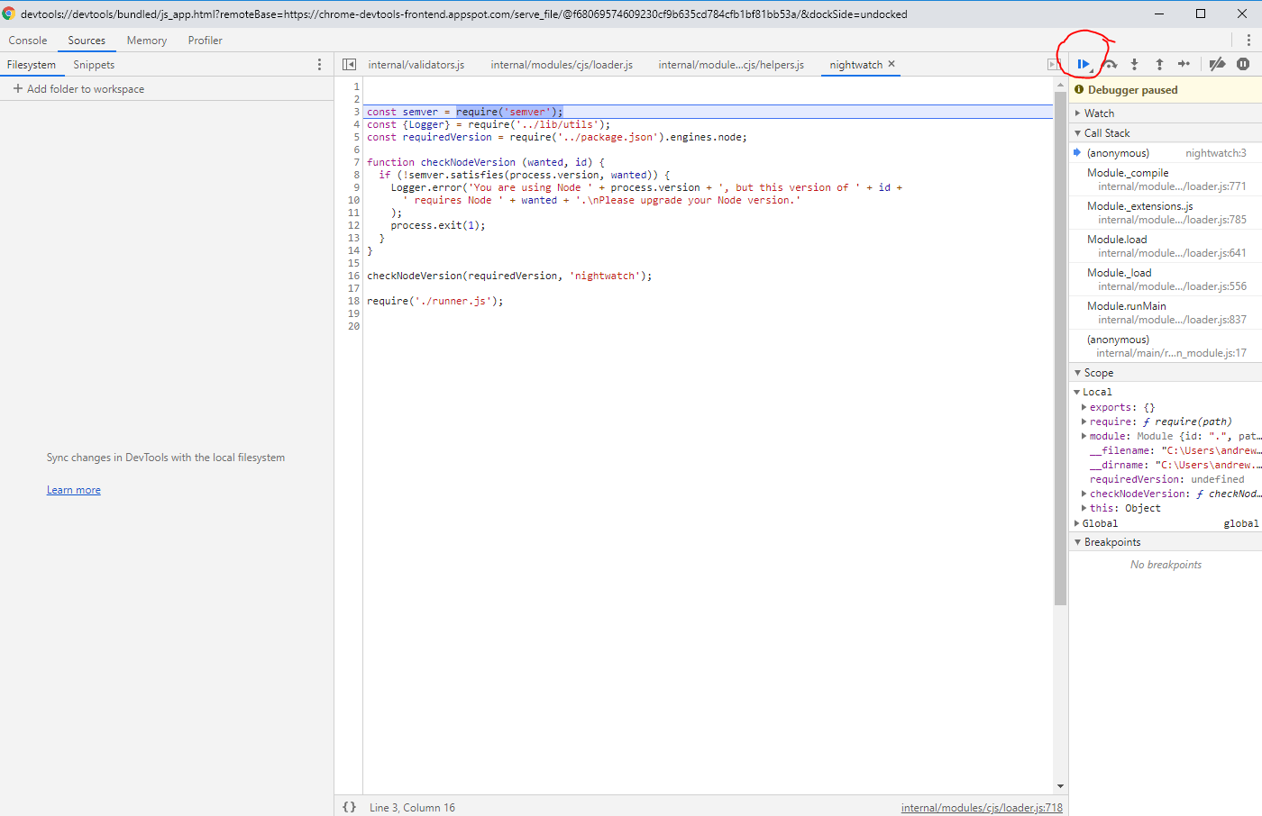

[19] Creating Page Objects:-

<https://nightwatchjs.org/guide/working-with-page-objects/>

Add the following line to the ‘nightwatch.json’ file:-

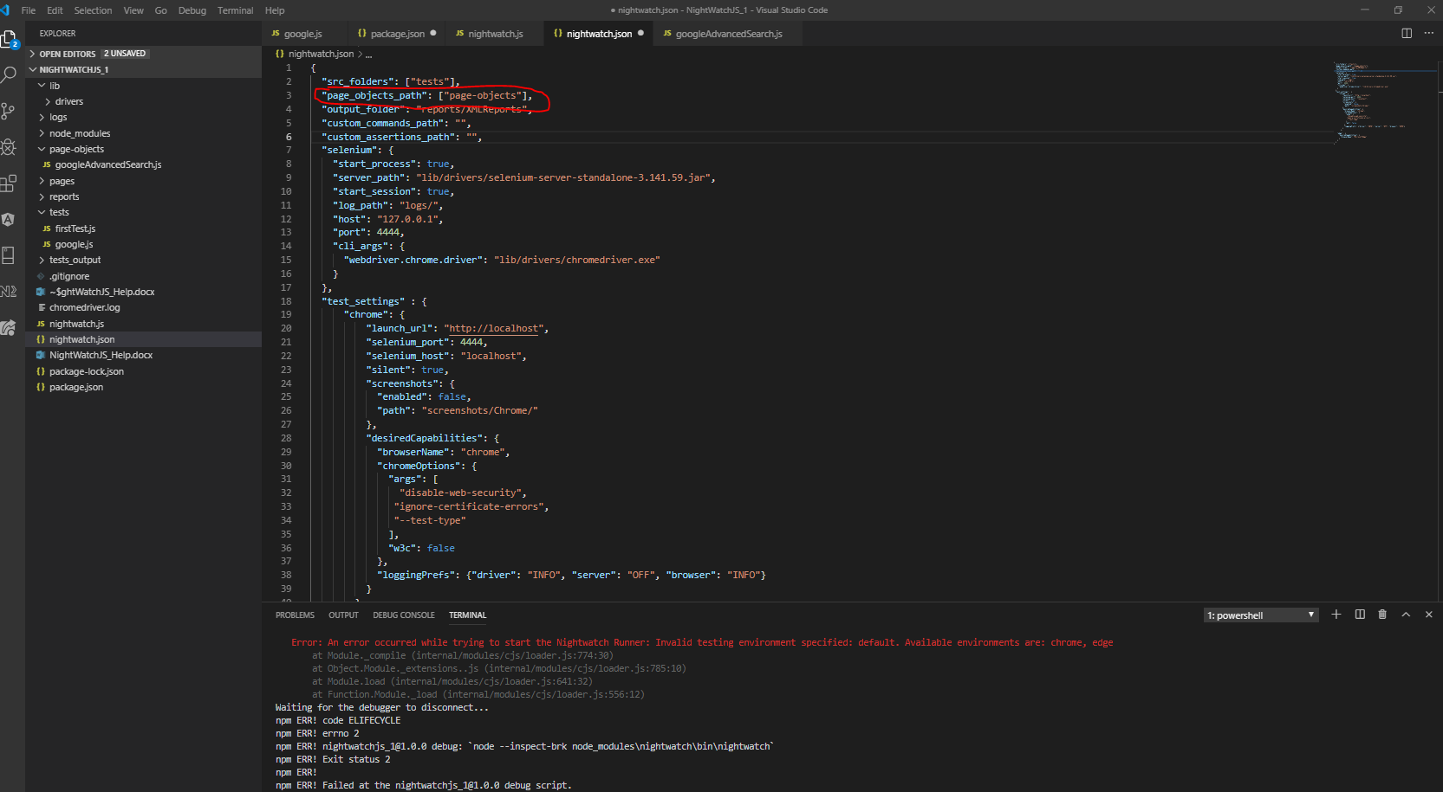

Create the following folder and file:-

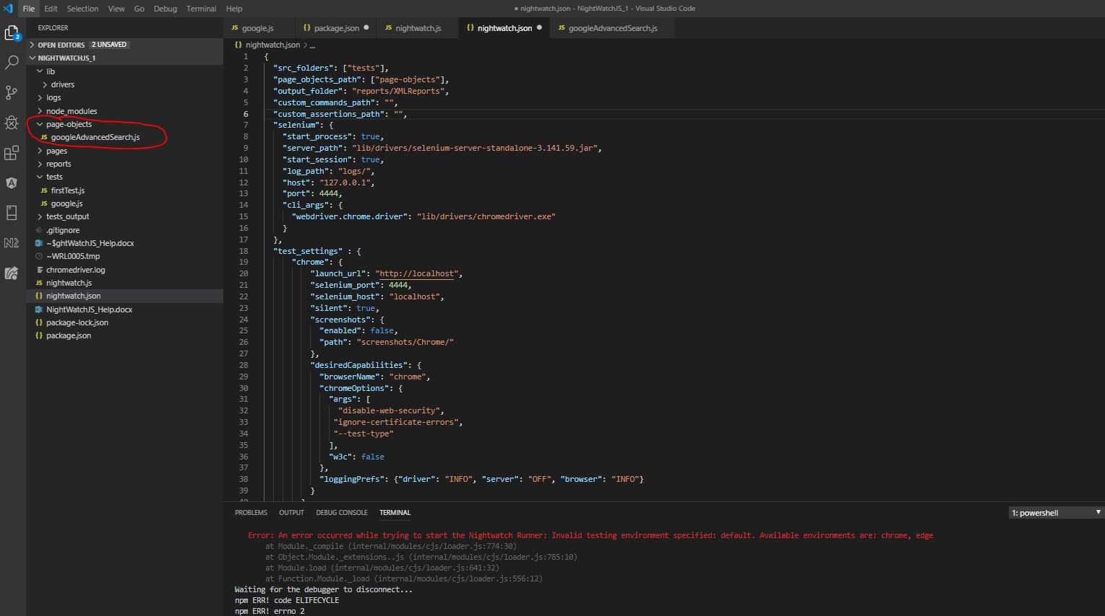

Add the following code to the ‘googleAdvancedSerach.js’ file:-

module.exports = {

  url: 'https://www.google.co.uk/advanced_search',

  elements: {

    mainQueryInput: 'input[name="as_q"]',

    languageDropdown: '#lr_button',

    lastUpdateDropdown: '#as_qdr_button',

    submitButton: '.jfk-button[type="submit"]',

  },

  commands: [{

    setQuery(value) {

      return this

        .setValue('@mainQueryInput', value);

    },

    selectFilter(selector, value) {

      return this

        .click(selector)

        .click(`.goog-menuitem[value="${value}"]`);

    },

    search() {

      return this

        .click('@submitButton');

    }

  }]

};

Created the following testcase file (google-using-page-objects.js):-

module.exports = {

  tags: ['googleUsingPageObjects'],

  'Google advanced search: Elon Musk'(browser) {

    const mainQuery = 'Elon Musk';

    const googlePage = browser.page.googleAdvancedSearch();

    const resultsPageQuerySelector = `#searchform input[name="q"][value="${mainQuery}"]`;

    // const resultsPageLanguageSelector = '[aria-label="Search Italian pages"]';

    const resultsPageLastUpdateSelector = '[aria-label="Past month"]';

    //debugger;

    googlePage

        .navigate()

        .setQuery(mainQuery)

        .selectFilter('@languageDropdown', 'lang_it')

        .selectFilter('@lastUpdateDropdown', 'm')

        .search();

    browser

        // Assertion Section

        // Assert that query parameter in browser address bar contains - 'as_q=Elon+Musk'

        .assert.urlContains('as_q=Elon+Musk', 'Query is Elon Musk')

        // Assert that query parameter in browser address bar contains - 'lr=lang_it'

        .assert.urlContains('lr=lang_it', 'Language is Italian')

        // Assert that query parameter in browser address bar contains - 'as_qdr=m'

        .assert.urlContains('as_qdr=m', 'Time period is last month');

    // browser.expect.element(resultsPageQuerySelector).to.be.visible

    browser.assert.visible(resultsPageQuerySelector, 'UI: Elon Musk is set in the query input')

    // browser.assert.containsText(resultsPageLanguageSelector, 'Search Italian pages', 'UI: Language is set to Italian')

    browser.assert.containsText(resultsPageLastUpdateSelector, 'Past month', 'UI: Last update is set to Past Month')

    browser.saveScreenshot('tests_output/google.png')

  }

}

Run the test by typing the following into the integrated terminal:-

*node nightwatch -e chrome -a googleUsingPageObjects*