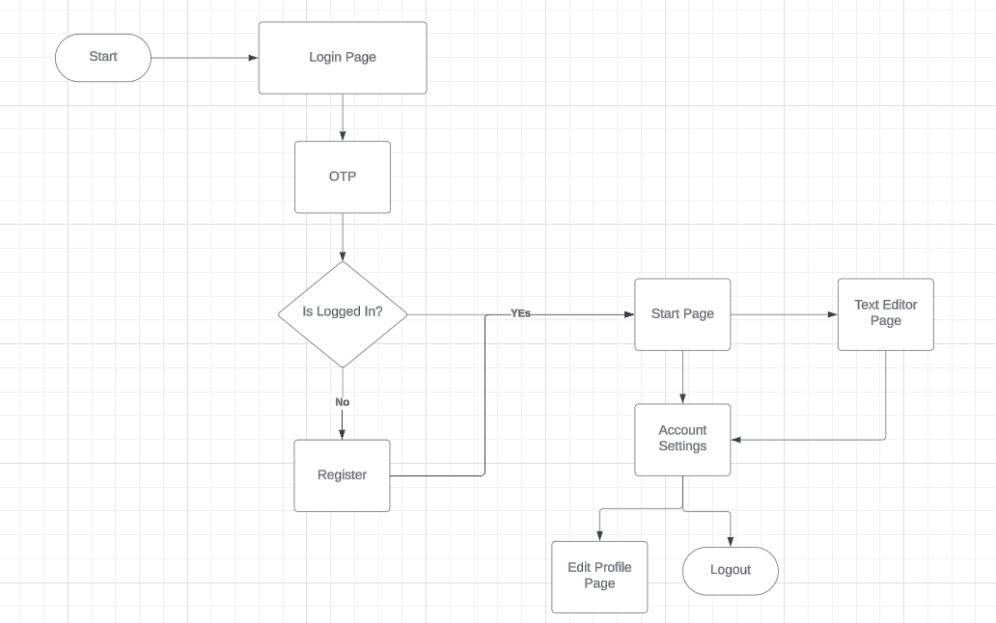

**Technology: A Comprehensive Report** 1

**1. Introduction** 1

**2. Historical Evolution of Technology** 2

**2.1 Ancient Innovations** 2

**2.2 Industrial Revolution** 2

**2.3 Digital Revolution** 2

**3. Key Areas of Technological Advancement** 2

**3.1 Information and Communication Technology (ICT)** 2

**3.2 Artificial Intelligence and Machine Learning** 2

**3.3 Biotechnology** 2

**3.4 Renewable Energy** 2

**3.5 Robotics and Automation** 2

**4. Impact of Technology on Society** 2

**4.1 Positive Impacts** 2

**4.2 Negative Impacts** 3

**5. Future Trends in Technology** 3

**5.1 Quantum Computing** 3

**5.2 Internet of Things (IoT)** 3

**5.3 Extended Reality (XR)** 3

**5.4 Ethical AI and Tech Regulation** 3

**6. Conclusion** 4

# Technology: A Comprehensive Report

## 1. Introduction

Technology refers to the application of scientific knowledge for practical purposes. From the invention of the wheel to artificial intelligence, technology has consistently shaped human civilization. In the 21st century, it influences every sector—from communication to healthcare. This report explores the evolution, trends, and implications of technology.

## 2. Historical Evolution of Technology

### 2.1 Ancient Innovations

Early humans created tools from stone and wood. The agricultural revolution brought irrigation systems and plows.

### 2.2 Industrial Revolution

The 18th–19th centuries saw mechanization via steam engines and electricity, transforming production and transportation.

### 2.3 Digital Revolution

Computers, the internet, and mobile devices reshaped communication and laid the foundation for today’s digital age.

## 3. Key Areas of Technological Advancement

### 3.1 Information and Communication Technology (ICT)

ICT encompasses computers, smartphones, networks, and software, enabling global connectivity.

### 3.2 Artificial Intelligence and Machine Learning

AI enables machines to mimic human intelligence, impacting industries with applications like virtual assistants and autonomous vehicles.

### 3.3 Biotechnology

Gene editing, sequencing, and synthetic biology revolutionize healthcare, agriculture, and environmental science.

### 3.4 Renewable Energy

Solar, wind, and hydroelectric energy reduce dependence on fossil fuels and combat climate change.

### 3.5 Robotics and Automation

Automation is growing in manufacturing and services. Robots perform tasks in surgeries, warehouses, and customer service.

## 4. Impact of Technology on Society

### 4.1 Positive Impacts

Technology improves communication, healthcare, education, and drives economic growth and innovation.

### 4.2 Negative Impacts

While technology offers numerous benefits, it also introduces significant challenges and concerns that warrant careful consideration. These include fundamental issues such as **data privacy**, the potential for widespread **job displacement** due to increasing automation, and the exacerbation of **digital inequality**, which creates a divide between those with access to technology and those without. Beyond these, there are growing concerns about the **mental health impacts** of constant connectivity and social media use. Addressing these negative consequences is crucial for ensuring technology develops responsibly and inclusively. Additional points of concern include:

* **Cybersecurity Risks**: The increasing reliance on digital systems makes individuals, businesses, and governments vulnerable to cyberattacks, data breaches, and identity theft.
* **Ethical Dilemmas in AI**: As AI becomes more sophisticated, questions arise regarding algorithmic bias, accountability for AI decisions, and the potential for autonomous systems to operate without sufficient human oversight.
* **Environmental Impact**: The production, use, and disposal of electronic devices contribute to e-waste, energy consumption, and the depletion of natural resources, posing significant environmental challenges.
* **Misinformation and Disinformation**: Digital platforms can amplify the spread of false or misleading information, impacting public discourse, social cohesion, and democratic processes.
* **Erosion of Human Connection**: Over-reliance on digital communication can sometimes diminish face-to-face interactions and foster feelings of isolation.
* **Privacy and Surveillance**: The vast amounts of data collected by technological platforms raise concerns about surveillance, individual privacy, and the potential for misuse of personal information.

## 5. Future Trends in Technology

### 5.1 Quantum Computing

Quantum computers will revolutionize data processing, cryptography, and simulations.

### 5.2 Internet of Things (IoT)

IoT links devices across homes, industries, and cities, enhancing automation and monitoring.

### 5.3 Extended Reality (XR)

VR, AR, and MR are transforming education, training, and entertainment experiences.

### 5.4 Ethical AI and Tech Regulation

Responsible AI use requires transparency, fairness, and international regulation to prevent harm.

## 6. Conclusion

Technology presents both opportunity and risk. Collaboration and ethical governance are essential to ensure inclusive and sustainable development.