Agent Walkthrough Guide
This guide provides a step-by-step walkthrough of the agent workflow for registering listing information with two payment process options: 1) Agent registers the customer’s credit card, and 2) Agent sends a payment link to the customer for self-registration. The walkthrough is based on the screenshots in the Agent directory.
Agent Login Page

Step 1: Agent Login
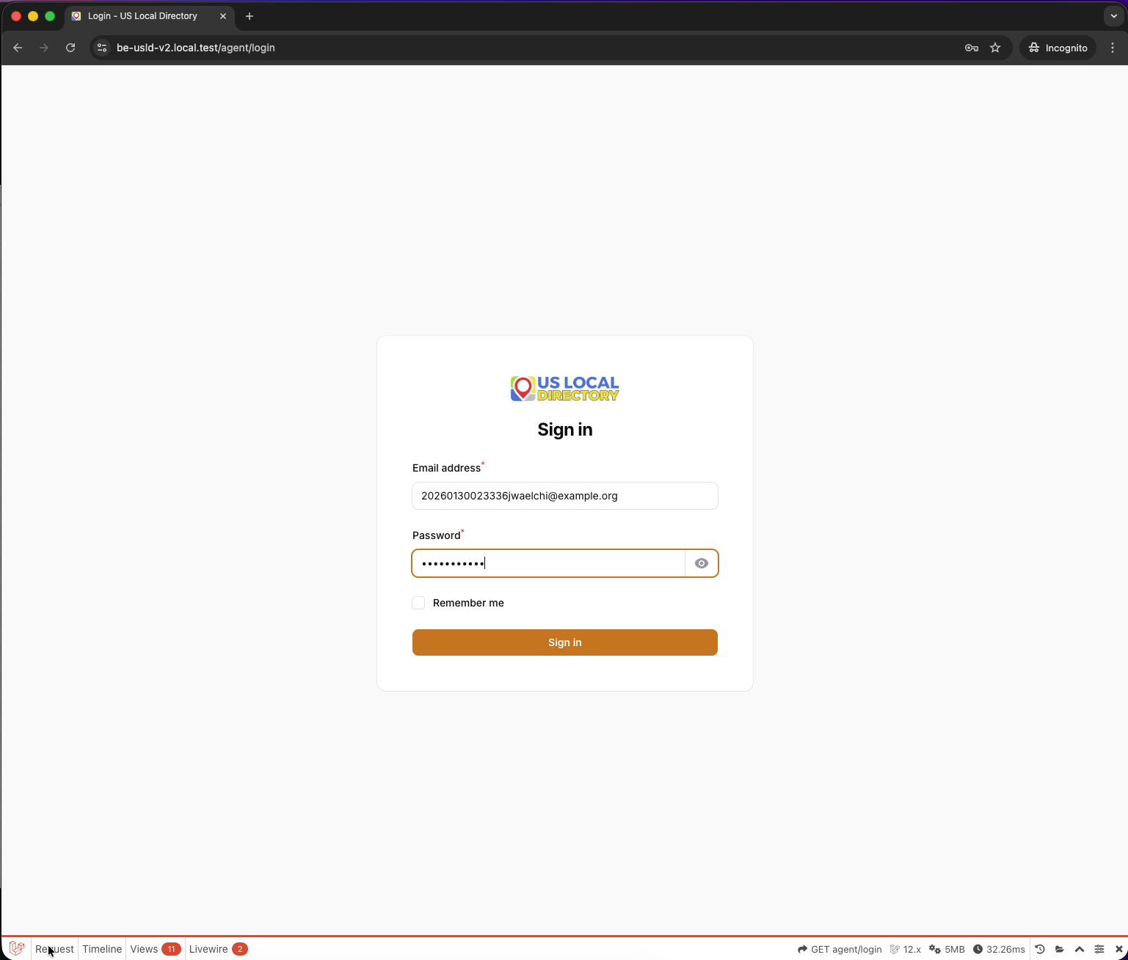
Agent Login
Context: The agent begins by logging into the system to access the dashboard and registration features.
Key Elements: - Login form with username and password fields - Authentication button to proceed - Secure login interface for agents
Instructions: 1. Enter your agent credentials (username and password). 2. Click the “Login” button to authenticate. 3. Upon successful login, you will be redirected to the dashboard.

Step 2: Dashboard View
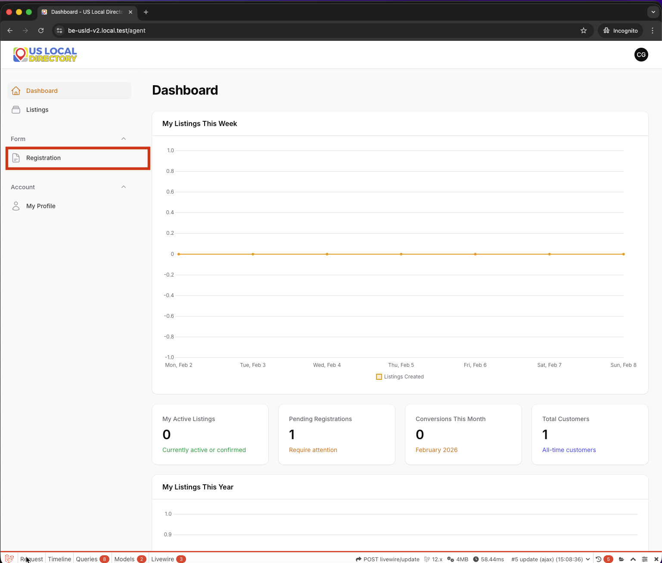
Dashboard View
Context: After logging in, the agent sees the main dashboard, which provides an overview of available actions and recent activities.
Key Elements: - Navigation menu with options like registration, listings, etc. - Dashboard widgets showing key metrics or quick actions - Access to start new registrations or view existing ones
Instructions: 1. Review the dashboard for any pending tasks or notifications. 2. Locate the “New Registration” or “Register Listing” option. 3. Click to proceed to the registration page.

Step 3: Registration Page
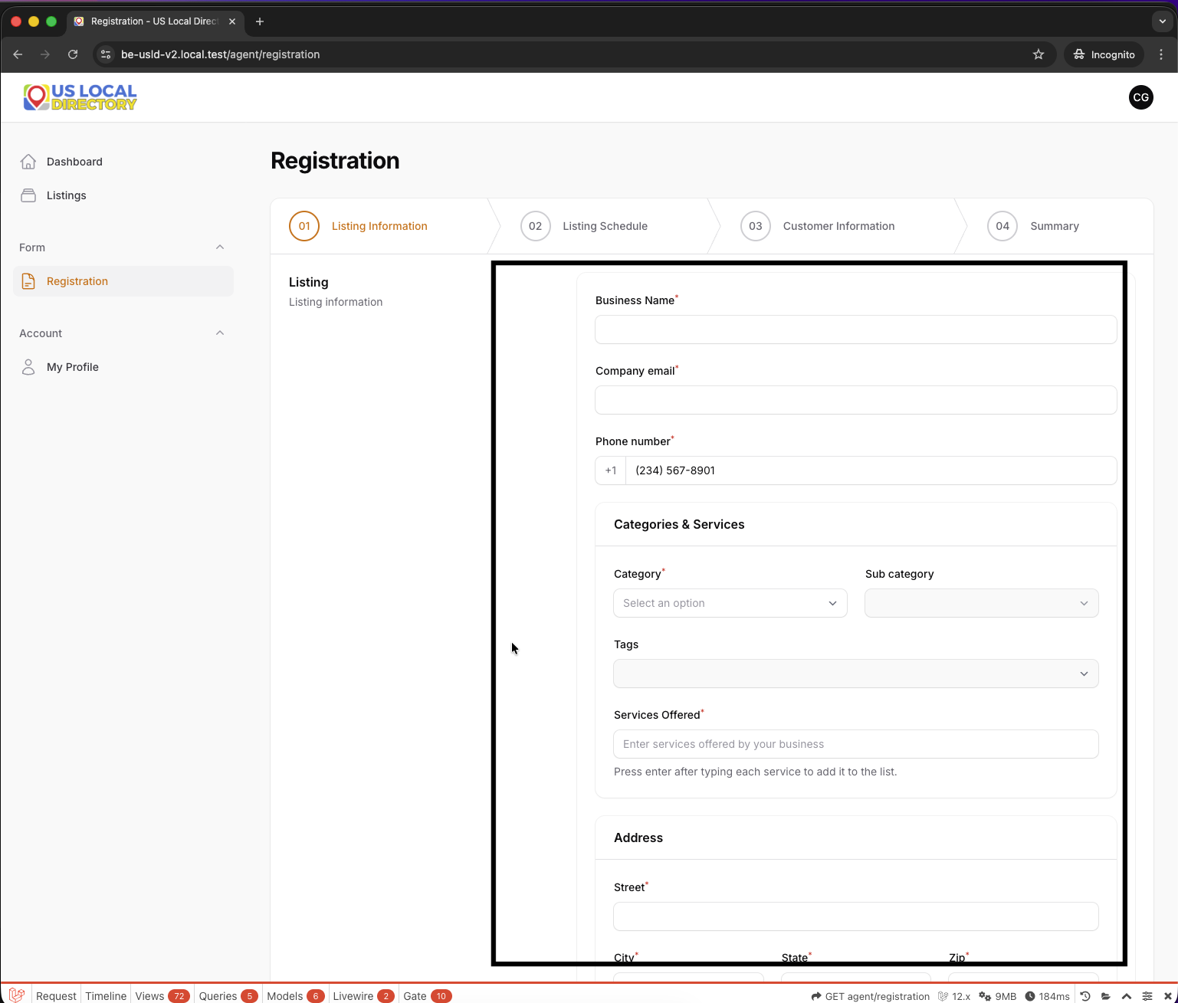
Registration Page
Context: The agent initiates the listing registration process by accessing the registration form.
Key Elements: - Initial registration form fields - Basic listing information input areas - Navigation to proceed to the next steps
Instructions: 1. Start filling in the basic listing details such as property address, type, etc. 2. Ensure all required fields are completed. 3. Proceed to the next section when ready.

Step 3.1: Registration Page - With Next Button
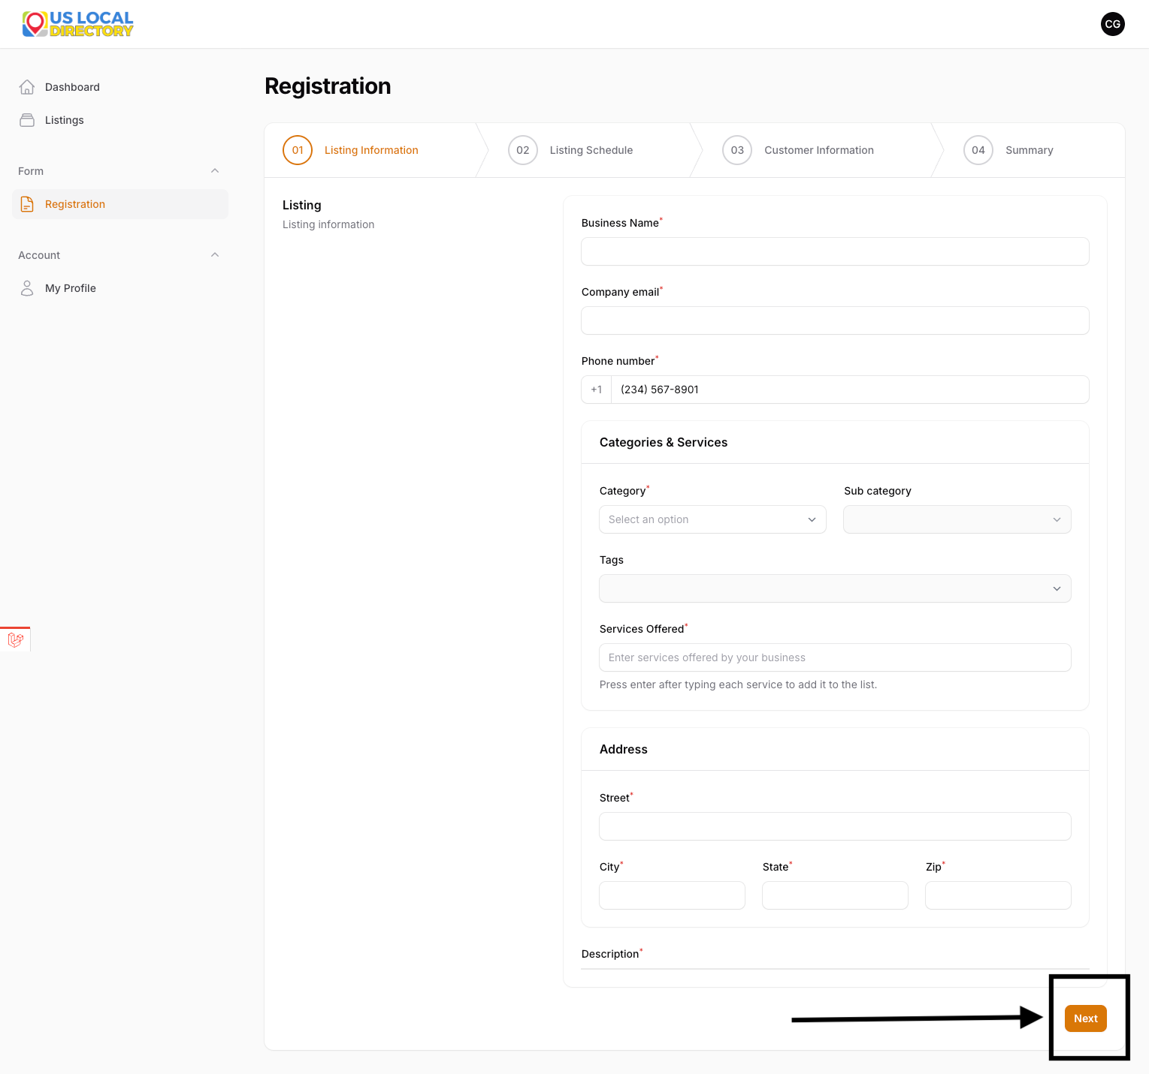
Registration Page - With Next Button
Context: The agent continues filling the registration form and sees the option to proceed to the next step.
Key Elements: - Expanded form with additional fields - “Next” button to advance in the workflow - Progress indicator showing current step
Instructions: 1. Complete any additional fields in the registration form. 2. Review the entered information for accuracy. 3. Click the “Next” button to move to the listing schedule section.

Step 3.2: Listing Schedule
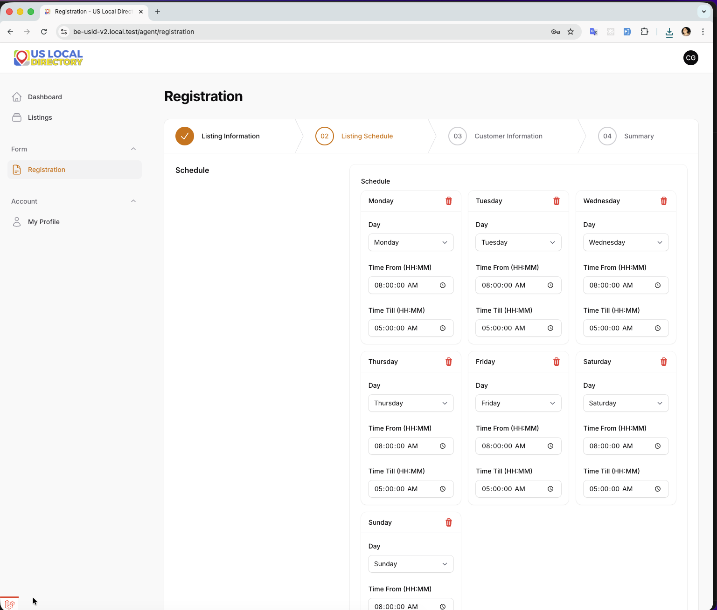
Listing Schedule
Context: The agent enters the scheduling information for the listing, such as availability dates and times.
Key Elements: - Date and time selection fields - Scheduling options for the listing - Calendar or time picker interface
Instructions: 1. Select the appropriate dates and times for the listing schedule. 2. Choose any recurring options if applicable. 3. Proceed to the customer information section.

Step 3.3: Customer Information
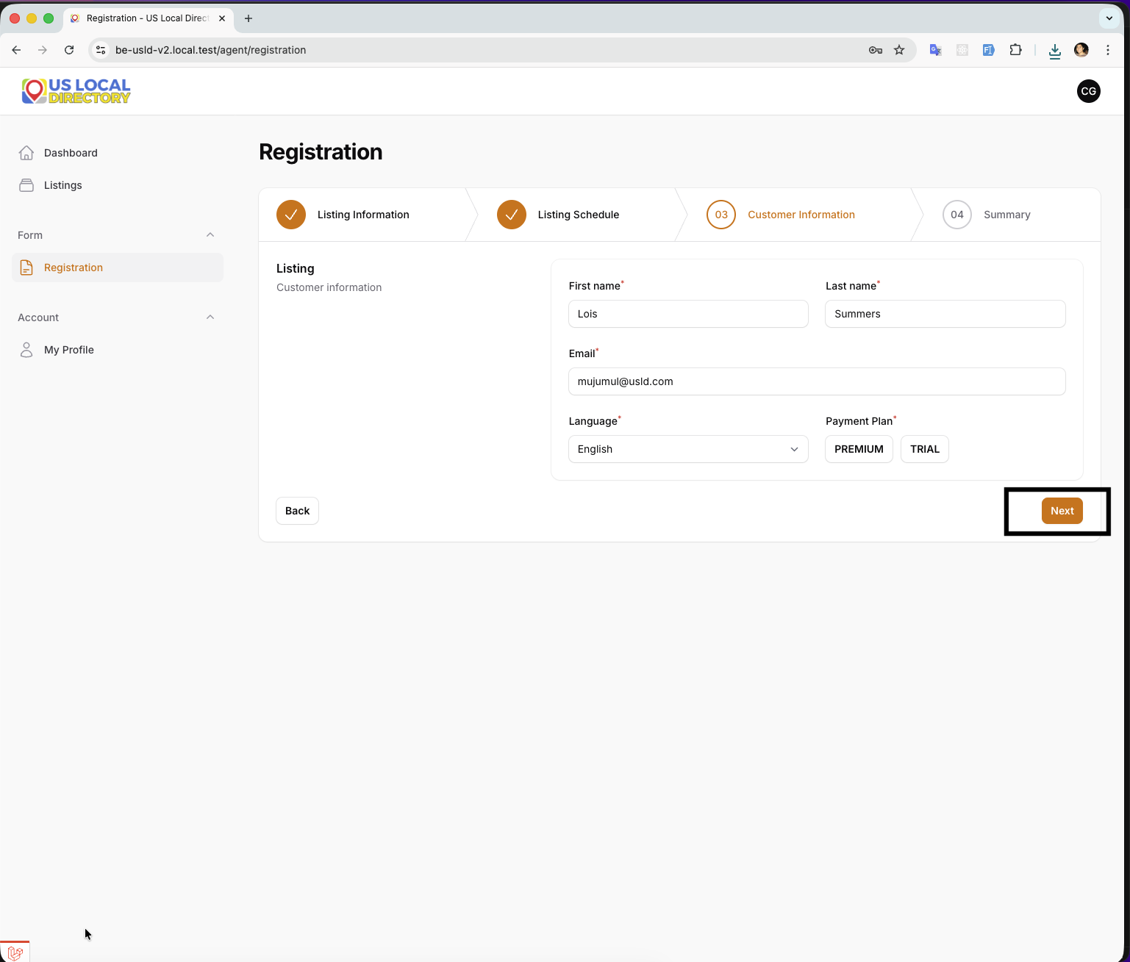
Customer Information
Context: The agent inputs the customer’s personal and contact information required for the registration.
Key Elements: - Customer details form (name, email, phone, etc.) - Address and contact information fields - Validation for required customer data
Instructions: 1. Enter the customer’s full name, email address, and phone number. 2. Provide any additional customer details as required. 3. Ensure all information is accurate before proceeding.

Step 3.4: Summary Page
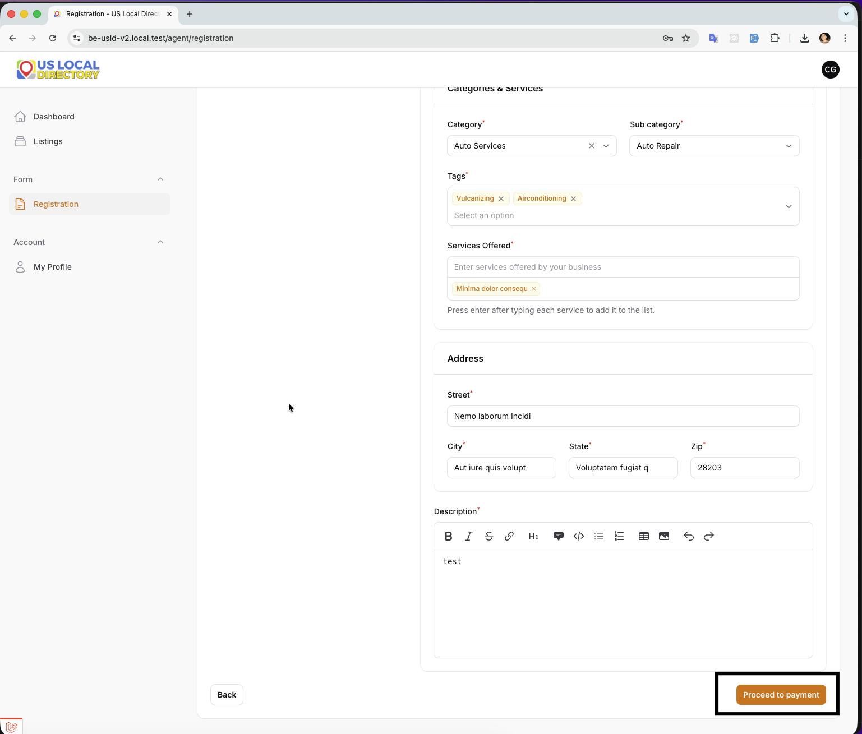
Summary Page
Context: The agent reviews a summary of all entered information before selecting the payment method.
Key Elements: - Summary of listing details, schedule, and customer info - Review and edit options - Confirmation to proceed to payment options
Instructions: 1. Review all the entered information for completeness and correctness. 2. Make any necessary edits by going back to previous steps. 3. Confirm the summary and proceed to payment options.

Step 3.5: Payment Options
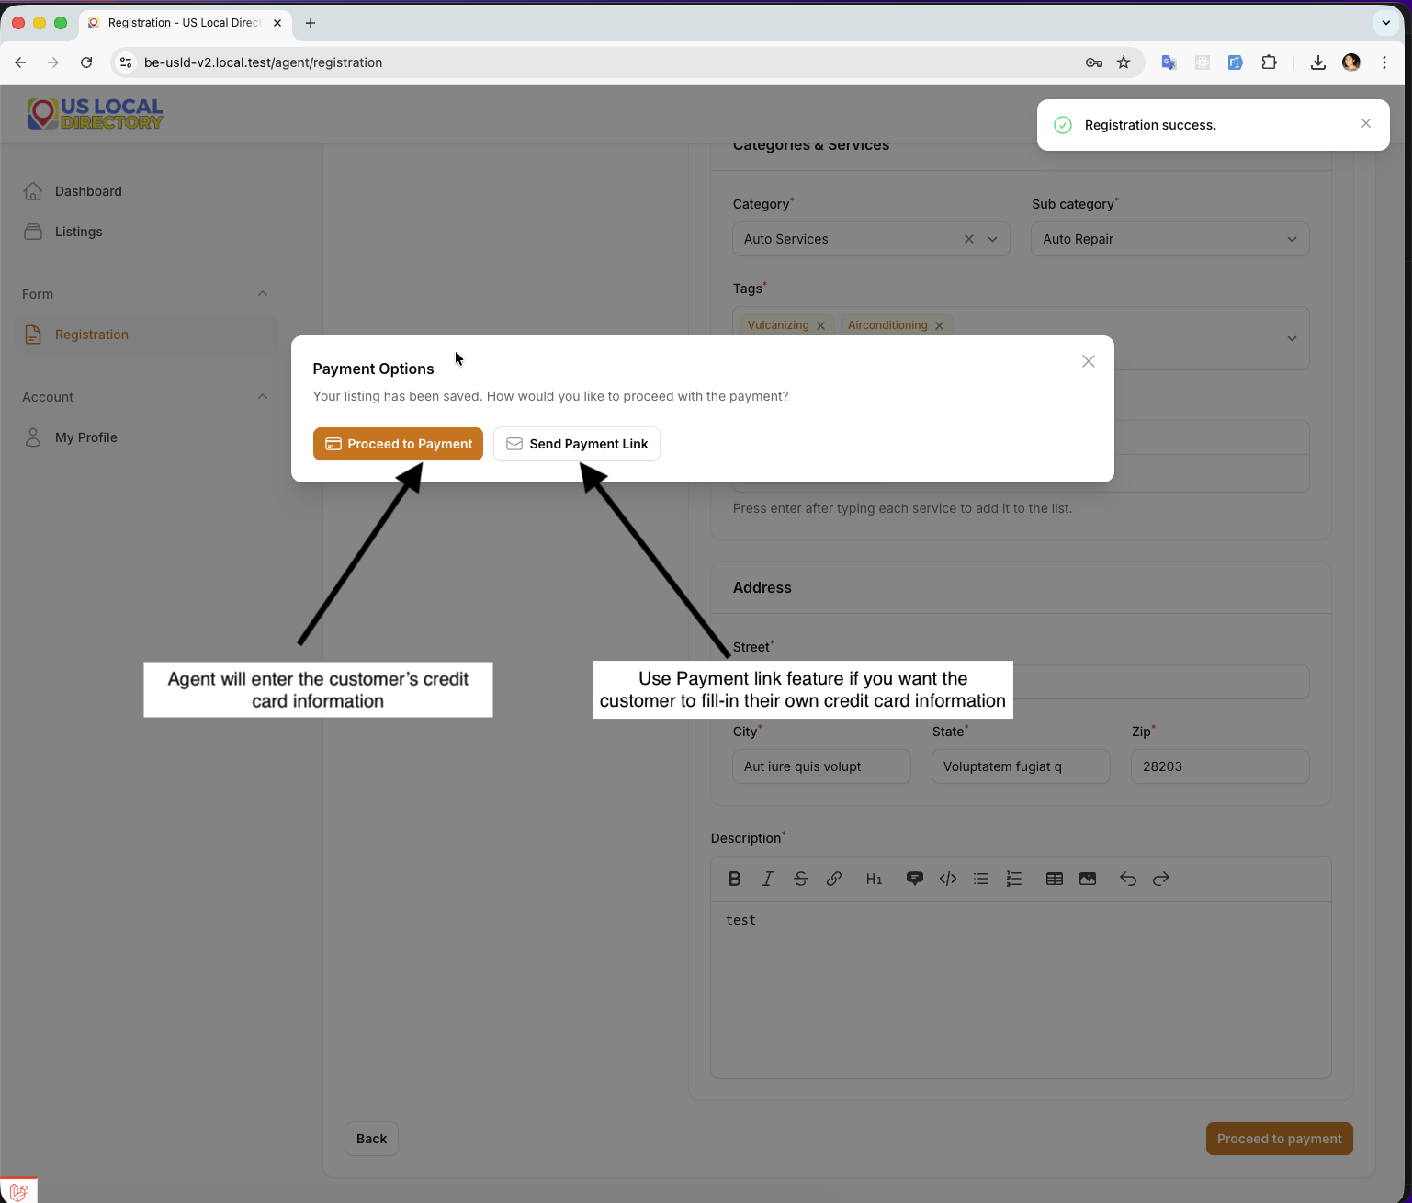
Payment Options
Context: The agent chooses between two payment processing options: registering the customer’s credit card directly or sending a payment link for the customer to handle their own card registration.
Key Elements: - Two payment method options displayed - Option 1: Agent registers credit card - Option 2: Send payment link to customer
Instructions: 1. Review the two available payment options. 2. Select the appropriate method based on customer preference or circumstances. 3. Proceed to the chosen payment workflow.

Option 1: Send Payment Link to Customer

Step 4: Payment Link Page
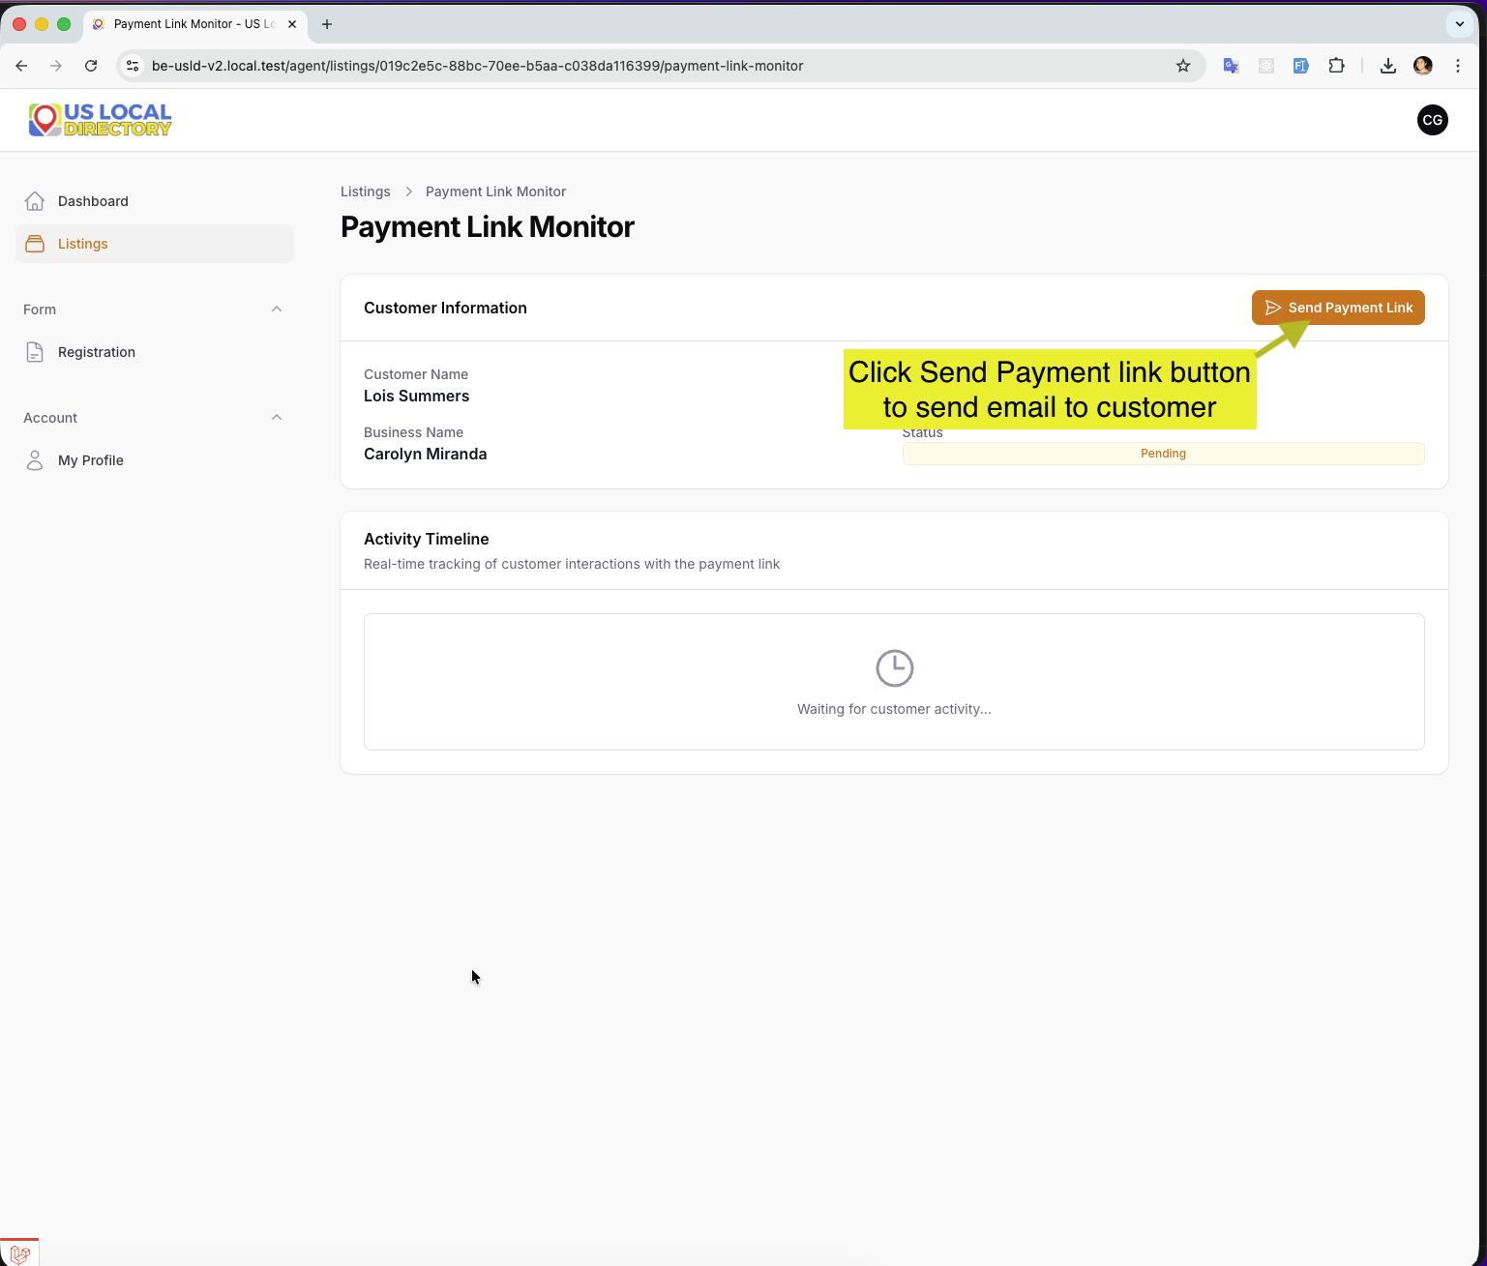
Payment Link Page
Context: The agent accesses the payment link generation page to create a secure link for the customer.
Key Elements: - Payment link generation interface - Link customization options - Preview of the link to be sent
Instructions: 1. Generate the payment link for the customer. 2. Customize any link settings if available. 3. Prepare to send the link to the customer’s email or preferred contact method.

Step 4.1: Send Payment Link to Customer
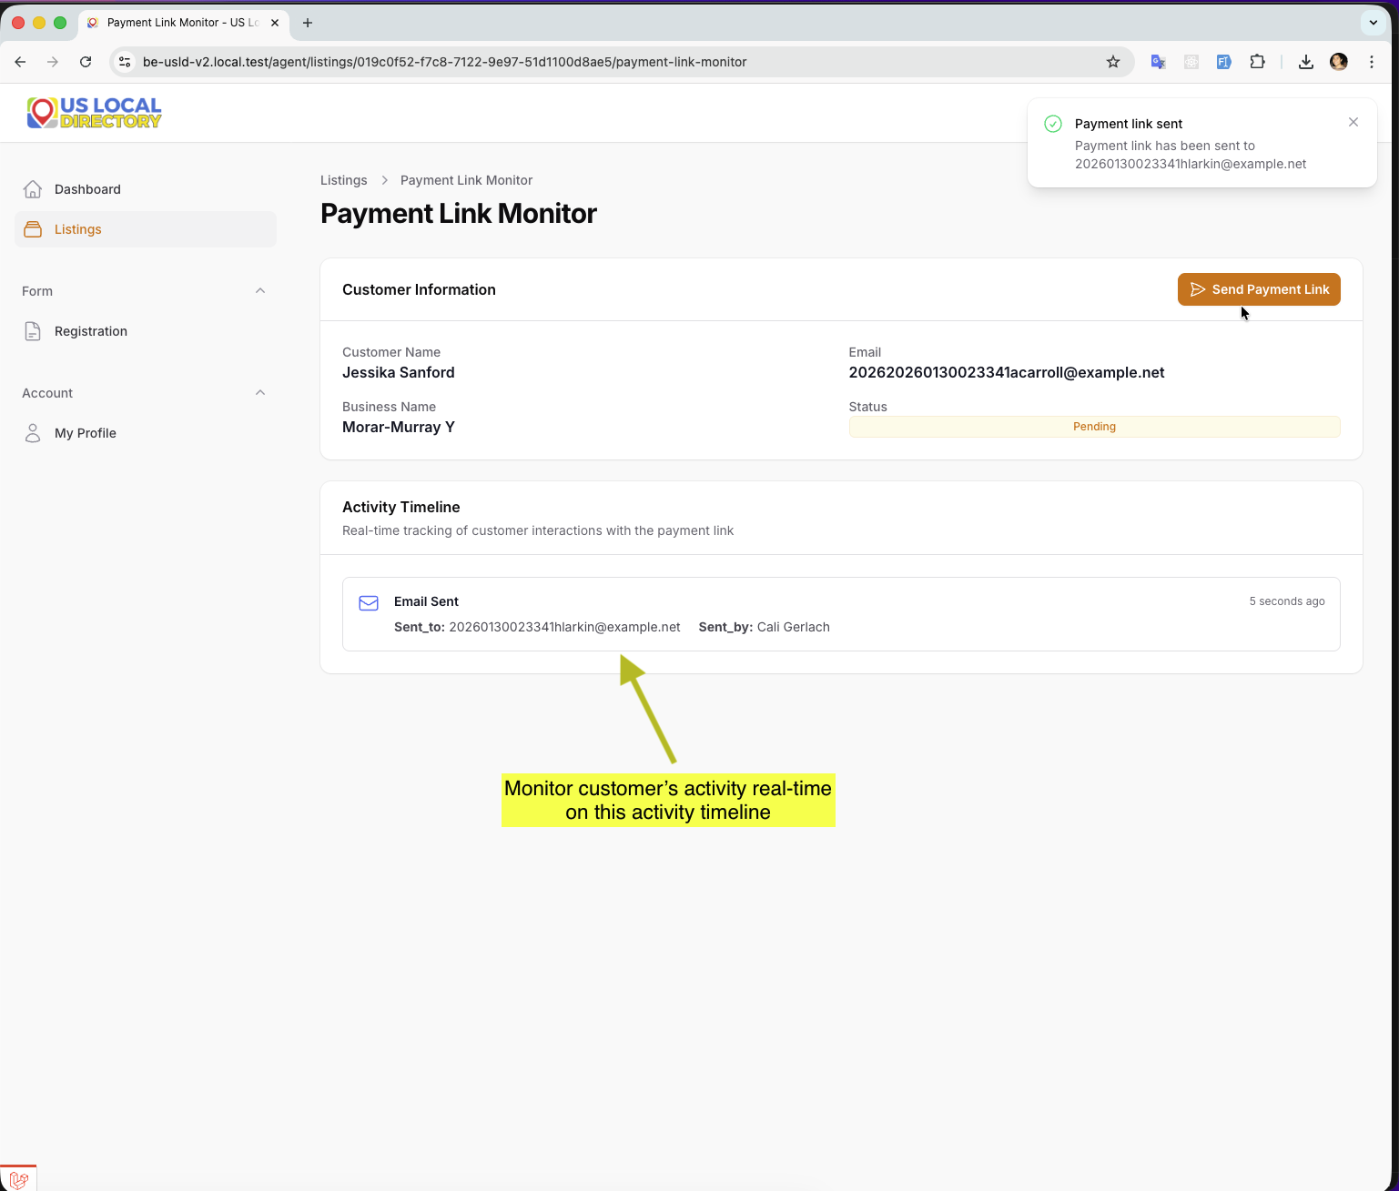
Send Payment Link
Context: The agent sends the generated payment link to the customer, allowing them to complete their own card registration.
Key Elements: - Send link functionality (email only) - Confirmation of link delivery - Status tracking for customer completion - Real-time activity monitoring and data updates based on customer interactions
Instructions: 1. Enter the customer’s contact information for link delivery. 2. Send the payment link via email or SMS. 3. Monitor the status for when the customer completes the payment registration. 4. Observe real-time updates as the customer interacts with the payment link, with data being updated instantly based on their activities.5. For detailed customer instructions on using the payment link, refer to the Customer Payment Link Walkthrough. —

Option 2: Agent Registers Credit Card

Step 5: Credit Card Registration - Two variations of credit card registration
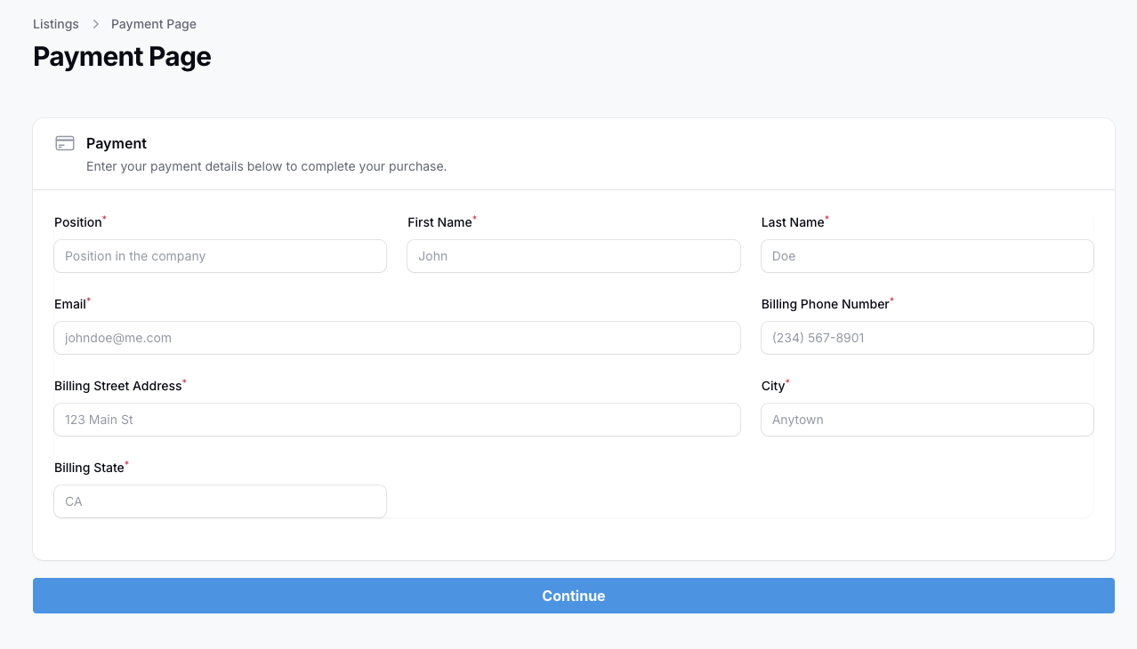
Credit Card Registration
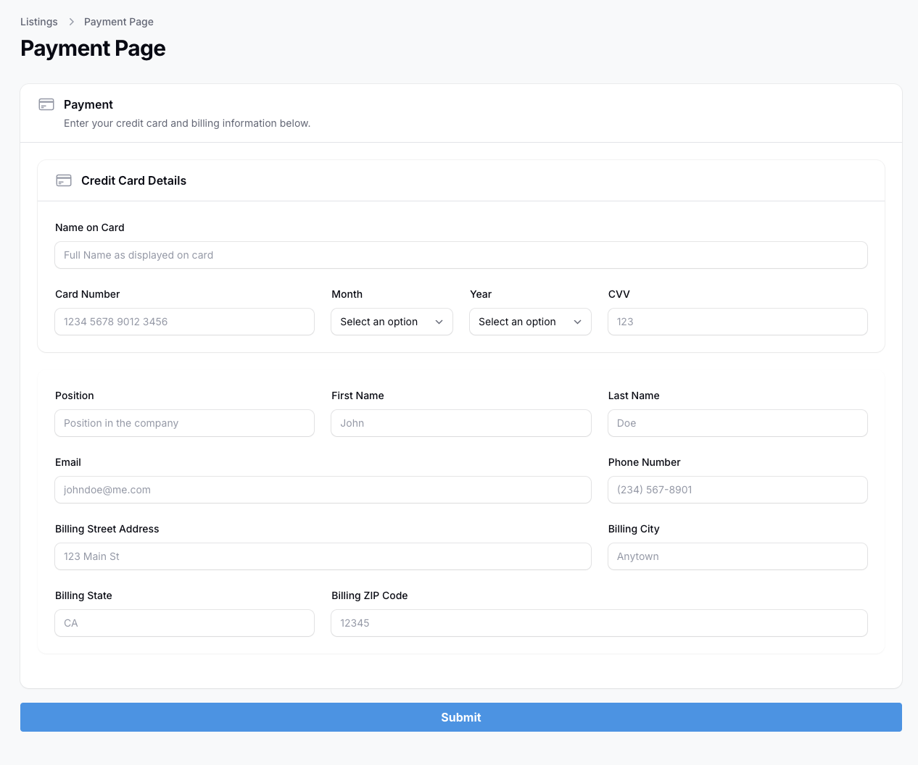
Credit Card Registration
Context: The agent directly enters the customer’s billing information for registration.
Key Elements: - Secure credit card input form - Fields for card number, expiration, CVV, etc. - Compliance with PCI standards
Instructions: 1. Obtain the customer’s credit card details securely. 2. Enter the card information in the provided fields. 3. Ensure all card details are entered accurately.

Step 5.1: Credit Card Registration Part 2
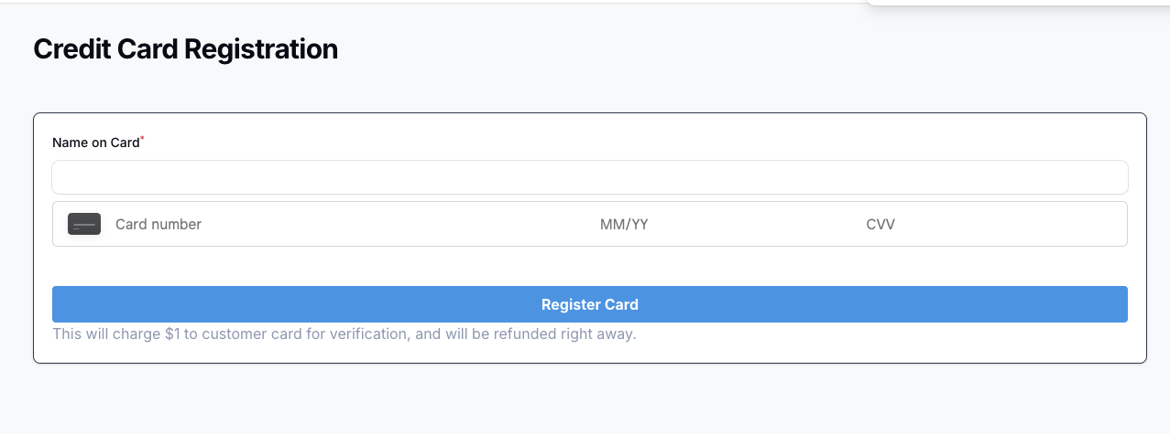
Credit Card Filled
Context: - Credit card registration this form may vary depending on payment gateway being used.

Step 6.1: List Listings After Registration
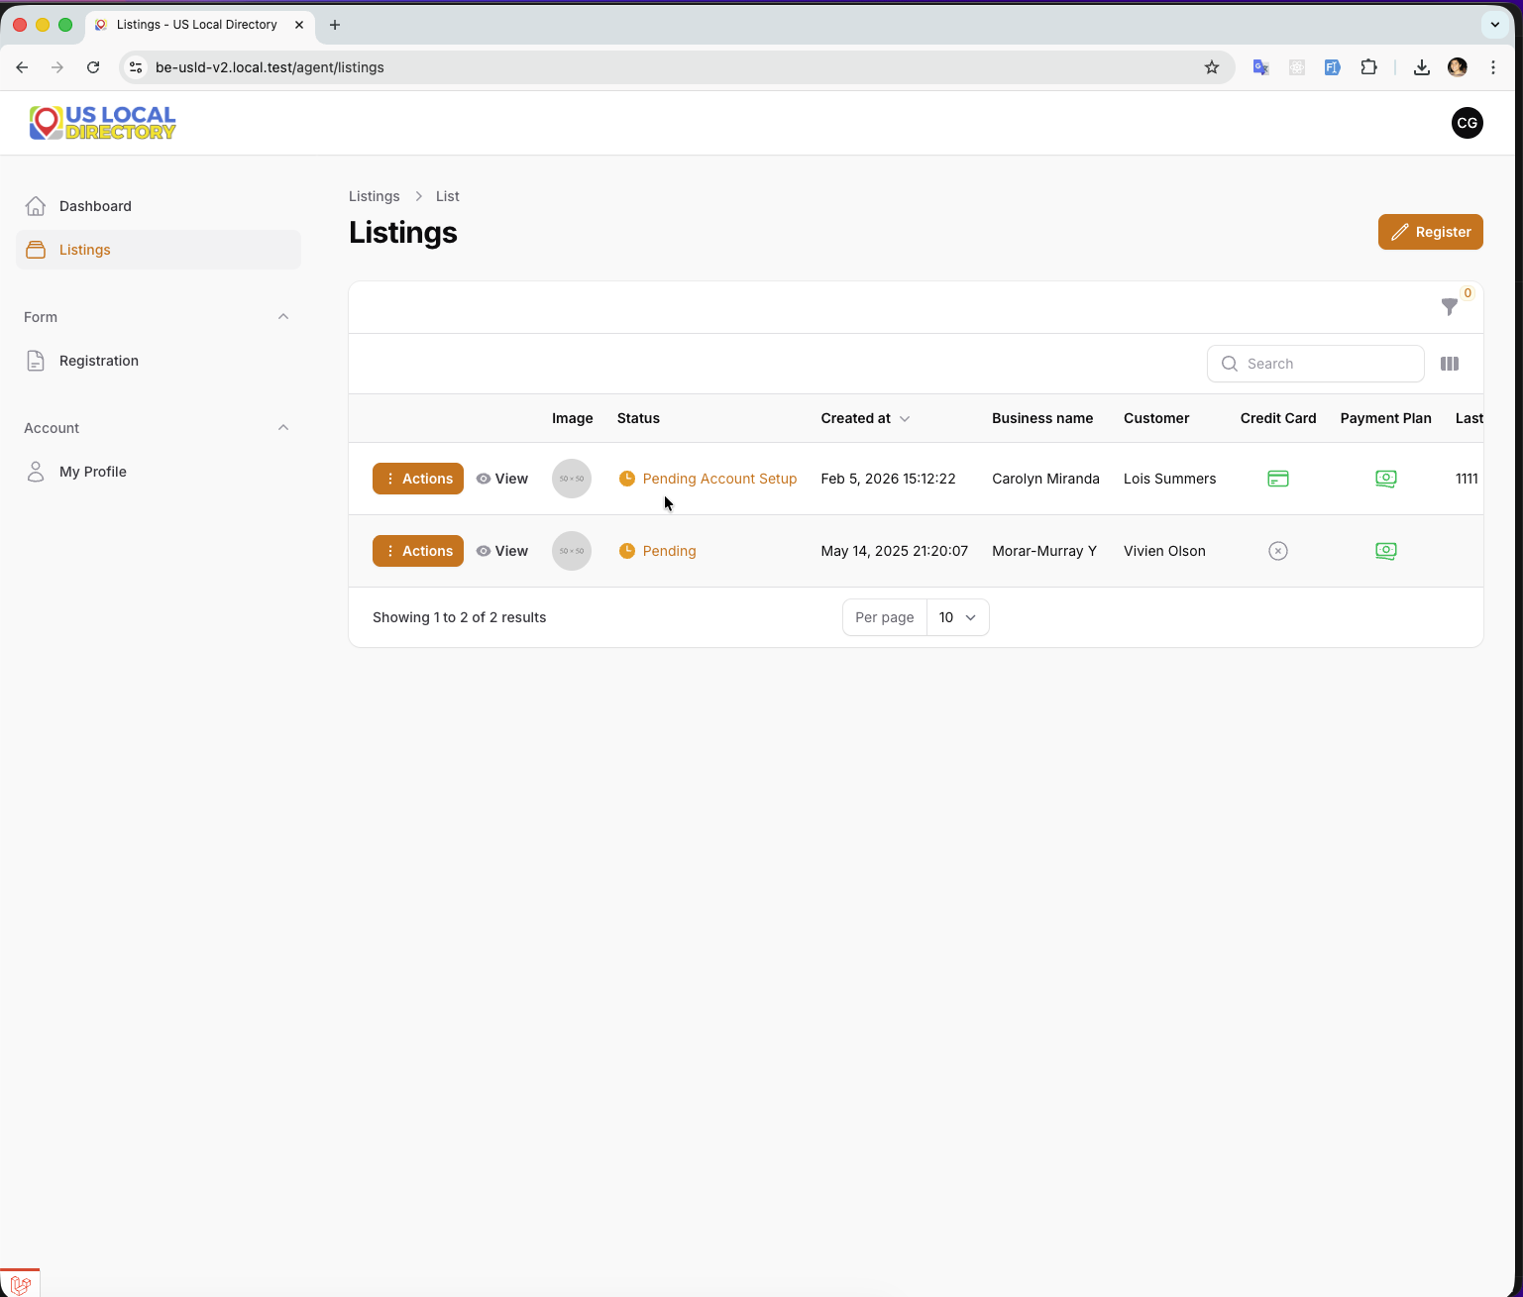
List Listings
Context: After successful credit card registration, the agent views the updated list of listings, confirming the registration is complete.
Key Elements: - List of registered listings - Status indicators for each listing - Confirmation of successful registration
Instructions: 1. Review the listings list to confirm the new registration appears. 2. Check the status of the listing to ensure it’s active. 3. Proceed with any additional actions or return to the dashboard.

Workflow Summary
This agent workflow demonstrates the complete process for registering listing information with flexible payment options:
- Login - Agent authenticates into the system
- Dashboard - Access main interface and start registration
- Registration - Enter listing details, schedule, and customer info
- Summary - Review all entered information
- Payment Choice - Select between direct card registration or payment link
- Payment Processing - Complete the chosen payment method
- Confirmation - Verify successful registration and listing status

Payment Options Overview
- Payment Link Option: Allows customers to register their own payment details securely via a link, reducing agent handling of sensitive information.
- Direct Card Registration: Enables agents to register customer credit cards directly when preferred or necessary.

Notes
- All screenshots were captured sequentially to demonstrate the agent workflow.
- The workflow supports both payment methods, providing flexibility for different customer scenarios.
- Security and compliance should be prioritized, especially when handling payment information.

For Developers
When implementing or modifying this workflow: - Ensure secure handling of payment information - Implement proper validation for all form fields - Provide clear user feedback at each step - Support both payment options seamlessly - Include error handling and recovery mechanisms - Maintain audit trails for registration activities

Last Updated: February 9, 2026

