Customer Walkthrough Guide
This guide provides a step-by-step walkthrough of the customer workflow for completing the full registration and onboarding process, including service agreements, ID verification, and payment authorization. The walkthrough is based on the screenshots in the Customer directory.

Step 1: Introduction Email
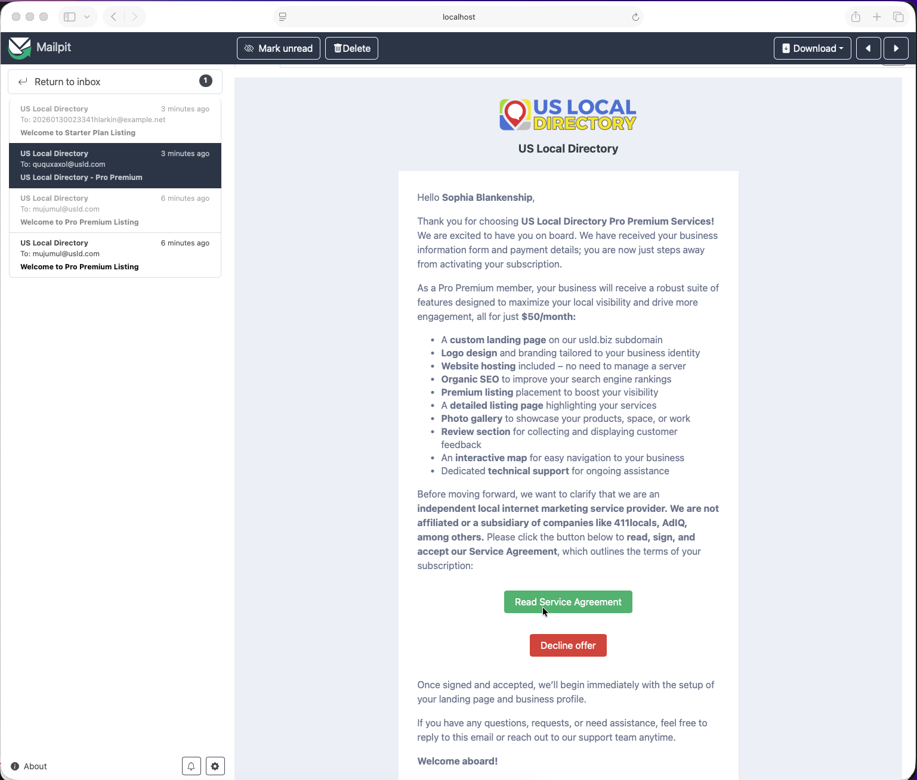
Introduction Email
Context: The customer receives an introduction email initiating the registration process and providing initial instructions.
Key Elements: - Welcome message and process overview - Links or buttons to start the registration - Contact information for support
Instructions: 1. Open the introduction email from the service provider. 2. Review the welcome message and understand the registration process. 3. Click the provided link or button to begin the onboarding.

Step 2: Service Agreement Page
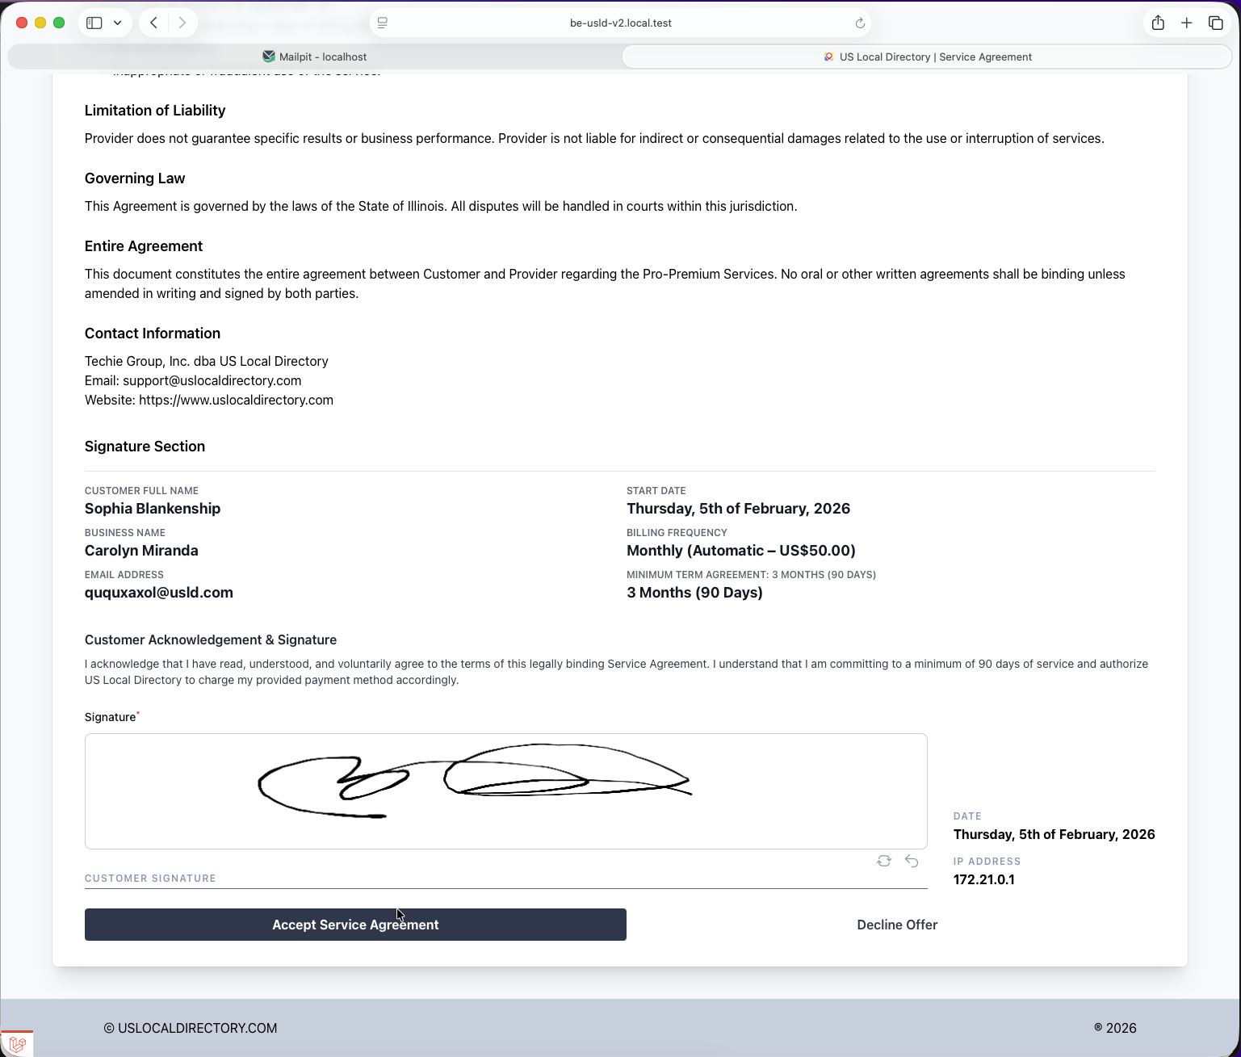
Service Agreement Page
Context: The customer accesses the service agreement page where they must review and sign the terms to proceed with registration.
Key Elements: - Full text of the service agreement - Signature field or electronic signature option - Proceed button after signing
Instructions: 1. Read through the entire service agreement carefully. 2. If you agree to the terms, provide your electronic signature. 3. Click the proceed button to continue to the next step.

Step 2.1: Authorization Page
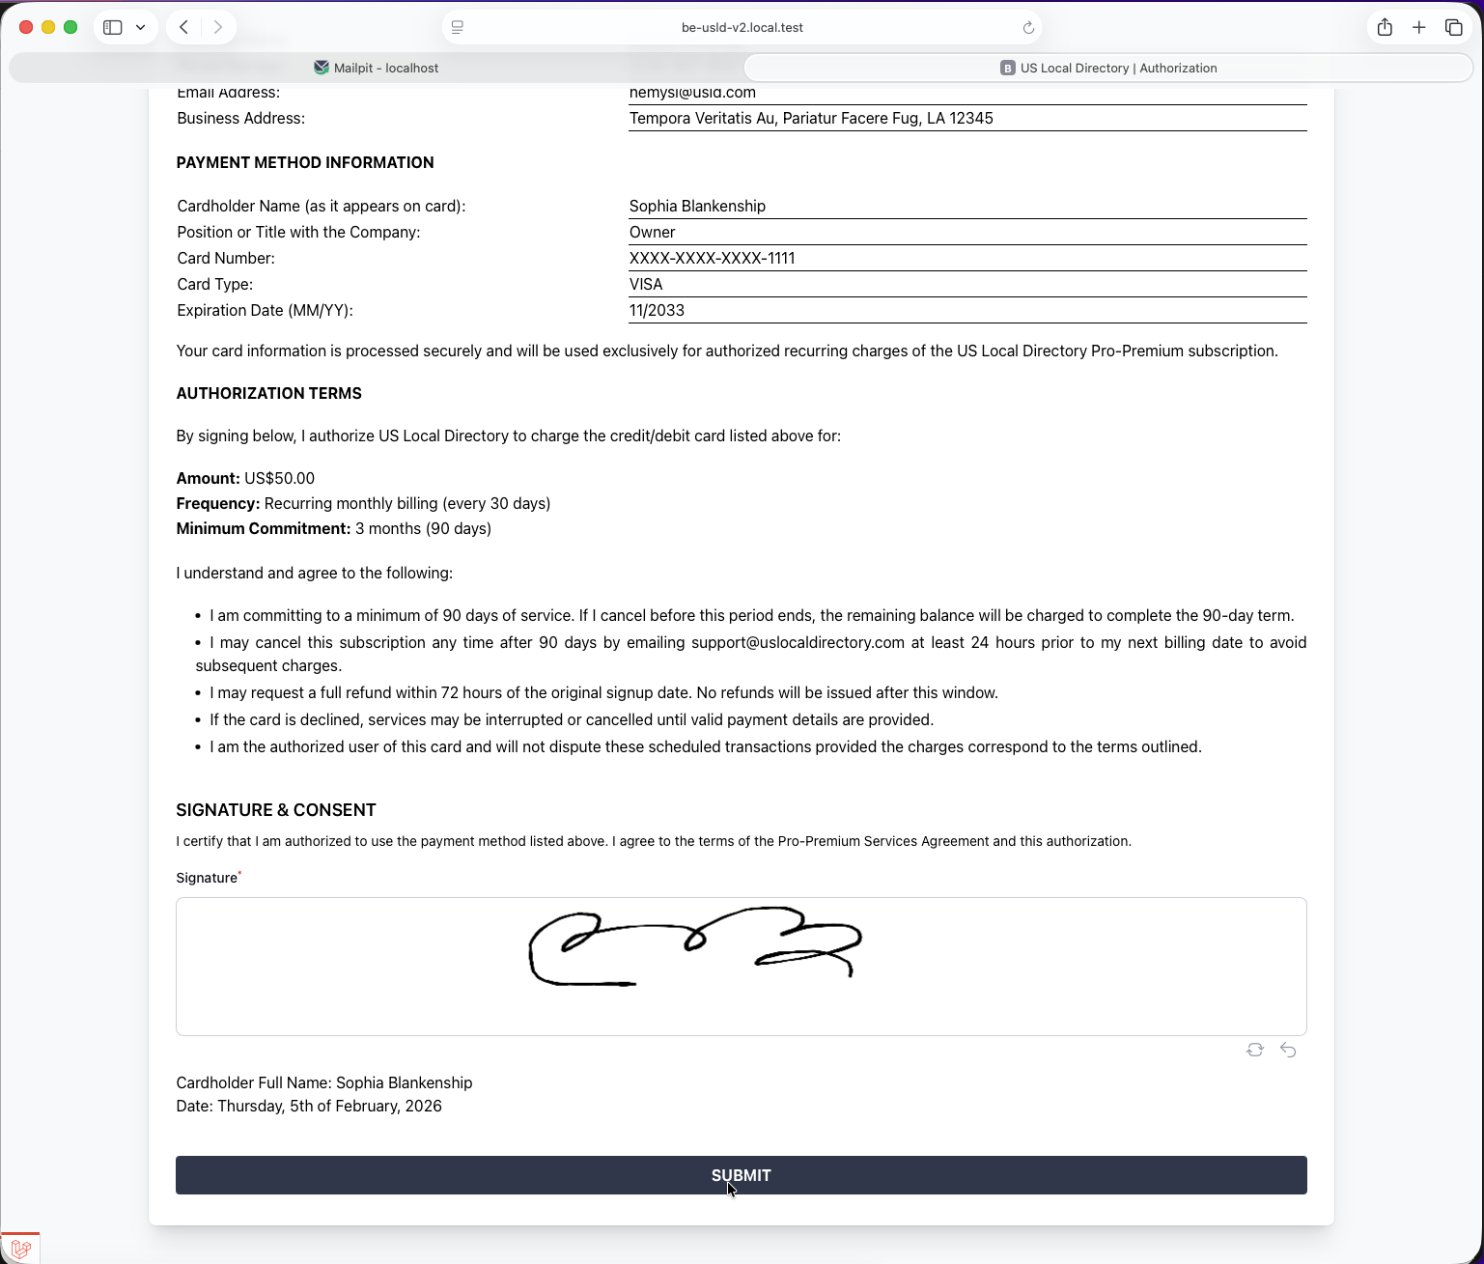
Authorization Page
Context: The customer reviews and signs the authorization page, granting necessary permissions for the service.
Key Elements: - Authorization terms and conditions - Signature requirement - Confirmation of authorization
Instructions: 1. Review the authorization terms. 2. Sign the authorization electronically. 3. Confirm your authorization to proceed.

Step 2.3: Thank You Page
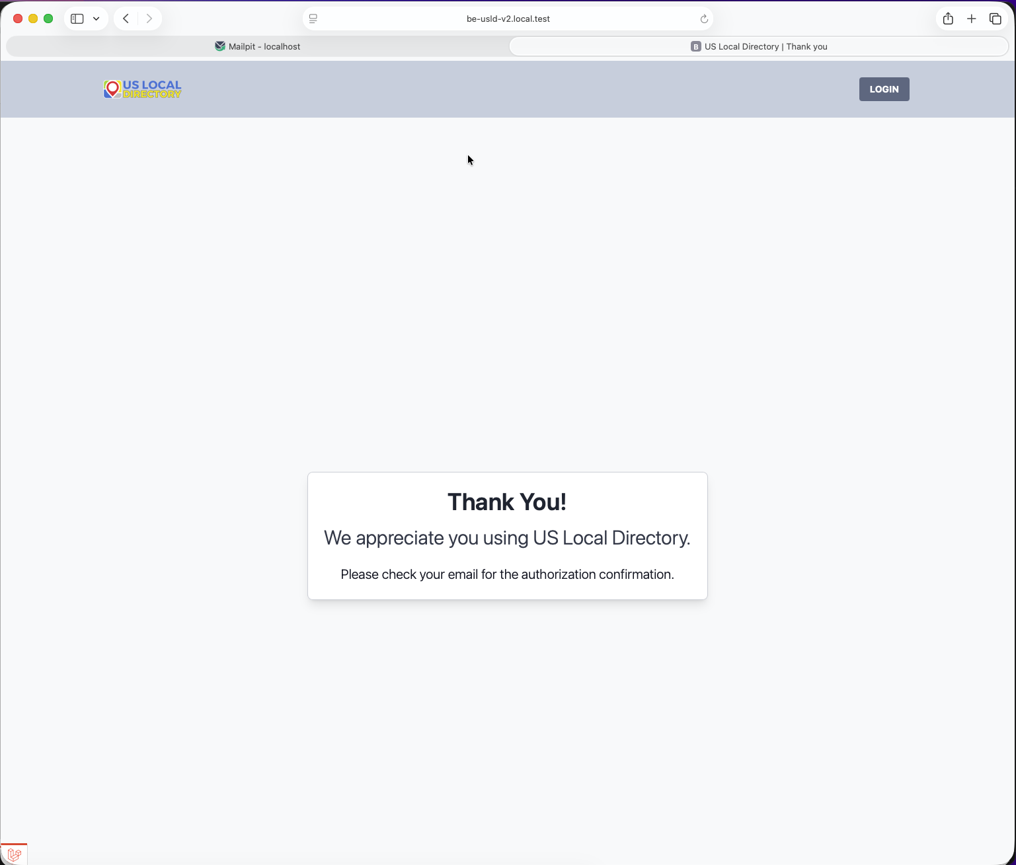
Thank You Page
Context: After signing the agreements, the customer sees a thank you page confirming completion of the agreement phase.
Key Elements: - Confirmation message - Next steps indication - Progress indicator
Instructions: 1. Acknowledge the thank you message. 2. Note any next steps provided on the page. 3. Proceed to the signup confirmation.

Step 3: Signup Confirmation Page
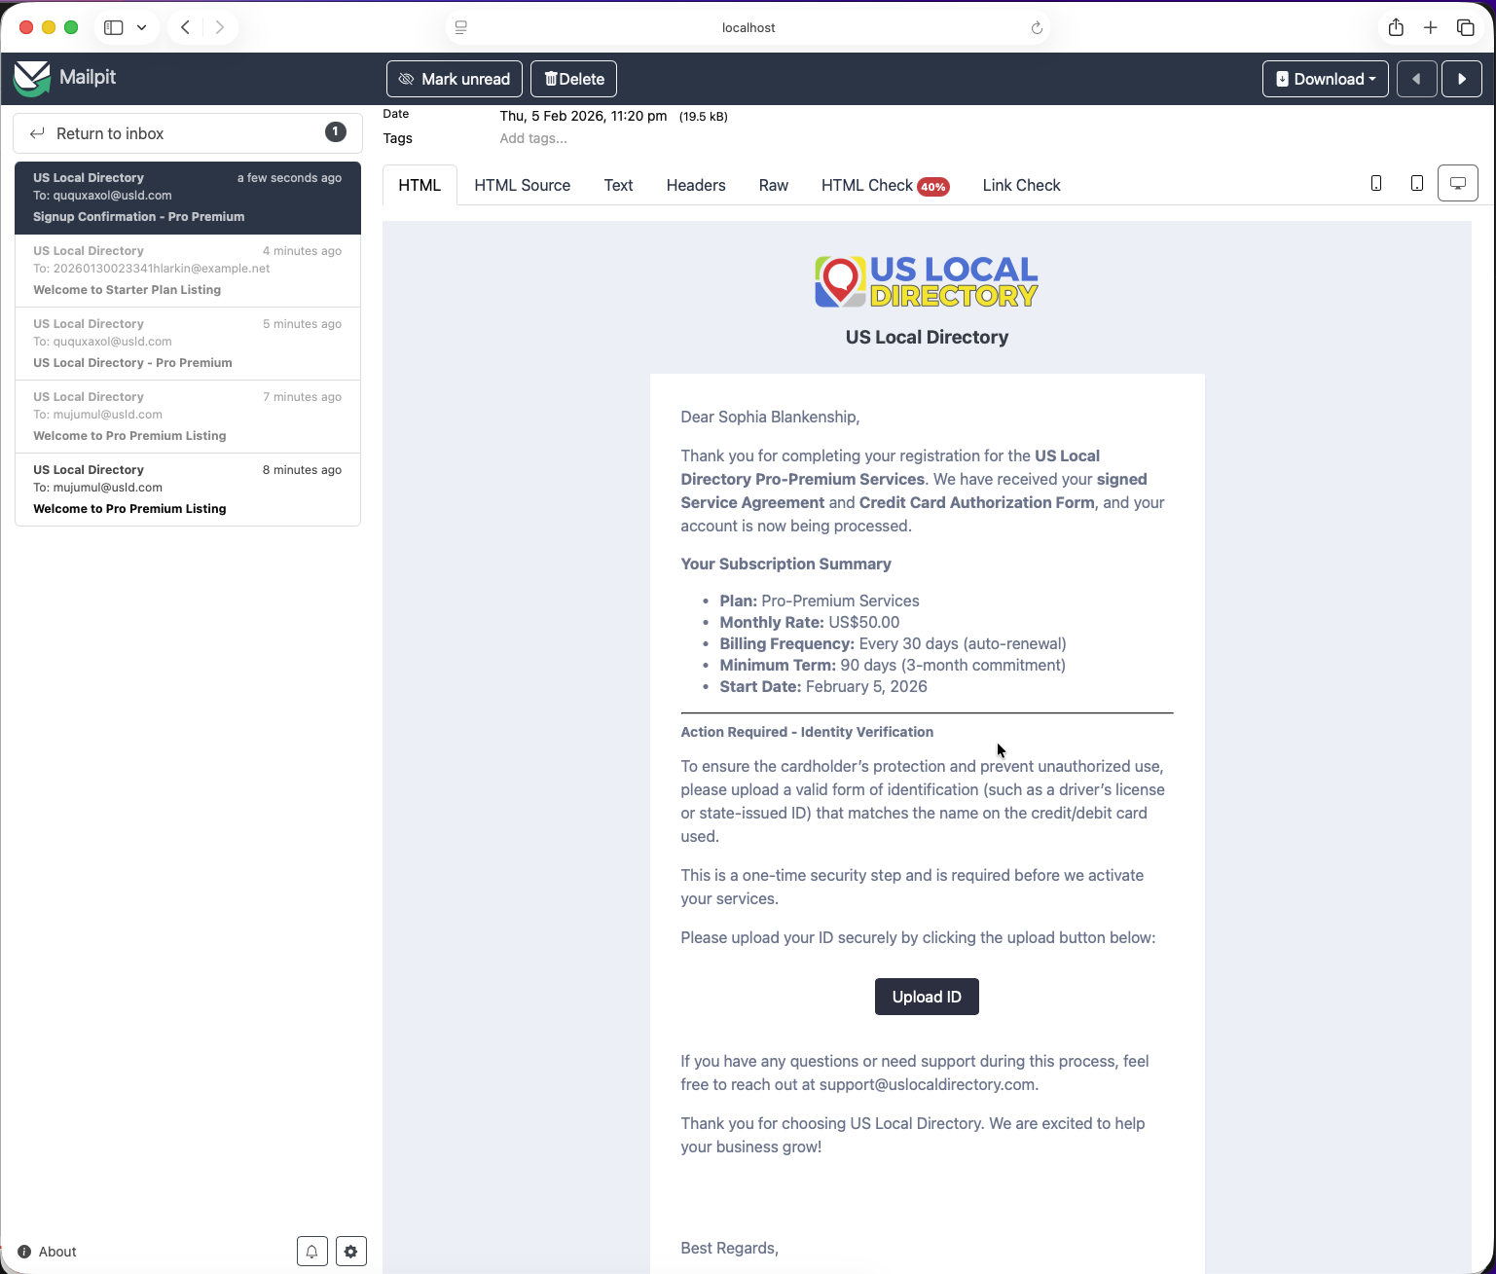
Signup Confirmation Page
Context: The customer reaches the signup confirmation page to verify their registration details.
Key Elements: - Summary of registration information - Confirmation options - Additional requirements notice
Instructions: 1. Review your registration details. 2. Confirm the information is accurate. 3. Proceed to ID verification if required.

Step 3.1: Upload ID Example
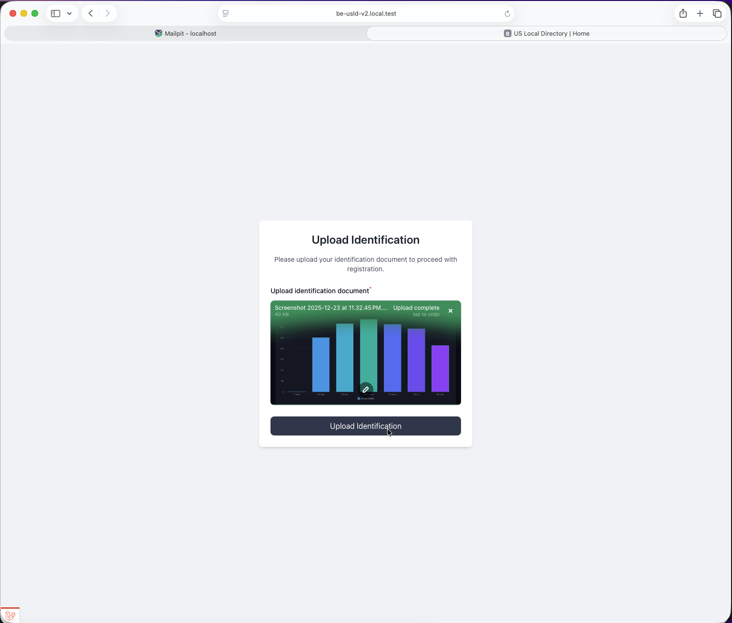
Upload ID Example
Context: The customer sees an example of acceptable ID documents for verification purposes.
Key Elements: - Sample ID images - Acceptable document types - Quality requirements
Instructions: 1. View the examples of valid ID documents. 2. Ensure you have similar documents ready. 3. Prepare to upload your own ID in the next step.

Step 3.1: Upload ID for Confirmation
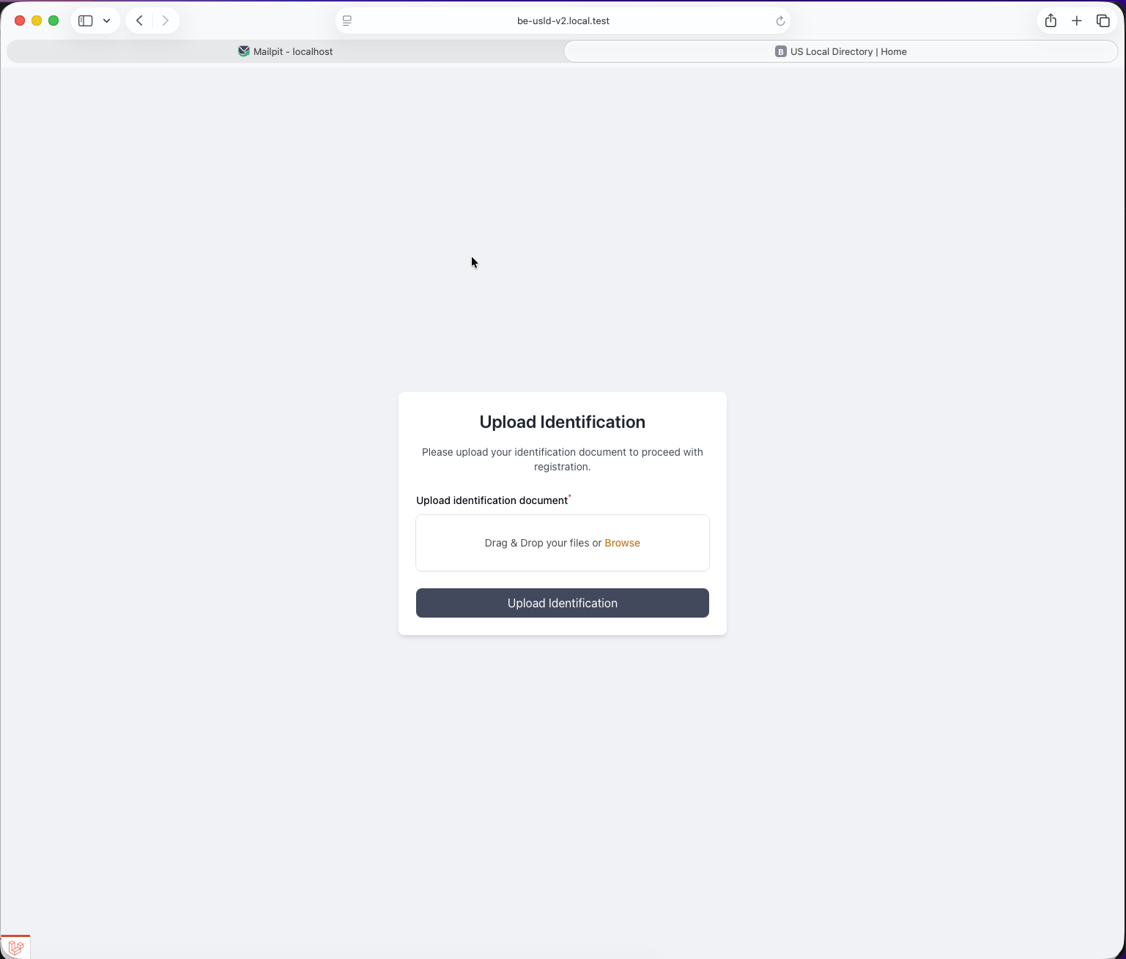
Upload ID for Confirmation
Context: The customer uploads their identification document for verification and confirmation.
Key Elements: - File upload interface - Supported file formats - Upload progress and confirmation
Instructions: 1. Select your ID document file. 2. Ensure it meets the quality and format requirements. 3. Upload the document and wait for confirmation.

Step 3.2: Confirmation Popup
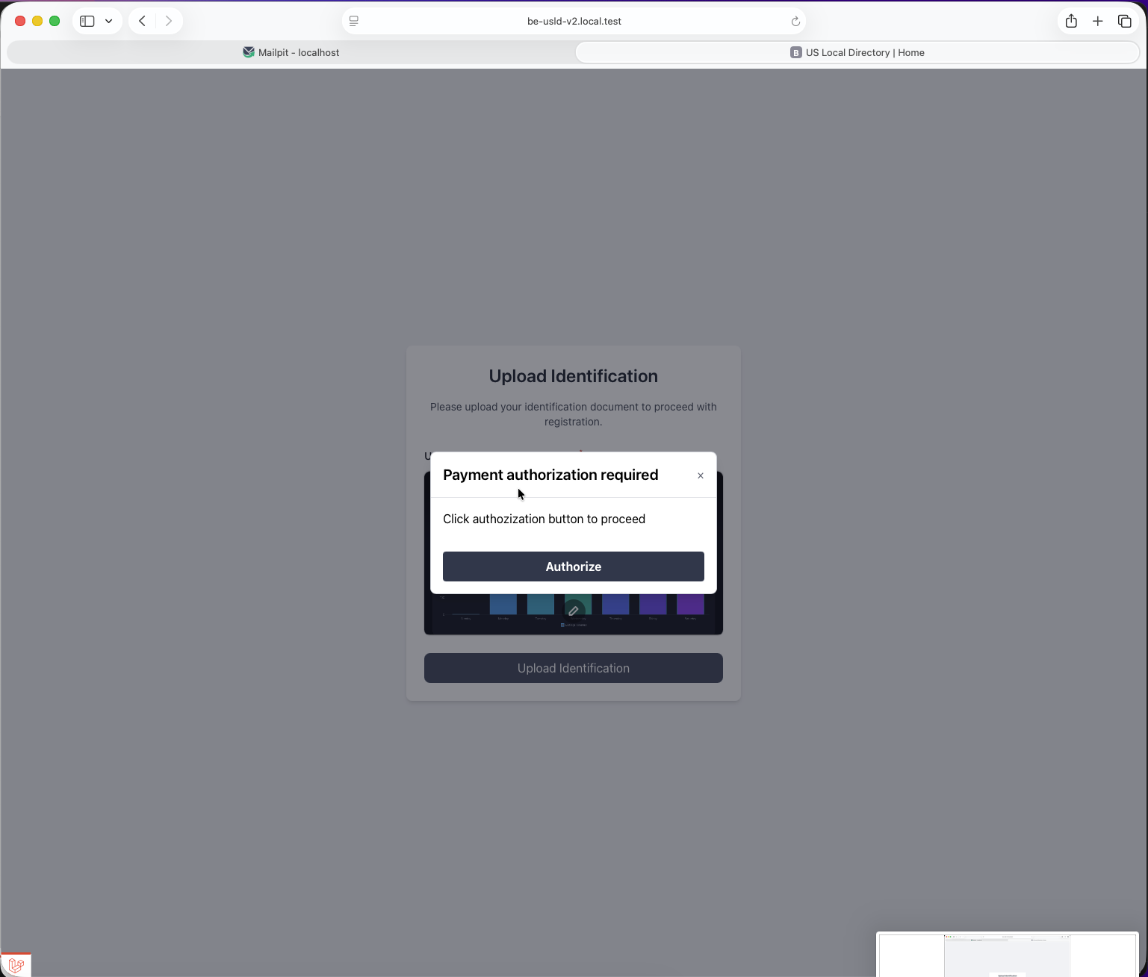
Confirmation Popup
Context: An optional confirmation popup appears to verify the customer’s actions or provide additional information.
Key Elements: - Popup dialog box - Confirmation message - Authorize button
Instructions: 1. Read the confirmation message in the popup. 2. Choose to Authorize button or provide additional input if required. 3. Click Authorize to continue.

Step 3.3: Thank You Page
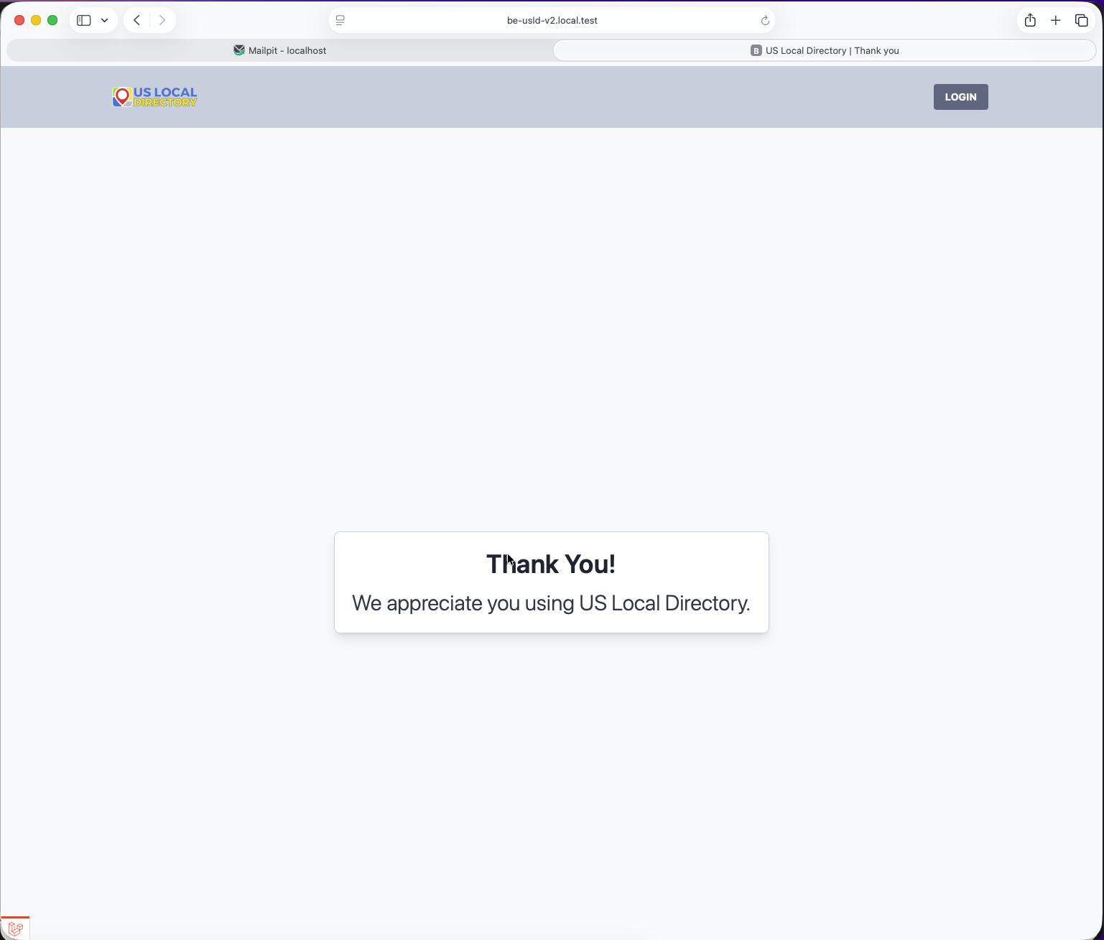
Thank You Page
Context: The customer sees another thank you page confirming completion of the verification process.
Key Elements: - Success confirmation - Final instructions - Completion status
Instructions: 1. Acknowledge the successful verification. 2. Follow any final instructions provided. 3. Proceed to the welcome phase.

Step 4.1: Welcome Email
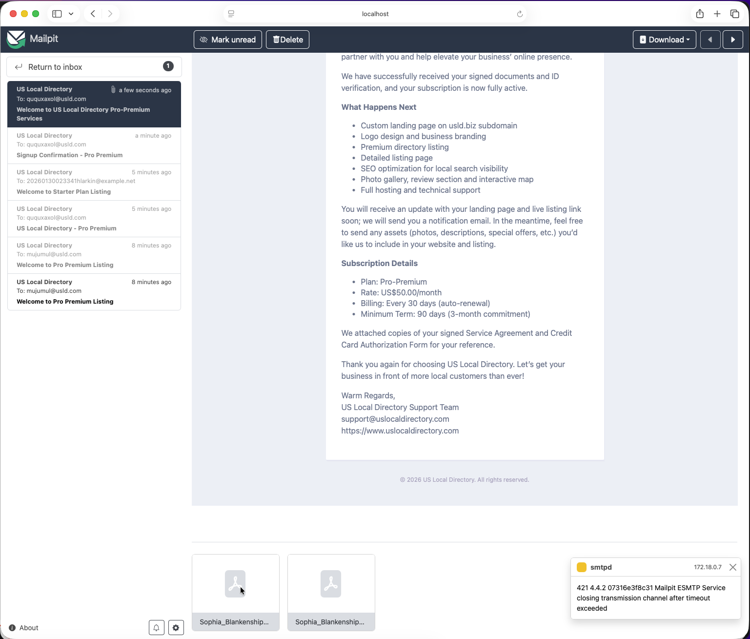
Welcome Email
Context: The customer receives a welcome email confirming successful registration and providing access details.
Key Elements: - Welcome message - Account access information - Next steps or resources
Instructions: 1. Open the welcome email. 2. Note your account details and access instructions. 3. Use the provided information to log in or access services.

Step 4.1.1: Credit Card Authorization PDF
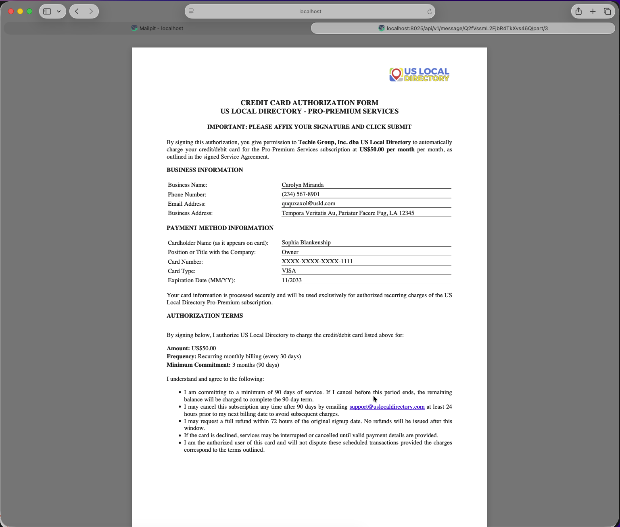
Credit Card Authorization PDF
Context: The customer reviews the credit card authorization PDF document included in the welcome materials.
Key Elements: - PDF document viewer - Credit card authorization terms - Download or print options
Instructions: 1. Open the credit card authorization PDF. 2. Review the authorization terms. 3. Save or print the document for your records.

Step 4.1.1: Example of Service Agreement PDF
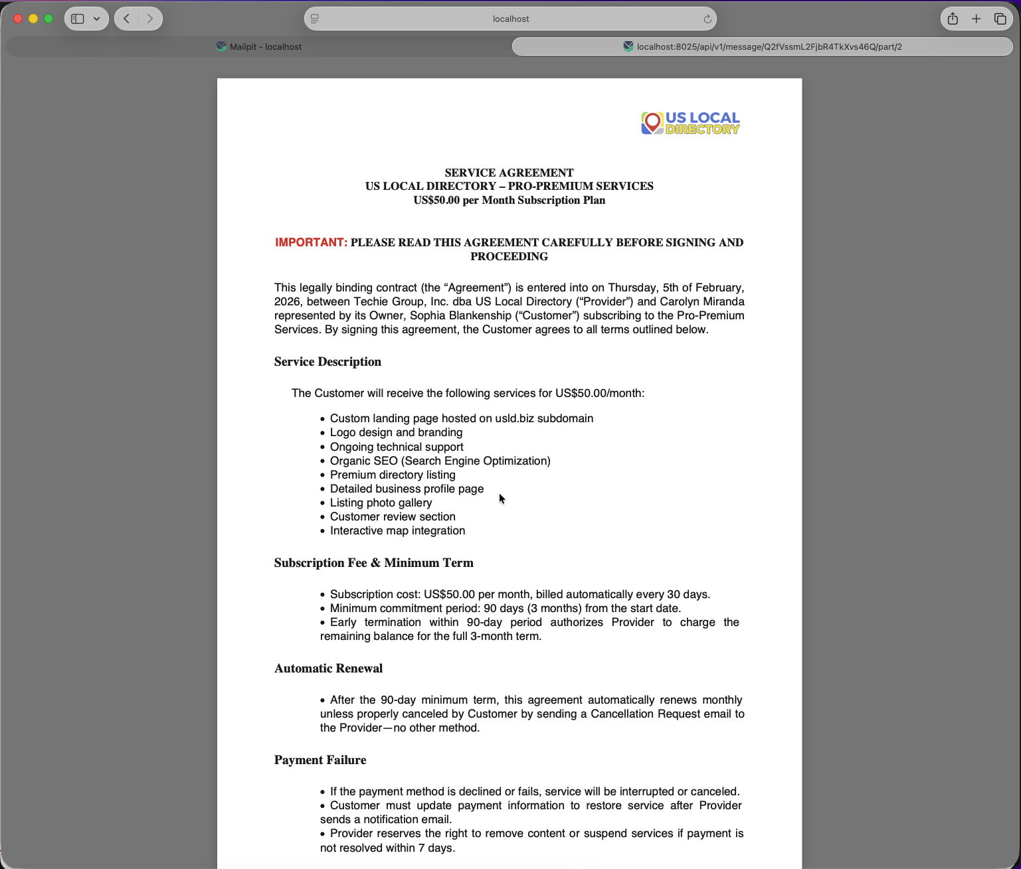
Service Agreement PDF
Context: The customer views an example of the service agreement PDF for reference.
Key Elements: - PDF document content - Service agreement details - Reference material
Instructions: 1. Access the service agreement PDF example. 2. Review the agreement terms. 3. Use this as reference for your signed agreement.

Workflow Summary
This customer workflow demonstrates the complete onboarding and registration process:
- Introduction - Receive initial email and start process
- Agreements - Review and sign service agreements and authorizations
- Verification - Confirm signup and upload ID for verification
- Welcome - Receive confirmation and access materials

Notes
- The workflow includes multiple confirmation and thank you pages for user reassurance
- ID verification is a key step for security and compliance
- PDF documents are provided for record-keeping and reference

For Developers
When implementing this workflow: - Ensure secure document upload and storage - Implement electronic signature capabilities - Provide clear progress indicators throughout the process - Include proper validation for all user inputs - Support multiple document formats and sizes - Maintain audit trails for all agreements and uploads

Last Updated: February 9, 2026

