Olist Customer Retention & RFM Segmentation
A SQL analysis of the Brazilian E-Commerce Public Dataset by Olist
Divine Taiwo | Tool: SQLite (DB Browser for SQLite)

1. Business Question
Why do so few Olist customers buy again, and who are the most valuable ones?
This was broken into four smaller questions:
- How many customers actually return?
- Who are the high-value customers?
- Has retention improved over time?
- What drives bad experiences, and do they affect whether customers return?

2. Dataset
The dataset contains about 100,000 orders placed on Olist, a Brazilian online marketplace, between 2016 and 2018. It is split across nine related tables covering customers, orders, order items, payments, reviews, products, sellers, product category translations and geolocation.
Table | Rows
orders | 99,441
order_items | 112,650
payments | 103,886
reviews | 99,224
customers | 99,441
products | 32,951
sellers | 3,095
category_translation | 71
geolocation | 1,000,163
Table 1: Tables loaded into SQLite after cleaning.
Important detail: Olist creates a new customer_id for every order. The real person is identified by customer_unique_id. Counting customer_id would make it look as if nobody ever returns, so all customer counts in this project use customer_unique_id.

3. Approach
- Data loading and cleaning. Imported the CSV files, renamed columns, converted prices and scores to numeric types, turned empty dates into NULLs, and removed header rows saved as data.
- Indexing. Added indexes on join keys (order_id, customer_id) to speed up queries.
- Base view. Built a delivered_orders view with one row per delivered order, holding the real customer, state, order date, total value (price plus freight) and a late-delivery flag. All later analysis reads from this view, leaving 96,470 delivered orders.
- Repeat rate. Counted customers with more than one delivered order.
- RFM segmentation. Scored every customer on Recency, Frequency and Monetary value. Recency and Monetary use NTILE(5). Frequency is scored by hand because 97% of customers have exactly one order, so quintiles would split identical customers into different groups.
- Cohort retention. Grouped customers by first-purchase month and measured the share who ordered again within 90 days.
- Root-cause checks. Compared review scores for late vs on-time orders, tested whether the first order's review predicts returning, and compared late-delivery rates by state.
SQL techniques used: joins, views, CTEs, aggregation, CASE expressions, window functions (NTILE, ROW_NUMBER, COUNT OVER) and date functions.

4. Findings

4.1 Almost nobody comes back
Of 93,350 customers with delivered orders, only 2,801 (3.0%) ever ordered again. 97 out of every 100 customers buy once and never return.

4.2 Revenue depends on one-time big spenders
Segment | Customers | % of customers | Avg spend (R$) | % of revenue
New big spenders | 14,425 | 15.5 | 302.71 | 28.3
At risk (high value) | 13,760 | 14.7 | 307.26 | 27.4
Need attention | 18,059 | 19.3 | 151.44 | 17.7
Lost | 22,593 | 24.2 | 72.69 | 10.7
New customers | 21,712 | 23.3 | 72.89 | 10.3
Loyal, drifting | 1,598 | 1.7 | 297.57 | 3.1
Champions | 1,203 | 1.3 | 323.08 | 2.5
Table 2: RFM segments ranked by share of revenue.
"New big spenders" and "At risk (high value)" are about 30% of customers but bring in 56% of revenue, and almost none of them have ordered twice. Truly loyal customers (Champions plus Loyal) are just 3% of customers and 5.6% of revenue.

4.3 Growth without loyalty
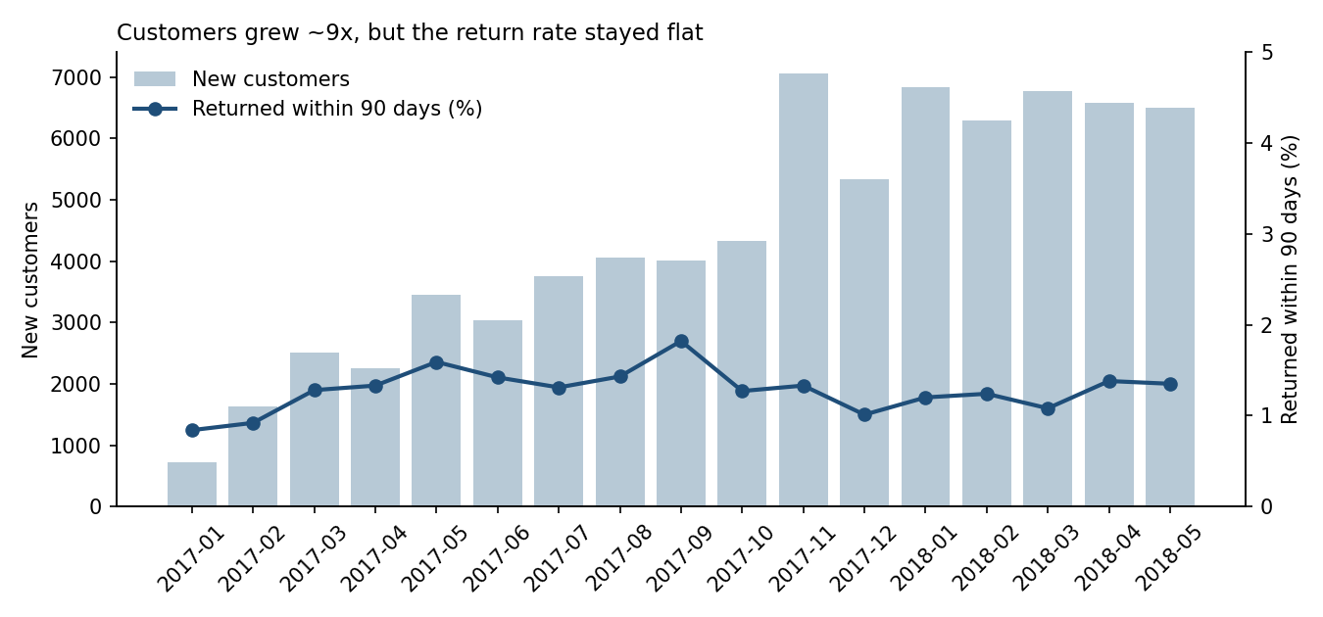
Figure 1: New customers per month vs share returning within 90 days (Jan 2017 to May 2018).
Monthly new customers grew about nine times, from 717 in January 2017 to over 6,500 in 2018. The share who returned within 90 days stayed flat at 1 to 2% the whole time. November 2017 (Black Friday) brought a record 7,059 new customers, but they returned at an ordinary 1.33%. The sale brought people in without keeping them.

4.4 Late deliveries ruin reviews
Delivery | Orders | Avg review score | 1-star reviews (%)
Late | 7,700 | 2.57 | 46.2
On time | 88,653 | 4.29 | 6.6
Table 3: Review scores for late vs on-time orders.
Late orders receive a 1-star review 46% of the time, compared with 6.6% for on-time orders. Late delivery is the single biggest driver of bad reviews.

4.5 But a bad first experience does not stop people returning
First order review score | Customers | Came back (%)
1 | 9,077 | 3.00
2 | 2,834 | 2.96
3 | 7,663 | 2.99
4 | 18,362 | 2.83
5 | 54,798 | 3.22
Table 4: Return rate by the review score of the customer's first order.
Customers whose first order earned 1 star returned at 3.0%, almost the same as those who gave 5 stars (3.2%). Low retention is not caused by bad experiences. Customers simply use Olist as a one-off marketplace. Fixing delivery protects the brand's ratings, but on its own it will not bring customers back.

4.6 Delivery problems are regional
State | Customers | Revenue (R$) | Late orders (%)
SP | 39,149 | 5,768,518 | 5.9
RJ | 11,917 | 2,055,402 | 13.5
MG | 11,001 | 1,818,892 | 5.6
RS | 5,167 | 861,279 | 7.1
PR | 4,769 | 781,709 | 5.0
SC | 3,449 | 595,128 | 9.8
BA | 3,158 | 591,138 | 14.0
DF | 2,019 | 346,123 | 7.1
Table 5: Top eight states by revenue.
Rio de Janeiro (13.5%) and Bahia (14.0%) are late more than twice as often as São Paulo (5.9%). RJ is the second-largest market, so a large share of revenue gets a worse experience. Since most sellers are in SP, distance is the likely cause.

5. Recommendations
- Win the second order. Target "New big spenders" with a personalised offer shortly after their first purchase. They hold 28% of revenue, so converting even a small share into repeat buyers has the biggest payoff.
- Fix delivery to RJ and BA. Improve logistics or set more realistic delivery estimates in these states to protect ratings in large markets.
- Treat retention as its own problem. Better delivery will not fix retention by itself. Olist needs deliberate reasons for customers to return, such as loyalty rewards, follow-up recommendations or seasonal campaigns aimed at past buyers.

6. Limitations and Next Steps
- The data covers about two years, so long-term loyalty cannot be measured.
- A small number of orders have more than one review, which slightly changes the first-review figures but not the overall pattern.
- Next step: use the geolocation table to calculate customer-to-seller distance and test whether distance explains late deliveries in RJ and BA.

