What Makes a Song Popular on Spotify?
A SQL analysis of 114,000 Spotify tracks across 114 genres
Divine Taiwo | Tool: SQLite (DB Browser for SQLite)

1. Business Question
Which genres, artists and audio features are linked to higher popularity, and what separates hits from the rest?
This was broken into four smaller questions:
- Which genres are most popular, and which actually produce hits?
- How do the audio features of hits differ from other songs?
- Which artists produce hits consistently?
- What is the most popular song in each genre?

2. Dataset
The Spotify Tracks Dataset (Kaggle, by maharshipandya) contains 114,000 rows collected through the Spotify Web API, with 1,000 tracks for each of 114 genres. Each row holds the track, artist, album, genre, a popularity score from 0 to 100, and audio features such as danceability, energy, valence, acousticness, instrumentalness, speechiness, loudness, tempo and duration.
Check | Result
Rows | 114,000
Unique songs (track_id) | 89,741
Genres | 114
Songs with popularity 0 | 16,020 rows (14%)
Clean songs used for analysis | 80,393
Table 1: Data checks before analysis.
Important detail: the same song appears several times when it is listed under more than one genre. Counting every row would count popular songs multiple times, so song-level analysis uses a deduplicated table with one row per track_id.

3. Approach
- Data cleaning. Imported the CSV, renamed columns, converted numbers to proper types, turned explicit (True/False) into 1/0, and removed the header row saved as data.
- Exploration. Measured duplicates and the spread of popularity, which revealed 24,259 duplicate rows and a large group of tracks with popularity 0.
- Clean base table. Built a songs table with one row per unique song and popularity above 0 (80,393 songs). Genre questions use the original table, since one song can belong to several genres.
- Defining a hit. A hit is a song with popularity of 70 or more, about the top 4% of songs.
- Analysis. Compared genres by average popularity and hit rate, compared audio features of hits vs the rest, ranked artists with at least 5 songs, and found the top song per genre with ROW_NUMBER().
SQL techniques used: CTEs, aggregation, GROUP BY with HAVING, CASE expressions, CAST and NULLIF for cleaning, and window functions (ROW_NUMBER with PARTITION BY).

4. Findings

4.1 Hits are rare
Only 3,128 of 80,393 songs (3.9%) reach a popularity of 70 or more, and just 1,201 tracks score 80 or above.

4.2 Genre sets the ceiling
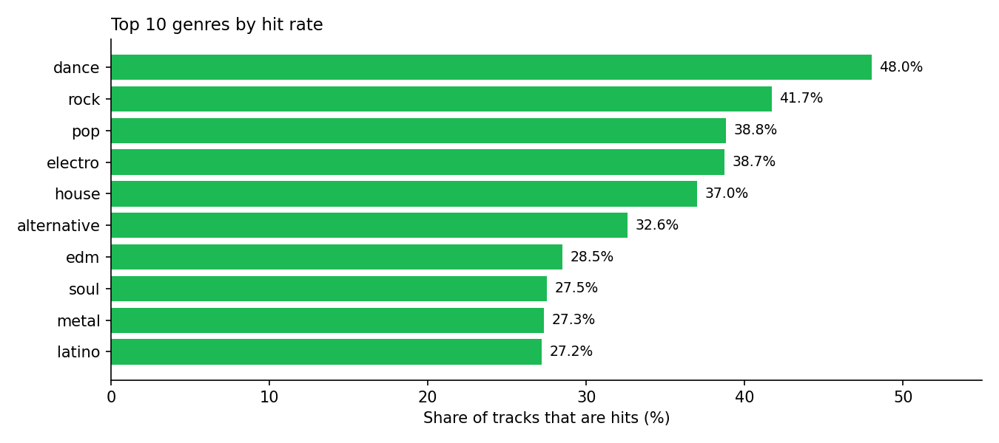
Figure 1: Share of each genre's tracks that are hits (top 10 genres).
Average popularity alone is misleading. Pop-film has the highest average popularity (59.4) but only 67 hits, so it does not reach the top 10 by hit rate. Dance has a middling average (44.5) yet the highest hit rate: 48% of its tracks are hits. Dance is polarised, with songs tending to be either big hits or barely played.
Genre | Tracks | Avg popularity | Hits
black-metal | 997 | 22.5 | 0
bluegrass | 990 | 25.9 | 0
detroit-techno | 999 | 11.2 | 0
forro | 1,000 | 41.8 | 0
gospel | 993 | 41.9 | 0
grindcore | 997 | 14.7 | 0
Table 2: Examples of genres with zero hits.
Many niche genres produce no hits at all. Forró and gospel stand out: their average popularity (about 42) is close to dance, yet not a single track becomes a hit. Their listeners are steady, but songs rarely break out.

4.3 What hits sound like
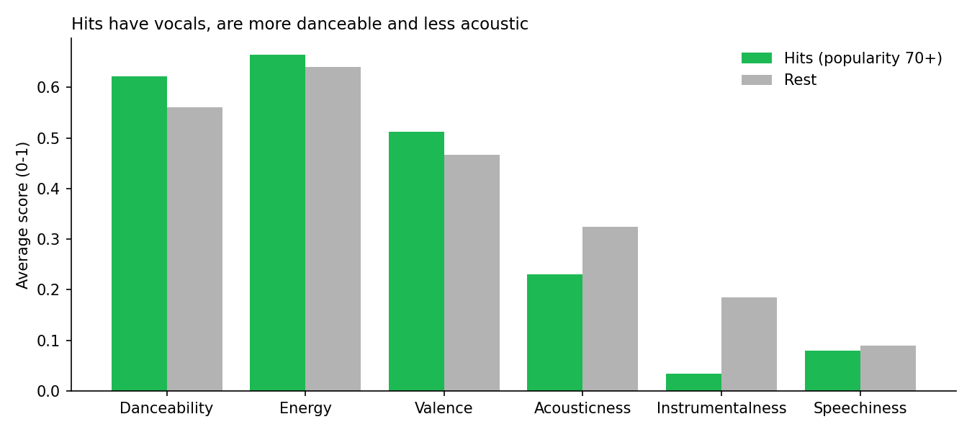
Figure 2: Average audio features of hits vs the rest.
Feature | Hits | Rest
Songs | 3,128 | 77,265
Danceability | 0.622 | 0.561
Energy | 0.664 | 0.640
Valence (positivity) | 0.512 | 0.466
Acousticness | 0.230 | 0.325
Instrumentalness | 0.034 | 0.185
Speechiness | 0.080 | 0.089
Loudness (dB) | -6.73 | -8.52
Duration (minutes) | 3.62 | 3.86
Explicit (%) | 17.9 | 8.3
Table 3: Audio features of hits compared with other songs.
- Vocals matter most. Instrumentalness is about 5 times lower for hits (0.034 vs 0.185).
- Explicit songs are twice as common among hits (17.9% vs 8.3%).
- Hits are louder, more danceable and less acoustic, and about 15 seconds shorter.
- Energy and mood barely differ. Being upbeat is not what separates hits.

4.4 Consistent hit-makers
Artist | Songs | Avg popularity | Hits
Olivia Rodrigo | 5 | 87.4 | 5
Bad Bunny | 22 | 85.4 | 22
Doja Cat | 6 | 83.8 | 6
Lil Nas X | 5 | 83.2 | 5
One Direction | 5 | 83.0 | 5
Måneskin | 5 | 82.6 | 5
Eminem | 6 | 81.2 | 6
Ariana Grande | 9 | 80.8 | 9
Table 4: Artists with at least 5 songs, ranked by average popularity.
Bad Bunny stands out: 22 songs, every one a hit, averaging 85.4. Every other artist in the top list has 5 to 9 songs, making this level of consistency rare.

4.5 Top song per genre
Genre | Top song | Artist | Popularity
dance / pop | Unholy (feat. Kim Petras) | Sam Smith; Kim Petras | 100
hip-hop | Quevedo: Bzrp Music Sessions, Vol. 52 | Bizarrap; Quevedo | 99
edm | I'm Good (Blue) | David Guetta; Bebe Rexha | 98
latin / latino / reggae / reggaeton | La Bachata | Manuel Turizo | 98
piano / rock | I Ain't Worried | OneRepublic | 96
alt-rock / alternative | Sweater Weather | The Neighbourhood | 93
Table 5: Most popular song in each genre, using ROW_NUMBER() OVER (PARTITION BY genre).
One song often tops several genres at once. La Bachata leads four, which shows how loosely genre labels are applied in this dataset.

5. Recommendations
For artists, labels or playlist curators looking to improve a song's chances:
- Genre choice matters. Dance, rock, pop and electro give songs the best odds of becoming hits. Niche genres rarely produce hits regardless of quality.
- Prioritise vocals and production. Hits almost always have vocals, are louder and more danceable, and are slightly shorter.
- Don't rely on mood. Energy and positivity are nearly identical for hits and other songs.

6. Limitations
- These are associations, not causes. Part of the gap in audio features comes from genre, since instrumental genres such as detroit techno have no hits.
- Genre labels are loose, and one song can appear under several genres.
- Collaborations are stored as a single artist string, so a feature counts as a separate artist.
- Popularity is a snapshot from around late 2022 and changes over time.

