**On 6th sept 2024**

**UMURERWA Divine**

**24RP01840**

**Algorithm and data structure using c**

Here I started by opening new project on dev

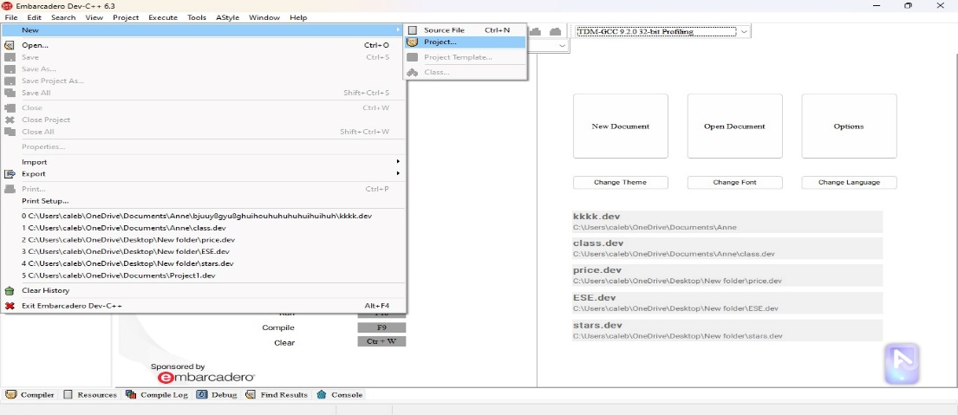

I continued by coding to give a “hello world” out p

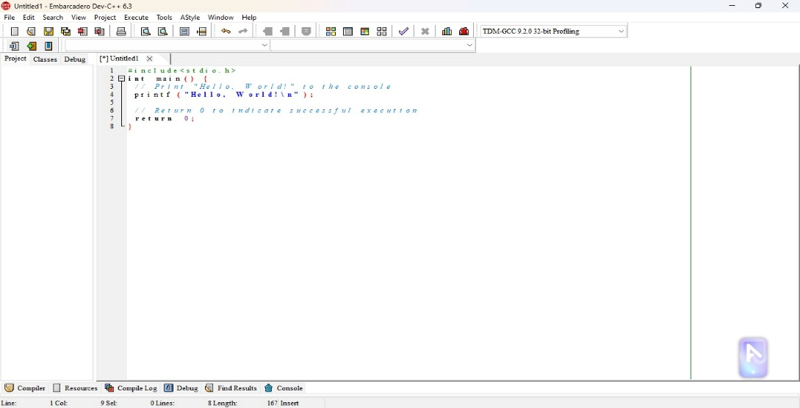

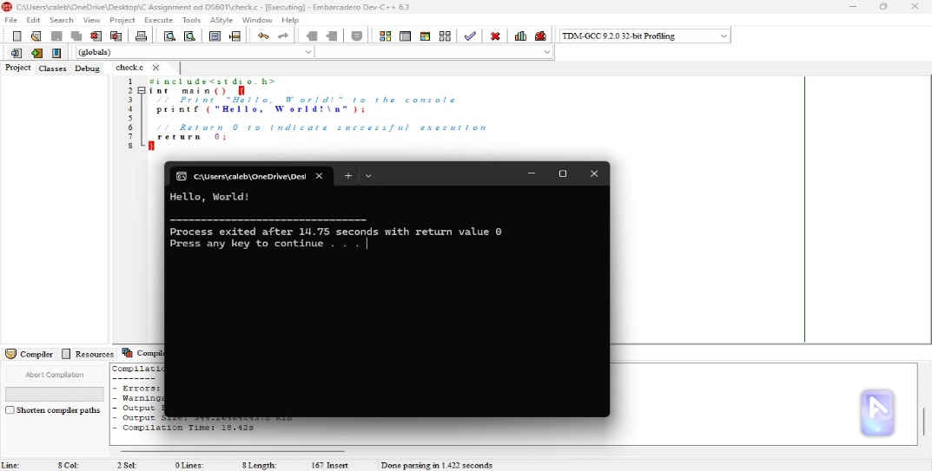

Here I was signing into my account

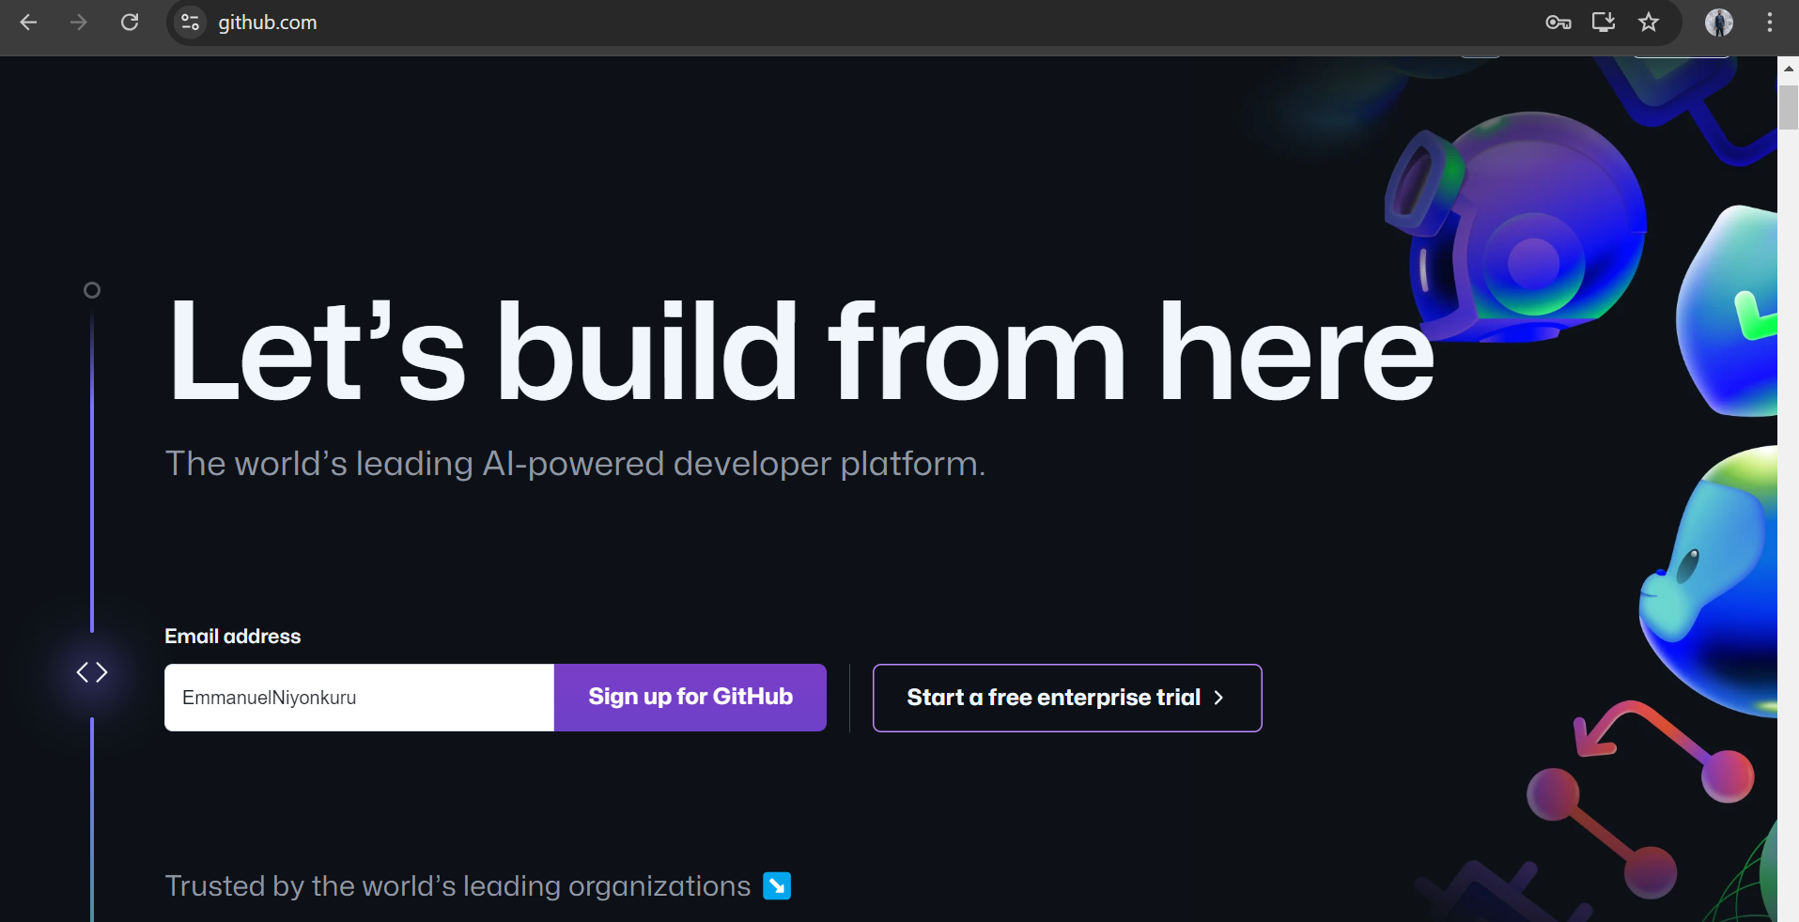

As shown I was entering my email address

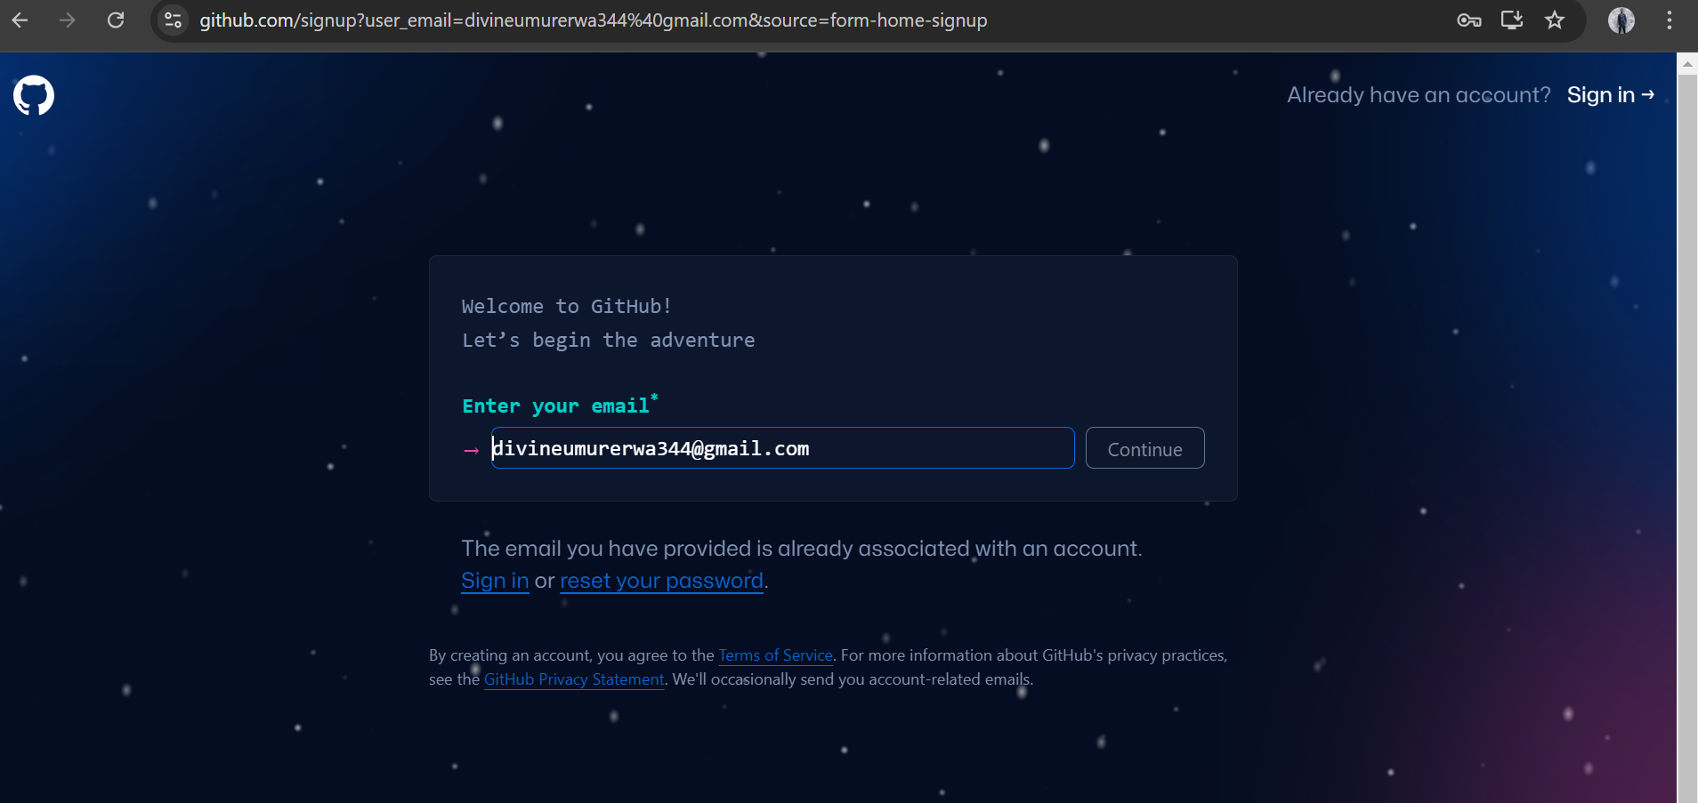

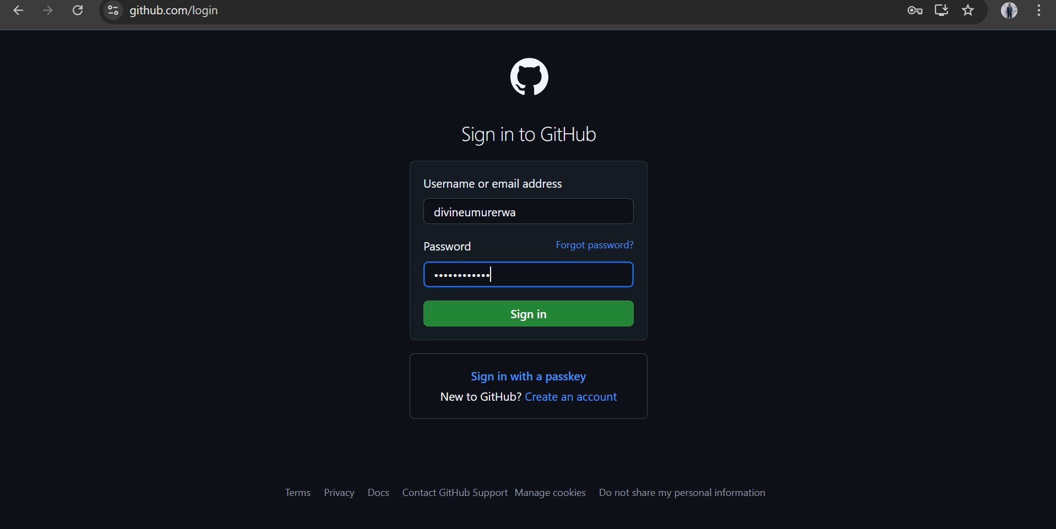

_the process continued by creating a repository which was named my REG NO

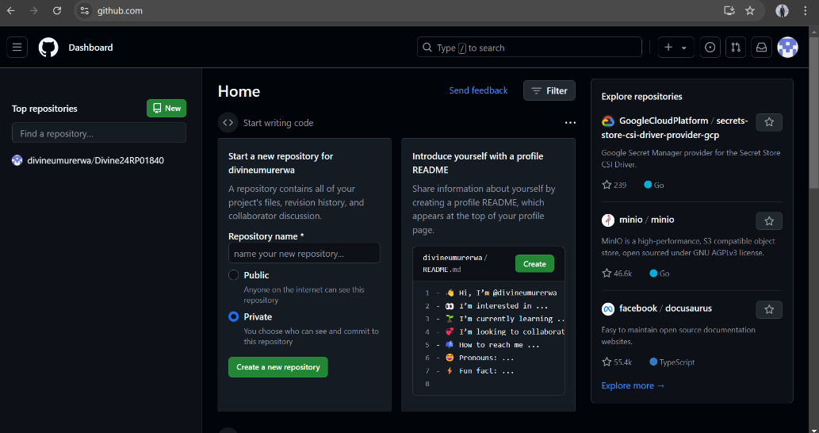   
_the process continued by creating a repository which was named my REG NO

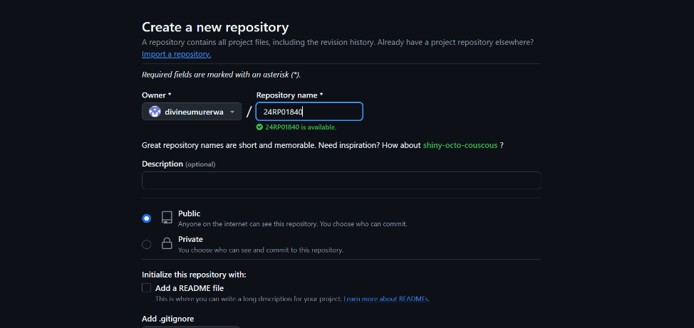

on home I was adding a repository

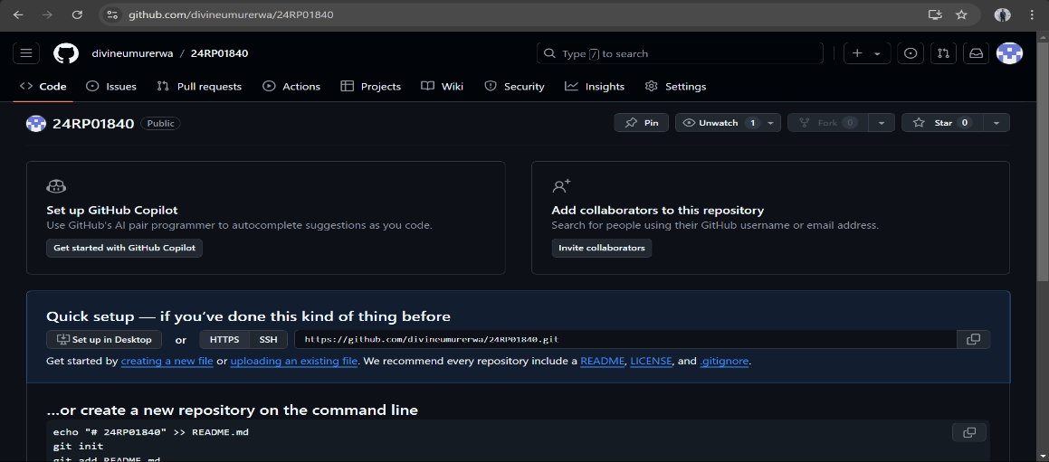

here I was on the process of adding a collaborator

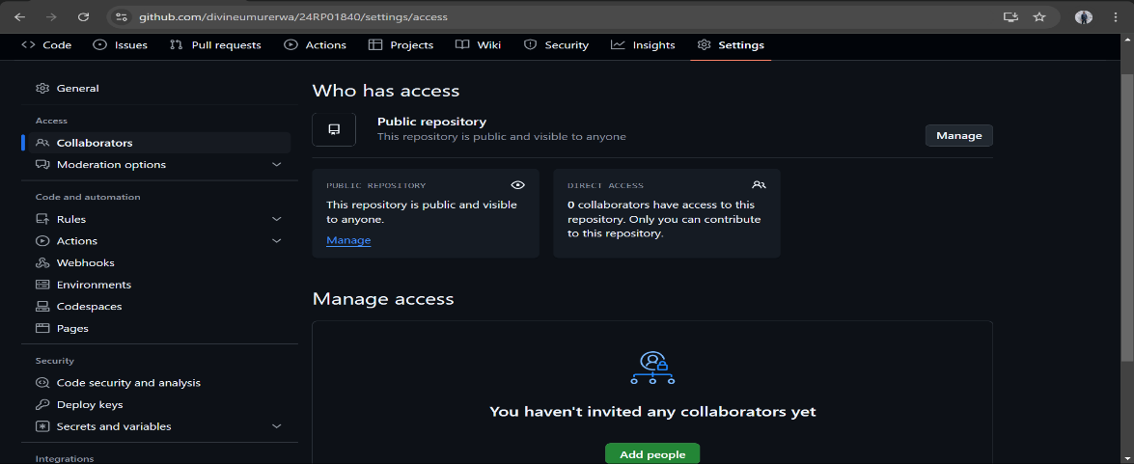

After I found my collaborator and he was added

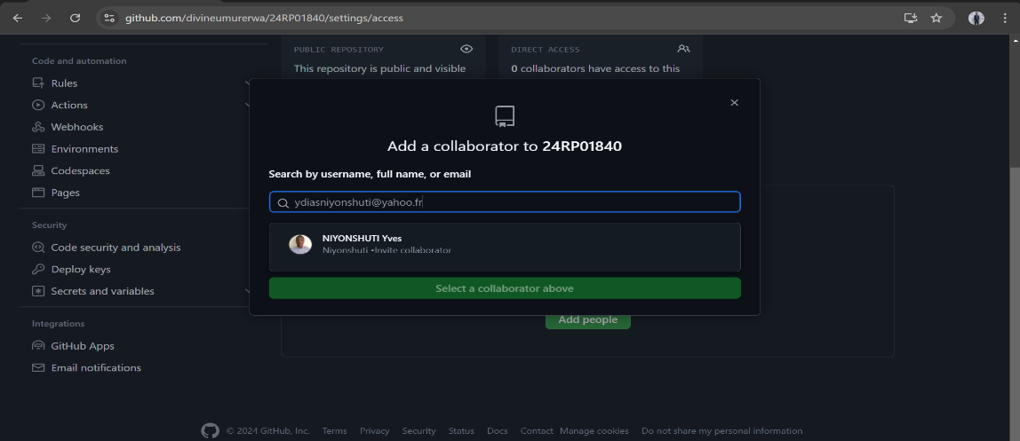

After git installation

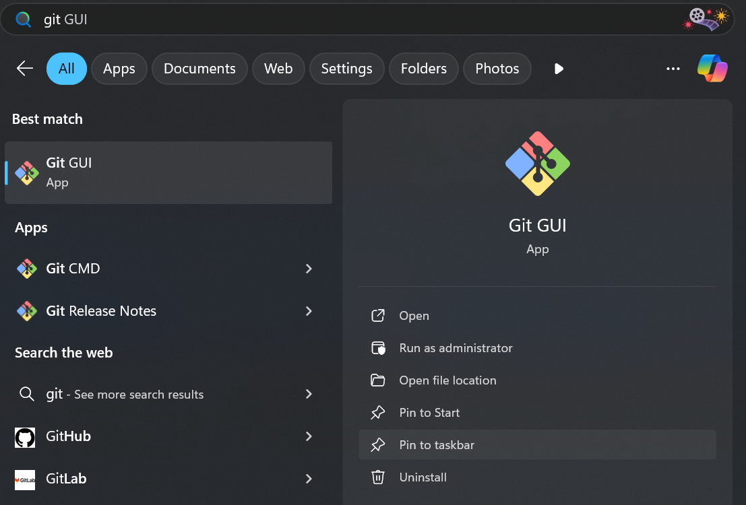

Project cloning by using CLI

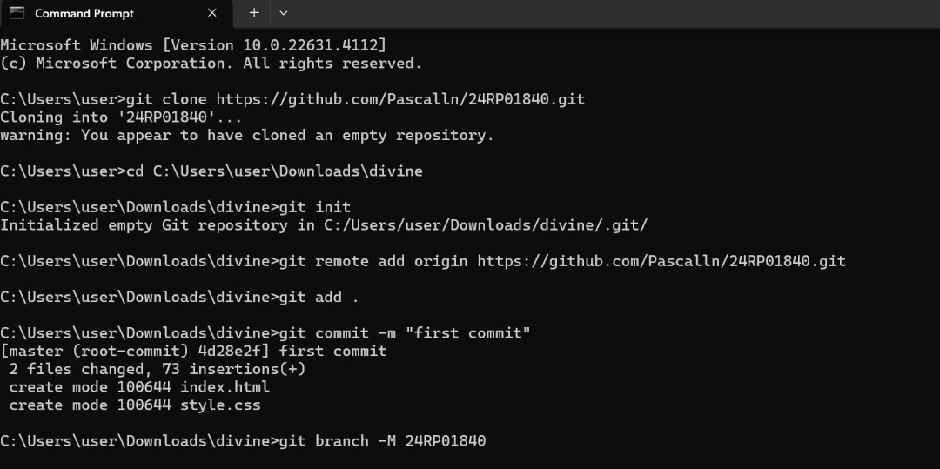

Connect by using Push

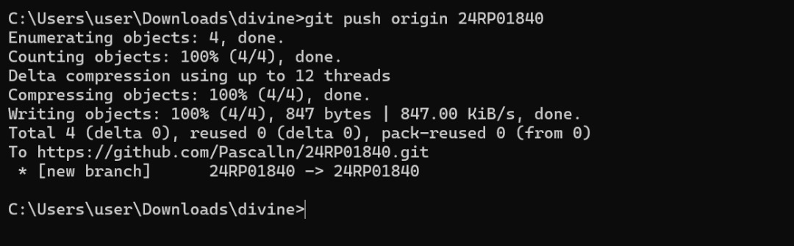

Connect by using Pull

