SE1201 — Foundations of Software Engineering
Project Report

Software Testing
A study of testing techniques in software engineering

Members | العنود دهير العتيبي – 445012543  غيداء علي المالكي – 446006930  رسيل مهدلي الجبيري – 44611609  نسيم محسن الثعبلي - 44611503
Course | SE1201 — Foundations of Software Engineering
Supervisor | Ms. Amnah Alluqmani

Table of Contents
1. Introduction 3
2. Objectives 3
3. Stakeholders 4
4. Planning 4
4.1. Project schedule 4
4.2. Meeting log 5
5. Requirements 5
5.1. Functional requirements 5
5.2. Non-functional requirements 6
5.3. System requirements 6
6. System Design 6
6.1. Data Flow Diagram (DFD) 7
6.2. Activity Diagram 8
7. Implementation 10
8. Software Testing 10
8.1. Why testing matters 10
8.2. Levels of testing 10
8.3. Methods of testing 11
8.4. The V-model 12
8.5. Defect lifecycle 13
8.6. Test cases for the sample application 14
8.7. Results 14
9. Deployment 15
10. Team and Roles 15
11. Conclusion 16

Introduction
This report studies software testing as a topic within software engineering. Testing is the part of the life cycle that decides whether a product is ready for release. A piece of software that has not been tested cannot be trusted, no matter how well the requirements were written or how clean the code looks. The goal of this report is to explain what software testing is, what kinds of testing exist, when each one is used, and how the techniques fit together. We then apply the ideas to a small sample application that the group built in Python and HTML, so that the testing techniques are demonstrated on real code rather than only described on paper.
The sample application is a small Library Management System. We chose it because it is simple enough that the whole group can read the code in an hour, but it has enough moving parts (books, members, loans) to show how different testing techniques apply to different layers of a system. The report follows the software engineering life cycle taught in the course: proposal, planning, requirements, design, implementation, testing, and deployment. The testing section is the largest one because testing is the focus of the project.

Objectives
- Explain why software testing matters in the SE life cycle.
- Describe the four testing levels: unit, integration, system, acceptance.
- Describe the main testing methods: static, dynamic, white-box, black-box.
- Show where each kind of test sits in the V-model.
- Explain the defect lifecycle from discovery to closure.
- Apply the techniques to a small sample application and report the results.

Stakeholders
Three groups of people interact with the sample application. The stakeholders matter for the testing study because each one expects the system to behave in a slightly different way, and the test cases need to cover those expectations.
Stakeholder | Role | Main actions in the system
Member | End user borrowing books. | Search the catalogue, borrow a book, return a book, view loan history.
Librarian | Staff member running daily operations. | Add new books, register new members, mark overdue loans.
Admin | System administrator. | Manage user accounts, view summary reports for the library.

Planning
The work was split into the seven phases of the life cycle and scheduled over a twelve-week semester. Some phases overlap because research on testing concepts continued while the sample application was being designed and coded.

Project schedule
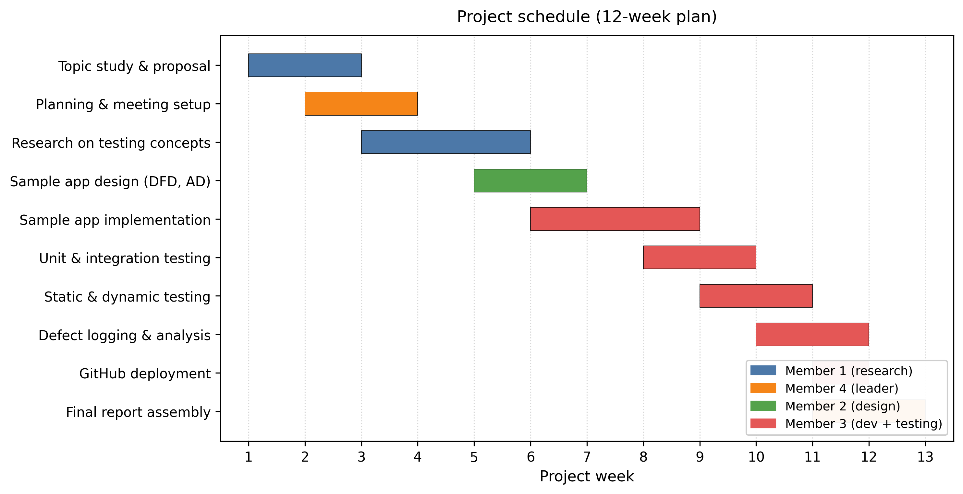
Figure 1: Project schedule as a Gantt chart.

Meeting log
All meetings are logged in the file Meeting_logs.xlsx, which is part of the submission folder. Every row records who attended, what was discussed, what was decided, and the date of the next meeting. The group leader maintained the log to keep the format consistent across the semester.
Field in the log | Purpose
Date | When the meeting took place.
Members | Who attended.
Issue discussed | The topic or problem on the agenda.
Result | The decision or output of the meeting.
Next meeting | Date and goal of the following meeting.

Requirements
The requirements describe what the sample application must do, how it must behave, and what environment it must run in. They are organized into functional, non-functional, and system categories.

Functional requirements
ID | Requirement | Stakeholder
FR1 | The system shall let a librarian add a new book to the catalogue. | Librarian
FR2 | The system shall let a librarian register a new member. | Librarian
FR3 | The system shall let a member search the catalogue by title or author. | Member
FR4 | The system shall let a member borrow a book that is available. | Member
FR5 | The system shall let a member return a borrowed book. | Member
FR6 | The system shall mark a loan as overdue when the due date has passed. | Librarian
FR7 | The system shall let an admin view total books and active loans. | Admin

Non-functional requirements
ID | Requirement
NFR1 | Borrowing a book should complete in under two seconds when the catalogue has fewer than one thousand records.
NFR2 | User passwords must be stored as hashes, not plain text.
NFR3 | The user interface should be readable on a 13-inch laptop without horizontal scrolling.
NFR4 | The system should give a clear error message when a member tries to borrow a book that is already on loan.
NFR5 | The code should be commented well enough that another student in the group can read a module and understand what it does.

System requirements
Type | Requirement
Hardware | Any laptop or desktop with at least 4 GB of RAM.
Operating system | Windows 10/11, macOS, or a recent Linux distribution.
Runtime | Python 3.10 or newer.
Browser | Any modern browser (Chrome, Firefox, Edge, or Safari).
Database | SQLite, which ships with Python.

System Design
Two design diagrams describe the sample application. A Data Flow Diagram (DFD) shows how data moves through the system, and an Activity Diagram shows the sequence of actions a user takes when borrowing a book. Both were drawn in draw.io and are inserted as images below.

Data Flow Diagram (DFD)
The DFD shows the external entities (Member, Librarian, Admin), the processes that operate on the data (search, borrow, return, manage catalogue), and the data stores (the book and loan databases). It explains, at a glance, where the data comes from and where it ends up.
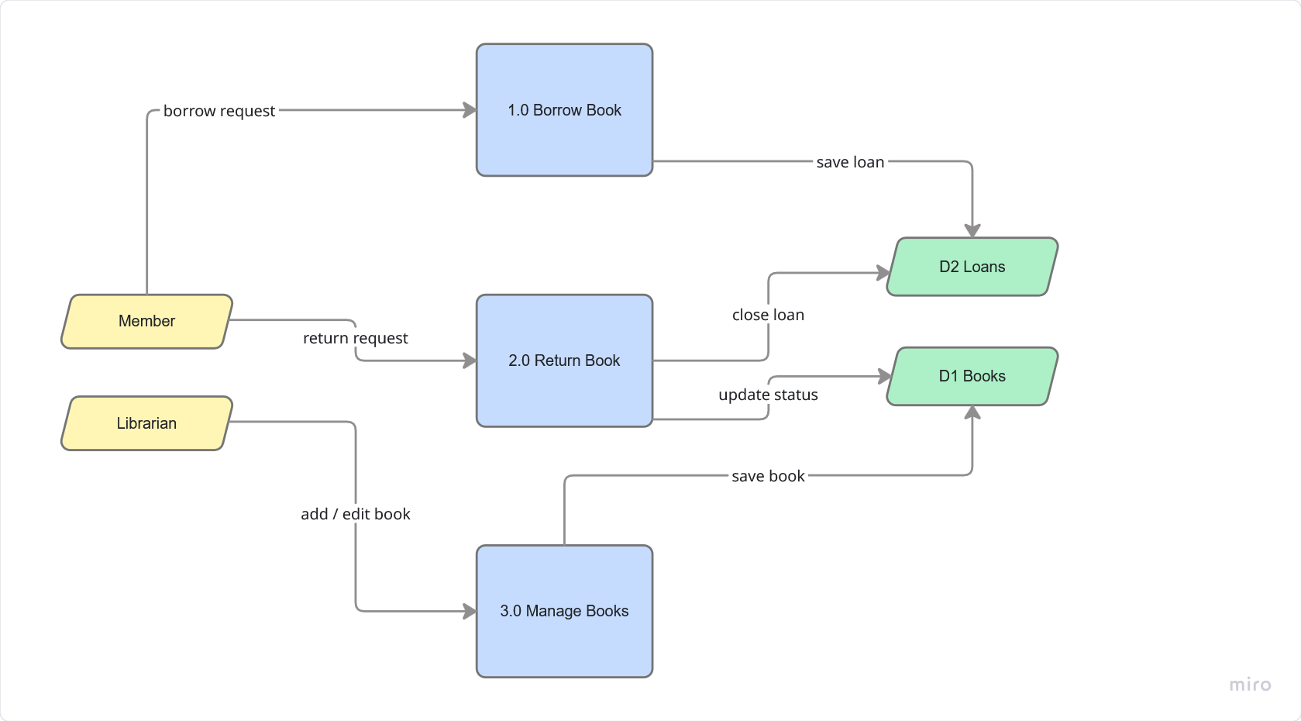
Figure 2: Data Flow Diagram of the sample application.

Activity Diagram
The Activity Diagram covers the borrow-a-book workflow: the member searches the catalogue, picks a book, the system checks availability, and the loan is recorded if the book is free. Decision points appear as diamonds and show what happens when a book is unavailable or when the member has reached the borrowing limit.

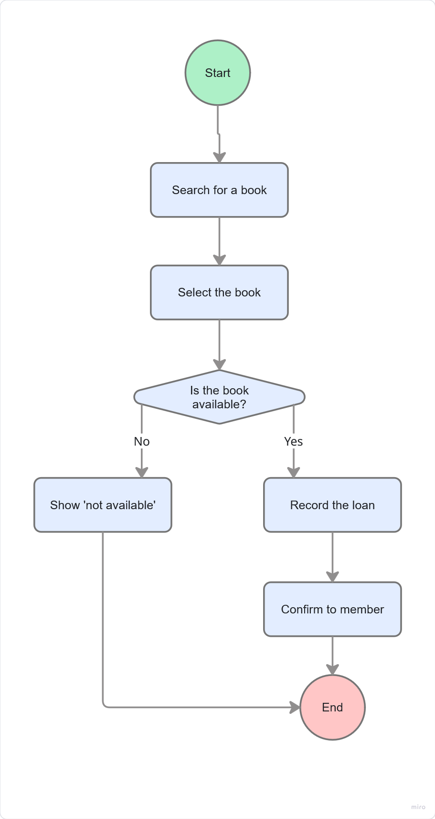
Figure 3: Activity Diagram for the borrow-a-book workflow (to be inserted).

Implementation
The sample application was written in Python with HTML templates for the user interface. The code is split into five modules so that each concern lives in one file, which made it easier to write the tests later. Every module starts with a docstring that explains its purpose, and every function carries inline comments where the logic is not obvious.
Module | Responsibility
auth.py | Login, logout, password hashing, session checks.
members.py | Register members, look up by ID, edit profile.
books.py | CRUD operations for books in the catalogue.
loans.py | Borrow, return, and overdue-marking logic.
reports.py | Summary numbers for the admin dashboard.
The Python back end renders HTML pages and sends them to the browser. No heavy front-end framework was used because the project does not need one and because the marker should be able to read the markup without learning a new library.

Software Testing

Why testing matters
Software testing is the process of running or inspecting a piece of software to find defects before the user does. A defect that escapes to production is more expensive to fix than one that was caught during development, both because the user is already affected and because the engineer has to recover the context of the code after having moved on. Testing also acts as documentation: a well-written test reads like an example of how the code is meant to behave, which helps new team members get up to speed.

Levels of testing
Software testing is usually described in four levels. Each level looks at the system from a different distance. Unit tests sit closest to the code; acceptance tests sit closest to the user.
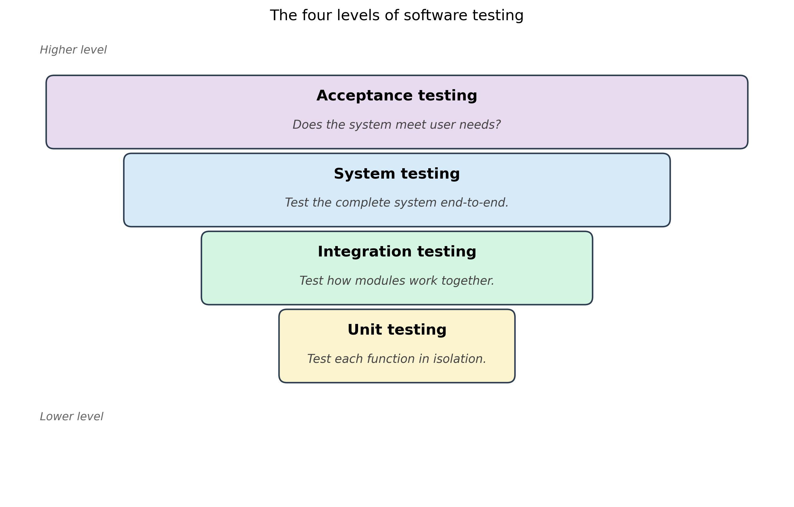
Figure 4: The four levels of software testing.
- Unit testing — each function is tested on its own, with known inputs and expected outputs. Fast and cheap to run.
- Integration testing — two or more modules are tested together, so the test covers the interaction between them.
- System testing — the complete system is tested end-to-end against the requirements list.
- Acceptance testing — the system is checked against what the user expects, often by the user themselves.

Methods of testing
Testing methods describe how the testing is done rather than what is tested. The main split is between static testing, where the code is inspected without running it, and dynamic testing, where the code is executed with input data. Dynamic testing then splits again into white-box testing, which uses knowledge of the source code, and black-box testing, which uses only the specification.
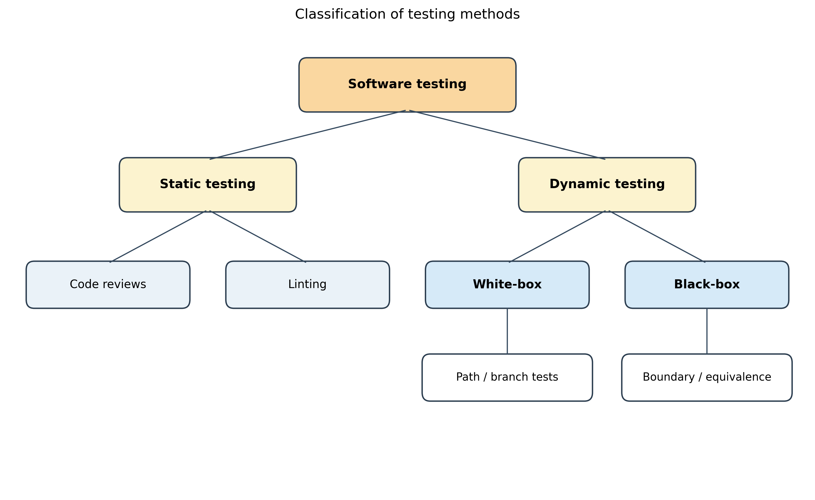
Figure 5: Classification of testing methods.

Method | What it looks at | Examples
Static testing | Source code, comments, documentation. No execution. | Code reviews, linting, walkthroughs.
Dynamic testing | The running program. Inputs in, outputs checked. | Unit tests, integration tests, system tests.
White-box | Internal logic and code paths. | Path coverage, branch coverage, statement coverage.
Black-box | Inputs and outputs, with no view of the code. | Boundary value analysis, equivalence partitioning.

The V-model
The V-model places each testing level next to the development phase it verifies. Reading the V from left to right shows the order in which the work happens, and reading the dashed lines from left to right shows which phase a particular test set is checking against.
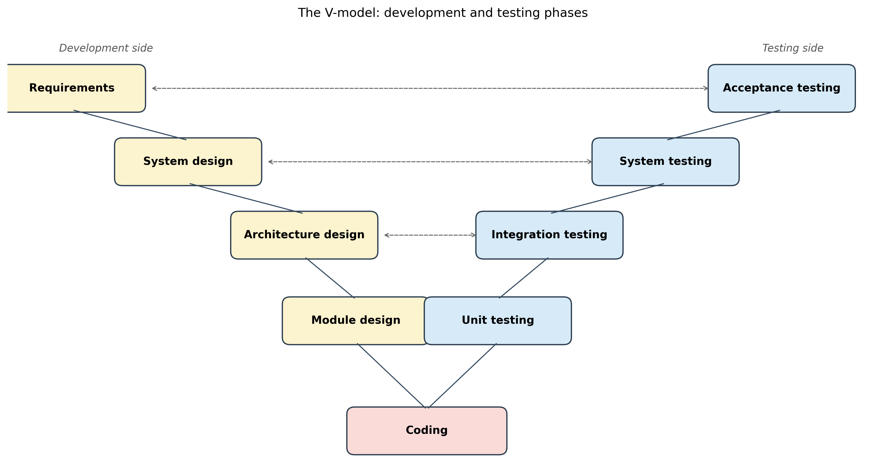
Figure 6: The V-model linking development phases to test phases.

Defect lifecycle
When a tester finds a defect, the defect does not disappear immediately. It goes through a sequence of states from discovery to closure. Tracking this lifecycle matters because a defect can be marked as fixed but still fail when re-tested, in which case it is reopened and sent back to the developer.
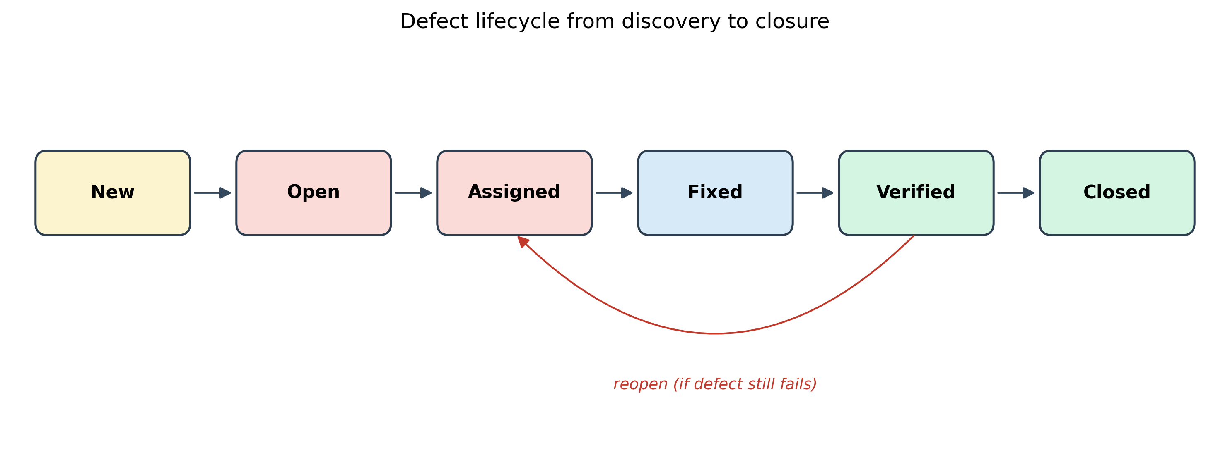
Figure 7: Defect lifecycle from discovery to closure.

Test cases for the sample application
The table below shows a small set of test cases written for the Library Management System. Each test case has an ID, the requirement it covers, the input, the expected output, and the result after the test was run. This format is similar to what is used in real test documents.
ID | Covers | Input | Expected output | Result
TC1 | FR4 | Member M01 borrows book B07 (available). | Loan is recorded, book marked as on loan. | Pass
TC2 | FR4 | Member M01 borrows book B07 (already on loan). | Error: book is not available. | Pass
TC3 | FR5 | Member M01 returns book B07. | Loan closed, book marked as available again. | Pass
TC4 | FR6 | Loan with due date in the past is checked. | Loan marked as overdue. | Pass
TC5 | FR3 | Search for title 'Dune'. | Matching book(s) returned in result list. | Pass
TC6 | FR1 | Librarian adds a book with empty title. | Error: title is required. | Pass

Results
All six test cases passed in the final run. TC6 failed on the first pass because the form was sending an empty string to the database instead of rejecting it; this was fixed by adding an input check in the books module and a unit test that exercises the empty-title case. The static-testing pass (flake8 plus a peer code review) caught fourteen small issues, mostly unused imports and inconsistent variable names, all of which were corrected before the report was assembled.

Deployment
The final code is hosted on GitHub. The submission folder is named after the group leader and the version number, and contains the files listed in the project brief: a readme.txt with the GitHub link and student IDs, the Meeting_logs.xlsx file, this report, and the source code in the repository.
Item | Location in submission
Source code | GitHub repository linked in readme.txt
Meeting log | Meeting_logs.xlsx
Project report | SE_projectReport.docx (this file)
Readme | readme.txt
GitHub link | Software Testing

Team and Roles
The four members of the group divided the work along the phases of the life cycle, so that each person owned a clear part of the project and could be the point of contact for that part during the weekly meetings.

Member | Role | Main deliverables
Member 1 | Research and analysis | Introduction, objectives, stakeholders, testing literature, written analysis.
Member 2 | System designer | DFD, Activity Diagram, draw.io source files.
Member 3 | Developer and tester | Sample app code in Python and HTML, all test cases, GitHub repository.
Member 4 | Leader and documentation | Meeting log, readme.txt, final assembly of this report, submission to BB.

Conclusion
Software testing is one of the parts of the life cycle that decides whether a product is fit to release. This report covered the four levels of testing, the main methods used at each level, the V-model that links the levels to the development phases, and the defect lifecycle that follows a bug from discovery to closure. The ideas were then applied to a small sample application: six test cases were written, one of them failed and was fixed, and the static review caught fourteen smaller issues that would have made it into the submission otherwise.
The exercise made clear that testing is not a single activity but a set of overlapping techniques. Unit tests catch obvious bugs early, integration tests catch the surprises that only show up when modules meet, and static reviews catch the slow erosion of code quality that no dynamic test will ever notice. Spending time on all four kinds during the project paid off in fewer last-minute fixes during the final week.

