**Introduction**

Toronto, being among the top destination for Indian immigrants, has a lot of scope for Indian Restaurants. We analyze the neighborhoods in Toronto to identify the most profitable area since the success of the restaurant depends on the people who would be visiting the restaurants.

However, keeping in mind the competition, we will try to narrow down to a particular riding.

The focus would be on the 2 aspects -

Riding with high number of Indian Population and Riding with a least number of Indian Restaurants currently

**Data Description**

The data which has been used along with the sources -

a) “List of Postal code of Canada: M” (https://en.wikipedia.org/wiki/List_of_postal_codes_of_Canada:_M) wiki page to get all the information about the neighborhoods present in Toronto. This page has the postal code, borough & the name of all the neighborhoods present in Toronto.

b) “https://cocl.us/Geospatial_data” csv file to get all the geographical coordinates of the neighborhoods.

c) “Demographics of Toronto” (https://en.m.wikipedia.org/wiki/Demographics_of_Toronto#Ethnic_diversity) wiki page to fetch data regarding Indian Population at various neighborhoods.

d) Foursquare API (which gives venues recommendations), to get the details like Venue names, categories, Latitude, Longitude details of existing places to visit.

**Methodology**

The aim is to find at what locations there are least Indian Restaurants and at the same time the population of Indians among the highest.

**Exploratory Data Analysis**

Below are the Indian Restaurants found via Foursquare in Toronto

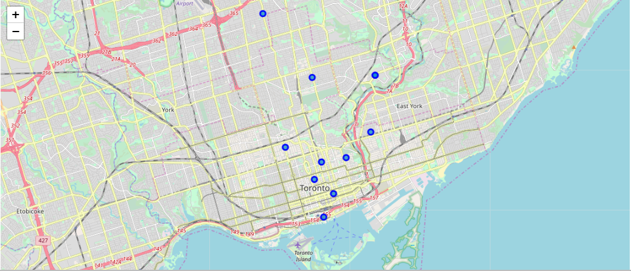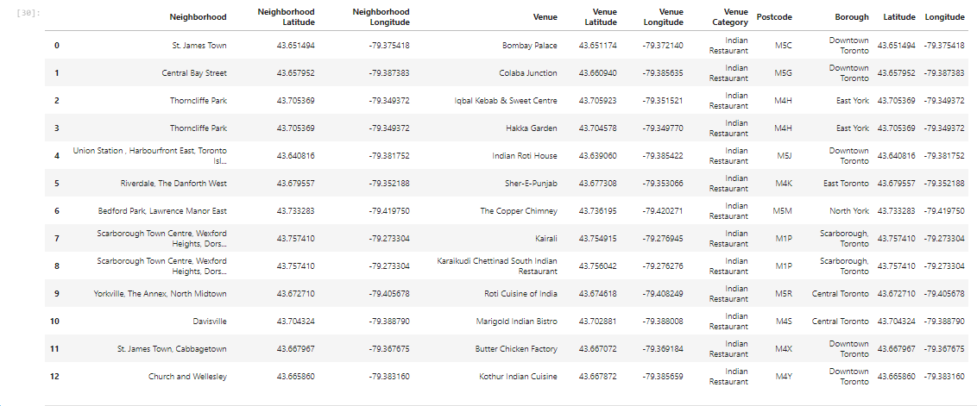

Below is the Indian Population in various Neighborhoods in Toronto

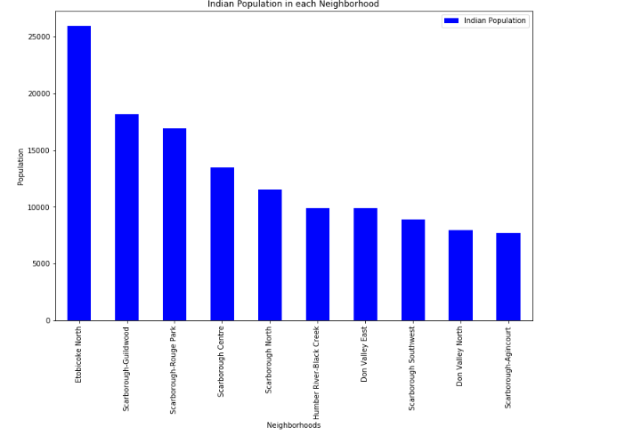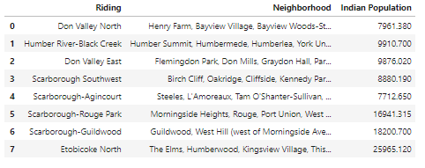

**Results**

We found 13 Indian Restaurants in Toronto. Majorly located in Scarborough, East York and Downtown Toronto.

Etobicoke and Scarborough are the Neighborhoods in Toronto with maximum Indian population

Etobicoke location does not have any Indian Restaurant hence it is a good location to open a new Indian Restaurant

**Discussion**

Based on the data which was collected from various sources, Etobicoke can be considered as a prime location for an Indian restaurant. However, the scope of this analysis is limited to the information gathered from Wikipedia and Foursquare. But it is possible that there could be Indian restaurants running in that area or it may have been the case that Indian Restaurants would have opened in the past and got closed later due to low business. Those aspects can only be determined after an in depth survey of the residents of Etobicoke. Scarborough can also be considered as an option since it also has a huge Indian population and also has a few Indian restaurants which indicate that there is actually demand for Indian restaurants. But the competitors will have to be taken into consideration.

**Conclusion**

In conclusion, based on the given resources and know how, I feel that Etobicoke would be the ideal location to open an Indian Restaurant. However, more in depth research needs to be done in the Scarborough location as well to assess the situation of the Indian Restaurants which are currently operational there.