Software Architecture and Design Specification
Project: File Compression Tool (Basic ZIP Implementation)
Version: 1.0
Authors: Debaditya Chakrabarti, Divisha Gupta, Greeshma N, Chandrakant V G
Date: 02-10-2026
Status: Draft – Part 1

Revision History
Version | Date | Author | Change Summary
Version | Date | Author | Change Summary
1.0 | 02-10-2026 | Team | Completed architecture, component design, security architecture and UML design for Part 1.
1.0 | 02-10-2026 | Team | Reviewed API, error handling, traceability and next steps.

Approvals
Role | Name | Signature/Date
Role | Name | Signature/Date
Team Lead / Architecture | Greeshma N | Pending review
Algorithm Lead | Debaditya Chakrabarti | Pending review
Archive & I/O Lead | Divisha Gupta | Pending review
Testing & Security Lead | Chandrakant V G | Pending review

1. Introduction
1.1 Purpose
This Software Architecture and Design Specification defines the architecture and design for the Huffman-based File Compression Tool. It translates the SRS requirements into an implementable modular design.
1.2 Scope
The design covers compression, decompression, Huffman tree/code generation, bit-level I/O, project-defined archive creation/parsing, metadata inspection, integrity validation, safe output handling, error reporting, and command-line integration.
1.3 Audience
The document is intended for the four-member development team, project guide/instructor, testers, reviewers, and future maintainers. It is used together with the SRS and Software Test Plan.
1.4 Definitions
Huffman tree, Huffman code, bit stream, archive, metadata, checksum, compression ratio, CLI, binary I/O, RTM.

2. Document Overview
2.1 How to use this document
Use Sections 3 and 4 to understand the architecture, component responsibilities, chosen pattern, security architecture, UML sequence flows, API contracts, and error-handling approach. Traceability connects design elements to SRS requirements.
2.2 Related Documents
Software Requirements Specification (SRS) v1.0; Software Test Plan (STP) v1.0; Group 14 project statement; Requirement Traceability Matrix (RTM).

3. Architecture
3.1 Goals & Constraints
Goals: lossless restoration, modularity, portability, predictable error handling, measurable compression, and secure archive validation. Constraints: Huffman coding is mandatory; implementation is C/C++; archive format is project-defined; no third-party compression engine; local file system only; no network dependency.
3.2 Stakeholders & Concerns
Users: simple commands and reliable output.
Project Guide/Reviewers: traceable requirements, UML/design completeness, and measurable quality.
Developers: modularity, testability, portability.
Testers: deterministic behavior, clear errors, and testable interfaces.
Maintainers: documented archive format and low coupling.
Architecture deliverables checklist: the component diagram, component descriptions, architecture pattern and rationale, technology/data-store decisions, risks/mitigations, requirement traceability, and security architecture are all included in Sections 3.3–3.9.

3.3 Component (UML) Diagram

Figure 1. UML Component Diagram
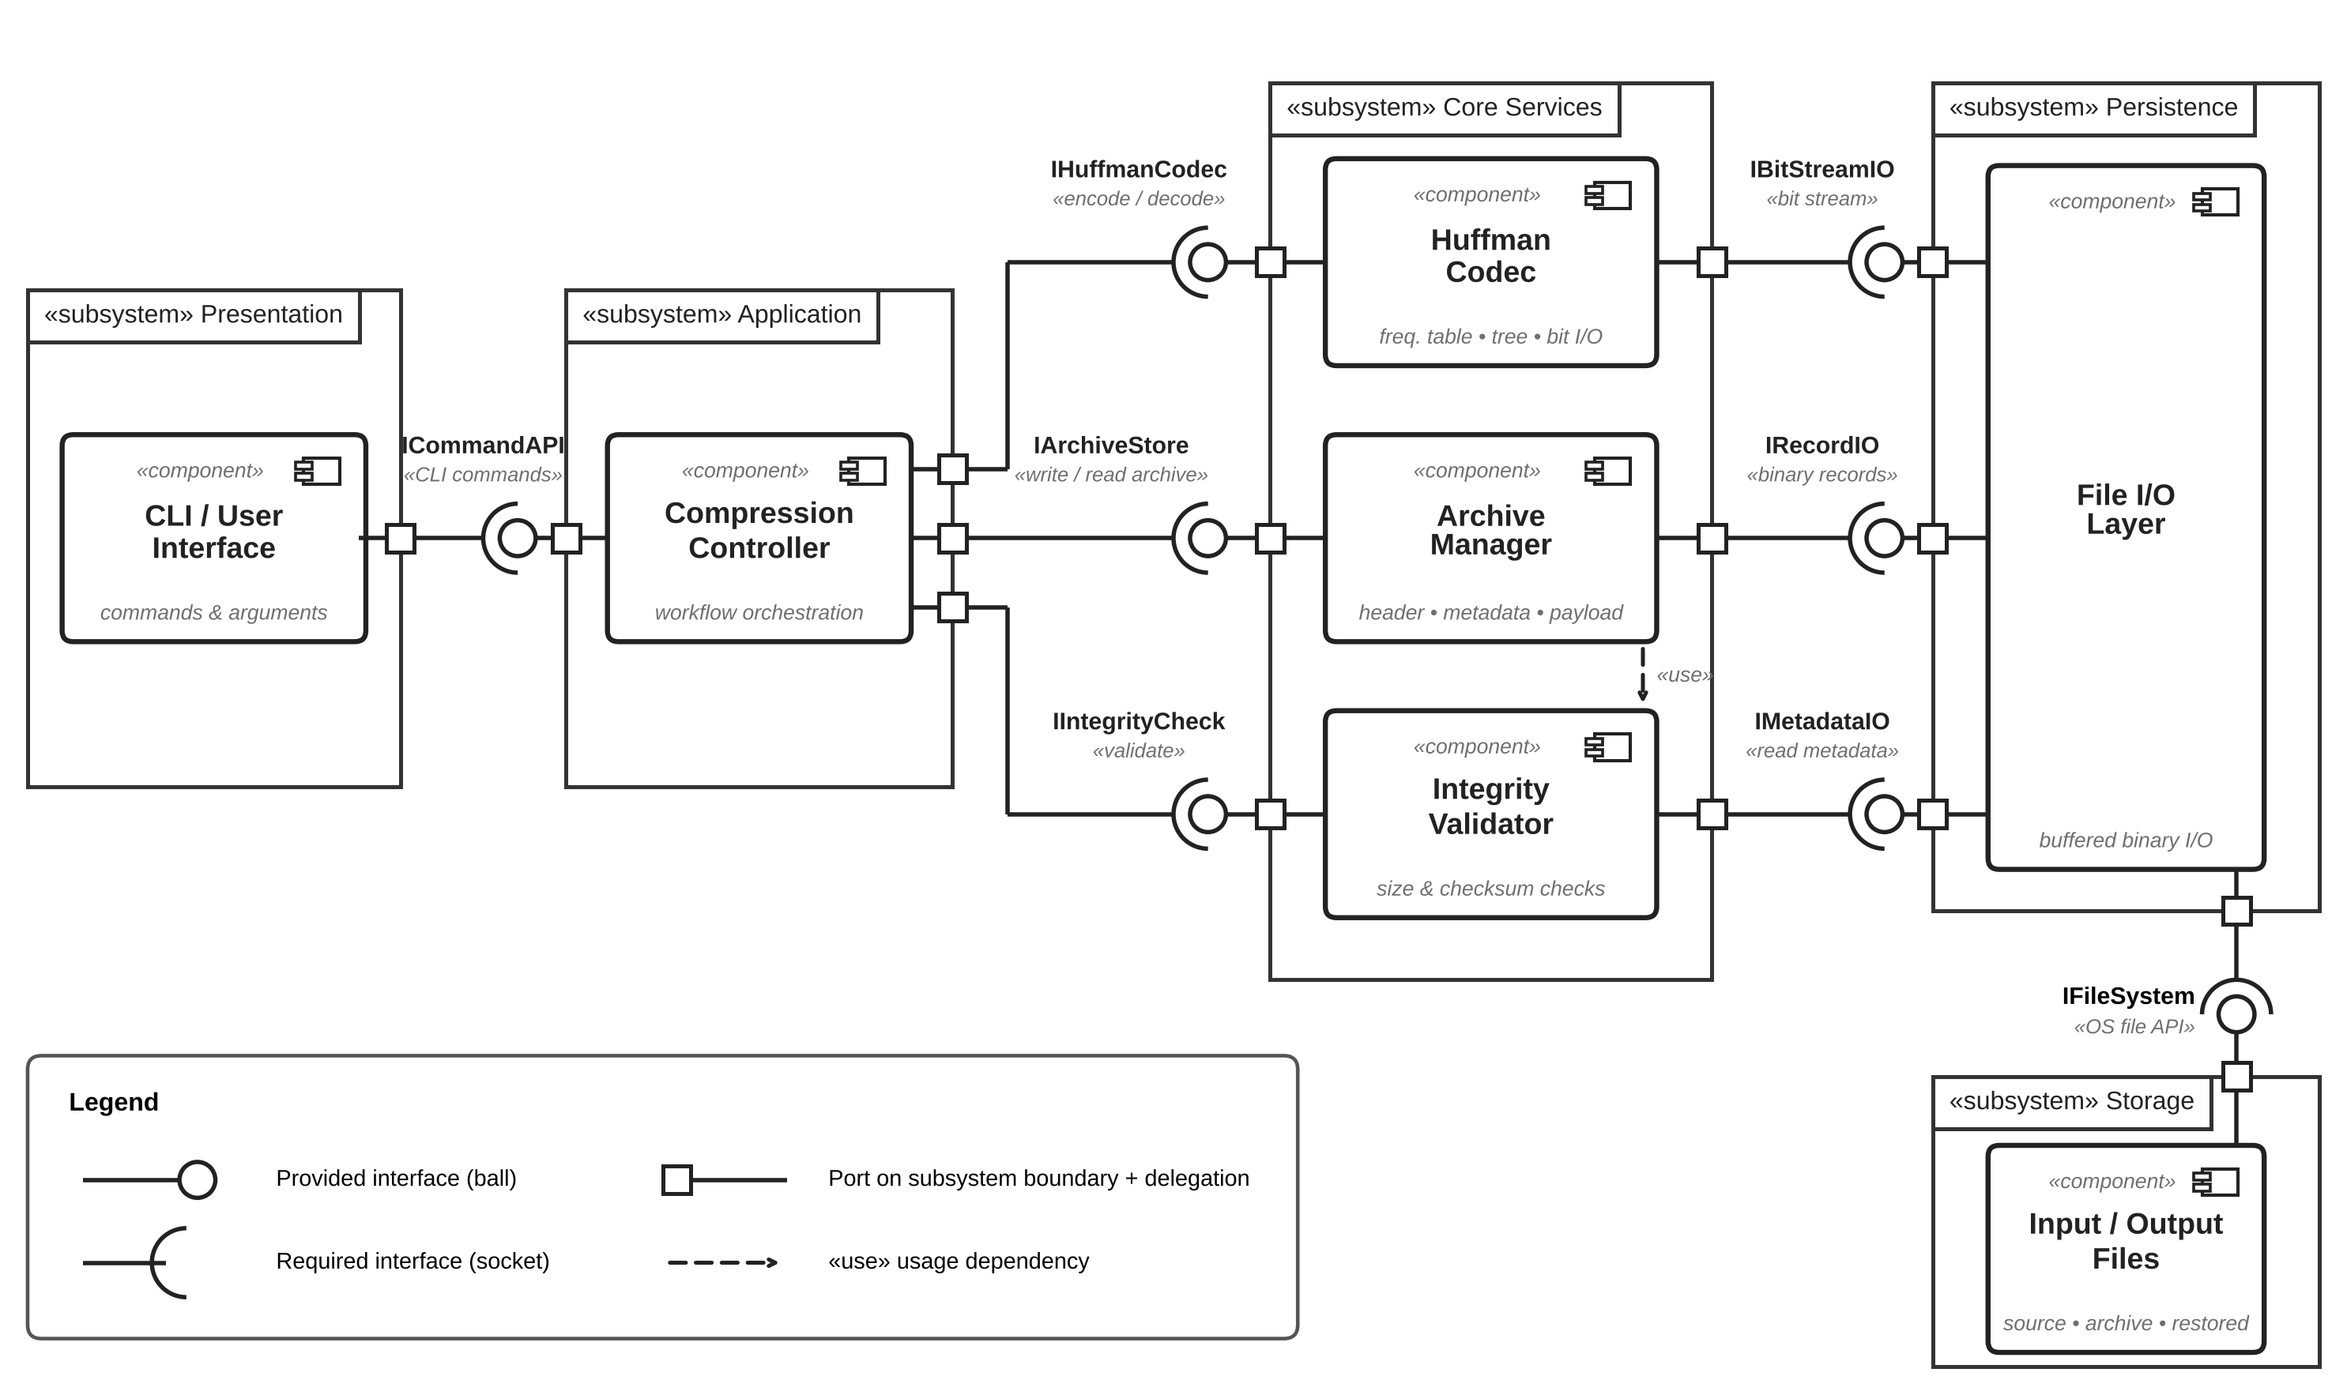

3.4 Component Descriptions
- CLI / User Interface: parses commands, validates basic arguments, and presents results.
- Compression Controller: orchestrates compression/decompression workflows and coordinates modules.
- Huffman Codec: builds frequency tables and Huffman trees, generates codes, encodes bytes, and decodes bit streams.
- Archive Manager: writes/reads archive headers, metadata, tree representation, and payload.
- File I/O Layer: performs buffered binary reads/writes and file existence/permission checks.
- Integrity Validator: checks archive magic/version, declared sizes, checksum/integrity information, and decoded output limits.
- Input/Output Files: persistent source, archive, and restored files.

3.5 Chosen Architecture Pattern and Rationale
Layered architecture with modular components is selected because the project is a small standalone utility with clear processing stages. The CLI/presentation layer, controller layer, algorithm layer, archive layer, and file I/O layer can be tested independently. A microservices architecture is rejected because it would add deployment and network complexity without benefit for a local compression utility.

3.6 Technology Stack & Data Stores
Implementation: C++17 (or later standard-compliant C++ compiler). Data structures: arrays/vectors, priority queue, tree nodes, bit buffers, and metadata structures. Storage: local binary files; no database. Development/testing tools may include GCC/Clang/MSVC, CMake/Make, PlantUML or Graphviz, and a unit-test framework where permitted.

3.7 Risks & Mitigations
Risk: malformed archive causes unsafe or incorrect restoration → Mitigation: validate magic/version/sizes/tree/checksum before trusted output.
Risk: bit-boundary errors → Mitigation: dedicated bit reader/writer and round-trip tests.
Risk: large file memory use → Mitigation: buffered streaming I/O and bounded metadata.
Risk: output overwrite → Mitigation: explicit overwrite option and pre-write existence checks.
Risk: inconsistent archive versions → Mitigation: version field and strict parser.

3.8 Traceability to Requirements
FR-CMP-01 → CLI + File I/O; FR-CMP-02/03/04/07 → Huffman Codec; FR-CMP-05 → Archive Manager; FR-CMP-06 → Compression Controller; NFR-PERF-01 → File I/O + Huffman Codec; SEC-REQ-01 → Integrity Validator; SEC-REQ-02 → Archive Manager; SAF-01/02 → File I/O + Controller.

3.9 Security Architecture
Security objectives: (1) detect malformed/tampered archives before trusted output; (2) prevent unsafe path handling and accidental overwrites. Controls: strict magic/version validation, declared-size limits, checksum verification, sanitized output paths, no path traversal, no sensitive content logging, and fail-closed behavior on validation errors. STRIDE mapping: Tampering → checksum and metadata validation; Information Disclosure → limited diagnostics; Denial of Service → output-size/structure bounds; Path Abuse → output path sanitization.
Security requirements covered: SEC-REQ-01 archive structure/integrity validation; SEC-REQ-02 path safety; SEC-REQ-03 information-exposure control; SEC-REQ-04 declared-size/resource guard. Security validation is mapped to TC-08 and TC-09 in the Test Plan.

4. Design

4.1 Design Overview
The design follows a linear but testable pipeline: CLI → Compression Controller → Huffman Codec / Archive Manager → File I/O, with Integrity Validator used during archive creation and decompression. The controller owns the workflow; algorithm and persistence modules do not depend on the CLI.

4.2 UML Sequence Diagrams
Figure 2 shows the compression flow from command input through frequency analysis, Huffman encoding, archive creation, integrity information, and final reporting. Figure 3 shows decompression, archive validation, tree reconstruction, decoding, output writing, and error reporting.
Figure 2. UML Sequence Diagram – Compression Flow
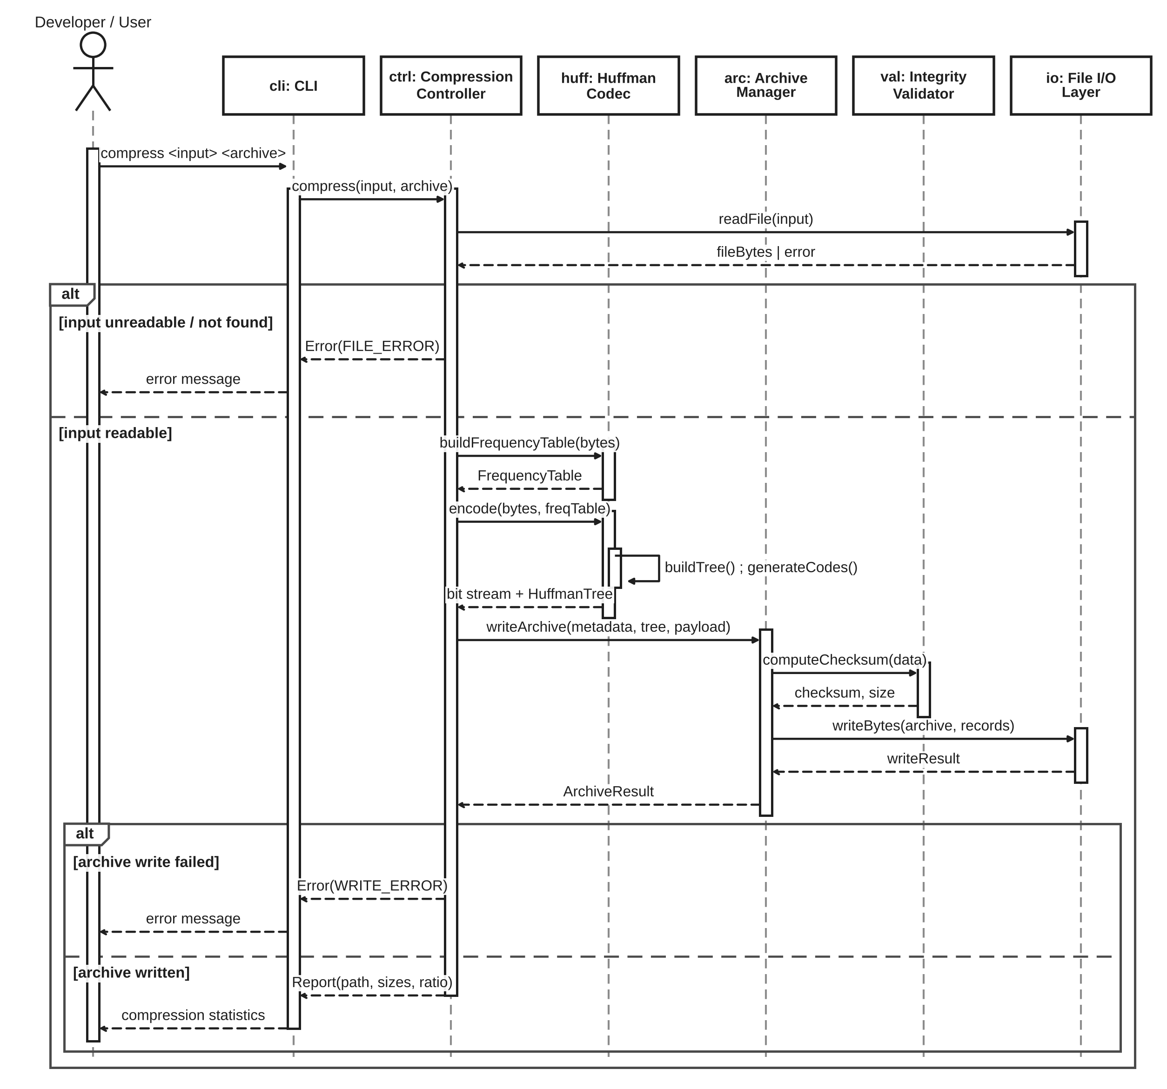
Figure 3. UML Sequence Diagram – Decompression Flow
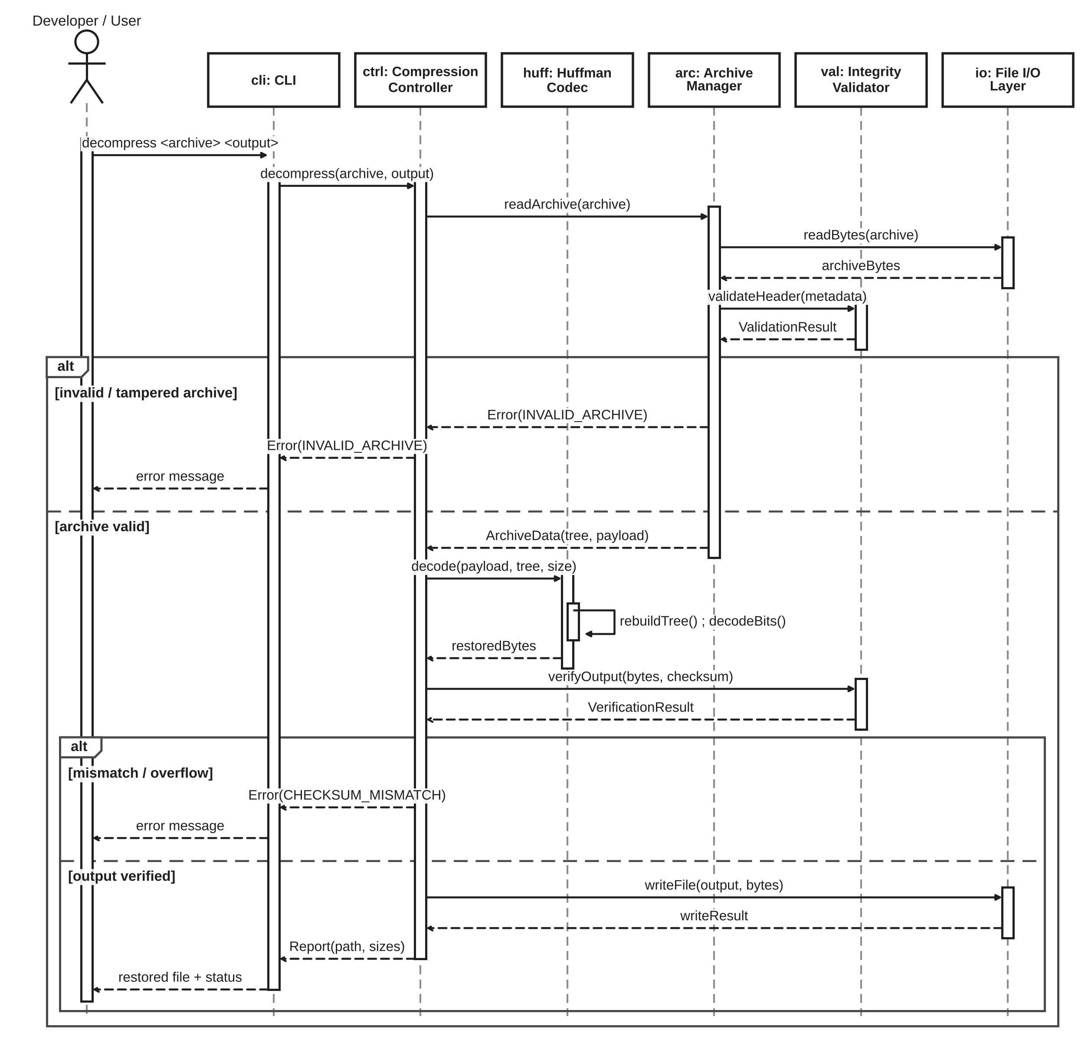

4.3 API Design
The internal API is designed as module-level interfaces so components can be unit tested independently. At least two component interfaces are defined below.
1) Huffman Codec API
- buildFrequencyTable(inputStream) → FrequencyTable
- buildTree(FrequencyTable) → HuffmanTree
- generateCodes(HuffmanTree) → CodeTable
- encode(inputStream, CodeTable, BitWriter) → EncodedStats
- decode(BitReader, HuffmanTree, expectedSize, outputStream) → DecodeStats
2) Archive Manager API
- writeArchive(outputPath, metadata, tree, payload) → ArchiveResult
- readArchive(inputPath) → ArchiveData / error
- validateHeader(metadata) → ValidationResult
- getMetadata(inputPath) → ArchiveMetadata
CLI commands: `compress <input> <archive>`, `decompress <archive> <output>`, `info <archive>`.

4.4 Error Handling, Logging & Monitoring
Errors use typed/result-style return values or exceptions only at module boundaries, with a single user-facing error formatter in the controller. Categories include invalid arguments, file-not-found, permission denied, invalid archive magic/version, malformed Huffman metadata, checksum mismatch, decoded-size overflow, and output-write failure. Diagnostic logs shall never contain complete file contents. Useful metrics include input/output sizes, compression ratio, operation duration, and validation result.

4.5 UX Design
The command-line interface shall use consistent command syntax, concise status messages, explicit error causes, and non-zero process exit codes on failure. Help output shall list commands and required arguments. Success output shall report the output path and compression statistics. The design avoids requiring knowledge of Huffman internals for normal users.

4.6 Open Issues & Next Steps
Implement and freeze the archive binary format; complete module implementation; add unit/integration/system tests; benchmark reference files; review security validation; and update the RTM with final code/test identifiers. Possible future enhancements include standard ZIP/DEFLATE interoperability, GUI support, multi-file archives, and optional password-based encryption.

5. Appendices
5.1 Glossary: Huffman tree – binary prefix-code tree; Bit stream – encoded sequence of bits; Archive – project-defined compressed file; Checksum – integrity value; CLI – command-line interface; RTM – requirement traceability matrix.
5.2 References: IEEE 29148-2018; IEEE 1016-2009; Huffman (1952); project SRS; project STP.
5.3 Tools: Graphviz/PlantUML for UML diagrams, C++17 toolchain, Git, CMake/Make, and a unit-test framework where permitted.
5.3 Test Plan / Test Case Update
TC-01–TC-07 cover normal functional behavior, TC-08 covers malformed/tampered archives and integrity/security validation, TC-09 covers path traversal and overwrite protection, and TC-10 covers the measurable performance requirement. Review/build checks cover maintainability, portability, and testability.

5.4 Architecture and Design Traceability
SRS Requirement | Architecture Component | Design Element | Verification
FR-CMP-01 | CLI, File I/O | Command parser and file-open checks | TC-01
FR-CMP-02 | Huffman Codec | Frequency table | TC-02
FR-CMP-03 | Huffman Codec | Priority queue + tree builder | TC-03
FR-CMP-04 | Huffman Codec | BitWriter + encoder | TC-04
FR-CMP-05 | Archive Manager | Header/tree/payload serializer | TC-05
FR-CMP-06 | Controller | Statistics/reporting | TC-06
FR-CMP-07 | Codec + Archive | Decoder + round-trip validation | TC-07
SEC-REQ-01 | Integrity Validator | Header/checksum/size validation | TC-08
SEC-REQ-02 | Archive Manager | Output path sanitization | TC-09
NFR-PERF-01 | File I/O + Codec | Streaming/buffering benchmark | TC-10
FR-DEC-01 | Archive Manager + Integrity Validator | Format/magic/version validation | TC-08
FR-DEC-02 | Huffman Codec + Archive Manager | Decode to declared original size | TC-07
FR-DEC-03 | Integrity Validator | Checksum/integrity verification | TC-08
FR-DEC-04 | Archive Manager | Output path validation | TC-09
FR-INFO-01 | Archive Manager | Metadata parser / info command | TC-05
FR-ERR-01 | Controller + File I/O | Error/result handling | TC-08
FR-OUT-01 | Archive Manager + File I/O | Validated output creation | TC-09
NFR-REL-01 | Controller + Validator | Fail-closed error flow | TC-08
NFR-USE-01 | CLI Controller | Help and actionable errors | TC-01
NFR-MAIN-01 | All Components | Single-responsibility module interfaces | Review-01
NFR-PORT-01 | All Components | Standard C++17 interfaces | Build-01
NFR-TEST-01 | All Components | Unit-testable APIs | Unit-01
NFR-SAFE-01 | File I/O + Archive Manager | No overwrite / cleanup | TC-09
NFR-SEC-01 | Integrity Validator | Archive integrity validation | TC-08
NFR-SEC-02 | Archive Manager | Path traversal protection | TC-09
NFR-SEC-03 | Controller / Logger | No full-content diagnostics | TC-08
NFR-SEC-04 | Validator + Decoder | Declared-size resource guard | TC-08

