K-Nearest Neighbours versus Decision Trees for Building Damage Classification from Satellite Imagery: Within-Event and Cross-Event Evaluation
Author Name  Dept. of Computer Engineering  Institution, City, Country  email@example.com | Author Name  Dept. of Computer Engineering  Institution, City, Country  email@example.com | Author Name  Dept. of Computer Engineering  Institution, City, Country  email@example.com
Author Name  Dept. of Computer Engineering  Institution, City, Country  email@example.com | Guide Name  Dept. of Computer Engineering  Institution, City, Country  email@example.com | [Author block placeholders: replace with the four authors and the project guide, in the agreed order.]

Abstract—Rapid building-level damage estimates help prioritise field surveys after a disaster. This study compares two classical, interpretable classifiers, k-nearest neighbours (KNN) and a decision tree (DT), for four-class building damage classification when each building is described by 37 engineered pre- and post-event image features covering colour, change, texture, surrounding context and shape. Building regions are derived from the annotation masks of the xBD training split; five disaster events provide 71,340 labelled buildings in 1,239 image pairs. Both classifiers share one preprocessing pipeline fitted on training data, are tuned on validation macro-F1 and are evaluated once on held-out test scenes under two designs: a scene-grouped within-event split and a cross-event split that holds out Hurricane Michael. Within events, KNN reaches a test macro-F1 of 0.520 (95% scene-level bootstrap interval 0.459–0.560) against 0.470 (0.401–0.526) for the DT. On the held-out event both models degrade and the ranking reverses (0.271 versus 0.294; paired difference -0.023, interval -0.034 to -0.011), while KNN keeps the higher accuracy. The DT used balanced class weights and KNN did not, which limits causal interpretation. The results show that conclusions depend on the evaluation design and metric, and that transfer to a new event is the main weakness; a single held-out event does not support general claims.
Index Terms—building damage assessment, xBD, k-nearest neighbours, decision tree, change features, cross-event generalisation, remote sensing.

I. Introduction
After a hurricane, flood, wildfire or tsunami, responders need an early picture of which buildings are damaged and how severely. Paired satellite images acquired before and after an event cover a whole affected area, but manual inspection of thousands of buildings is slow. The xBD dataset [1], [2] made this a standard machine learning task by providing pre- and post-event image pairs with building annotations graded on a four-level damage scale. Much of the subsequent work uses deep convolutional networks [3], [4], which learn features directly from pixels.
Classical classifiers on engineered features remain attractive for teaching and for low-resource settings, and each of their predictions can be traced to measurable quantities. Two such classifiers explain themselves in different ways: k-nearest neighbours (KNN) [5] justifies a label with similar labelled examples, and a decision tree (DT) [6] with an explicit sequence of threshold tests. How these two compare on building damage, and how their comparison behaves when a model meets a disaster it has not seen, is the subject of this paper. We address three research questions. RQ1: How do KNN and a DT compare on four-class damage classification of new scenes from disasters represented in training? RQ2: How does the comparison change when an entire event is held out? RQ3: Which damage classes account for the errors under each design?
The study is built on AfterSight, an explainable damage-triage application developed by the authors, whose pipeline fixes the data, features and evaluation protocol. The contributions are: (i) a leakage-controlled protocol with scene-grouped and event-held-out splits, preprocessing fitted on training data only and a single test evaluation per model; (ii) a KNN–DT comparison reporting per-class results and scene-level bootstrap intervals rather than single scores; and (iii) an explicit account of the protocol differences between the two models and of how the conclusion depends on the metric. This is an applied comparative study; it proposes no new algorithm or dataset and makes no state-of-the-art claim. Fig. 1 summarises the pipeline.
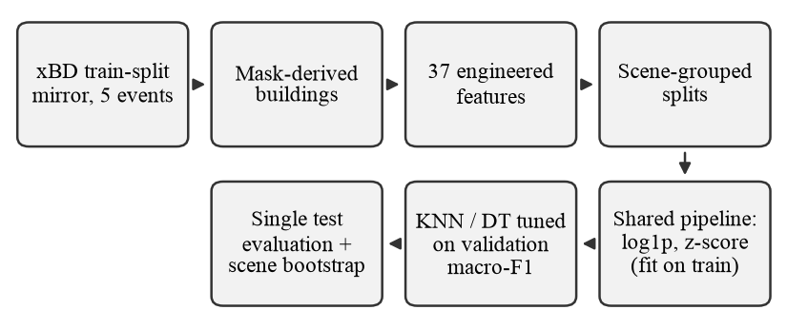
Fig. 1. Implemented pipeline used for both classifiers. Building regions come from annotation masks, not from a detector.

II. Related Work
Remote sensing has long been used to map building damage. Reviews of earthquake damage detection [7] distinguish post-event-only from pre/post change-based approaches, and classical change detection compares co-registered images through differencing, ratios and transformed features [8]. Texture and structure descriptors are particularly useful at high spatial resolution: Cooner et al. [9] classified damage after the 2010 Haiti earthquake with random forests and neural networks and reported that texture and structure variables mattered more than spectral ones. Our features follow this tradition, using grey-level co-occurrence statistics [10] and Canny edges [11].
xBD [1], [2] provides imagery for many disasters, targeted below 0.8 m ground sample distance, with four damage levels. Deep models such as RescueNet [3] and BDANet [4] jointly segment buildings and grade damage on this data. Generalisation across events is a central concern: Valentijn et al. [12] tested a convolutional network on 13 xBD disasters and found that performance, measured by the area under the ROC curve, differed strongly between disasters yet remained high without labelled data from the test disaster. We study the same question for classical classifiers on engineered features, measured by four-class macro-F1.
KNN [5] and classification trees [6] are standard methods implemented in scikit-learn [13]. With imbalanced classes, accuracy can be dominated by the majority class [14], so macro-averaged F1 is commonly preferred [15]. Because the buildings of one image share acquisition conditions, we quantify uncertainty with a bootstrap [16] that resamples whole scenes, as recommended for clustered data [17].

III. Dataset and Problem Formulation

A. Source and Event Selection
We use a third-party Parquet repackaging of the xBD training split (10 events, 2,799 pre/post image pairs of 1024 × 1024 RGB pixels). The official xBD test and hold-out splits are not part of this copy, so all evaluation partitions are carved from the training split. Each record holds the pre- and post-event images, a binary building-footprint mask and a damage mask with values 1–4 for no, minor, major and destroyed damage. Five events were chosen in an earlier project phase to cover four hazard types with substantial numbers of severely damaged buildings: Hurricanes Harvey, Matthew and Michael, the Palu tsunami and the Santa Rosa wildfire. The choice was a design decision rather than a formal rule (for example, Santa Rosa contributes many destroyed but only 55 major-damage buildings), and it is treated as a threat to validity in Section VII. Table I lists the resulting counts.
TABLE I
Labelled buildings per event and damage class
Event | Scenes | No dmg. | Minor | Major | Destr.
Hurricane Harvey | 319 | 9,463 | 2,251 | 7,034 | 373
Hurricane Matthew | 238 | 2,103 | 4,440 | 1,140 | 1,887
Hurricane Michael | 343 | 13,870 | 4,998 | 1,841 | 720
Palu tsunami | 113 | 7,360 | 1 | 200 | 1,596
Santa Rosa wildfire | 226 | 8,653 | 76 | 55 | 3,279
Total | 1,239 | 41,449 | 11,766 | 10,270 | 7,855

B. Building Regions from Annotation Masks
The copy contains no building polygons, so building regions are reconstructed from the masks rather than detected: each 4-connected component of the footprint mask becomes one building, and its label is the most frequent damage value inside it. Components smaller than 16 px (54), without any damage value (1,396) or with a tied vote (1) are excluded and logged, leaving 71,340 buildings. Touching buildings can merge into one component; 782 components contain more than one damage value and receive the majority label. Original building identifiers and geographic coordinates are unavailable, so all geometry is in image pixels.

C. Task
Each building i is represented by a feature vector xᵢ ∈ ℝ³⁷ and a label yᵢ ∈ {no damage, minor, major, destroyed}. The classes are imbalanced: 58% of buildings are undamaged.

IV. Features and Classifiers

A. Engineered Features
Features are computed on the building's pixels in the pre-event and post-event images (Table II). Grey levels use g = 0.299R + 0.587G + 0.114B. Writing Ω for the set of footprint pixels and g^{pre}, g^{post} for the two grey images, the mean absolute grey change and the brightness ratio are
D = (1/|Ω|) Σ_{p∈Ω} |g^{post}(p) − g^{pre}(p)|, (1)
B = ḡ^{post} / max(ḡ^{pre}, 1), (2)
where ḡ denotes the mean grey level over Ω. Texture uses the fraction of footprint pixels on Canny edges (σ = 1.5) and two grey-level co-occurrence statistics [10] computed from horizontally and vertically adjacent pixel pairs (i, j) inside the footprint, after quantising grey levels to 32 bins:
C = Σ P(i,j)(i − j)², H = Σ P(i,j) / (1 + (i − j)²) (3)
where P is the normalised co-occurrence matrix. Each texture statistic is reported before, after and as post − pre. Context features compare the building with a ring of ground pixels within 8 px of it (excluding all buildings); with ring mean r̄, the relative brightening is
K = (ḡ^{post} − r̄^{post}) − (ḡ^{pre} − r̄^{pre}) (4)
Shape is described by area in pixels and compactness 4πA/P², with polygon area A and perimeter P. No feature selection is performed, and both classifiers receive all 37 features in the same order.
TABLE II
The 37 engineered features
Group | No. | Features (pre, post and change)
Colour | 12 | per-channel mean and std. dev., pre and post
Change | 8 | |Δ mean| and Δ std. dev. per channel; D; B
Texture | 12 | grey std., Canny edge density, GLCM C and H: pre, post, Δ
Context | 3 | ring mean change, ring mean abs. change, K
Shape | 2 | area (px), compactness

B. Shared Preprocessing
Both classifiers use one scikit-learn [13] pipeline fitted on the training split only: log(1 + x) for the 7 features whose training skewness exceeds 2 (absolute colour change, D, GLCM contrast and area), median imputation and standardisation to zero mean and unit variance. The feature table contains no missing values, so imputation has no effect on these data.

C. Classifiers
KNN predicts the majority label among the k training buildings nearest to a query x in the standardised feature space under the Euclidean distance
d(x, x_{i}) = ( Σ_{j=1}³⁷ (x_{j} − x_{ij})² )^{1/2} (5)
with uniform votes; the selected value is k = 15 in both designs. Its confidence is the vote fraction. The DT is a CART-style tree [6] grown with the Gini impurity of a node with class proportions p_{c},
G = 1 − Σ_{c} p_{c}², (6)
using balanced class weights w_{c} = N / (4N_{c}), where N is the number of training buildings and N_{c} the number in class c. The selected tree has maximum depth 8 and at least 100 training buildings per leaf.

V. Experimental Setup

A. Evaluation Designs
Buildings in one image share acquisition conditions and often damage, so every split assigns whole scenes. The within-event design partitions scenes of all five events with stratified group folds (seed 42; requested 70/15/15). The cross-event design uses every Hurricane Michael scene as the test set and splits the other four events into training and validation scenes (requested 85/15). Table III gives the realised sizes. Split manifests are hashed and checked automatically for scene overlap. The cross-event test distribution differs from training: minor damage is 23.3% of Hurricane Michael buildings but 13.6% of the other events'.
TABLE III
Scene-grouped splits
Design | Split | Scenes | Buildings
Within-event | train | 821 | 49,929
 | val | 181 | 10,705
 | test | 177 | 10,706
Cross-event | train | 716 | 42,425
 | val | 130 | 7,486
 | test | 333 | 21,429

B. Model Selection and Protocol Differences
KNN is tuned over k ∈ {5, 15, 31} and uniform or distance weighting (6 settings); the DT over maximum depth ∈ {4, 6, 8, 12} and minimum leaf size ∈ {20, 100} (8 settings). For each design and model, every setting is fitted on the training split, the one with the highest validation macro-F1 is kept, and that fitted model is evaluated on the test split exactly once; a guard object in the code rejects a second test evaluation. Both models use the same splits, labels, features, preprocessing and metric code.
Three protocol differences remain and are reported rather than removed. First, the DT uses balanced class weights, whereas scikit-learn's KNN classifier has no class-weight option and was trained unweighted. Second, the search spaces differ in size (6 versus 8 settings). Third, standardisation affects KNN distances but not the DT's choice of splits, which is invariant to monotone rescaling of a feature; the step is present in both pipelines.

C. Metrics and Uncertainty
For each class c, precision P_{c}, recall R_{c} and F1_{c} = 2P_{c}R_{c}/(P_{c} + R_{c}) are computed from the test confusion matrix, and the primary metric is their unweighted mean,
macro-F1 = (1/4) Σ_{c} F1_{c}, (7)
with accuracy reported alongside. Each model was trained once (seed 42), so we quantify only test-set sampling variability: 2,000 bootstrap replicates draw test scenes with replacement (seed 42) and recompute the metric on all buildings of the drawn scenes; 2.5th and 97.5th percentiles form 95% intervals [16], [17]. KNN and the DT are evaluated on the same draws, giving a paired interval for their difference. The intervals use the saved test predictions; no model was retrained for this analysis. Experiments ran with Python 3.11 and scikit-learn 1.9.1 on a laptop with an Apple M4 processor.

VI. Results and Discussion

A. Overall Comparison
Table IV and Fig. 2 summarise the test results. Within events, KNN reaches a macro-F1 of 0.520 and the DT 0.470; the paired difference of +0.050 has a 95% interval of +0.013 to +0.084, which excludes zero (RQ1). With Hurricane Michael held out, both scores fall, to 0.271 and 0.294, and the ranking reverses: the difference is -0.023 (-0.034 to -0.011) (RQ2). Accuracy does not follow macro-F1: KNN is more accurate in both designs (0.636 versus 0.484 within events and 0.554 versus 0.502 across events), because it classifies the majority no-damage class well. Which model is preferable therefore depends on both the design and the metric.
Validation scores did not anticipate the cross-event drop: the selected models scored 0.581 (KNN) and 0.576 (DT) on validation scenes from the four training events, roughly twice their test scores on the held-out event. Validation drawn from the training events is thus an optimistic guide to performance on a new event.
TABLE IV
Test results (single training run; scene-bootstrap intervals)
Model | Within-event macro-F1 [95% CI] | Acc. | Cross-event macro-F1 [95% CI] | Acc.
KNN | 0.520 [0.459–0.560] | 0.636 | 0.271 [0.259–0.284] | 0.554
Decision tree | 0.470 [0.401–0.526] | 0.484 | 0.294 [0.284–0.304] | 0.502
KNN − DT | +0.050 [+0.013, +0.084] |  | -0.023 [-0.034, -0.011]
For context only, other models trained in the same pipeline score (within/cross macro-F1): logistic regression 0.527/0.290, random forest 0.546/0.291, one-feature threshold rule 0.383/0.193.

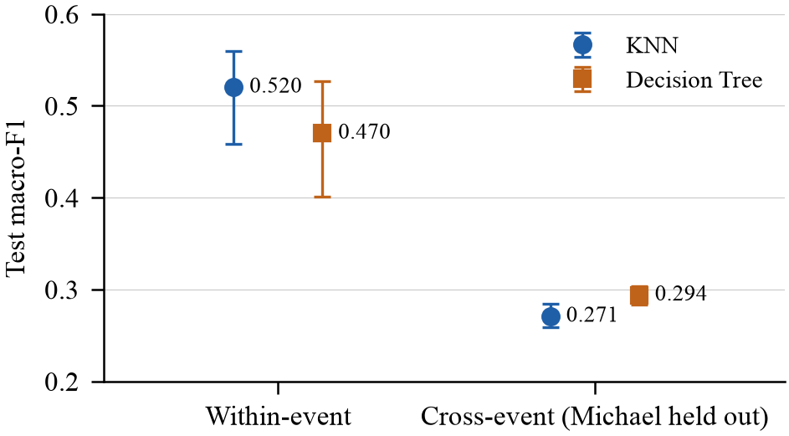
Fig. 2. Test macro-F1 of KNN and the DT under both designs. Error bars: 95% scene-level bootstrap intervals for fixed trained models.

B. Per-Class Behaviour
Table V and Fig. 3 show where the errors arise (RQ3). Within events, KNN recovers 83% of undamaged buildings but only 27% of minor and 25% of major damage, labelling most of them undamaged. The DT spreads recall more evenly (43%–78%), at the cost of no-damage recall and of major-damage precision (0.24). Among the damage classes, destroyed buildings are recognised best by both models (F1 0.69 and 0.59). On the held-out event, major damage is almost never identified (F1 0.04 and 0.03), destroyed recall falls to 35% and 43%, and KNN recovers only 7% of minor-damage buildings against 24% for the DT. The DT's higher cross-event macro-F1 comes mainly from minor damage (F1 0.26 versus 0.11), whereas KNN is better on the large no-damage class (F1 0.73 versus 0.68), which also explains its higher accuracy.
TABLE V
Per-class test precision (P), recall (R) and F1
Class | KNN P | R | F1 | DT P | R | F1
Within-event
No damage | 0.70 | 0.83 | 0.76 | 0.78 | 0.43 | 0.56
Minor | 0.51 | 0.27 | 0.35 | 0.37 | 0.45 | 0.40
Major | 0.31 | 0.25 | 0.28 | 0.24 | 0.50 | 0.33
Destroyed | 0.73 | 0.66 | 0.69 | 0.47 | 0.78 | 0.59
Cross-event
No damage | 0.67 | 0.81 | 0.73 | 0.69 | 0.66 | 0.68
Minor | 0.25 | 0.07 | 0.11 | 0.27 | 0.24 | 0.26
Major | 0.04 | 0.03 | 0.04 | 0.03 | 0.02 | 0.03
Destroyed | 0.14 | 0.35 | 0.20 | 0.14 | 0.43 | 0.22

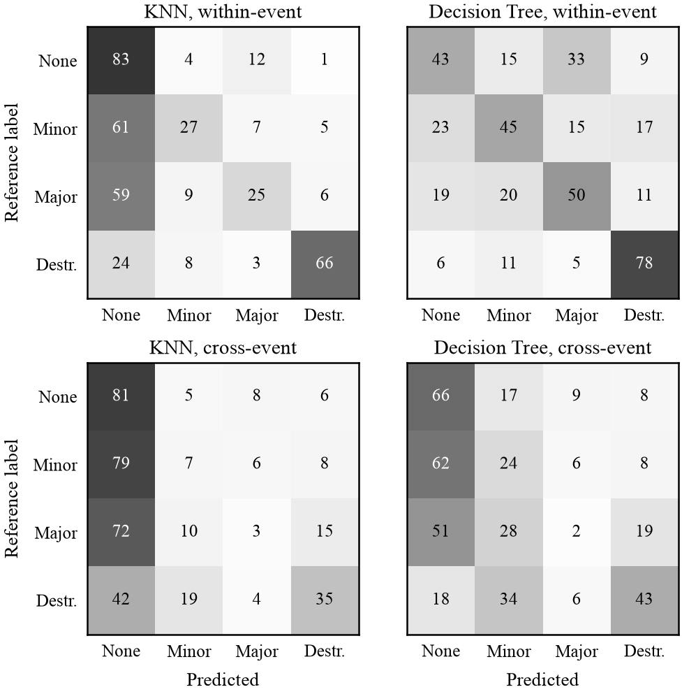
Fig. 3. Row-normalised test confusion matrices (percent of each reference class). The diagonal gives per-class recall.

C. Interpreting the Differences
The opposite recall profiles are consistent with the protocol difference in Section V-B: the class-weighted DT is pushed towards minority classes, whereas unweighted KNN votes reflect the class frequencies among neighbours. Because weighting was not varied, this remains an explanation to be tested, not an established cause. Two measured facts bear on the cross-event drop. First, the held-out event has a different class mix (Section V-A). Second, the features carry a strong event signature: a logistic-regression classifier predicts the source event from the same 37 features with test accuracy 0.829, against 0.252 for always predicting the largest event. When Hurricane Michael scenes were available in training (within-event design), its test scenes scored 0.367 (KNN) and 0.329 (DT) macro-F1, compared with 0.271 and 0.294 when the event was unseen. A plausible reading, not tested here, is that event-specific appearance (sensor, season, region and building stock) accounts for part of the within-event performance, and KNN, which relies on similarity to stored examples, loses more when that similarity is no longer available.
The models also differ in cost and explanation. On our hardware, test inference took 19.7 ms per 1,000 buildings for KNN, which compares each query with all 49,929 training buildings, versus 0.27 ms for the DT (single measurements). In the AfterSight application a KNN prediction is explained by its nearest labelled training buildings and a DT prediction by its root-to-leaf path in raw feature units.

VII. Limitations and Threats to Validity
Internal validity. The comparison is not fully controlled: class weighting and search-space size differ between the models, and each model was trained once. The bootstrap intervals describe variability over test scenes for fixed models; they do not include training variability or variability across events.
Construct validity. Labels come from mask-derived regions: touching buildings may merge (782 mixed components), 1,396 unlabelled components are excluded, and an alignment check flags 168 image pairs whose pre/post registration may be imperfect. These pairs were kept, and their effect was not measured.
External validity. Only one event is held out, so the cross-event result describes Hurricane Michael under this protocol, not unseen disasters in general. Five of the ten available events were chosen by design decision, and other selections could change the results; only xBD's training split is available, through a third-party copy, so official test partitions were not used.
Measurement. Macro-F1 gives rare classes equal weight and is sensitive to small changes in them; scene resampling assumes independence between scenes of one event. Model confidences are not calibrated, and the system has not been validated in operational disaster response.

VIII. Conclusion and Future Work
On 71,340 buildings from five xBD events, KNN outperformed a class-weighted decision tree in macro-F1 on new scenes of known events, but the tree was slightly better on the held-out Hurricane Michael, where the models lost 48% (KNN) and 37% (DT) of their within-event macro-F1; KNN remained more accurate in both designs because of the majority class. The ranking therefore depends on the evaluation design and the metric, and the main limitation of engineered-feature classifiers here is transfer to a new event rather than the choice between these two models. Future work should equalise class handling (for example by resampling for KNN), repeat training with several seeds, hold out each event in turn, include more events, and compare against learned features under the same protocol.

Acknowledgment
[PLACEHOLDER: acknowledgements, to be completed by the authors.] [PLACEHOLDER: AI-assisted writing disclosure, to be completed according to the institution's and the venue's policy, stating which tools were used and for what.]

References
[1] R. Gupta, B. Goodman, N. Patel, R. Hosfelt, S. Sajeev, E. Heim, J. Doshi, K. Lucas, H. Choset, and M. Gaston, “Creating xBD: A dataset for assessing building damage from satellite imagery,” in Proc. IEEE/CVF Conf. Computer Vision and Pattern Recognition Workshops, 2019, pp. 10–17.
[2] R. Gupta et al., “xBD: A dataset for assessing building damage from satellite imagery,” arXiv:1911.09296, 2019.
[3] R. Gupta and M. Shah, “RescueNet: Joint building segmentation and damage assessment from satellite imagery,” in Proc. 25th Int. Conf. Pattern Recognition (ICPR), 2021, pp. 4405–4411, doi: 10.1109/ICPR48806.2021.9412295.
[4] Y. Shen, S. Zhu, T. Yang, C. Chen, D. Pan, J. Chen, L. Xiao, and Q. Du, “BDANet: Multiscale convolutional neural network with cross-directional attention for building damage assessment from satellite images,” IEEE Trans. Geosci. Remote Sens., vol. 60, pp. 1–14, 2022, doi: 10.1109/TGRS.2021.3080580.
[5] T. Cover and P. Hart, “Nearest neighbor pattern classification,” IEEE Trans. Inf. Theory, vol. 13, no. 1, pp. 21–27, 1967, doi: 10.1109/TIT.1967.1053964.
[6] L. Breiman, J. H. Friedman, R. A. Olshen, and C. J. Stone, Classification and Regression Trees. Belmont, CA, USA: Wadsworth, 1984 (reprinted by CRC Press, doi: 10.1201/9781315139470).
[7] L. Dong and J. Shan, “A comprehensive review of earthquake-induced building damage detection with remote sensing techniques,” ISPRS J. Photogramm. Remote Sens., vol. 84, pp. 85–99, 2013, doi: 10.1016/j.isprsjprs.2013.06.011.
[8] A. Singh, “Digital change detection techniques using remotely-sensed data,” Int. J. Remote Sens., vol. 10, no. 6, pp. 989–1003, 1989, doi: 10.1080/01431168908903939.
[9] A. Cooner, Y. Shao, and J. Campbell, “Detection of urban damage using remote sensing and machine learning algorithms: Revisiting the 2010 Haiti earthquake,” Remote Sens., vol. 8, no. 10, Art. no. 868, 2016, doi: 10.3390/rs8100868.
[10] R. M. Haralick, K. Shanmugam, and I. Dinstein, “Textural features for image classification,” IEEE Trans. Syst., Man, Cybern., vol. SMC-3, no. 6, pp. 610–621, 1973, doi: 10.1109/TSMC.1973.4309314.
[11] J. Canny, “A computational approach to edge detection,” IEEE Trans. Pattern Anal. Mach. Intell., vol. PAMI-8, no. 6, pp. 679–698, 1986, doi: 10.1109/TPAMI.1986.4767851.
[12] T. Valentijn, J. Margutti, M. van den Homberg, and J. Laaksonen, “Multi-hazard and spatial transferability of a CNN for automated building damage assessment,” Remote Sens., vol. 12, no. 17, Art. no. 2839, 2020, doi: 10.3390/rs12172839.
[13] F. Pedregosa et al., “Scikit-learn: Machine learning in Python,” J. Mach. Learn. Res., vol. 12, pp. 2825–2830, 2011.
[14] H. He and E. A. Garcia, “Learning from imbalanced data,” IEEE Trans. Knowl. Data Eng., vol. 21, no. 9, pp. 1263–1284, 2009, doi: 10.1109/TKDE.2008.239.
[15] M. Sokolova and G. Lapalme, “A systematic analysis of performance measures for classification tasks,” Inf. Process. Manage., vol. 45, no. 4, pp. 427–437, 2009, doi: 10.1016/j.ipm.2009.03.002.
[16] B. Efron and R. J. Tibshirani, An Introduction to the Bootstrap. New York, NY, USA: Chapman & Hall/CRC, 1994, doi: 10.1201/9780429246593.
[17] C. A. Field and A. H. Welsh, “Bootstrapping clustered data,” J. Roy. Statist. Soc. B, vol. 69, no. 3, pp. 369–390, 2007, doi: 10.1111/j.1467-9868.2007.00593.x.

