MKSSS’s
Cummins College of Engineering for Women, Pune
(An Autonomous Institute Affiliated to Savitribai Phule Pune University)
Third Year B. Tech (Computer Engineering)
MINI PROJECT REPORT
On
“AfterSight: Explainable Building Damage Triage from Pre/Post-Disaster Satellite Imagery using Classical Machine Learning”
Submitted by
Student Name | U. No. | Class / Division | Roll No.

Under the Guidance of
Guide Name: ______________________________
Department of Computer Engineering
Academic Year: 2026–27
Table of Contents
1. Introduction 1
2. Motivation 1
3. Literature Survey 3
3.1 Gap addressed by this project 3
4. Dataset Used 5
4.1 Source and format 5
4.2 Events selected 5
4.3 Building footprints derived from masks 5
4.4 Feature description 6
4.5 Missing values and quality checks 7
4.6 Class imbalance 8
5. Flow Diagram / Block Diagram 9
6. Methods Used / Technology Stack 10
6.1 Programming languages 10
6.2 Libraries 10
6.3 Development environment 10
7. Model Development 11
7.1 Data preprocessing 11
7.2 Exploratory data analysis 11
7.3 Feature engineering 12
7.4 Model selection 12
7.5 Training 13
7.6 Evaluation 13
8. Version Control 14
9. Experiment Tracking 15
10. AutoML / MLOps 16
11. Deployment 18
12. Results and Discussions 22
12.1 Within-event results 22
12.2 Cross-event results (unseen disaster) 22
12.3 Per-event scores 23
12.4 Event-confounding check 23
12.5 Phase 3b: reducing the event signature 24
12.6 K-Means clustering 24
12.7 3-class experiment 25
12.8 Demo scenes and review suggestions 25
12.9 Discussion 26
13. Future Scope 27
14. Conclusion 27
15. References 27

List of Figures
Figure 4.1: Footprints derived from the masks, drawn on a pre/post pair from the Santa Rosa wildfire 6
Figure 4.2: Distribution of footprint sizes with the 16 px minimum marked 8
Figure 4.3: Ground-truth class counts and class share per selected event 8
Figure 5.1: AfterSight end-to-end pipeline 9
Figure 7.1: Feature Lab: separation ranking, per-class box plot and two-feature scatter (training split) 12
Figure 8.1: git log --graph --oneline of the repository at the time of writing 14
Figure 9.1: Model Arena: every model on known vs unseen disasters, and the comparison table 16
Figure 11.1: Readiness board: build status, honest headline results and the served models 18
Figure 11.2: Scene Library, opening on held-out test scenes with ground-truth damage bars 19
Figure 11.3: Triage Desk: before/after swipe viewer with predicted damage overlays and building list 19
Figure 11.4: Building Case File with a Logistic Regression explanation 20
Figure 11.5: Case File with a KNN explanation: the most similar training buildings 20
Figure 11.6: Review Queue: buildings suggested for human review 21
Figure 12.1: Confusion matrices, Logistic Regression: within-event test set (left) and cross-event test set (right); row % = recall 22
Figure 12.2: Confounding check: confusion matrix for predicting the event from the features (test set) 23
Figure 12.3: K-Means: inertia (elbow) and sampled silhouette for k = 2 … 10 25
Figure 12.4: K-Means (k = 4) clusters against ground-truth damage classes 25

List of Tables
Table 3.1: Literature survey 3
Table 4.1: Columns of the Parquet mirror (verified by reading the files) 5
Table 4.2: Selected events: scenes, buildings and ground-truth class counts 5
Table 4.3: Feature dictionary: 37 input features and the target 6
Table 6.1: Libraries and their purpose 10
Table 6.2: Development environment 10
Table 7.1: Strongest features by separation score (training split) 11
Table 7.2: Models and their important parameters (tuned on validation) 12
Table 7.3: Training settings 13
Table 8.1: Version control details 14
Table 8.2: Commit milestones 14
Table 9.1: Tracked experiments (4-class, test set evaluated once per model) 15
Table 11.1: Deployment components 18
Table 12.1: Within-event test results (4-class) 22
Table 12.2: Cross-event test results (4-class, hurricane-michael held out) 22
Table 12.3: Logistic Regression macro-F1 per event (within-event test) 23
Table 12.4: Phase 3b results (separate models; Phase 3 models untouched) 24
Table 12.5: 3-class experiment: test macro-F1 (no-damage / damaged / destroyed) 25
Table 12.6: Demo scenes (test split): ground truth and scene macro-F1 per model 26
Table 12.7: Review thresholds chosen on validation 26

1. Introduction
When a hurricane, flood, wildfire or tsunami strikes, emergency managers need to know quickly which buildings are damaged and how badly. Ground surveys are slow, expensive and often dangerous in the first days after an event. High-resolution satellite images taken before and after the disaster cover an entire city within hours, but inspecting tens of thousands of roofs by eye is not feasible. Automatic building damage assessment from satellite imagery is therefore an important problem in remote sensing and disaster response.
The xBD dataset (Gupta et al., 2019) made this problem measurable at scale. It provides pairs of pre- and post-disaster satellite images with building footprints and a four-level damage scale: no damage, minor damage, major damage and destroyed [1]. Most published approaches to xBD use deep convolutional networks, which are accurate but difficult to explain and expensive to train.
AfterSight takes a deliberately different route. It classifies each building with classical, explainable machine learning (a threshold baseline, Logistic Regression, K-Nearest Neighbours, a Decision Tree and, as a reference, a Random Forest) using 37 hand-crafted features per building: colour, change, texture, the surroundings of the building and its shape. Every prediction comes with an explanation: the features that pushed a Logistic Regression decision, the exact path through the Decision Tree, or the most similar training buildings for KNN.
The project is delivered as a complete web application. A FastAPI backend serves saved models and results, and a React interface provides a Triage Desk, a Building Case File, a Model Arena, a Feature Lab, a Cluster Atlas, a Review Queue and Reports. The Triage Desk has a before/after swipe viewer with building overlays. The scope is stated on every page: “Damage classification on building footprints derived from xBD annotations.” The system does not detect buildings itself and gives no rescue or routing advice.
A central aim of the project is honest evaluation. Models are tested in two ways: on new scenes of the five disasters they were trained on (within-event), and on a disaster they never saw (cross-event, hurricane-michael held out). The default model reaches a test macro-F1 of 0.527 within-event, but 0.290 on the unseen disaster. Chapter 12 shows why this gap exists.

2. Motivation
Three observations motivated AfterSight.
- Speed matters after a disaster. A first, approximate damage map helps prioritise ground teams. Even an imperfect model that ranks buildings for human review can save time.
- Explanations build trust. Responders and examiners need to know why a building is marked destroyed. Classical models on interpretable features can show their reasoning directly (“the roof texture became much rougher”). A deep network cannot do this without extra tools.
- Scores are often over-optimistic. Buildings in the same image share lighting, sensor and often damage. Random splits leak this information, and evaluating only on known disasters hides how a model behaves on a new event. We wanted to measure performance honestly and show the limits clearly.
The project also had a teaching motivation: to apply the classical machine-learning syllabus (feature engineering, linear models, nearest neighbours, decision trees, clustering, class imbalance and evaluation) end to end on a real, messy, large dataset, with reproducible code and a usable interface.

3. Literature Survey
Table 3.1 summarises the five works most relevant to this project. Every reference was checked against its publisher or arXiv record.
Table 3.1: Literature survey
Sr. No. | Author(s) | Year | Title / Method | Dataset | Technique | Major Findings | Limitation
1 | R. Gupta, R. Hosfelt, S. Sajeev et al. [1] | 2019 | xBD: A Dataset for Assessing Building Damage from Satellite Imagery | xBD: pre/post satellite pairs, building polygons, 4-level damage scale | Dataset creation with a joint damage scale; baseline models for the xView2 challenge | Released 850,736 building annotations over 45,362 km² of imagery, enabling large-scale damage assessment research | Strong class imbalance (most buildings undamaged); baseline models are not designed for explanation
2 | R. M. Haralick, K. Shanmugam, I. Dinstein [2] | 1973 | Textural Features for Image Classification | Photo-micrographs of sandstone, aerial photographs, satellite imagery | Grey-level co-occurrence (spatial dependency) texture statistics | Texture features gave about 89%, 82% and 83% accuracy on the three image sets | Hand-crafted; depends on grey-level quantisation and pixel offset; texture only
3 | A. J. Cooner, Y. Shao, J. B. Campbell [3] | 2016 | Detection of Urban Damage Using Remote Sensing and Machine Learning Algorithms: Revisiting the 2010 Haiti Earthquake | High-resolution imagery of Port-au-Prince; UNITAR/UNOSAT damage data | Feed-forward and radial-basis neural networks, Random Forest; texture and structure features | Each algorithm reached about 90% agreement with the UNOSAT validation data | Single event; transfer to other disaster types not tested
4 | E. Weber, H. Kané [4] | 2020 | Building Disaster Damage Assessment in Satellite Imagery with Multi-Temporal Fusion | xBD | Shared-weight ResNet50 backbone on pre and post images, fused features, segmentation into damage classes | Substantial improvement over the xBD baseline; among the top results on the xView2 leaderboard | Deep CNN: needs GPU training, decisions hard to explain
5 | R. Gupta, M. Shah [5] | 2020 | RescueNet: Joint Building Segmentation and Damage Assessment from Satellite Imagery | xBD | Single end-to-end network for building segmentation and damage classification with a combined loss | Better segmentation and damage classification than earlier multi-stage methods; reported generalisation across regions and disaster types | Deep model with high compute cost; per-building reasoning not exposed

3.1 Gap addressed by this project
Work on xBD concentrates on deep networks optimised for leaderboard scores, while classical studies such as [3] evaluate a single disaster. Two questions remain open for a student-scale, explainable system:
- How far can classical models on interpretable features go on xBD, with every decision explained per building?
- How much of the score survives on a disaster the model has never seen, and is the gap caused by the model recognising the disaster rather than the damage?
AfterSight answers both. It uses texture ideas from [2] and the Canny edge detector [6], scene-grouped and event-held-out splits, an explicit test of event confounding, and an interface that shows every explanation. All models are implemented with scikit-learn [7].

4. Dataset Used

4.1 Source and format
The project uses the training split of xBD [1], published by the xView2 organisers under the CC BY-NC-SA 4.0 licence [11]. The copy available to us was a Hugging Face-style Parquet mirror of 17 shards holding 2,799 scene pairs from 10 disaster events. Each row contains the pre-disaster image, the post-disaster image and two annotation masks (Table 4.1). The data is not redistributed with the code.
Table 4.1: Columns of the Parquet mirror (verified by reading the files)
Column | Content
t1_image | pre-disaster image, PNG, 1024 × 1024 RGB
t2_image | post-disaster image, PNG, 1024 × 1024 RGB
t1_mask | building footprint mask: 0 background, 1 building
t2_mask | damage mask: 0 background, 1 no-damage, 2 minor, 3 major, 4 destroyed
image_name | e.g. train/images/socal-fire_00000106 (event and scene number)

4.2 Events selected
A first inspection of all ten events showed that some, such as mexico-earthquake and midwest-flooding, contain almost no major-damage or destroyed buildings. Five events covering four disaster types were selected (Table 4.2). The disaster type is not stored in the mirror and is taken from the project configuration.
Table 4.2: Selected events: scenes, buildings and ground-truth class counts
Event | Type | Scenes | Empty | Buildings | No damage | Minor | Major | Destroyed
hurricane-harvey | flooding | 319 | 22 | 19,121 | 9,463 | 2,251 | 7,034 | 373
hurricane-matthew | wind | 238 | 19 | 9,570 | 2,103 | 4,440 | 1,140 | 1,887
hurricane-michael | wind | 343 | 10 | 21,429 | 13,870 | 4,998 | 1,841 | 720
palu-tsunami | tsunami | 113 | 2 | 9,157 | 7,360 | 1 | 200 | 1,596
santa-rosa-wildfire | fire | 226 | 7 | 12,063 | 8,653 | 76 | 55 | 3,279
Total | — | 1,239 | 60 | 71,340 | 41,449 | 11,766 | 10,270 | 7,855

4.3 Building footprints derived from masks
The mirror has no polygons, so buildings are reconstructed. Each connected blob of the footprint mask (4-connectivity) becomes one building, and its label is the majority damage value inside the blob. A full scan of all scenes found only the damage values 0–4. In the five events, 72,791 blobs were found and 71,340 were kept. Excluded blobs were logged: 1,396 had no damage value (most likely xBD’s “un-classified” buildings), 54 were smaller than 16 px and 1 had a tied vote. 782 blobs contained more than one damage value and were labelled by majority. Each blob outline is traced into a polygon in image pixel coordinates (Figure 4.1).
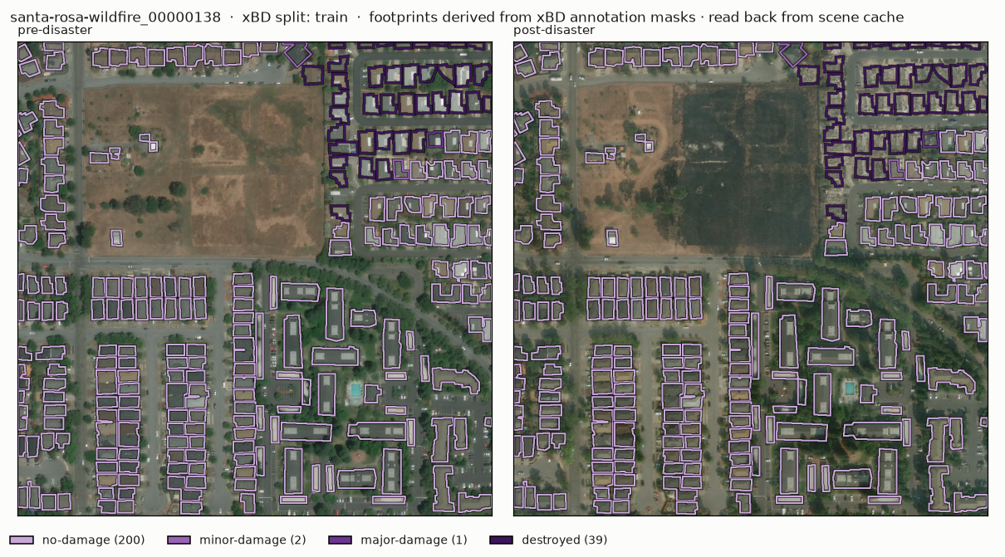
Figure 4.1: Footprints derived from the masks, drawn on a pre/post pair from the Santa Rosa wildfire

4.4 Feature description
For every building, 37 numeric features are computed on its exact pixels in both images (Table 4.3). Most are region statistics such as means, spreads and proportions, which tolerate small misalignment between the pre and post images. The target is the damage label. Identifiers (scene, event, disaster type) and quality flags are stored separately and are never model inputs.
Table 4.3: Feature dictionary: 37 input features and the target
Feature | Type | Description | Role
pre_mean_r | numeric (colour) | Average red value of the footprint pixels, pre-disaster | input feature
pre_mean_g | numeric (colour) | Average green, pre | input feature
pre_mean_b | numeric (colour) | Average blue, pre | input feature
pre_std_r | numeric (colour) | Standard deviation of red inside the footprint, pre | input feature
pre_std_g | numeric (colour) | Std of green, pre | input feature
pre_std_b | numeric (colour) | Std of blue, pre | input feature
post_mean_r | numeric (colour) | Average red, post | input feature
post_mean_g | numeric (colour) | Average green, post | input feature
post_mean_b | numeric (colour) | Average blue, post | input feature
post_std_r | numeric (colour) | Std of red, post | input feature
post_std_g | numeric (colour) | Std of green, post | input feature
post_std_b | numeric (colour) | Std of blue, post | input feature
abs_dmean_r | numeric (change) | |post mean red − pre mean red| | input feature
abs_dmean_g | numeric (change) | |post − pre| mean green | input feature
abs_dmean_b | numeric (change) | |post − pre| mean blue | input feature
dstd_r | numeric (change) | post std red − pre std red (signed) | input feature
dstd_g | numeric (change) | post − pre std green | input feature
dstd_b | numeric (change) | post − pre std blue | input feature
gray_absdiff_mean | numeric (change) | Average of |post grey − pre grey| over footprint pixels (misalignment-sensitive) | input feature
brightness_ratio | numeric (change) | post grey mean ÷ max(pre grey mean, 1) | input feature
gray_std_pre | numeric (texture) | Std of grey inside the footprint, pre | input feature
gray_std_post | numeric (texture) | Std of grey, post | input feature
gray_std_delta | numeric (texture) | post − pre grey std | input feature
edge_density_pre | numeric (texture) | Share of footprint pixels marked as edges by Canny (σ = 1.5, run on the footprint + margin) | input feature
edge_density_post | numeric (texture) | Same, post | input feature
edge_density_delta | numeric (texture) | post − pre edge density | input feature
glcm_contrast_pre | numeric (texture) | Mean of (i − j)² over neighbouring pixel pairs inside the footprint (grey quantised to 32 levels; right and down neighbours) | input feature
glcm_contrast_post | numeric (texture) | Same, post | input feature
glcm_contrast_delta | numeric (texture) | post − pre | input feature
glcm_homogeneity_pre | numeric (texture) | Mean of 1 / (1 + (i − j)²) over the same pairs (1 = perfectly smooth) | input feature
glcm_homogeneity_post | numeric (texture) | Same, post | input feature
glcm_homogeneity_delta | numeric (texture) | post − pre | input feature
ring_dmean | numeric (context) | post ring grey mean − pre ring grey mean | input feature
ring_absdiff_mean | numeric (context) | Average |post − pre| grey over ring pixels (misalignment-sensitive) | input feature
contrast_change | numeric (context) | (post building − post ring) − (pre building − pre ring), grey means | input feature
area_px | numeric (shape) | Number of pixels in the footprint blob (exact) | input feature
compactness | numeric (shape) | 4π × area ÷ perimeter² of the footprint polygon (1 = circle, 0.785 = square, → 0 = thin or irregular) | input feature
label | categorical (4 classes) | majority damage-mask value inside the footprint: no-damage, minor-damage, major-damage, destroyed | target

4.5 Missing values and quality checks
- Missing / infinite values: none and none in the 71,340-row feature table. Median imputation is still kept in every pipeline as a safeguard.
- Image checks: every one of the 1,239 selected scenes decoded correctly as 1024 × 1024 RGB. A phase-correlation check flagged 168 scenes with an estimated pre/post shift above 8 px, which is shown as a data-quality warning in the app.
- Footprint size: blob areas range from 1 to 648,034 px, with a median of 1,023 px (Figure 4.2). The 16 px minimum sits in a natural gap in the histogram.
- Feature table: 71,340 rows × 37 features, 22.8 MB in Parquet, extracted in 28.46 s with 4 workers.
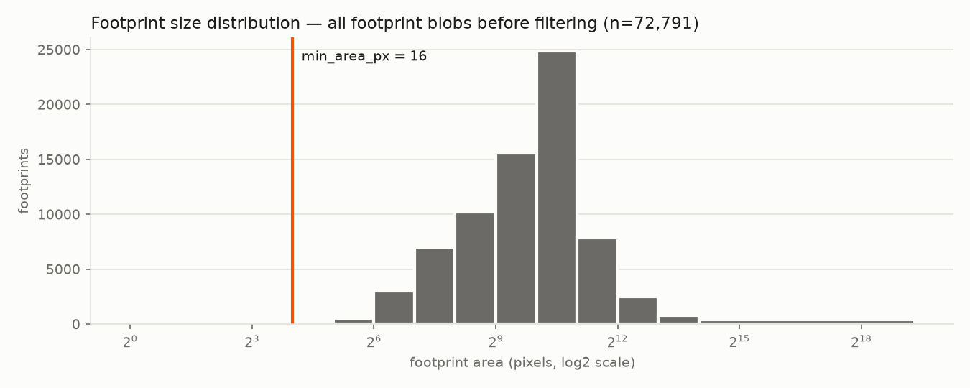
Figure 4.2: Distribution of footprint sizes with the 16 px minimum marked

4.6 Class imbalance
The classes are imbalanced: no-damage makes up 58.1% of buildings, minor 16.5%, major 14.4% and destroyed 11.0%. The mix also differs strongly between events (Figure 4.3): the fire and tsunami events are dominated by no-damage and destroyed, while the hurricanes contain most of the minor and major damage. This is handled with balanced class weights and macro-F1 as the primary metric (Section 7.6).
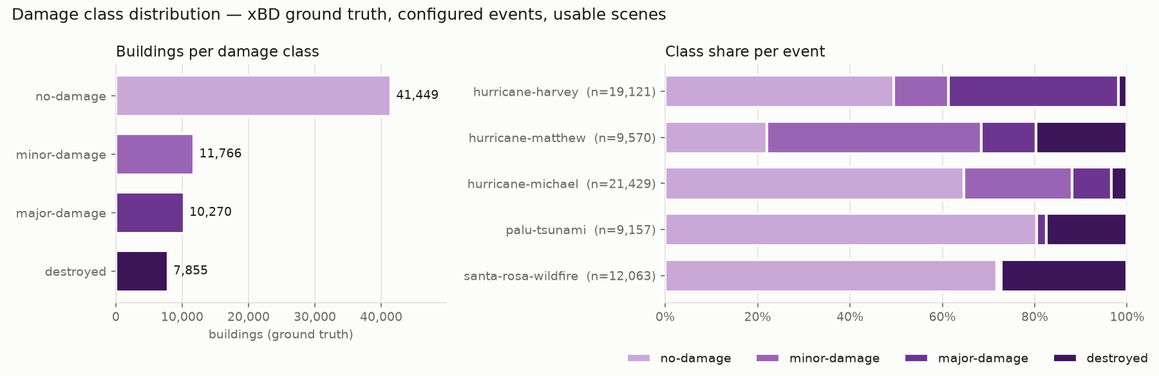
Figure 4.3: Ground-truth class counts and class share per selected event

5. Flow Diagram / Block Diagram
Figure 5.1 shows the complete pipeline from the raw Parquet shards to the web application. Each stage writes files that the next stage reads, so every number in the interface can be traced back to a saved artifact.
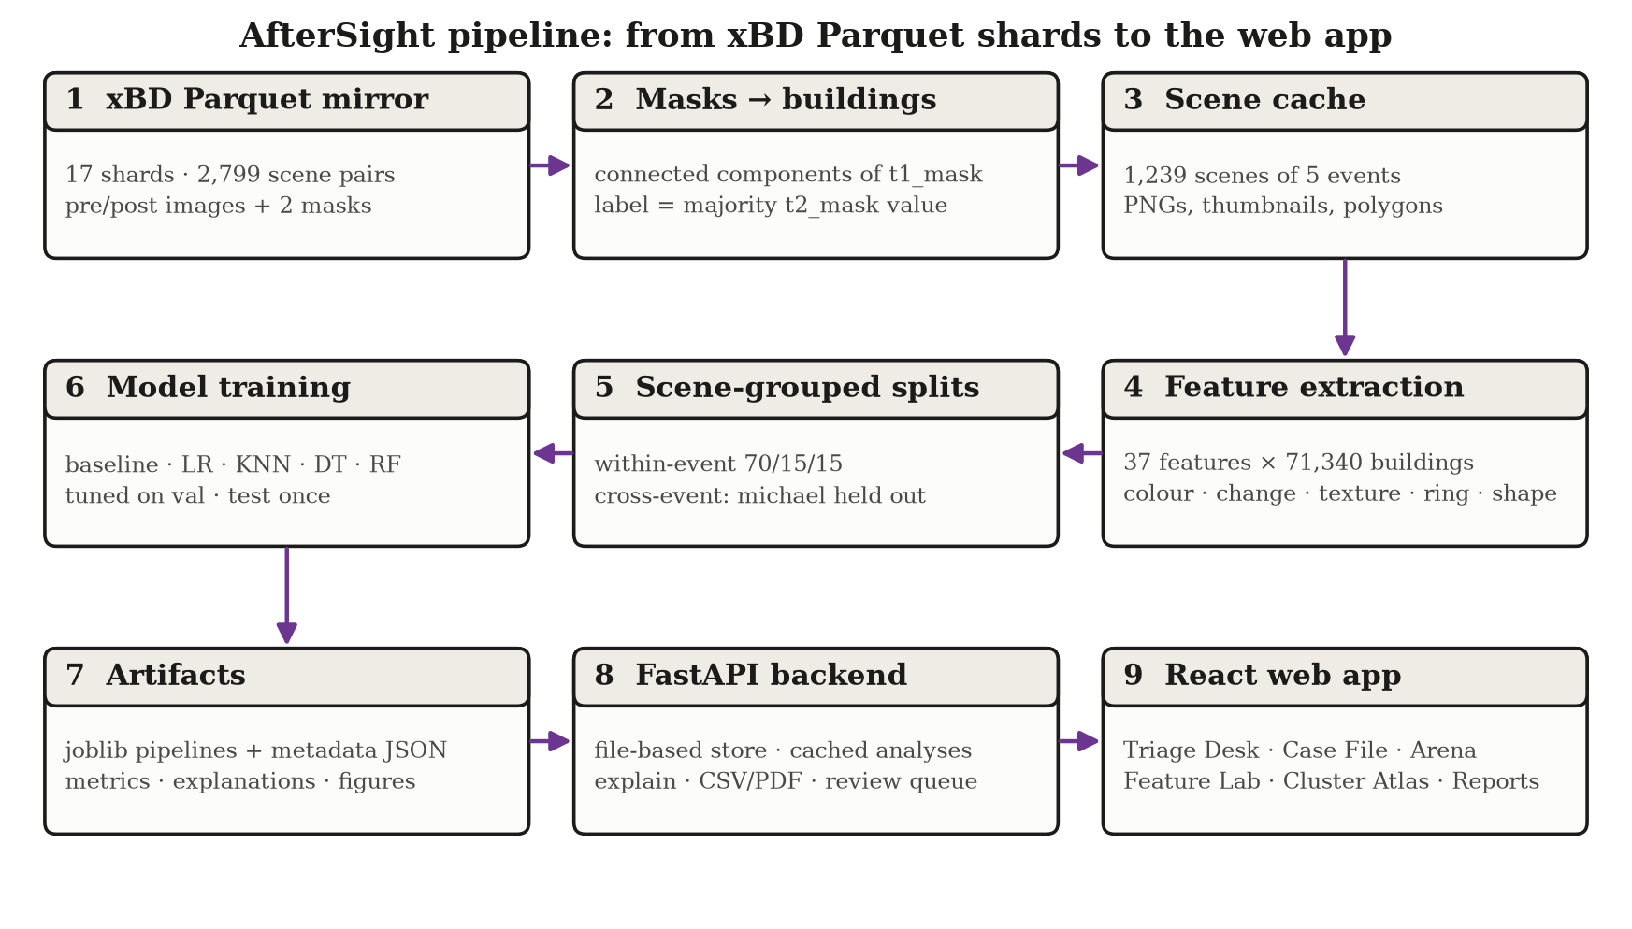
Figure 5.1: AfterSight end-to-end pipeline
- Parquet mirror: the shards are streamed in small batches, so memory stays at about one row group regardless of dataset size.
- Masks → buildings: connected components of the footprint mask become buildings, labelled by the majority damage value. Every dropped blob is logged with its reason.
- Scene cache: only the five selected events are extracted, as original PNGs, thumbnails and polygons, so later stages open single scenes quickly.
- Feature extraction: 37 features per building, cached in a versioned Parquet table with a fingerprint of the settings.
- Splits: scene-grouped manifests for the within-event and cross-event designs, with automatic leakage checks.
- Model training: scikit-learn pipelines tuned on validation. Each final model is evaluated on its test set exactly once, and explanations and figures are produced.
- Artifacts: every model is saved with joblib plus a metadata JSON (hyperparameters, schema version, split hash, metrics, library version).
- FastAPI backend: a file-based store that validates every ID, caches analyses, and serves explanations, images, CSV/PDF reports and the review queue.
- React web app: the Triage Desk, Case File, Model Arena, Feature Lab, Cluster Atlas, Review Queue and Reports pages.

6. Methods Used / Technology Stack

6.1 Programming languages
- Python 3.11: data pipeline, feature extraction, machine learning, evaluation and the REST API.
- TypeScript (React): the web interface, including the hand-built SVG charts and the scene viewer.
- Bash: the one-command pipeline (run_pipeline.sh) and application launcher (start.sh).

6.2 Libraries
Table 6.1: Libraries and their purpose
Library (version) | Purpose | Main functions used
scikit-learn 1.9.1 | models, preprocessing, splits, metrics | LogisticRegression, KNeighborsClassifier, DecisionTreeClassifier, RandomForestClassifier, KMeans, PCA, Pipeline, StandardScaler, SimpleImputer, StratifiedGroupKFold, permutation_importance, silhouette_score, adjusted_rand_score
NumPy 2.4.6 | array computation | vectorised statistics, histograms, percentiles
pandas 3.0.6 | tables | DataFrame, groupby, pivot_table, read/write Parquet
PyArrow 26.0.0 | Parquet I/O | ParquetFile.iter_batches (streaming), write_table
SciPy 1.17.1 | image labelling, statistics | ndimage.label, find_objects, binary_dilation; stats.skew, spearmanr
scikit-image 0.26.0 | image features | feature.canny, registration.phase_cross_correlation
OpenCV 5.0.0.93 | contours | findContours (blob outline → polygon)
Shapely 2.2.0 | geometry | Polygon, make_valid, union_all, WKT
Pillow 13.0.0 | images | decode PNG, thumbnails, JPEG crops
FastAPI 0.153.0 / Pydantic 2.14.1 | REST API and schemas | APIRouter, dependency injection, response models, validation
Matplotlib 3.11.2 / ReportLab 5.0.1 | figures and PDF reports | confusion matrices, charts; SimpleDocTemplate
joblib 1.6.0 | model persistence | dump / load of fitted pipelines
pytest 9.1.1 | backend tests | fixtures, parametrised tests, TestClient
React 19.3.1 / Vite 8.3.4 | web interface and build | components, hooks, dev server with API proxy
TanStack Query 5.104.5 / React Router 7.18.4 | data fetching, routing | useQuery, URL state
Tailwind CSS 4.3.3 | styling | design tokens, light/dark themes
Vitest 5.0.5 / Testing Library 16.3.3 | frontend tests | render, user events, mocked API

6.3 Development environment
Table 6.2: Development environment
Item | Details
Operating system | macOS 15.6
Hardware | Apple Silicon (Apple M4, arm64)
Python | Python 3.11.17 in a virtual environment at the repository root (.venv)
Node.js / npm | Node.js v26.0.0, npm 11.12.1
Editor | Visual Studio Code
Version control | Git 2.39.5, GitHub
Browser | Google Chrome (development and headless screenshots)

7. Model Development

7.1 Data preprocessing
All preprocessing happens inside each scikit-learn Pipeline and is fitted on the training split only, so validation and test data never influence it:
- log1p on features whose training-set skewness exceeds 2. Seven features qualified: abs_dmean_r, abs_dmean_g, abs_dmean_b, gray_absdiff_mean, glcm_contrast_pre, glcm_contrast_post, area_px. Footprint area, for example, has a very long tail.
- Median imputation as a safeguard; the real table has no missing values.
- StandardScaler, so that Logistic Regression and KNN treat all features on the same scale. The threshold baseline works in raw units and needs no preprocessing.

7.2 Exploratory data analysis
The Feature Lab (Figure 7.1) ranks every feature by its separation score η², the share of the feature’s variance explained by the damage class, computed on the training split. Table 7.1 lists the strongest features. Texture features dominate, led by the post-disaster co-occurrence homogeneity (η² = 0.185). The weakest on their own are gray_std_post (η² 0.005), post_std_r (η² 0.003), area_px (η² 0.002). Even the best single feature explains under a fifth of the variance, so the models must combine many; a feature that is weak alone, such as gray_std_post, can still matter in combination (it is among the most relied-on features of Logistic Regression).
Table 7.1: Strongest features by separation score (training split)
Feature | Group | η² | Median: no | minor | major | destroyed
glcm_homogeneity_post | texture | 0.185 | 0.720 | 0.676 | 0.767 | 0.534
glcm_homogeneity_delta | texture | 0.136 | 0.008 | 0.020 | 0.070 | -0.132
glcm_contrast_post | texture | 0.096 | 1.225 | 1.613 | 0.776 | 3.246
gray_absdiff_mean | change | 0.079 | 20.938 | 26.855 | 22.932 | 34.532
edge_density_post | texture | 0.074 | 0.105 | 0.121 | 0.080 | 0.168
abs_dmean_g | change | 0.070 | 9.254 | 13.147 | 9.925 | 23.307
abs_dmean_r | change | 0.067 | 10.841 | 15.138 | 11.184 | 25.297
ring_absdiff_mean | context | 0.066 | 22.937 | 26.107 | 23.829 | 28.903
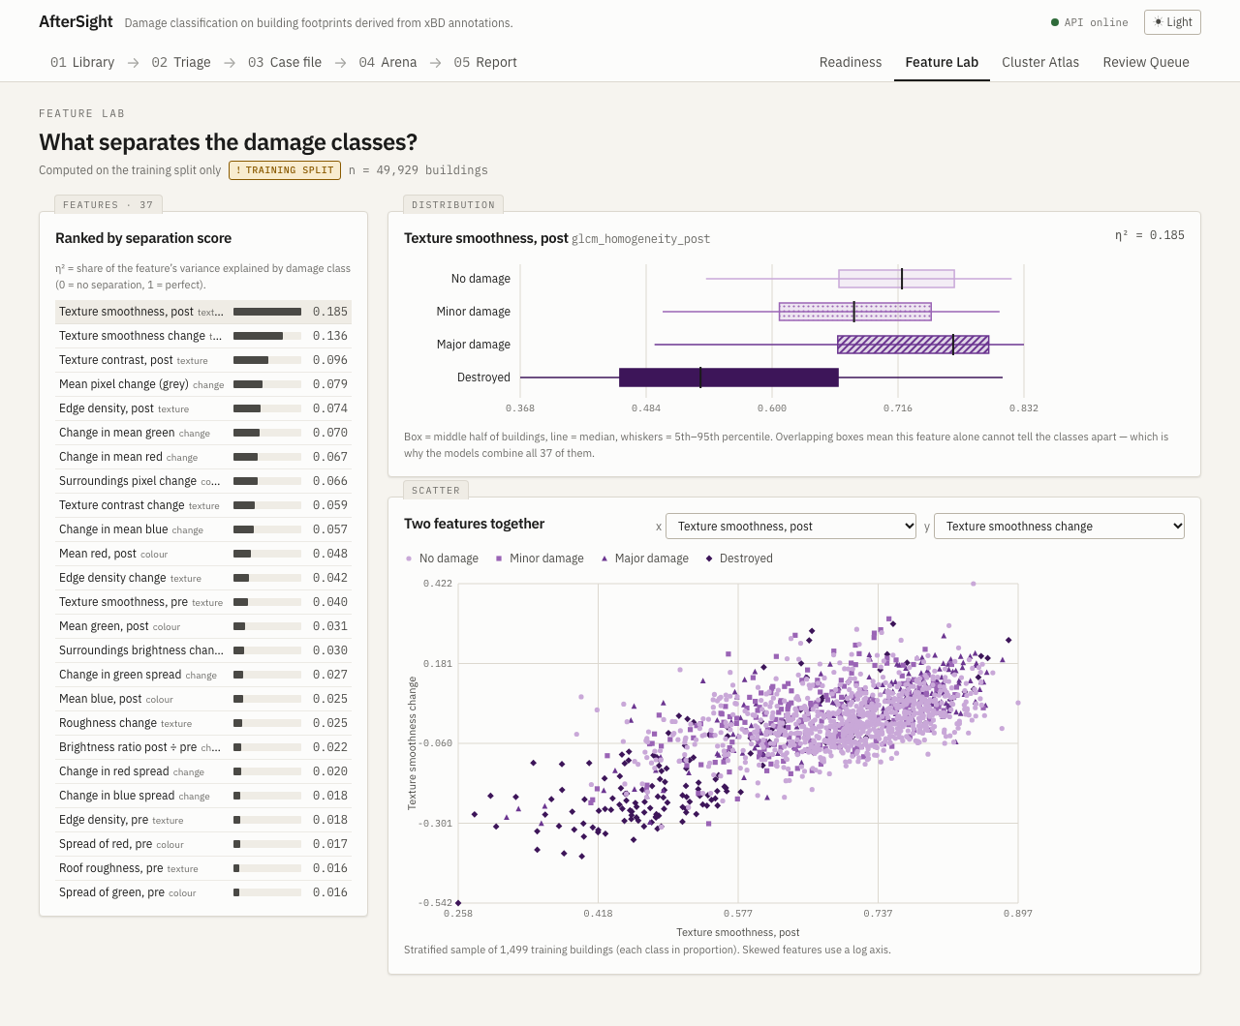
Figure 7.1: Feature Lab: separation ranking, per-class box plot and two-feature scatter (training split)

7.3 Feature engineering
The 37 features (Table 4.3) were designed around how damage looks from above. Burnt or collapsed roofs change colour and brightness, so the colour and change groups capture that. Rubble is rough and patchy: grey-level spread, Canny edge density and co-occurrence contrast and homogeneity [2], [6] measure texture before and after. The context ring (ground within 8 px of the footprint, excluding all buildings) separates a change of the building from a change of the whole area, such as flood water or shadows. Two shape features (area, compactness) let the model normalise for building size. A separate experiment (Phase 3b, Section 12.5) tested change-only and scene-normalised variants of these features.

7.4 Model selection
Table 7.2: Models and their important parameters (tuned on validation)
Model | Why included | Important parameters | Selected (within-event)
Threshold baseline (non-ML) | floor: one feature with ordered thresholds | candidate change features; thresholds from training quantiles (5% steps), chosen on validation | feature: glcm_homogeneity_delta
Logistic Regression | linear, fast, coefficients explain decisions (app default) | multinomial, class_weight=balanced, C ∈ {0.01, 0.1, 1, 10} | C:10
K-Nearest Neighbours | explanation by similar examples | k ∈ {5, 15, 31}, weights ∈ {uniform, distance} | n_neighbors:15, weights:uniform
Decision Tree | human-readable rules | max_depth ∈ {4, 6, 8, 12}, min_samples_leaf ∈ {20, 100}, balanced | max_depth:8, min_samples_leaf:100
Random Forest (optional) | stronger classical reference [8] | 200 trees, max_depth ∈ {12, None}, min_samples_leaf ∈ {2, 10}, balanced_subsample | max_depth:null, min_samples_leaf:10
K-Means (analysis only) | is there natural structure in the features? | k = 2 … 10, n_init = 10 | k = 2 (best silhouette)

7.5 Training
Table 7.3: Training settings
Setting | Value
Split unit | whole scenes (buildings of one scene never cross splits); leakage test on the real manifests
Within-event design | class-stratified, scene-grouped (StratifiedGroupKFold, 20 folds of 5%) → train 49,929 / val 10,705 / test 10,706 buildings; hash 7bba8a9fbbd2740a
Cross-event design | hurricane-michael held out as test (21,429 buildings); train 42,425 / val 7,486 from the other four events; hash dd7d8566b7dbaf7a
Class weights | balanced (LR, DT), balanced_subsample (RF); KNN unweighted by class
Model selection | best validation macro-F1 over the grid in Table 7.2
Test-set use | exactly once per final model, enforced by a TestSetGuard object in code
Random seed | 42 everywhere
Label schemes | 4-class (primary); 3-class experiment no-damage / damaged / destroyed

7.6 Evaluation
Because 58% of buildings are undamaged, accuracy alone would reward a model that ignores the rare classes. The primary metric is macro-F1: the F1 score is computed per class and averaged with equal weight. Accuracy, weighted-F1, per-class precision and recall, confusion matrices, training time and inference time per 1,000 buildings are also reported. Interpretation is supported by permutation importance on validation, Logistic Regression coefficients, Decision Tree importances and paths, and KNN neighbours. Two extra analyses test the limits of the results: per-event scores, and a classifier that predicts the event from the same features (the confounding check).

8. Version Control
The project was developed in phases, each finished with a tested commit. Table 8.1 gives the version-control details, Table 8.2 lists the commit milestones and Figure 8.1 shows the history graph.
Table 8.1: Version control details
Item | Details
Tool | Git 2.39.5
Platform | GitHub
Repository name | aftersight
Branch | main (linear history, one commit per phase)
Contributors | ______________________________ (to be filled in by the group)
Ignored from version control | dataset, scene cache, feature table, trained models, outputs, virtual environment, node_modules, secrets (.env)

Table 8.2: Commit milestones
Commit | Date | Milestone
92f6ba8 | 2026-10-22 | Set up AfterSight skeleton and xBD data-readiness pipeline (Phases 0-1)
2fa2d0a | 2026-10-22 | Add per-building features and scene-grouped split manifests (Phase 2)
d443e90 | 2026-10-22 | Train and evaluate classical damage models on both split designs (Phase 3)
1a5ff14 | 2026-10-22 | Add Phase 3b confounding-reduction experiment (separate from Phase 3)
e289f03 | 2026-10-22 | Add the FastAPI backend serving real artifacts (Phase 4)
87f2a04 | 2026-10-22 | Add the "field case file" design system, Readiness board and Scene Library (Phase 5A)
70f3768 | 2026-10-22 | Add Triage Desk, Case File, Arena, Feature Lab, Cluster Atlas, Review Queue and Reports (Phase 5B)
38e3cd0 | 2026-10-22 | Integration and polish: e2e check, one-command pipeline and start, demo cache (Phase 6)
f3e0787 | 2026-10-22 | Write the Phase 7 documentation
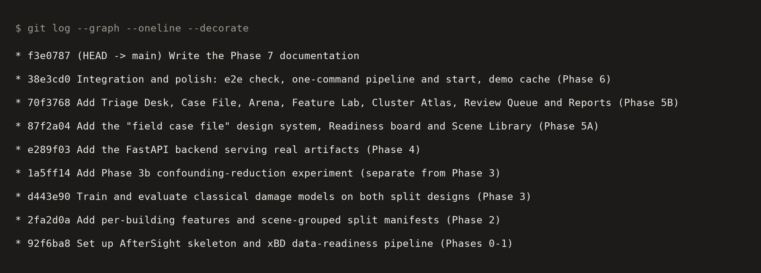
Figure 8.1: git log --graph --oneline of the repository at the time of writing

9. Experiment Tracking
No external tracking service was used. Every run is tracked with files kept next to the models:
- Model metadata JSON: for each saved model, the hyperparameters, the full validation search log, the preprocessing chosen, the feature-schema version, the split-manifest hash, the scikit-learn version, validation, test and per-event metrics, timings and the number of test evaluations (always 1).
- Comparison files and RESULTS.md: a comparison table per design and label scheme is written by the training run, and docs/RESULTS.md records the results with the commands that reproduce them.
- Experiments kept separate: the Phase 3b feature-variant models live in their own folder with their own test evaluations, so they can never overwrite the main models.
Table 9.1 lists the tracked experiments for the 4-class task. The Model Arena page (Figure 9.1) presents the same files visually.
Table 9.1: Tracked experiments (4-class, test set evaluated once per model)
Model | Design | Feature set | Val macro-F1 | Test accuracy | Test macro-F1
Threshold baseline | within-event | full (37) | 0.332 | 0.584 | 0.383
Logistic Regression | within-event | full (37) | 0.538 | 0.552 | 0.527
K-Nearest Neighbours | within-event | full (37) | 0.518 | 0.636 | 0.520
Decision Tree | within-event | full (37) | 0.511 | 0.484 | 0.470
Random Forest (optional) | within-event | full (37) | 0.589 | 0.590 | 0.546
Threshold baseline | cross-event | full (37) | 0.362 | 0.245 | 0.193
Logistic Regression | cross-event | full (37) | 0.665 | 0.433 | 0.290
K-Nearest Neighbours | cross-event | full (37) | 0.581 | 0.554 | 0.271
Decision Tree | cross-event | full (37) | 0.576 | 0.502 | 0.294
Random Forest (optional) | cross-event | full (37) | 0.639 | 0.606 | 0.291
Logistic Regression · Phase 3b | within-event | change_only (17) | 0.464 | — | 0.450
Decision Tree · Phase 3b | within-event | change_only (17) | 0.471 | — | 0.436
Logistic Regression · Phase 3b | cross-event | change_only (17) | 0.571 | — | 0.243
Decision Tree · Phase 3b | cross-event | change_only (17) | 0.535 | — | 0.278
Logistic Regression · Phase 3b | within-event | scene_normalised (37) | 0.350 | — | 0.330
Decision Tree · Phase 3b | within-event | scene_normalised (37) | 0.380 | — | 0.342
Logistic Regression · Phase 3b | cross-event | scene_normalised (37) | 0.395 | — | 0.236
Decision Tree · Phase 3b | cross-event | scene_normalised (37) | 0.442 | — | 0.241
Logistic Regression · Phase 3b | within-event | change_only_scene_normalised (17) | 0.319 | — | 0.309
Decision Tree · Phase 3b | within-event | change_only_scene_normalised (17) | 0.362 | — | 0.374
Logistic Regression · Phase 3b | cross-event | change_only_scene_normalised (17) | 0.352 | — | 0.248
Decision Tree · Phase 3b | cross-event | change_only_scene_normalised (17) | 0.445 | — | 0.262
Phase 3b runs record macro-F1 and recall; their accuracy is not part of the saved summary, so it is marked “—”.
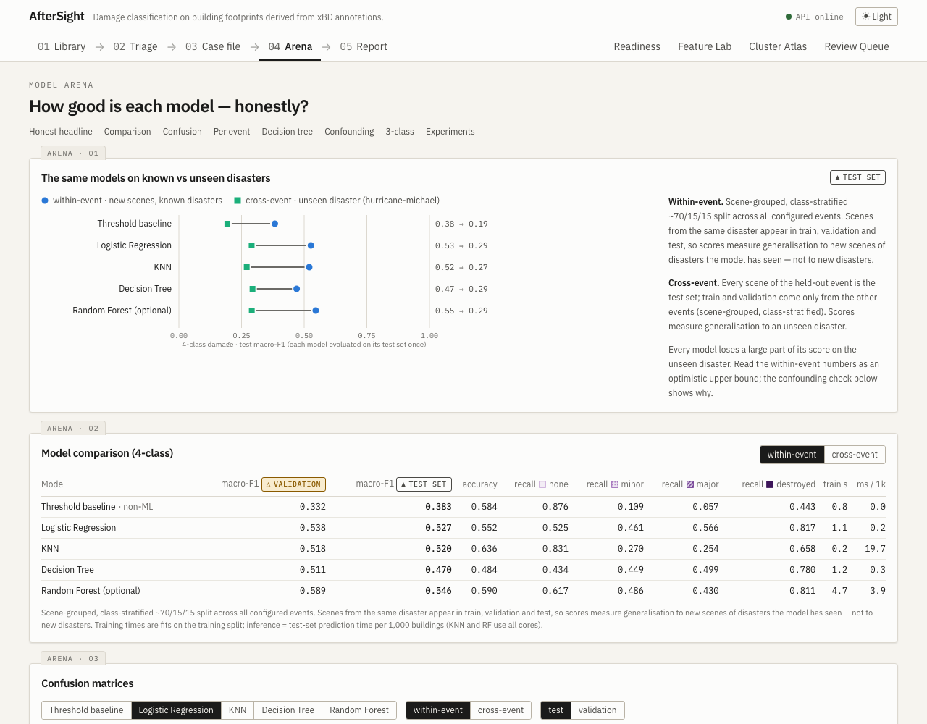
Figure 9.1: Model Arena: every model on known vs unseen disasters, and the comparison table

10. AutoML / MLOps
No AutoML was used. All models, grids and features were chosen by hand so that every decision can be explained in the viva. Hyperparameters were tuned with small, explicit grids on the validation split. The project does follow several MLOps practices:
- Automated tests: 123 backend tests (pytest), 26 frontend tests (Vitest) and an end-to-end check with 22 assertions. They cover the parser, features with known answers, split leakage, saving and reloading models, the API (including path-traversal attempts) and the user interface.
- Reproducible pipeline: one command (scripts/run_pipeline.sh) rebuilds everything from the raw shards. A fresh clone following only the README reproduced every test score exactly.
- Model metadata and loading checks: a model refuses to load if the feature schema, the scikit-learn version or the split manifest differs from what it was trained with.
- Test-set guard: a code object raises an error if any model’s test set is evaluated a second time.
- Versioned, fingerprinted data products: the feature table records a fingerprint of its settings and is rebuilt only when they change. Split manifests carry a hash that detects hand edits.
- Pinned dependencies: exact versions in requirements.txt and package-lock.json.
Not done: continuous integration, model monitoring in production and automated retraining. The system runs locally and is not deployed for operational use.

11. Deployment
AfterSight is deployed locally on a laptop and works fully offline after installation. Two scripts cover the whole life cycle: scripts/run_pipeline.sh builds every data product and model in order (inspect → features → splits → train → review thresholds → experiments → demo cache), and ./start.sh frees the two ports, starts the API and the web app, prints the URL and stops both cleanly. Table 11.1 lists the components. Figures 11.1–11.6 show the main pages; the Cluster Atlas and Reports pages are shown through their content in Chapter 12.
Table 11.1: Deployment components
Component | Technology | Port / location | Role
Data pipeline | Python scripts | scripts/, data/, artifacts/ | builds the cache, features, splits, models, thresholds and demo cache
REST API | FastAPI + Uvicorn | localhost:8020 (/docs for Swagger) | serves scenes, images, analyses, explanations, reports; validates IDs
Web app | React + Vite | localhost:5200 | user interface; proxies /api to the backend
Artifact store | files (JSON, Parquet, joblib, JPEG) | artifacts/, data/processed/ | no database; every number traces to a file
Launcher | Bash | start.sh | frees ports, starts and stops both servers

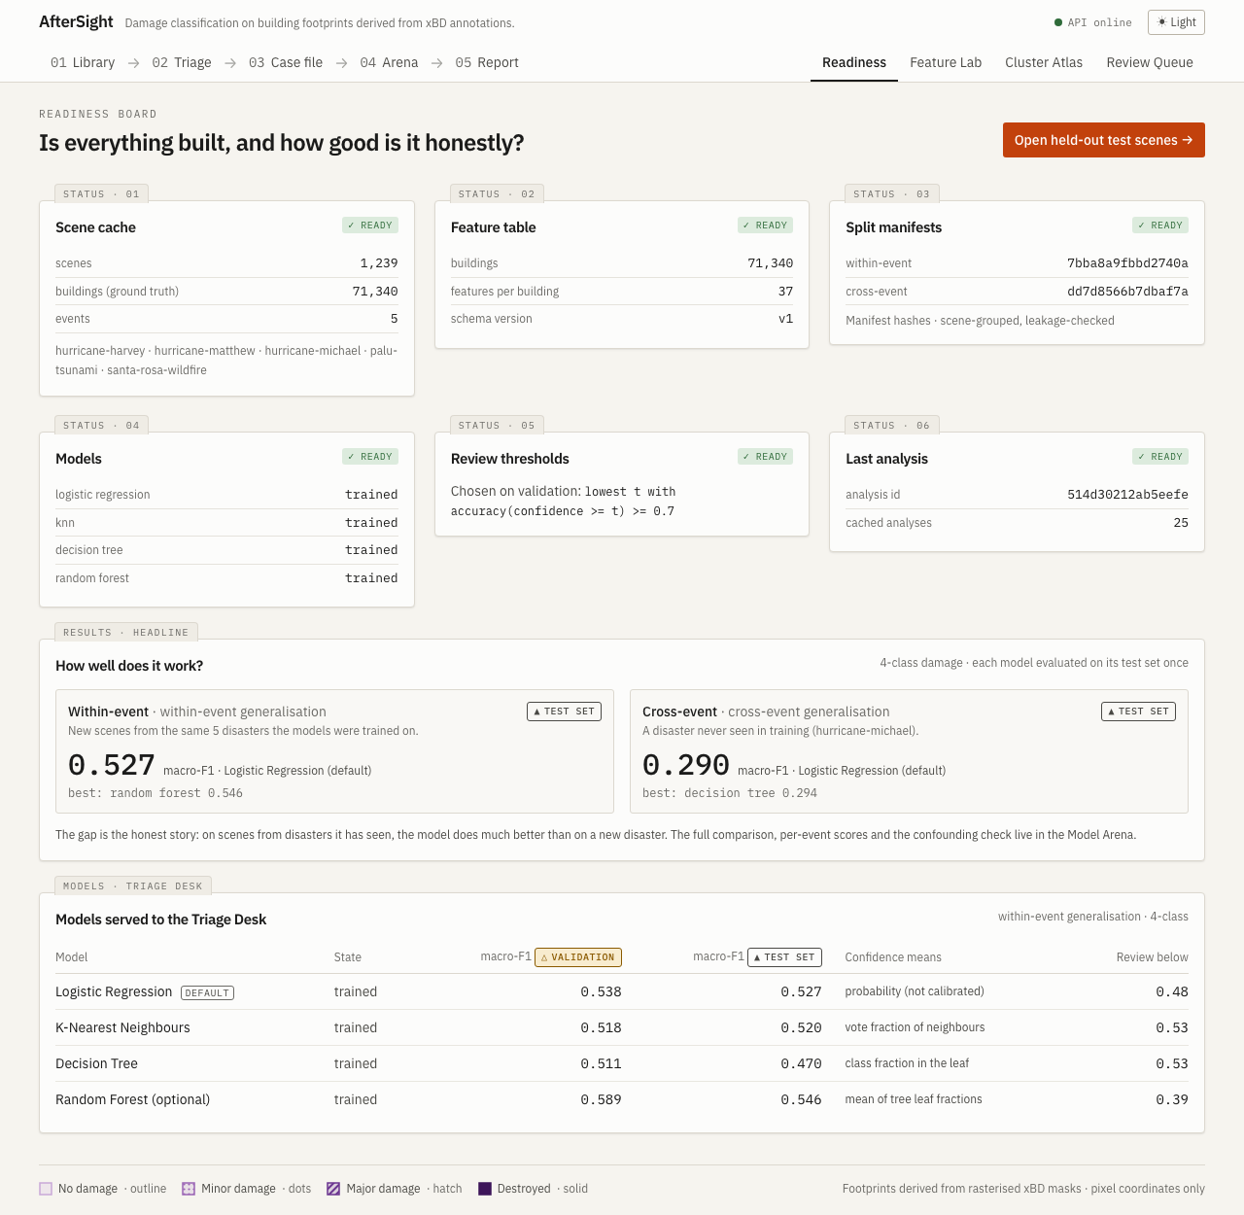
Figure 11.1: Readiness board: build status, honest headline results and the served models
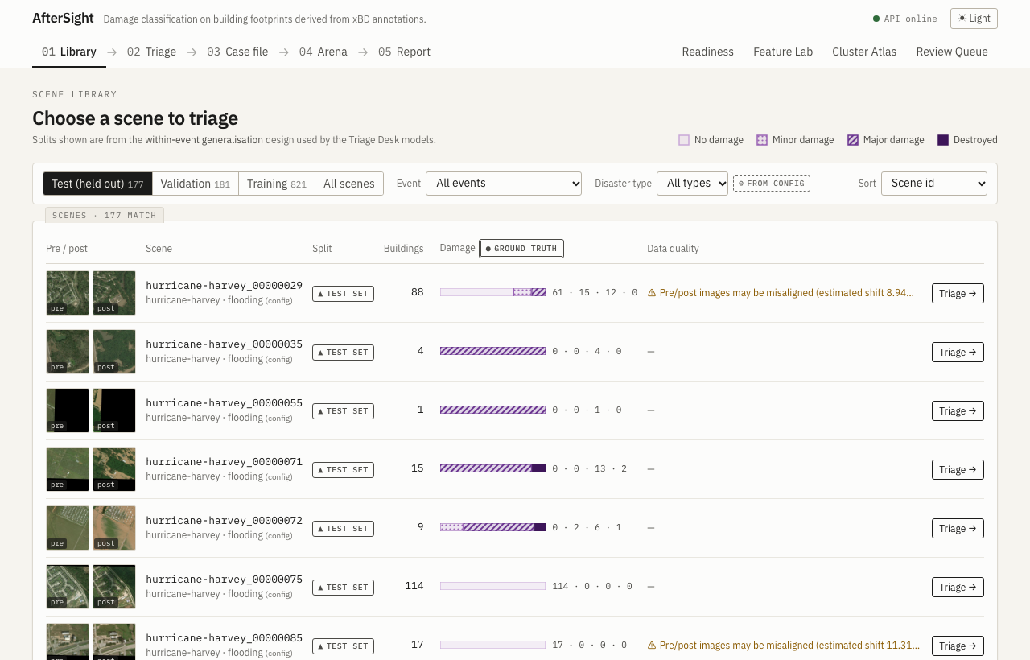
Figure 11.2: Scene Library, opening on held-out test scenes with ground-truth damage bars
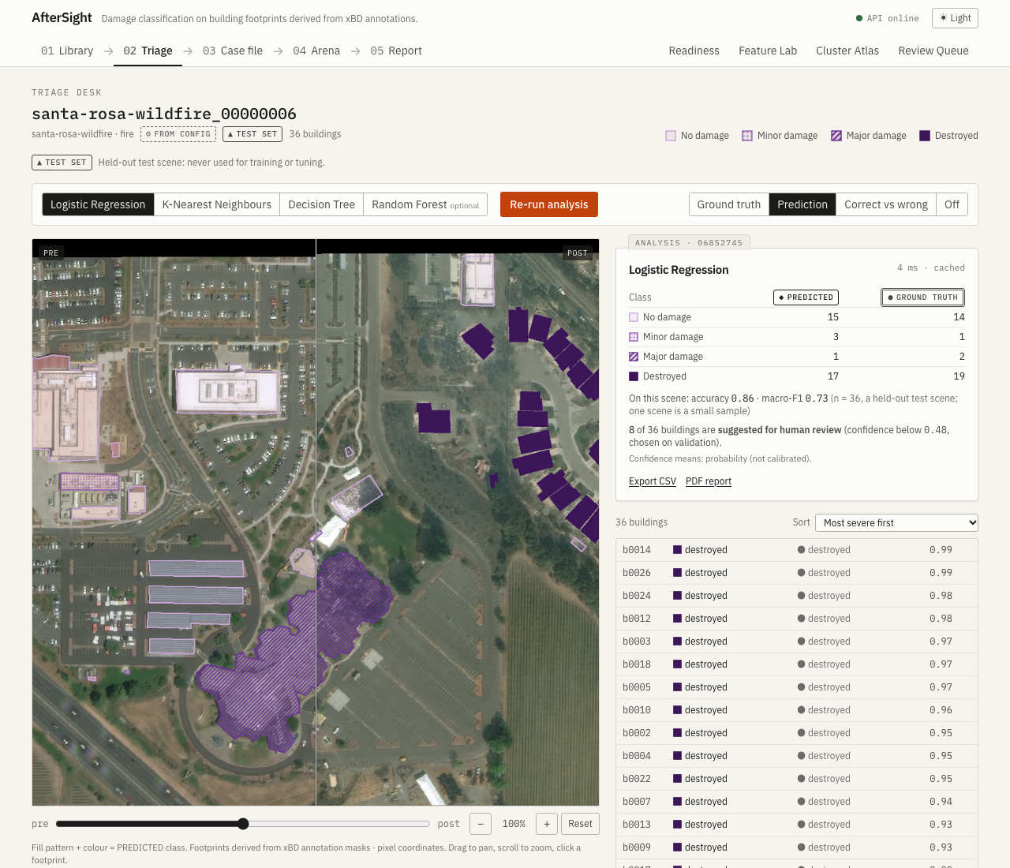
Figure 11.3: Triage Desk: before/after swipe viewer with predicted damage overlays and building list
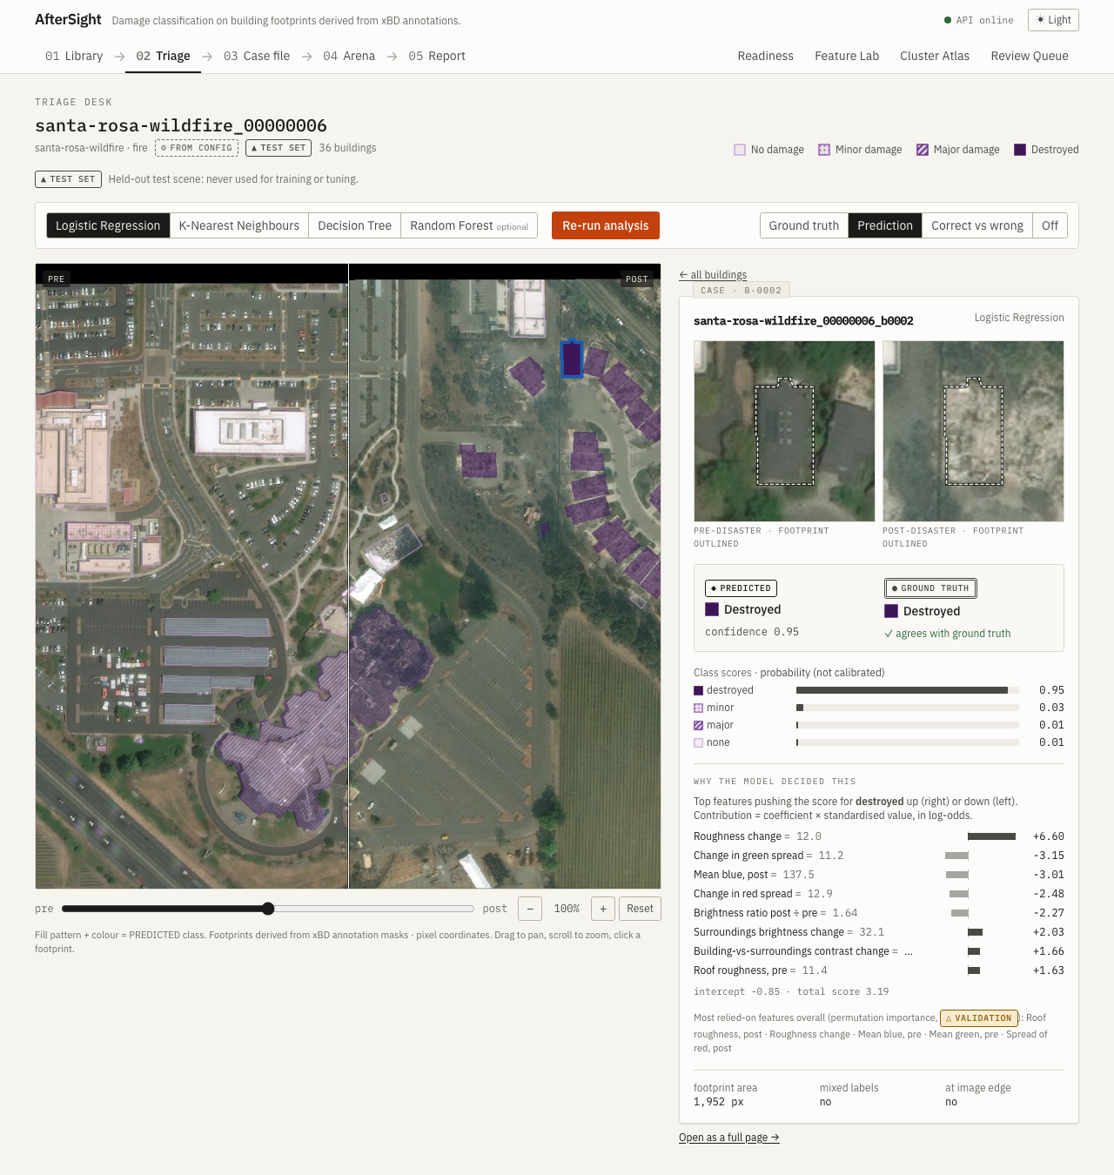
Figure 11.4: Building Case File with a Logistic Regression explanation
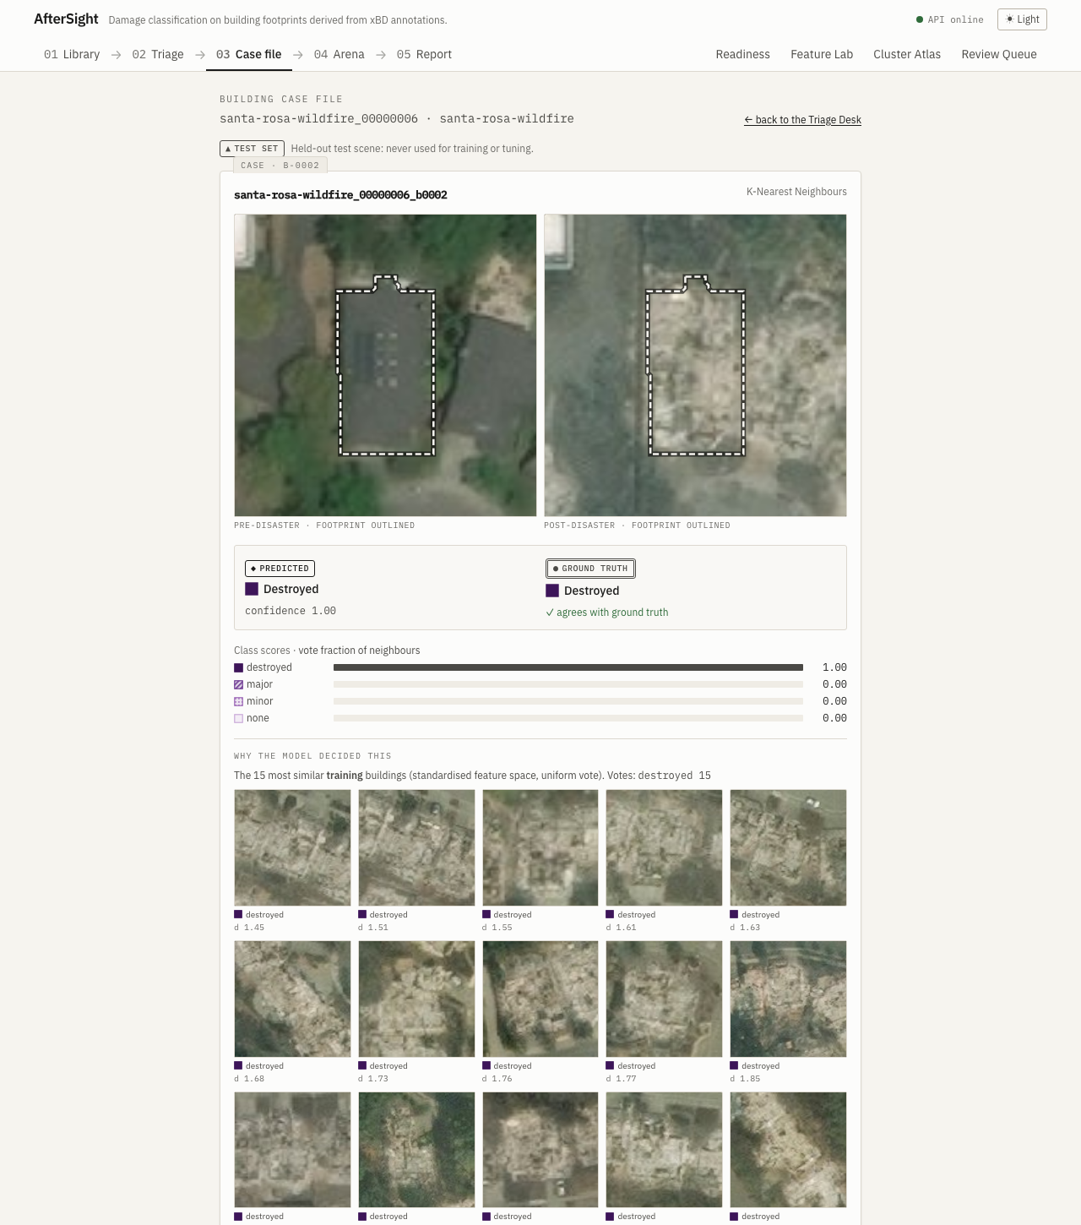
Figure 11.5: Case File with a KNN explanation: the most similar training buildings
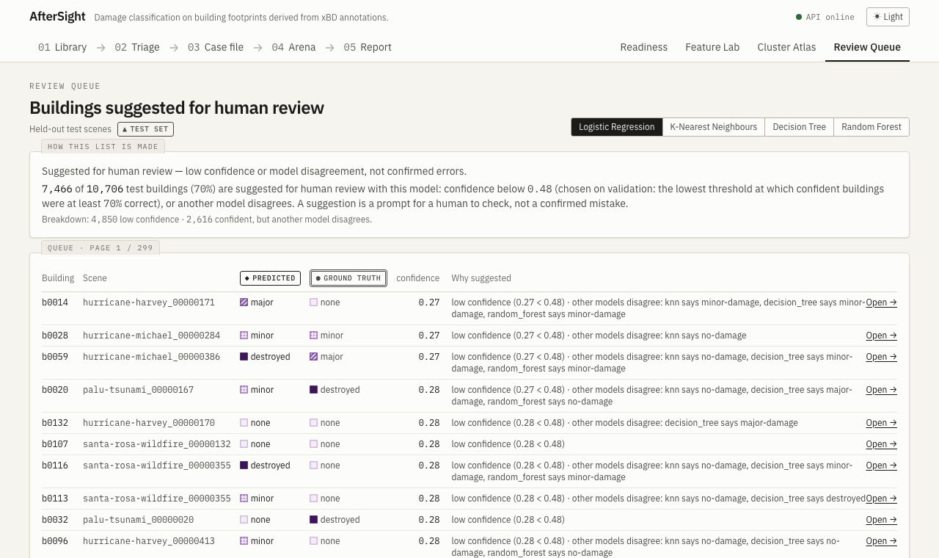
Figure 11.6: Review Queue: buildings suggested for human review

12. Results and Discussions

12.1 Within-event results
Test set: 10,706 buildings from new scenes of the five training disasters (Table 12.1). Logistic Regression reaches a macro-F1 of 0.527 and the optional Random Forest 0.546, against 0.383 for the single-feature baseline. Destroyed is the easiest class (LR recall 0.817). Minor and major damage are harder. KNN is about two orders of magnitude slower at inference than LR because it compares every building with all 49,929 training buildings.
Table 12.1: Within-event test results (4-class)
Model | Acc. | Macro F1 | Wtd. F1 | Rec. none | Rec. minor | Rec. major | Rec. destr. | Train s | ms/1k
Threshold baseline | 0.584 | 0.383 | 0.526 | 0.876 | 0.109 | 0.057 | 0.443 | 0.84 | 0.02
Logistic Regression | 0.552 | 0.527 | 0.571 | 0.525 | 0.461 | 0.566 | 0.817 | 1.08 | 0.22
K-Nearest Neighbours | 0.636 | 0.520 | 0.614 | 0.831 | 0.270 | 0.254 | 0.658 | 0.18 | 19.71
Decision Tree | 0.484 | 0.470 | 0.503 | 0.434 | 0.449 | 0.499 | 0.780 | 1.18 | 0.27
Random Forest (optional) | 0.590 | 0.546 | 0.603 | 0.617 | 0.486 | 0.430 | 0.811 | 4.71 | 3.89

12.2 Cross-event results (unseen disaster)
Test set: all 21,429 hurricane-michael buildings, a disaster never seen in training (Table 12.2). Every model drops sharply: the best macro-F1 is 0.294 (Decision Tree), and LR scores 0.290, although the same models reached 0.576–0.665 on validation scenes from the four training events. Major-damage recall nearly vanishes (Figure 12.1, right).
Table 12.2: Cross-event test results (4-class, hurricane-michael held out)
Model | Acc. | Macro F1 | Wtd. F1 | Rec. none | Rec. minor | Rec. major | Rec. destr. | Train s | ms/1k
Threshold baseline | 0.245 | 0.193 | 0.298 | 0.264 | 0.153 | 0.260 | 0.461 | 1.00 | 0.02
Logistic Regression | 0.433 | 0.290 | 0.464 | 0.561 | 0.179 | 0.153 | 0.447 | 0.87 | 0.25
K-Nearest Neighbours | 0.554 | 0.271 | 0.509 | 0.808 | 0.071 | 0.033 | 0.354 | 0.16 | 16.78
Decision Tree | 0.502 | 0.294 | 0.507 | 0.663 | 0.241 | 0.024 | 0.428 | 1.00 | 0.24
Random Forest (optional) | 0.606 | 0.291 | 0.531 | 0.888 | 0.069 | 0.008 | 0.431 | 4.74 | 3.29
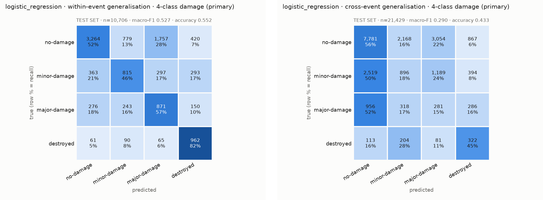
Figure 12.1: Confusion matrices, Logistic Regression: within-event test set (left) and cross-event test set (right); row % = recall

12.3 Per-event scores
Splitting the within-event test set by disaster (Table 12.3) shows that every single event scores below the pooled 0.527. Part of the pooled score therefore comes from telling the disasters apart, since each has its own typical damage mix, rather than from reading damage on each roof.
Table 12.3: Logistic Regression macro-F1 per event (within-event test)
Event | Macro-F1
hurricane-harvey | 0.333
hurricane-matthew | 0.333
hurricane-michael | 0.363
palu-tsunami | 0.529
santa-rosa-wildfire | 0.460
All events pooled | 0.527

12.4 Event-confounding check
A Logistic Regression was trained to predict the event (not the damage) from the same 37 features. It reaches 82.9% test accuracy (macro-F1 0.819), against 25.2% for always guessing the most common event and 20.0% uniform chance (Figure 12.2). The features carry a strong signature of where a building comes from: sensor, region, vegetation and roof style. This explains the gap between Tables 12.1 and 12.2. Event is never an input to any damage model.
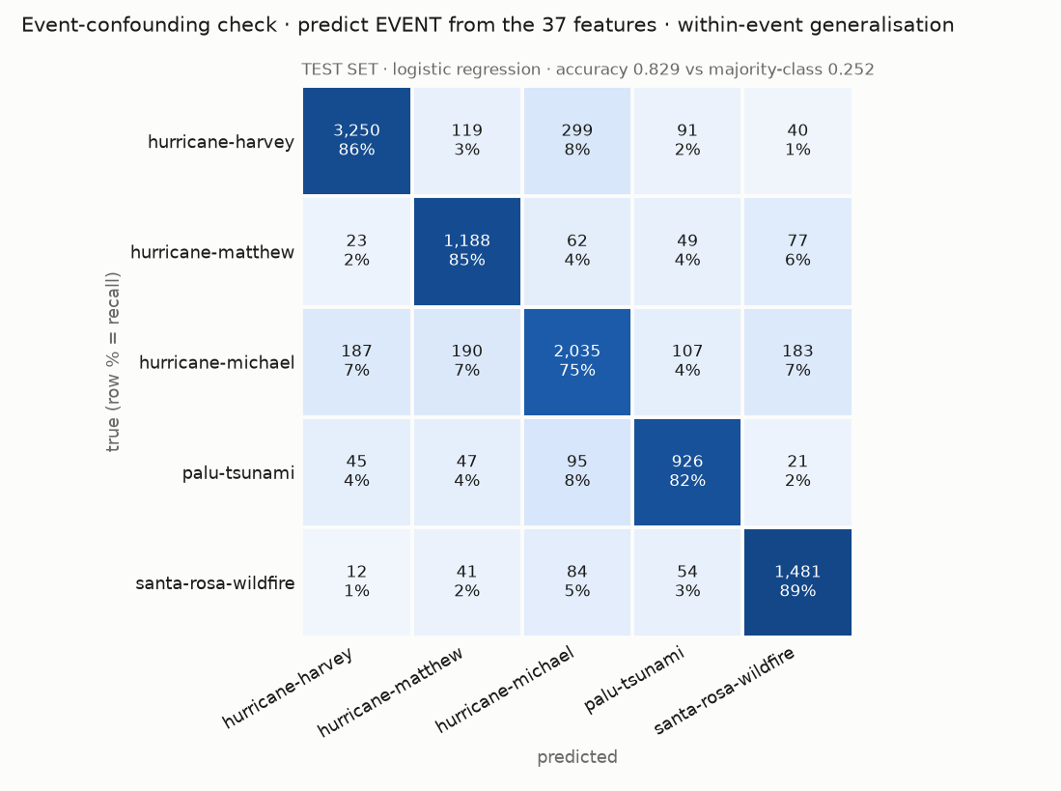
Figure 12.2: Confounding check: confusion matrix for predicting the event from the features (test set)

12.5 Phase 3b: reducing the event signature
Three feature variants were tested to remove that signature: change-only (17 features with no absolute colour or texture levels), scene-normalised (each feature minus its scene median) and both combined. New LR and Decision Tree models were trained and tested once each (Table 12.4).
Table 12.4: Phase 3b results (separate models; Phase 3 models untouched)
Variant | Design | Model | Test macro-F1 | Recall major | Recall destroyed | Event-pred. accuracy
change_only | within-event | Logistic Regression | 0.450 | 0.501 | 0.764 | 0.632
change_only | within-event | Decision Tree | 0.436 | 0.442 | 0.717 | 0.632
change_only | cross-event | Logistic Regression | 0.243 | 0.087 | 0.579
change_only | cross-event | Decision Tree | 0.278 | 0.022 | 0.314
scene_normalised | within-event | Logistic Regression | 0.330 | 0.511 | 0.408 | 0.518
scene_normalised | within-event | Decision Tree | 0.342 | 0.438 | 0.616 | 0.518
scene_normalised | cross-event | Logistic Regression | 0.236 | 0.200 | 0.804
scene_normalised | cross-event | Decision Tree | 0.241 | 0.168 | 0.506
change_only_scene_normalised | within-event | Logistic Regression | 0.309 | 0.388 | 0.431 | 0.374
change_only_scene_normalised | within-event | Decision Tree | 0.374 | 0.129 | 0.523 | 0.374
change_only_scene_normalised | cross-event | Logistic Regression | 0.248 | 0.330 | 0.711
change_only_scene_normalised | cross-event | Decision Tree | 0.262 | 0.188 | 0.464
Event prediction fell from 82.9% to as low as 37.4%, but cross-event macro-F1 did not improve (0.236–0.278 against 0.290), and within-event scores fell. The poor transfer is therefore not mainly the model exploiting event identity. It is a genuine domain shift between disasters that these features cannot bridge. The full 37-feature models remain the default.

12.6 K-Means clustering
K-Means was run on the training buildings for k = 2 … 10 (Figure 12.3). The silhouette is highest at k = 2 (0.253) and the elbow heuristic suggests k = 3. Agreement with the damage labels is weak: the adjusted Rand index [10] is 0.041 at k = 2 and 0.095 at k = 4 (Figure 12.4). The strongest natural structure in the features is therefore not damage. Clusters are an analysis only and are never used as predictions [9].
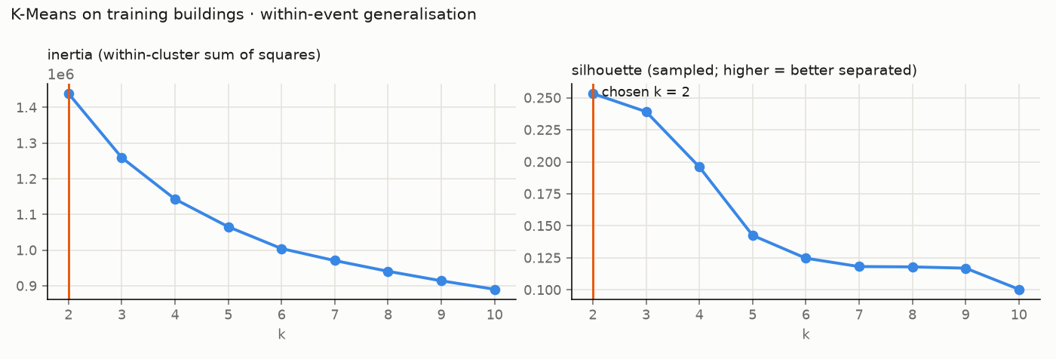
Figure 12.3: K-Means: inertia (elbow) and sampled silhouette for k = 2 … 10
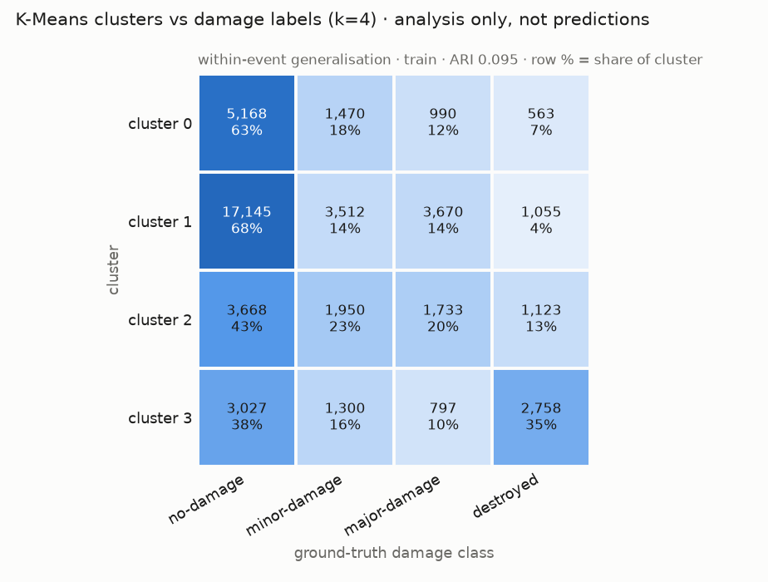
Figure 12.4: K-Means (k = 4) clusters against ground-truth damage classes

12.7 3-class experiment
Merging minor and major damage into one damaged class (Table 12.5) raises scores, because the hardest distinction is removed. The drop on the unseen disaster remains. The 4-class task stays primary.
Table 12.5: 3-class experiment: test macro-F1 (no-damage / damaged / destroyed)
Model | Within-event | Cross-event
Threshold baseline | 0.373 | 0.334
Logistic Regression | 0.612 | 0.413
K-Nearest Neighbours | 0.634 | 0.379
Decision Tree | 0.558 | 0.371
Random Forest (optional) | 0.640 | 0.414

12.8 Demo scenes and review suggestions
Three held-out test scenes of different disaster types were chosen automatically for the demonstration, picking scenes with a clear mix of damage classes (Table 12.6). Scene-level scores are small samples and vary widely: the fire scene is predicted well, while the flooding scene, mostly minor damage under water, is difficult.
Table 12.6: Demo scenes (test split): ground truth and scene macro-F1 per model
Scene | Type | Buildings | GT none · minor · major · destroyed | LR | KNN | DT | RF
hurricane-matthew_00000185 | wind | 37 | 12 · 10 · 8 · 7 | 0.22 | 0.35 | 0.16 | 0.20
hurricane-harvey_00000356 | flooding | 115 | 25 · 61 · 27 · 2 | 0.21 | 0.17 | 0.26 | 0.23
santa-rosa-wildfire_00000006 | fire | 36 | 14 · 1 · 2 · 19 | 0.73 | 0.55 | 0.58 | 0.78
For the Review Queue, each model’s confidence threshold was chosen on validation as the lowest value at which confident buildings are at least 70% correct (Table 12.7). Buildings below it are presented neutrally as suggested for human review.
Table 12.7: Review thresholds chosen on validation
Model | Threshold | Share flagged | Accuracy ≥ threshold | Accuracy < threshold
Logistic Regression | 0.484 | 40% | 0.703 | 0.421
K-Nearest Neighbours | 0.533 | 22% | 0.725 | 0.414
Decision Tree | 0.526 | 55% | 0.706 | 0.435
Random Forest (optional) | 0.387 | 14% | 0.701 | 0.380

12.9 Discussion
- 0.527 is an upper bound. Within-event scores include help from recognising the disaster (per-event scores are all lower, and the event is predictable at 82.9%).
- 0.290 is the realistic figure for a new disaster. All learned models converge to about this value on hurricane-michael, still above the 0.193 baseline.
- Domain shift, not just a shortcut. Removing the event signature did not help transfer. Roofs, imagery and the appearance of damage differ between disasters, and hurricane-michael has a different class mix: 23% of its buildings are minor damage, against 14% in the training events.
- What works: destroyed buildings are recognised well within-event, texture change is the most informative signal across all models, and every model beats the non-ML baseline.
- What does not: separating minor from major damage at sub-metre resolution (xBD targeted imagery below 0.8 m per pixel [1]), and transferring to new events. Balanced class weights also push some undamaged buildings into damaged classes.
- Explainability is a real benefit. Every prediction can be traced to features, tree questions or similar examples, which makes these failure modes visible instead of hidden.

13. Future Scope
- Compare learned features (CNN or Siamese networks on pre/post crops) against this classical baseline on the same honest, scene-grouped and event-held-out splits.
- Use the original xBD JSON polygons to avoid merged buildings, and add more events and the official test and holdout splits.
- Domain adaptation or per-event normalisation that keeps scene-wide damage information, since the scene-median normalisation removed it.
- Calibrate the model scores (for example with isotonic regression) so that confidence can be read as a probability.
- Georeferenced output for map overlays and integration with real response workflows, with human review built in.

14. Conclusion
AfterSight shows that classical, explainable machine learning can perform meaningful building damage triage on xBD. On 71,340 buildings from five disasters, Logistic Regression on 37 hand-crafted features reaches a test macro-F1 of 0.527 on new scenes of known disasters and explains every decision. The project's main finding is an honest one: on an unseen disaster the score falls to about 0.290. The features reveal which disaster a building comes from, but removing that signature does not restore performance, so the gap reflects a genuine domain shift.
Beyond the models, the project delivers a reproducible pipeline, leakage-checked splits, a test-set guard, 171 automated checks in total and a complete web application. Its Triage Desk, Case File and Model Arena make both the strengths and the limits of the approach visible to users and examiners.

15. References
[1] R. Gupta, R. Hosfelt, S. Sajeev, N. Patel, B. Goodman, J. Doshi, E. Heim, H. Choset and M. Gaston, “xBD: A Dataset for Assessing Building Damage from Satellite Imagery,” arXiv:1911.09296, 2019.
[2] R. M. Haralick, K. Shanmugam and I. Dinstein, “Textural Features for Image Classification,” IEEE Transactions on Systems, Man, and Cybernetics, vol. SMC-3, no. 6, pp. 610–621, 1973, doi: 10.1109/TSMC.1973.4309314.
[3] A. J. Cooner, Y. Shao and J. B. Campbell, “Detection of Urban Damage Using Remote Sensing and Machine Learning Algorithms: Revisiting the 2010 Haiti Earthquake,” Remote Sensing, vol. 8, no. 10, art. 868, 2016, doi: 10.3390/rs8100868.
[4] E. Weber and H. Kané, “Building Disaster Damage Assessment in Satellite Imagery with Multi-Temporal Fusion,” ICLR 2020 Workshop on AI for Earth Sciences, arXiv:2004.05525, 2020.
[5] R. Gupta and M. Shah, “RescueNet: Joint Building Segmentation and Damage Assessment from Satellite Imagery,” in Proc. 25th International Conference on Pattern Recognition (ICPR), 2020, arXiv:2004.07312.
[6] J. Canny, “A Computational Approach to Edge Detection,” IEEE Transactions on Pattern Analysis and Machine Intelligence, vol. PAMI-8, no. 6, pp. 679–698, 1986, doi: 10.1109/TPAMI.1986.4767851.
[7] F. Pedregosa et al., “Scikit-learn: Machine Learning in Python,” Journal of Machine Learning Research, vol. 12, pp. 2825–2830, 2011.
[8] L. Breiman, “Random Forests,” Machine Learning, vol. 45, no. 1, pp. 5–32, 2001, doi: 10.1023/A:1010933404324.
[9] P. J. Rousseeuw, “Silhouettes: A Graphical Aid to the Interpretation and Validation of Cluster Analysis,” Journal of Computational and Applied Mathematics, vol. 20, pp. 53–65, 1987, doi: 10.1016/0377-0427(87)90125-7.
[10] L. Hubert and P. Arabie, “Comparing Partitions,” Journal of Classification, vol. 2, no. 1, pp. 193–218, 1985.
[11] xView2 Challenge, “xBD Dataset,” [Online]. Available: https://xview2.org/dataset. Licence: CC BY-NC-SA 4.0.

